**Hellenic** **Army**

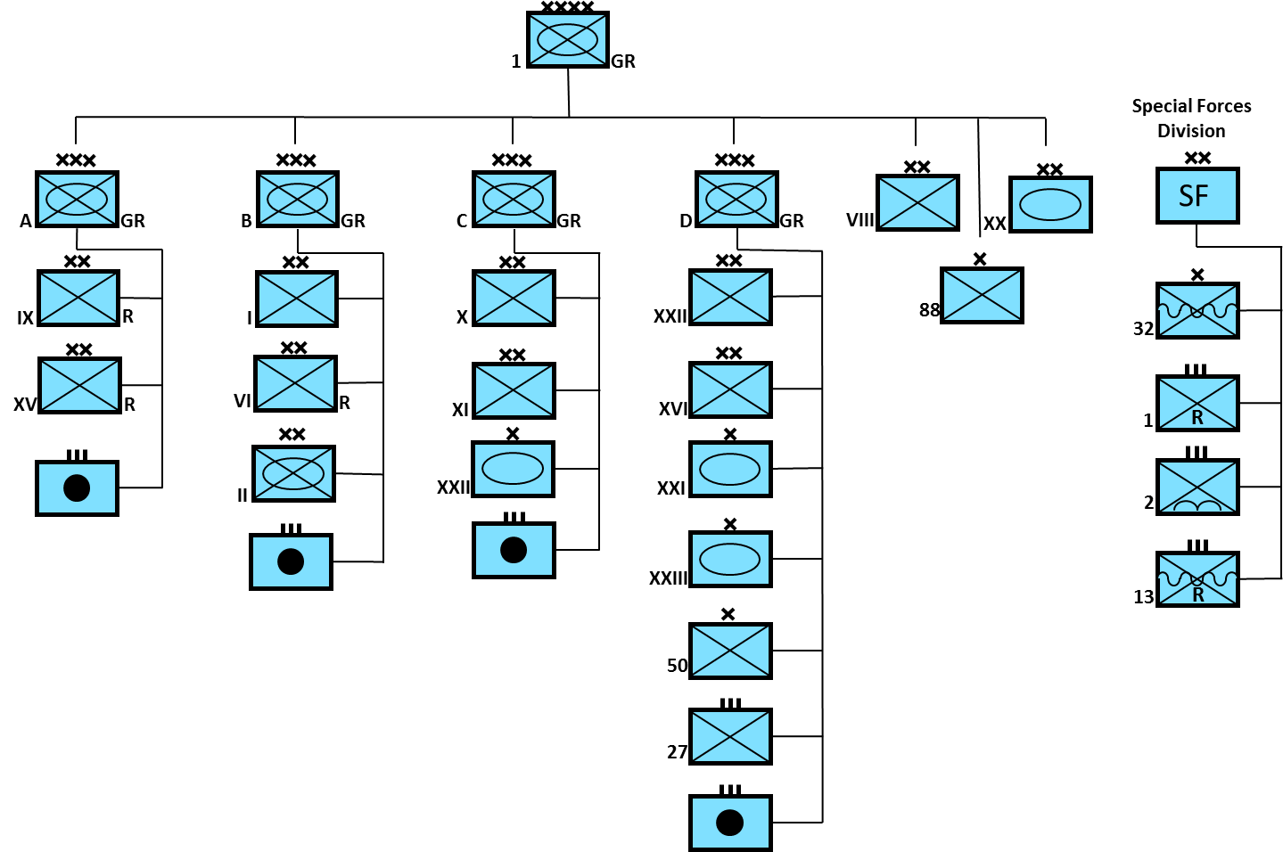

The Hellenic (Greek) army is primarily an infantry based force but they do have one Armored Davison, a Mechanized Division and three Armoured Brigades. Each infantry division also has a tank battalion. The Special Forces Division is an administrative organization as these units are under national control and not meant to fight together. In addition to the forces indicated above are island garrisons and the Greek force on Cyprus (a small regiment) plus about 100 Home Guard battalions.

The main role of the Greek Army is to defend against any threats from the north with ‘D Corps’ to the northeast, ‘B Corps’ to the northwest with 20th (XX)Armored Division at Thessaloniki to respond quickly in either direction. Interestingly, this deployment could serve to defend a threat from Turkey just as well as a threat from Bulgaria. The rugged and mountainous terrain lends itself to a lighter force and the Hellenic Army is focused along those lines.

**MBT**

Greece fields about 1750 Main Battle Tanks (MBT), although there is quite a mix and most are getting old. The initial purchase of 104 Leopard 1 tanks was made by Greece in 1984 but since then, no more have been obtained. The historic purchases from the Netherlands and Germany in 1993 did not occur as those counties held onto their tanks. Replacement M60’s are available and if needed would have been acquired. It is uncertain how these various tanks would be used but my assumption is that the 20th Armored Division was equipped with the AMX-30s, one of the Armored Brigades would use the Leopards while 2nd Mechanized Division would use M60s, as would the tank battalions in all other formations. The M47 and M48 MBT are probably in reserve.

* 190 AMX-30
* 104 Leopard 1A3
* 312 M60A3 TTS
* 357 M60A1 RISE
* 390 M48A5 MOLF
* 396 M47 Patton

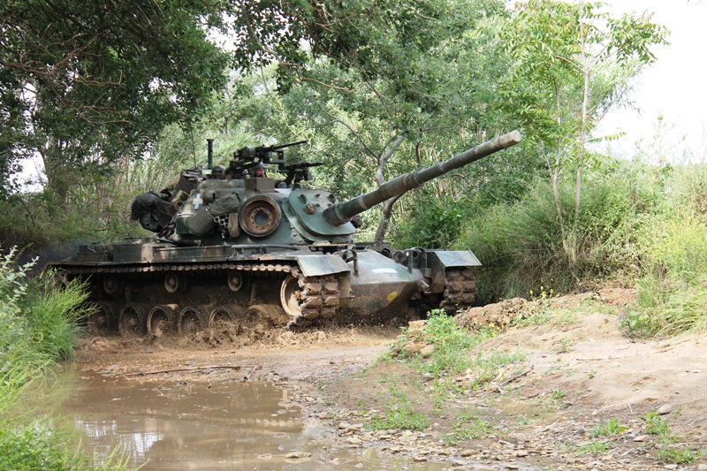

**APC**

With almost 3000 Armored Personal Carriers (APC) available the Greeks have more than enough to equip the one mechanized division. Therefore it’s quite likely that some or all of the light infantry formations have some mechanized capability as well as much of the supporting forces. The Leonidas is a locally designed APC built in conjunction with Austria.

* 2500 M113, including:
  + 257 M106A1 Mortar carriers
  + 362 M901A1 ITV
  + 12 M113 TOW
  + 249 M577A2
* 100 Leonidas I
* 344 Leonidas II

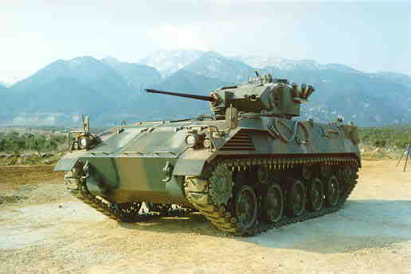

Leonidas II

**Reconnaissance**

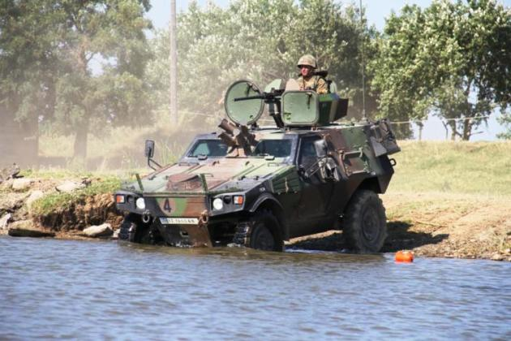

Reconnaissance battalions are equipped with a combination of light wheeled vehicles and 242 French VBL 4-wheeled light armored vehicles. There is one reconnaissance battalion in each Corps and in both the 20th Armored and 2nd Mechanized Divisions.

**Artillery**

Greek artillery is dated but they are gradually modernizing from the post WW2 equipment to some more modern versions. Close support throughout the army is provided by 105mm guns while general support is conducted by 155mm and heavy artillery.

* 18 Mod 56, 105mm Pack howitzer
* 478 M101, 105mm towed howitzer
* 180 M102, 105mm towed howitzer
* 325 M114, 155mm towed howitzer
* 84 M115, 155mm towed howitzer
* 130 M109 A1B/A2, 155mm SP howitzer
* 12 M107, 175mm SP howitzer
* 28 M110A2, 8” SP howitzer

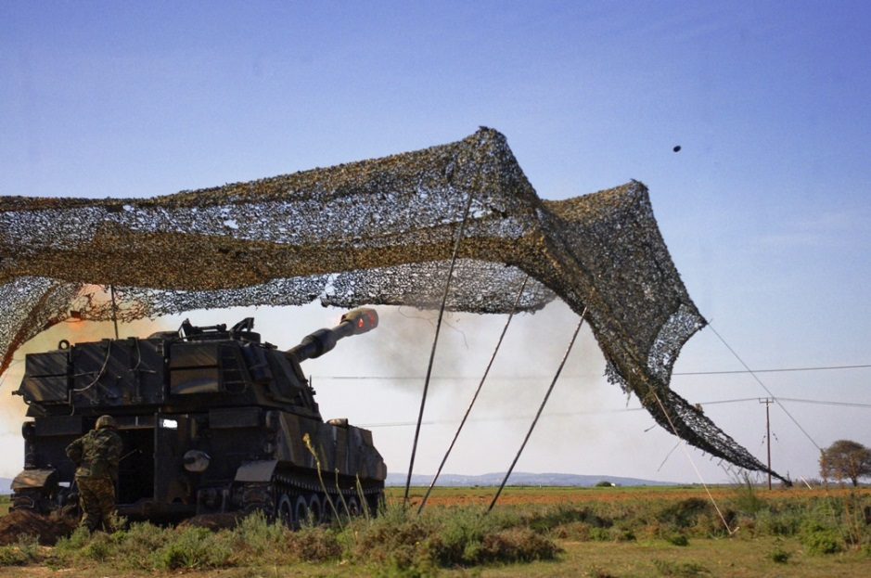

**Air Defence**

The air defence systems, as many other elements in the Hellenic Army are dated. The I-Hawk is focused on defending major infrastructure while the remainder is used for defence of the field force

* 101 RH-202 twin 20mm
* 24 Artemis twin 30mm
* 227 Bofors 40mm
* 101 M42 Duster twin 40mm
* 42 I-Hawk
* FIM-43 Redeye MANPADS

