**Greek Navy**

The Greek Navy in Northern Fury is in a difficult position. Since the USN was holding onto older ships in order to satisfy their 600 ship navy commitment, the sale of 5 Charles F. Adams Class DDGs and 3 Knox Class FFs did not occur, so the 8 Ex-Gearing class DDs were retained. Similarly the 8 Dutch Kortenaer class FFGs remained in the Netherlands navy and were not transferred. To compensate for these shortfalls, the Hellenic Navy commissioned another two Hydra class (MEKO-200) FFGs which were built in Germany in order to expedite construction.

**Destroyers**

In Northern Fury all eight destroyers in the Hellenic Navy are Ex US Gearing/Sumner class, launched near the end of World War Two and upgraded in the 1960s under the USNs Fleet Rehabilitation and Modernization (FRAM) program. The two ships of the Themistoklis Class were FRAM II ships focusing on Anti-Surface warfare (ASuW) while the six ships of the Kanaris class focused on Anti-Submarine Warfare (ASW) operations

**Themistoklis Class:** These two DDs, one previously a Gearing and the other an Allen M. Sumner class both FRAM II, are equipped with 6x 5” guns in twin turrets, torpedo tubes a flight deck and small hanger but no facilities for a permanent helicopter. These ships are well past their prime and rarely sail.

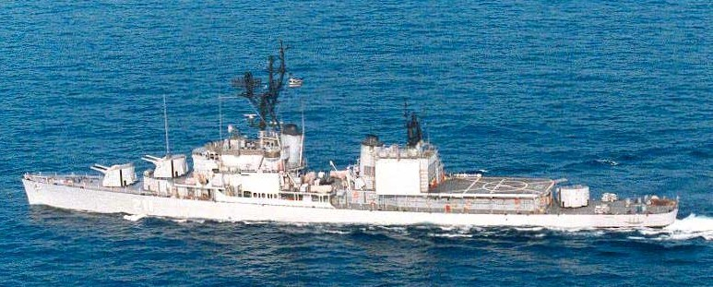

**Kanaris Class:** Outfitted for ASW work, these six ships are all based on Gearing FRAM I hulls. They only have 2x 5” twin turrets, but also carry 8x Harpoon ASuW missiles, ASW rockets (ASROC), an Oto Melara 76mm gun for air defence but no flight deck.

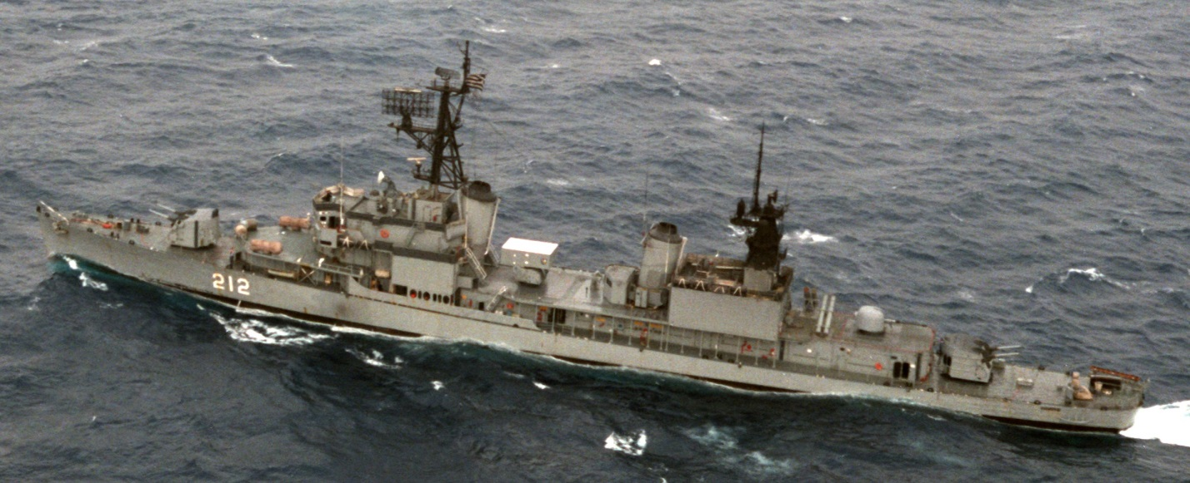

|  |  |  |  |  |
| --- | --- | --- | --- | --- |
| Class | Pennant | Name | Status | Remarks |
| Themistoklis | D 210 | Themistoklis | Tied up |  |
|  | D 211 | Miaoulis | Refit |  |
| Kanaris | D 212 | Kanaris | Tied up |  |
|  | D 213 | Kountouriotis | Tied up |  |
|  | D 214 | Sachtouris | Refit |  |
|  | D 215 | Tombazis | Tied up |  |
|  | D 216 | Apostolis | Patrol |  |
|  | D 217 | Kriezis | Refit |  |

**Frigates**

**Elli Class**: The two Elli Class were new build Kortenaer class ships which Greece received in the early 1980s. These are excellent ships of Dutch design but the eight sister ships, which historically transferred to Greece beginning 1993, were kept in Dutch service. These ships have a very modern propulsion system, aircraft facilities for two AB-212 ASW helicopters, 8x Harpoon missiles, Sea Sparrow air defence missiles, an Oto-Melara 76mm gun and Phalanx Close In Weapons System (CIWS).

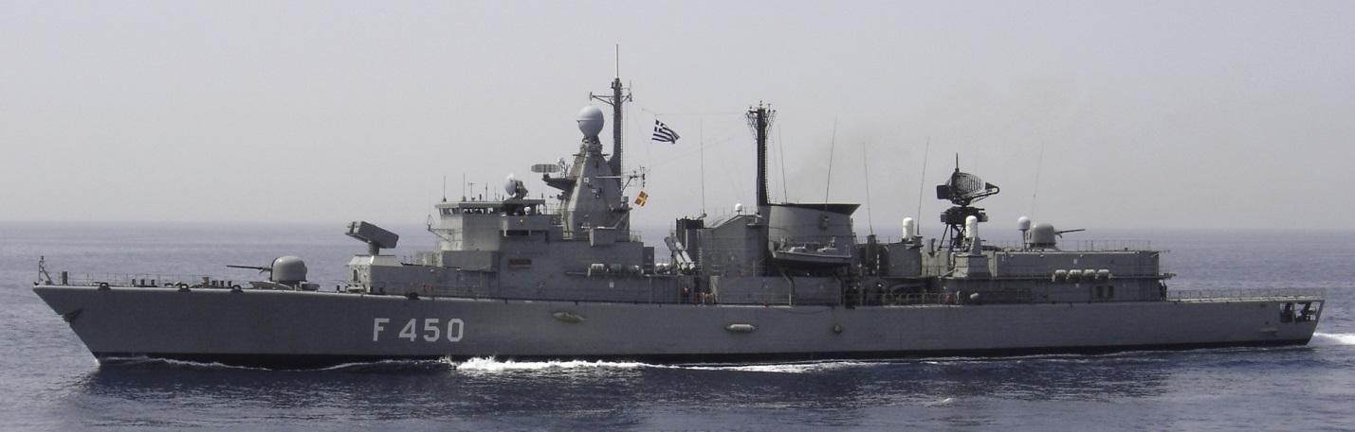

|  |  |  |  |  |
| --- | --- | --- | --- | --- |
| Class | Pennant | Name | Status | Remarks |
| Elli | F 450 | Elli | Tied up |  |
|  | F 451 | Limnos | Patrol |  |

**Hydra Class (MEKO 200)**: This is a German designed modular warship with several variations, in three basic configurations (MEKO 140, 200, 360), the MEKO 200 is the most prolific with six nations either operating or building the design. The Hellenic Navy’s Hydra Class are large (3,200 tons) capable and well-rounded ships with Harpoon ASMs, Sea Sparrow air defence missiles, 2x CIWS, a 5” gun and facilities for an S-70B Seahawk helicopter. Six ships of this class were approved in 1988 and historically one was built in Germany, two were canceled and three were completed after long delays in Greece. For Northern Fury the evolving Soviet threat and the lack of other ship transfers spurred the building program so that the two canceled ships were built in Germany, both completing in 1993 while one locally built has been commissioned and the other two will come into service later in 1994.

|  |  |  |  |  |
| --- | --- | --- | --- | --- |
| Class | Pennant | Name | Status | Remarks |
| Hydra | F 452 | Hydra | Active |  |
|  | F 453 | Spetsai | Active |  |
|  | F 454 | Psara | Building |  |
|  | F 455 | Salamis | Building |  |
|  | F 456 | Aigaion | Active | Name from F 460, built in Germany |
|  | F 457 | Bouboulina | Active | Name from F 463, built in Germany |

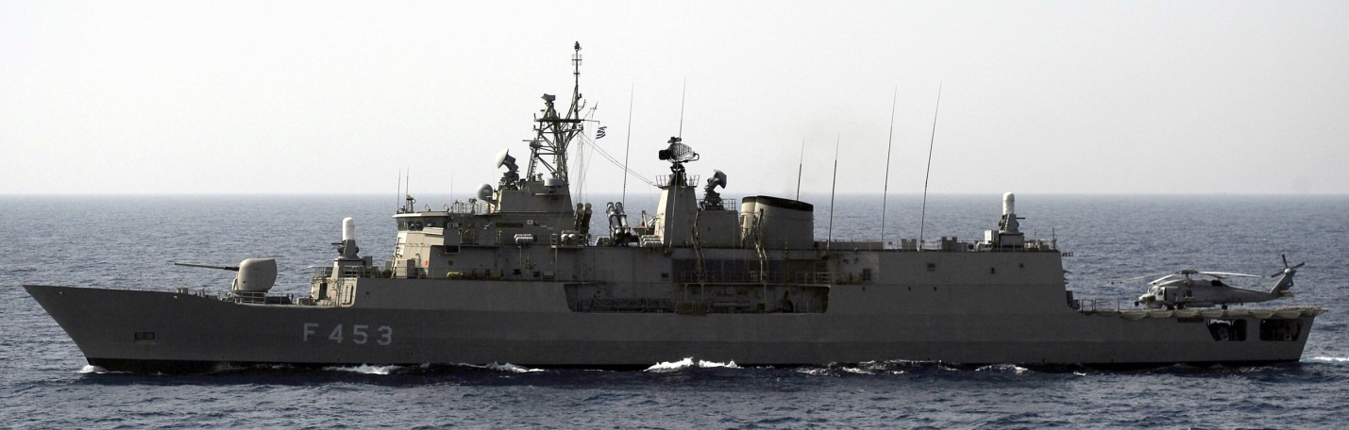

**Fast Attack Craft (FAC)**

As with the larger ships, Greece was at the mercy of other navies, in this case Germany. When the threat increased and Germany held on to her military assets, Greece did not receive six cast-off Combattant IIa class ships. Beginning in the 1970s Greece began operating La Combattant FACs in the Aegean Sea as an inexpensive and effective way of countering any threat in those confined and busy waters. Over the years more boats were added; 14 boats were in service in 1994, the six from Germany would have allowed retirement of some of the older craft but the numbers would have remained stable.

|  |  |  |  |  |
| --- | --- | --- | --- | --- |
| Class | Pennant | Name | Status | Remarks |
| La Combattante II | P 14 | Anninos | Active | 4x mm-38 Exocet |
|  | P 15 | Arliotis | Active | 4x mm-38 Exocet |
|  | P 16 | Konidis | Active | 4x mm-38 Exocet |
|  | P 17 | Batsis | Active | 4x mm-38 Exocet |
| La Combattante III | P 20 | Laskos | Active | 4x mm-38 Exocet |
|  | P 21 | Blessas | Active | 4x mm-38 Exocet |
|  | P 22 | Mikonios | Active | 4x mm-38 Exocet |
|  | P 23 | Troupakis | Active | 4x mm-38 Exocet |
| La Combattante IIIb | P 24 | Kavaloudis | Active | 6x Penguin Mk 2 |
|  | P 25 | Kostakos | Active | 6x Penguin Mk 2 |
|  | P 26 | Degiannis | Active | 2x RGM-84 Harpoon |
|  | P 27 | Xenos | Active | 6x Penguin Mk 2 |
|  | P 28 | Simitzopoulos | Active | 6x Penguin Mk 2 |
|  | P 29 | Starakis | Active | 6x Penguin Mk 2 |

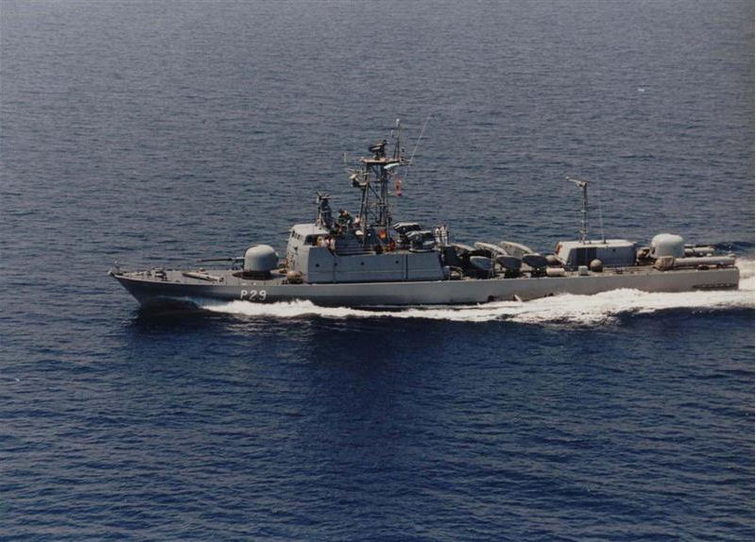

Gun Boats

There are three main classes of small gun boats used by the Hellenic Navy, the common factor is size, between 550 and 600 tons, speed of about 24 knts, and role – to patrol the hundreds of Greek islands in the Aegean archipelago. The Thetis boats have an ASW capability but the two Osprey types are simply gunboats.

|  |  |  |  |  |
| --- | --- | --- | --- | --- |
| Class | Pennant | Name | Status | Remarks |
| Osprey 55 | P 18 | Armatolos |  | Oto-Melara 76mm |
|  | P 19 | Navmachos |  | Oto-Melara 76mm |
| HSY-55 | P 57 | Pyrpolitis |  | Oto-Melara 76mm |
|  | P 61 | Polemistis |  | Oto-Melara 76mm |
| Thetis | P 62 | Niki |  | Two twin Boffors L70/Breda 40 mm/70 |
|  | P 63 | Doxa |  | Two twin Boffors L70/Breda 40 mm/70 |
|  | P 64 | Eleftheria |  | Two twin Boffors L70/Breda 40 mm/70 |
|  | P 65 | Karteria |  | Two twin Boffors L70/Breda 40 mm/70 |
|  | P 66 | Agon |  | Two twin Boffors L70/Breda 40 mm/70 |

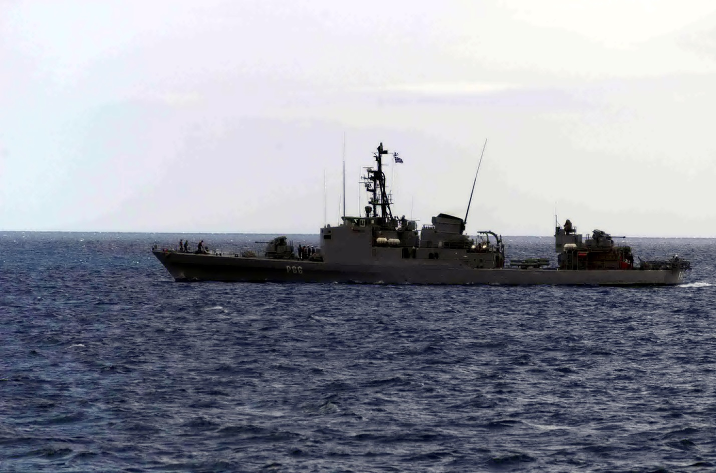

**Amphibious vessels**

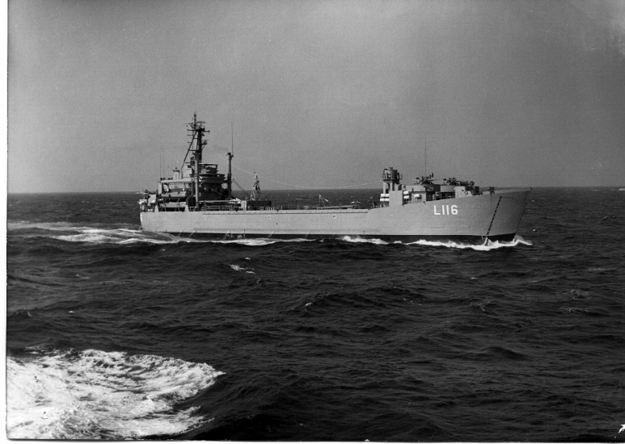**Kos Class LST**: These two ‘Landing Ship Tank’ of the World War Two ‘Terrebonne Parish-class’ were transferred to Greece in the early 1970s after many years of service for the USN in both Korea and Viet Nam as well as other service.

**Casa Grande LSD**: Another World War Two design, this ship was commissioned immediately after the war and transferred to Greece in 1971.

**Ikaria/Samos LST**: These are truly World War Two veterans, the two Ikarias transferred to Greece after service in Korea and Viet Nam, while the six Samos class were delivered in the early 1950s.

**Grigoropoulos class LSM**: More veterans transferred in 1958.

|  |  |  |  |
| --- | --- | --- | --- |
| Class | Pennant | Name | Remarks |
| Terrebonne Parish LST | L 116 | Kos | about 400 troops or several vehicles |
|  | L 104 | Oinoussai |  |
| Casa Grande LSD | L 153 | Nafkratousa | about 200 troops and 15 tanks |
| Ikaria LST | L 154 | Ikaria | about 150 troops and 5 tanks |
|  | L 171 | Krit |  |
| Samos | L 144 | Siros |  |
|  | L 157 | Rodos |  |
|  | L 158 | Limnos |  |
|  | L 172 | Lesbos |  |
|  | L 179 | Samos |  |
|  | L 195 | Chios |  |
| Grigoropoulos class LSM | L 161 | Grigoropoulos | 5 Tanks |
|  | L 162 | Tournas |  |
|  | L 163 | Daniolos |  |
|  | L 164 | Roussen |  |
|  | L 165 | Krystallidis |  |
|  | L 166 | Merlin |  |

**Submarines**

Greece operates eight submarines of the German Type 209 design. Four are the older Type 209-1100 and four of the Harpoon missile capable Type 209-1200. These are very capable and agile submarines ideal for the restricted water of the Aegean Sea.

|  |  |  |  |  |
| --- | --- | --- | --- | --- |
| Class | Pennant | Name | Status | Remarks |
| Glaukos | S 110 | Glaukos |  | Type 209-1100 |
|  | S 111 | Nireus |  |  |
|  | S 112 | Triton |  |  |
|  | S 113 | Proteus |  |  |
| Poseidon | S 116 | Prontos |  | Type 209-1200 |
|  | S 117 | Amphitriti |  |  |
|  | S 118 | Okeanos |  |  |
|  | S 119 | Poseidon |  |  |

