Although Iceland is one of the 12 founding members of NATO, it does not maintain an armed force but relies on NATO forces stationed at the strategic bases in and around Keflavik to defend its sovereignty. The only military type element in Iceland is its Coast Guard.

**The Icelandic Coast Guard** consists of two patrol ships, 4 helicopters and one fixed wing aircraft.

The two patrol ships of the Ægir class are the Ægir itself and the Týr, they are only lightly armed but can support one of the four ‘SA-365N-1 Dauphin 2’ helicopters, although only for landing and fueling, they have no hanger.

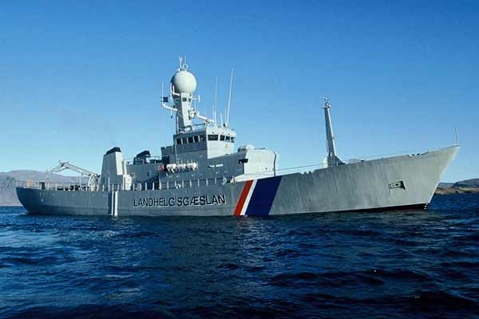

The single fixed wing asset is a Fokker F-27 used for maritime patrol and search and rescue tasks.

