**Italian Air Force**: The Aeronautica Militare (AM) was formed from the Regia Aeronautica when Italy transformed from a monarchy to a republic in 1946. The AM is a medium sized air force employing most modern capabilities available in 1994.

[**Panavia Tornado**](https://en.wikipedia.org/wiki/Panavia_Tornado#Italian_Air_Force_(Aeronautica_Militare)): The Tornado was developed jointly by Britain, Germany and Italy. Eventually almost 1000 Tornados were produced in three main variants: The ADV or Air Defence Variant; IDS or Interdictor/Strike variant and; ECR, the Electronic Combat Reconnaissance version. Italy was primarily focused on the IDS and purchased 100 examples to fulfill the strike role. Eventually converting 16 of these to ECRs but not until 1998, so they do not figure into Northern Fury. For the Air superiority role, the AM was counting on the much delayed Eurofighter Typhoon to replace its aging fleet of Starfighters, but since the first production would be more than a decade away (in 2003), a quick solutions was needed. Therefore 24 British ADV aircraft were leased from the RAF and flown by the AM; historically this deal was made in 1993 with acceptance in 1995 but in Northern Fury these dates are advanced by two years to 1991 and 1993 respectively. Therefore at the start of Northern Fury the AM is operating 124 Tornados including 100 IDS and 24 ADVs.

|  |  |  |  |  |  |
| --- | --- | --- | --- | --- | --- |
| Sqn | Name | Location | No. | Type | Remarks |
| 12* Gruppo | Saetta | Gioia del Colle | 24 | Tornado ADV |  |
| 102* Gruppo | Paperi | Ghedi | 24 | Tornado IDS |  |
| 154* Gruppo | Diavoli Rossi | Ghedi | 24 | Tornado IDS |  |
| 155* Gruppo | Pantere Nere | Piacenza | 24 | Tornado IDS |  |
| 156* Gruppo | Linci | Ghedi | 24 | Tornado IDS |  |

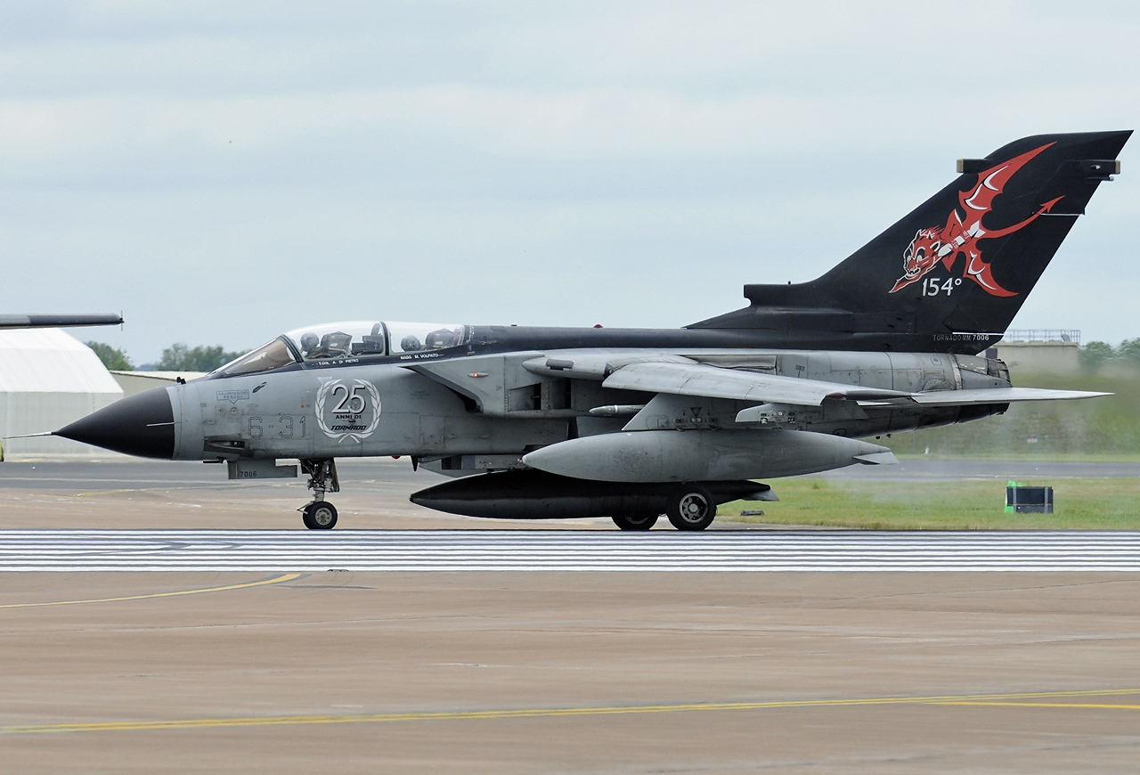

[**F-104 Starfighter**](https://en.wikipedia.org/wiki/Lockheed_F-104_Starfighter): Most of NATO used the Starfighter for a time but as it’s popularity faded in many countries, it became the backbone of Italy’s AM for many years with the last one not retiring until 2004. With over 360 received, by 1994 most were the Aeritalia built F-104S and with over 100 destroyed in accidents the older variants had all but disappeared. Used primarily as air to air interceptors the F-104S was the ultimate fighter version with improved radar, increased stability and much needed safety improvements. 147 were subsequently modified to the ASA (Weapons Systems Update) standard, improving the radar once again with a ‘Look-down – Shoot-down’ capability. The ASA-2, which all were later modified to could fire ‘all-aspect’ Aim-9L Sidewinders, Aim-7 Sparrow and Aspide missiles. 28* Gruppo historically lost all of its aircraft in 1982, which were moved to Grosseto but remained active until 1993 – in Northern Fury this squadron was re-equipped with F-104s instead of adopting the AMX.

|  |  |  |  |  |  |
| --- | --- | --- | --- | --- | --- |
| Sqn | Name | Location | No. | Type | Remarks |
| 9* Gruppo | Meraviglioso | Grosseto | 24 | F-104S |  |
| 10* Gruppo | Cavallino Rampante | Grazzanise | 24 | F-104S |  |
| 21* Gruppo | Tigre | Cameri | 24 | F-104S |  |
| 22* Gruppo | Spauracchi | Treviso | 24 | F-104S |  |
| 23* Gruppo | Veltri | Rimini | 24 | F-104S |  |
| 28* Gruppo | Streghe | Grosseto | 24 | F-104S |  |

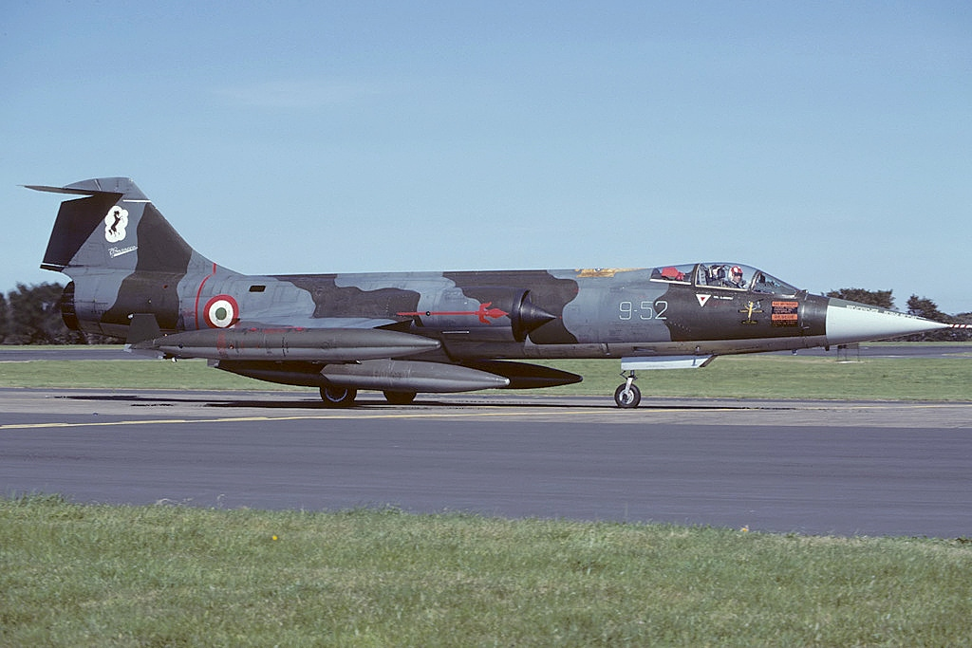

[**A-11 Ghibli (AMX)**:](https://en.wikipedia.org/wiki/AMX_International_AMX) The Italian designed ground attack aircraft was intended to replace the G.91 but those plans were never followed through. The A-11 was useful in its limited ground attack role but could not compete internationally with the American A-10 or Soviet Su-25. Only Italy and Brazil operated these aircraft and Italy only acquired 35 operational aircraft and 11 two seat training versions. Some of the single and all of the double seat AMX were upgraded (in Northern Fury) to enable the use of PGM about two years before they were historically.

|  |  |  |  |  |  |
| --- | --- | --- | --- | --- | --- |
| Sqn | Name | Location | No. | Type | Remarks |
| 103* Gruppo | Indiani | Treviso | 16 | A-11 |  |
| 132* Gruppo | Gatti Neri | Villafranca | 16 | A-11 |  |
| 201* Gruppo | Scorpioni | Capodichino | 14 | A-11 |  |

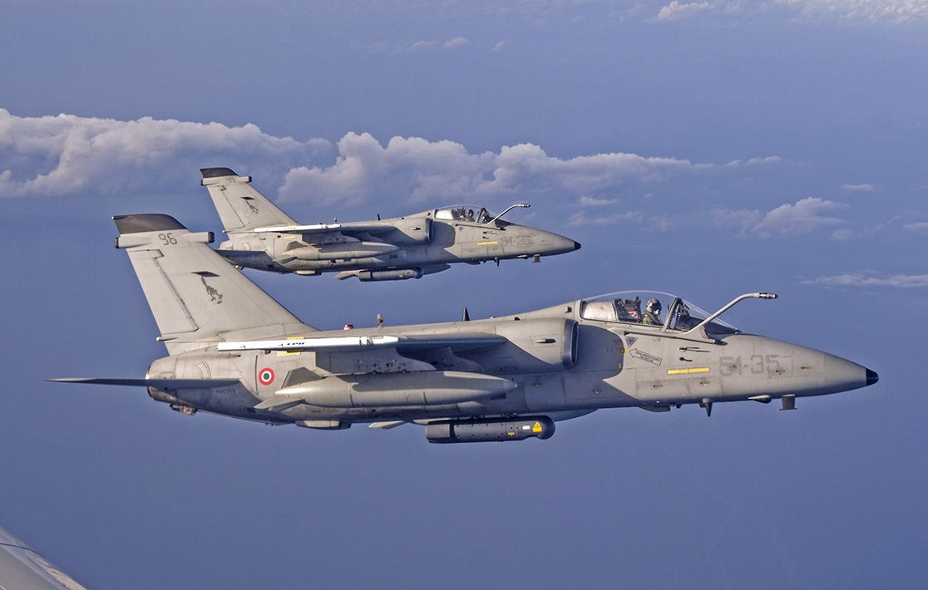

[**G.91Y**](https://en.wikipedia.org/wiki/Fiat_G.91Y): Another Italian designed ground attack aircraft entering service in the 1970s. By 1994 this subsonic aircraft was considered two small and limited for front line service, but not enough A-11s were procured to replace it. In Northern Fury, 65 aircraft remained with 48 employed in operational squadrons.

|  |  |  |  |  |  |
| --- | --- | --- | --- | --- | --- |
| Sqn | Name | Location | No. | Type | Remarks |
| 13* Gruppo | Falchi | Brindisi | 24 | G.91Y |  |
| 101* Gruppo | Lampi | Rimini | 24 | G.91Y |  |

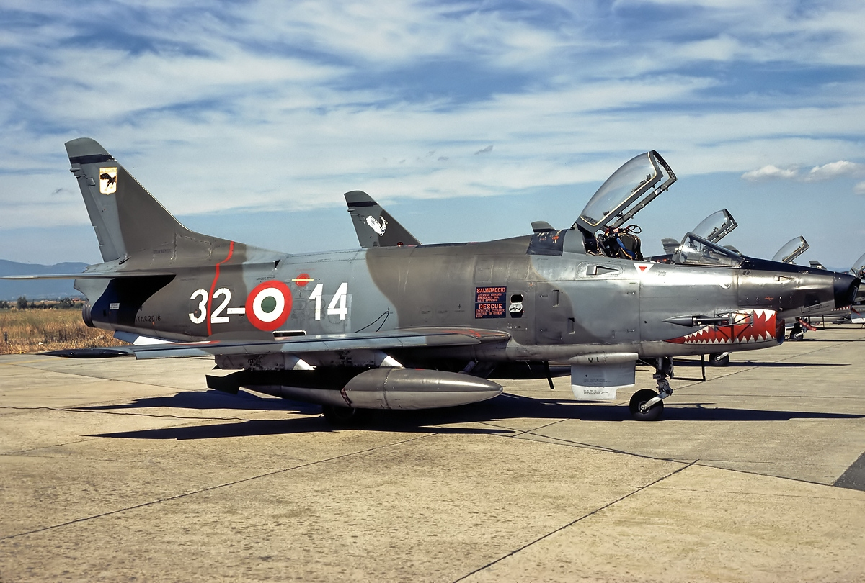

[**BR.1150 Atlantic**](https://en.wikipedia.org/wiki/Bréguet_1150_Atlantic): A French designed Maritime Patrol Aircraft (MPA) primarily focused on Anti-Submarine Warfare (ASW) support to the Navy. Italy purchased 18 which by 1994 were operated by two Stormo (Air Wing) each with one Gruppo (Squadron).

|  |  |  |  |  |  |
| --- | --- | --- | --- | --- | --- |
| Sqn | Wing | Location | No. | Type | Remarks |
| 86* Gruppo | 30* Stormo | Cagliari-Elmas | 9 | BR.1150 |  |
| 88* Gruppo | 41* Stormo | Sigonella | 9 | BR.1150 |  |

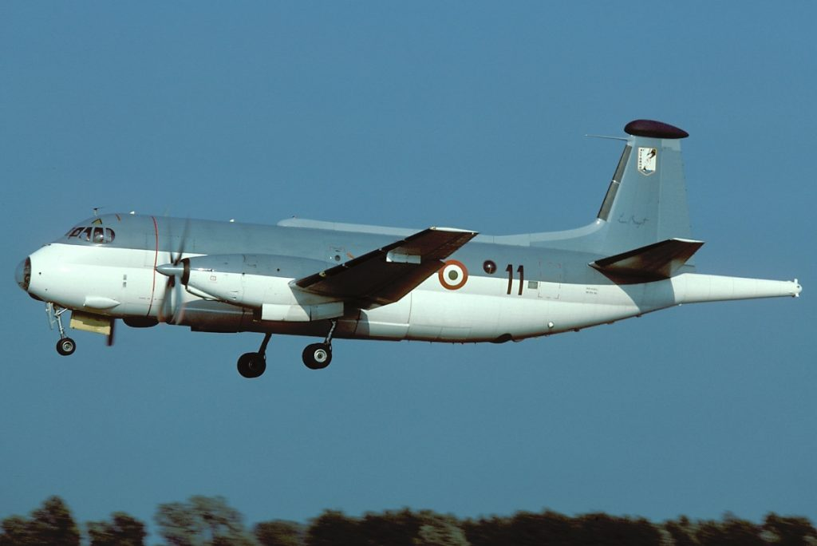

[**G.222**](https://en.wikipedia.org/wiki/Aeritalia_G.222)**:** An Italian designed and built medium transport aircraft, the only other NATO country to purchase the G.222 was the US who acquired ten in 1990 for use in Panama (called the C-27A), although Venezuela, Nigeria, Somalia UAE, Thailand, Peru, Libya and Argentina. Compared to the French C.160 Transall the G.222 has shorter range, is slower and carries about half the load. Italy operated about 50 aircraft (not including Fire Fighting versions), 44 of them being standard transports and two Electronic Warfare versions (G.222VS), and four Radio/Radar calibration version (G.222RM).

|  |  |  |  |  |  |
| --- | --- | --- | --- | --- | --- |
| Sqn | Name | Location | No. | Type | Remarks |
| 2* Gruppo | Lyra | Pisa | 22 | G.222A |  |
| 71* Gruppo | Persei | Pratica di Mare | 6 | G.222VS/RM |  |
| 98* Groppo | Lupi | Pisa | 22 | G.222A |  |

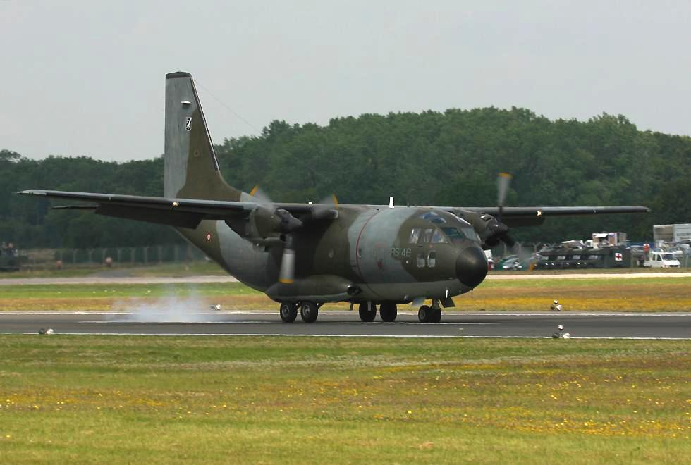

**Other Transport Aircraft**: Italy operated 14 C-130H Hercules and four Boeing 707 Tankers

|  |  |  |  |  |  |
| --- | --- | --- | --- | --- | --- |
| Sqn | Name | Location | No. | Type | Remarks |
| 8* Gruppo | Cavalieri | Pratica di Mare | 4 | Boeing 707T/T |  |
| 50* Gruppo | Vega | Pisa | 14 | C-130H |  |

