**C-551 Giuseppe Garibaldi**

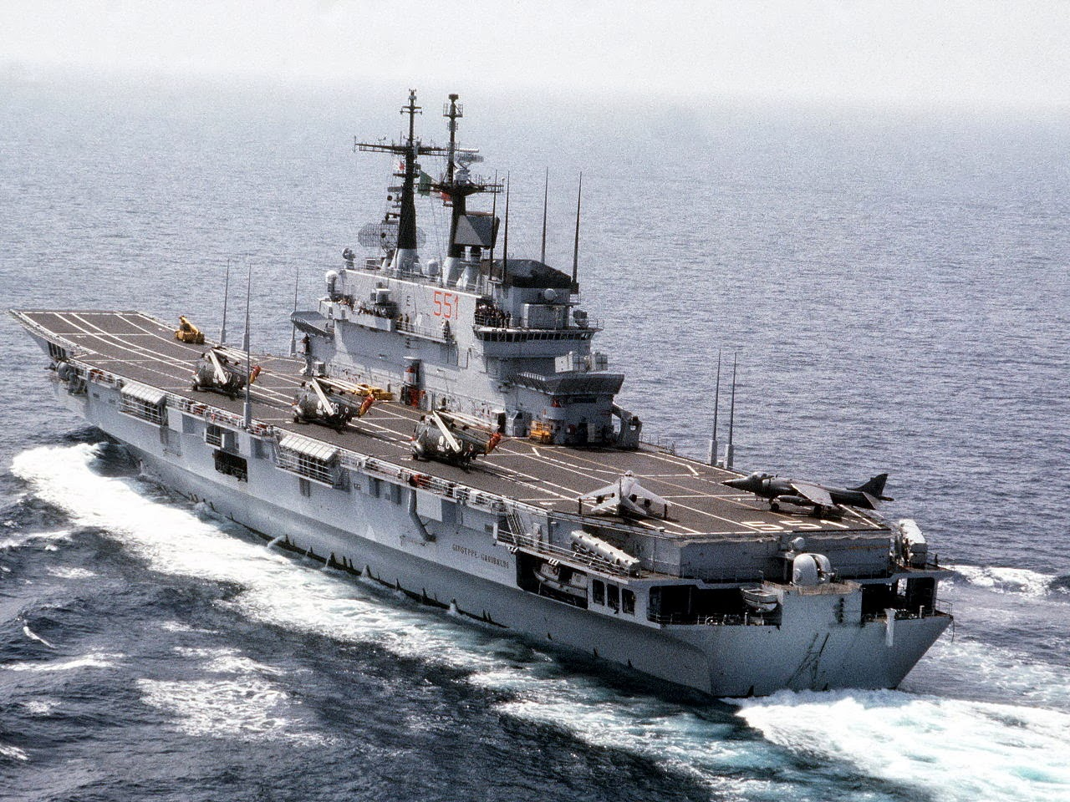

*C-551 Giuseppe Garibaldi with SH-3D Sea Kings and AV-8B Harrier IIs on deck*.

The *Giuseppe Garibaldi* has spent most of the past year patrolling the Adriatic Sea as part of NATO’s ***Operation Maritime Guard*** enforcing UN Sanctions against the splinter countries of the Former Republic of Yugoslavia (FRY). She returned to port in November 1993 and is departing on 16 Feb for a tour of the Indian Ocean, from a NATO perspective she will replace HMS Ark Royal as part of Combined Task Force (CTF)150. Because of this she is ready to sortie in support of operations within 24 hours of war starting.

* C-551 Giuseppe Garibaldi
  + Gruppo AI, 12x AV-8B Harrier II
  + 4* Gruppo, 6x SH-3H Sea King
  + 5* Gruppo, 4x SH-3D Sea King
* D-560 Luigi Durande De La Penne
* D-551 Audace
* F-565 Saggitario