**Italian Aircraft Carriers**

The Italian Navy (Marina Militare) is new to operating fixed wing aircraft from ships, although it has had hybrid helicopter cruisers since the early 1960s. With the acquisition of AV-8B Harriers the role of the navy is expanding to more of an expeditionary force as opposed to conducting Anti-Submarine Warfare (ASW) operation primarily in the Mediterranean. Italy has two active and two reserve carriers available although the Giuseppe Garibaldi is the only truly modern ship.

**C-551 Giuseppe Garibaldi**

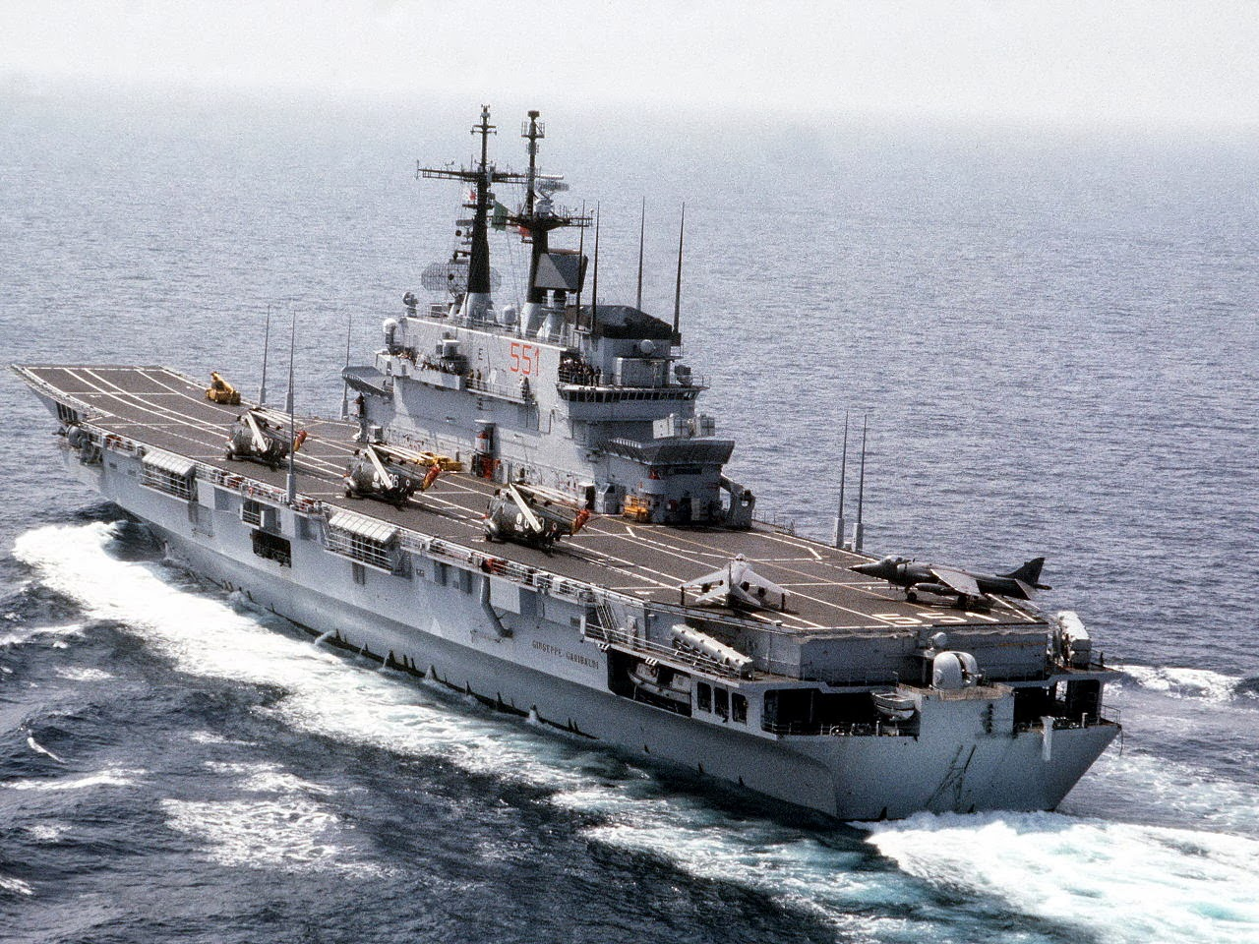

*C-551 Giuseppe Garibaldi with SH-3D Sea Kings and AV-8B Harrier IIs on deck*.

The *Giuseppe Garibaldi* is the Flagship of the Italian Fleet. Built as an Anti-Submarine Warfare (ASW) carrier it was launched in 1985 with the capability to operate Short Take Off and Landing (STOL) or Vertical Take Off and Landing (VTOL) aircraft. This was a significant departure from post WW2 Italian policy and historically there was significant delay in receiving its full complement of AV-8B Harriers. In Northern Fury however, this purchase was expedited and the Italian Navy had 12 of its 16 Harriers operational by the end of 1993. Although this was 18 months faster than the historic timeline it was still 8 years after they were needed. The addition of the Harriers allowed the Italian Navy much more flexibility in roles and freedom of action within its traditional area of interest – the Mediterranean Sea and Indian Ocean. At war start she is preparing for a cruise through the Indian Ocean and is ready to sail with her task group within 24 hours.

**C-550 Vittorio Venito**

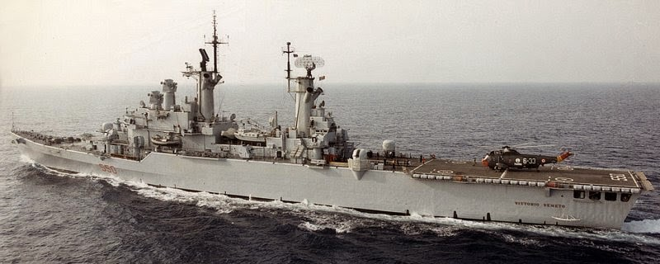

*C-550 Vittorio Venito*

The *Vittorio Venito* is a classic Helicopter Cruiser designed specifically for ASW and was ideal to lead an ASW task force. With 9 AB-212 helicopters, 40 ‘Standard’ SM-1 air defense missiles, 4 Otomat anti-ship missiles and 8 76mm guns, she is a very heavily armed ship ready to take on all roles. At war start she is tied up undergoing routine maintenance and will be ready for sea within a week.

**Andrea Doria Class**

The two ships of this class are laid up in reserve status. These are classic helicopter cruisers with room for four AB-212 ASW helicopters. The *Andrea Doria (C-553)* was modernized in the late 1970s and its air defense suite was upgraded to the Standard SM-1ER missiles and updated radar, sonar and electronics. The *Caio Duilio (C-554)* received a partial modernization but retains its RIM-2 Tarrier SAMs, it has been the fleet training ship since 1980. The *Andrea Doria* will take about 60 days to activate and put to sea if required, the *Caio Duilio* would take about six months but activation is unlikely.

