**Italian Naval Aviation**

Italy’s Naval Air Arm is relatively small but, like its navy in general contains all relevant capabilities.

[**Breguet Br.1150 Atlantic**](https://en.wikipedia.org/wiki/Breguet_Atlantic#Current_operators)**:** These fixed wing Maritime Patrol Aircraft (MPA) were operated jointly, owned by the Italian Air Force and commanded by the Navy with a mix of Air and Navy crew. There were 18 used by the *88th Gruppo* flying out of Decimomannu Sardinia and Sigonella Sicily. Acquired in the 1970s, these aircraft routinely conduct 12-hour surveillance and Anti-Submarine Warfare (ASW) patrols across the Mediterranean and further afield.

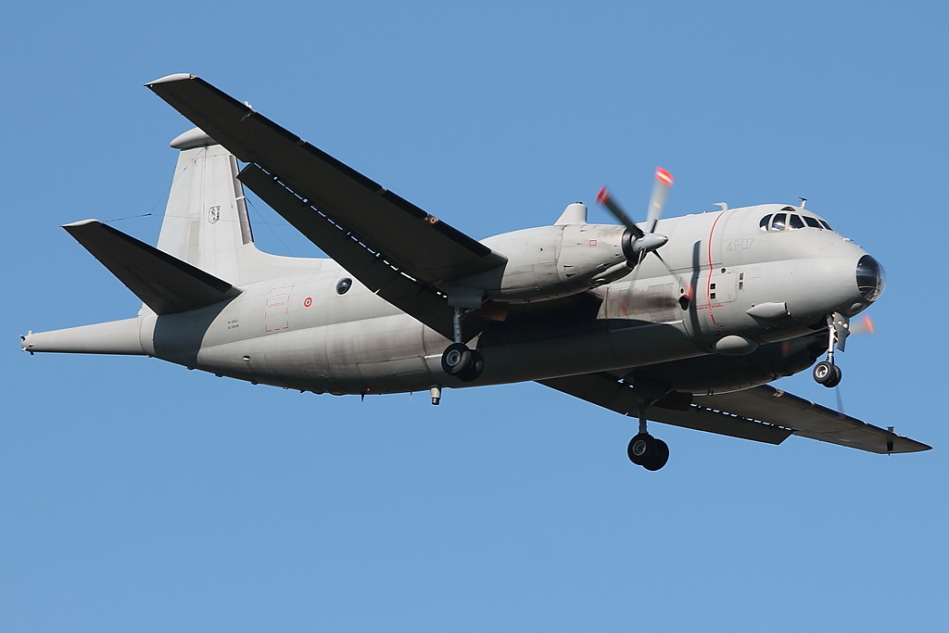

[**AV-8B Harrier II+**:](https://en.wikipedia.org/wiki/McDonnell_Douglas_AV-8B_Harrier_II#Italian_Navy) The purchase of AV-8B Harriers for the Italian Navy was a long and tortuous process with an order being placed in 1989, two seat TAV-8Bs being delivered in 1991 but the first operational aircraft not arriving until early 1994. In Northern Fury this timeline is accelerated by a few months and the first 12 of 16 operational aircraft are available in Feb 1994. The Italian Harrier is night attack capable and can use Precision Guided Munitions (PGM) but like many Harriers of this era, it does not have an on board laser designator, nor can it use the AIM-120 AMRAAM air to air missile. Embarked on the aircraft carrier ***Giuseppe Garibaldi*** as they operate as part of *Gruppo AI* (Embarked Aircraft Group).

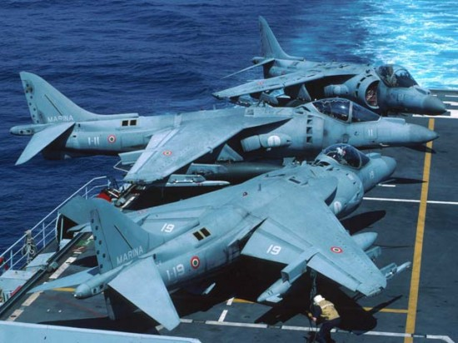

[**AB-212**](http://www.marina.difesa.it/EN/thefleet/airfleet/Pagine/ab212.aspx): These are a derivative of the famous Bell Twin Huey and became the mainstay of the Italian ship-borne ASW helicopter force. In total 68 were received and they operated of destroyers, frigates and larger ships including the aircraft carriers. Equipped with a dipping sonar, radar, FLIR (Forward Looking InfraRed), sonobouys and two torpedoes, these were very capable in their role. They were operated by *2*, 3* and 4* Gruppos.*

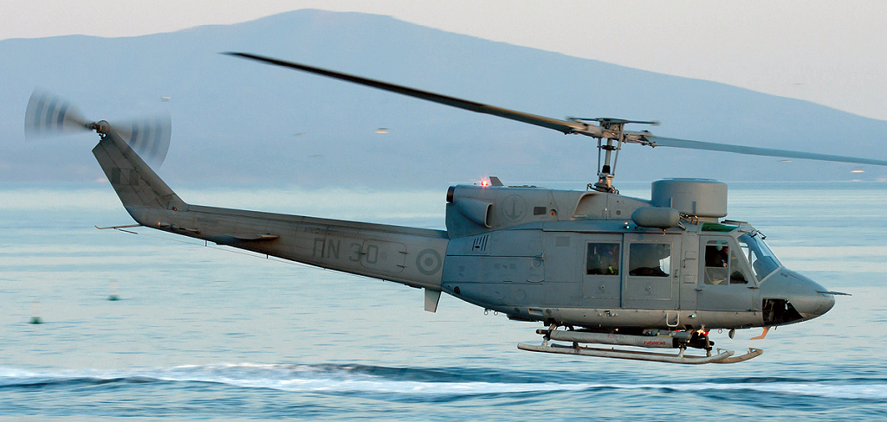

[**SH-3 Sea King**](https://www.milavia.net/specials/italian-navy-sea-king/)**:** Two man versions of this helicopter were used, primarily operating from shore installations and from the carriers ***Giuseppe Garibaldi*** and ***Andrea Doria*** as well as the three ***San Giorgio*** Landing ships.

For ASW in Italian service, the SH-3D is called the AS-61B and there are 24 of them working in four squadrons (Gruppo). In the 1980s, 12 more ASW versions were added, these were the SH-3H (AS-61D) although they are used interchangeably with the earlier versions. ***1* Gruppo***, ***2* Gruppo*** and ***3* Gruppo*** operate these aircraft exclusively while ***4* Gruppo*** also operate AB-212s.

The Air Force operates the second major version, the HH-3F (AS-61R) for Search and Rescue and supports the Navy in this task.

