**C-550 Vittorio Venito**

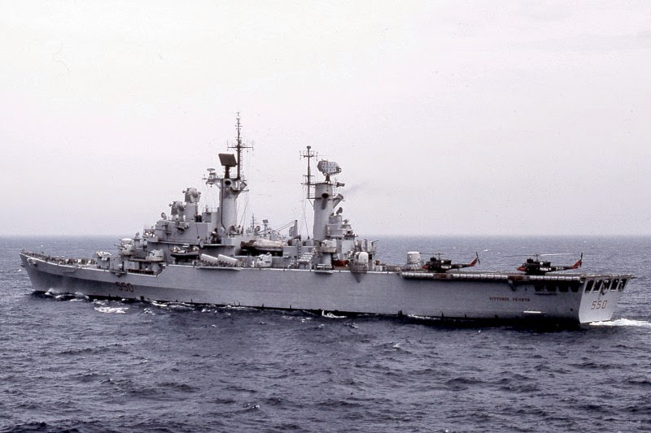

*C-550 Vittorio Venito*

The ***Vittorio Venito*** is due to start a patrol as part of NATO’s ***Operation Maritime Guard*** off the coast of the Former Republic of Yugoslavia (FRY). Although she doesn’t have the striking power of the *Giuseppe Garibaldi*  but here helicopters will prove very useful in interdicting any potential blockade runners.

* C-550 Vitorio Veneto
  + 5* Gruppo 6x SH-3D Sea King
* D-561 Francesco Mimbelli
* F-567 Orsa