**Italian DD/DDG’s**

Italy operates four destroyers and uses them to provide air defence to the carriers, lead independent task forces or operate independently. These are potent and modern ships that exhibit excellent sea keeping characteristics

[**Audace** **Class**](http://www.military-today.com/navy/audace_class.htm): These two general purpose Destroyers were commissioned in 1972 but modernized between 1988 and 1991. In their current form they represent a hybrid of American and Italian systems with Aspide short range and Standard SM-1 missiles for medium range air defense. In addition to the 127mm gun, these ships use eight Italian designed Otomat Surface to Surface Missiles (SSM) for anti-ship targeting. The Otomats are good missiles with a range of 110 nautical miles but suffer from needing mid-course guidance and are limited to ship launched systems only. A single 127mm and four OTO-Melara 76mm rapid fire guns augment both the air defense and anti-surface batteries. Two AB-212 Anti-Submarine Warfare (ASW) helicopters round out the armament making these very potent well rounded ships.

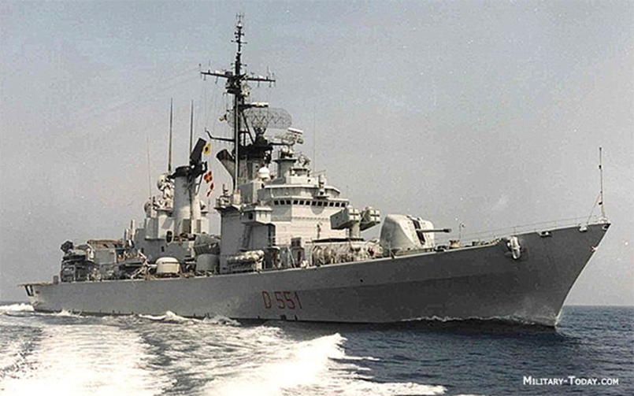

[**De la Penne Class**:](http://www.military-today.com/navy/de_la_penne_class.htm) Both of these brand new ships (launched in March and October 1993) were designed as improved versions of the very successful Audace class. They have essentially the same armament but with more modern sensors and control systems than their predecessors and only three 76mm guns vice four, considering most other modern ships have one gun (5” or 76mm), this arrangement is quite powerful. These are well rounded world class ships

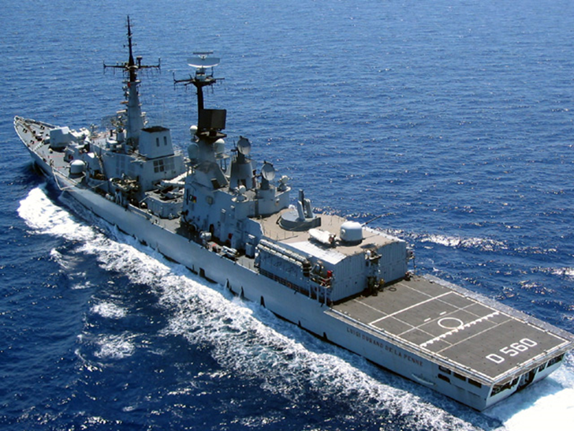

|  |  |  |  |  |
| --- | --- | --- | --- | --- |
| Class | Pennant | Name | Task | Remarks |
| Audace | D 550 | Ardito |  |  |
|  | D 551 | Audace | TG Garibaldi |  |
| De la Penne | D 560 | Durand de la Penne | TG Garibaldi |  |
|  | D 561 | Francesco Mimbeli | TG V Venito |  |