**Italian Frigates**

Italy operates Six classes of Frigate and Offshore Patrol Vessels (OPV) comprising 30 ships. Used primarily for Anti-Submarine Warfare (ASW) escort work and showing the flag around the globe. These ships are generally modern and quite capable, only the Alpino class could be considered nearing obsolescence and they had many systems modernized in the 1980s, most others are less than 20 or even 10 years old. All but the Minerva class operate ASW helicopters. Sparviero-class patrol boats are also included in this section for convenience, they are not Frigates.

[**Maestrale** **Class**](https://en.wikipedia.org/wiki/Maestrale-class_frigate): This class of eight general purpose ASW Frigates were commissioned in the early ‘80s and widely used by the Italian Navy on many operations. For air defense they have the Italian designed Aspide short range surface to air missiles (SAM) augmented by 20mm and 40mm cannon. In addition to the 127mm gun, these ships use four Italian designed Otomat Mk2 Surface to Surface Missiles (SSM) for anti-ship targeting. ASW work is carried out by two AB-212 ASW helicopters backed up by onboard torpedoes and sonar.

|  |  |  |  |  |
| --- | --- | --- | --- | --- |
| Class | Pennant | Name | Task | Remarks |
| Maestrale | F 570 | Maestrale | Atlantic |  |
|  | F 571 | Grecale |  |  |
|  | F 572 | Libeccio |  |  |
|  | F 573 | Scirocco |  |  |
|  | F 574 | Aliseo | Gulf of Oman |  |
|  | F 575 | Euro |  |  |
|  | F 576 | Espero |  |  |
|  | F 577 | Zeffiro |  |  |

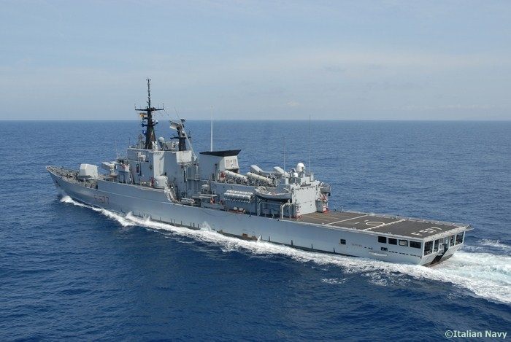

[**Lupo/Artigliere Class**:](https://en.wikipedia.org/wiki/Lupo-class_frigate) The Lupo is a general purpose ASW frigate commissioned into the Italian Navy in the late ‘80s, it enjoyed some commercial success, Peru acquiring four and Venezuela purchasing another six. The Artigliere class were originally destined for Iraq as the Soldati class but were seized aftter the Gulf war and outfitted as OPVs with all ASW equipment removed. Historically this seizure happened in 93 with the ships commissioning in 94-96, for Northern Fury the seizure happened in 1991 and they were all commissioned by the end of 1993. For air defense they have the Aspide short range SAMs augmented by 40mm cannon. For anti-ship targeting there are eight Otomat Mk2 SSM and a the 127mm gun. ASW work on the Lupo ships is carried out by an AB-212 Anti-Submarine Warfare (ASW) helicopters backed up by onboard torpedoes and sonar. The Artigliere ships have double the number of Aspide SAMs but no sonar or onboard torpedoes, they do have a helicopter which can carry out ASW work but it is primarily for maritime patrolling.

|  |  |  |  |  |
| --- | --- | --- | --- | --- |
| Class | Pennant | Name | Task | Remarks |
| Lupo | F-564 | Lupo | Persian Gulf |  |
|  | F-565 | Sagittario | TG Garibaldi9 |  |
|  | F-566 | Perseo | STANAVFORLANT |  |
|  | F-567 | Orsa |  |  |
| Artigliere | F-582 | Artigliere |  |  |
|  | F-583 | Aviere | Adriatic Sea |  |
|  | F-584 | Bersagliere | Philippines |  |
|  | F-585 | Granatiere |  |  |

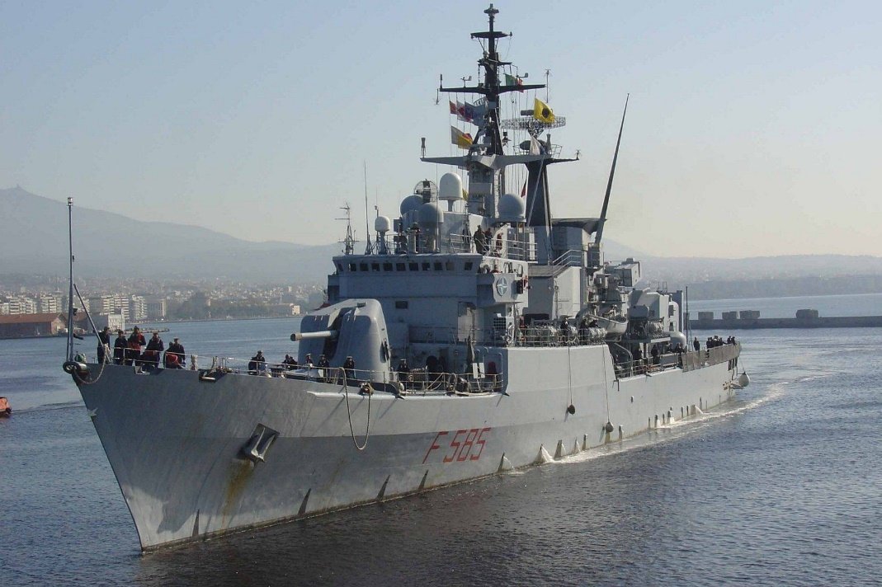

[**Alpino Class**](https://en.wikipedia.org/wiki/Alpino-class_frigate): Although these are the oldest of the ASW Frigates in the Italian Navy they were both modernized in the 1980s with updated sonar and electronic warfare equipment. The class introduced variable depth sonar and on board helicopters to the Italian Navy but they are severely lacking in air defense or anti shipping capability, having six 76mm guns but no missiles.

|  |  |  |  |  |
| --- | --- | --- | --- | --- |
| Class | Pennant | Name | Task | Remarks |
| Alpino | F 580 | Alpino |  |  |
|  | F 581 | Carabiniere |  |  |

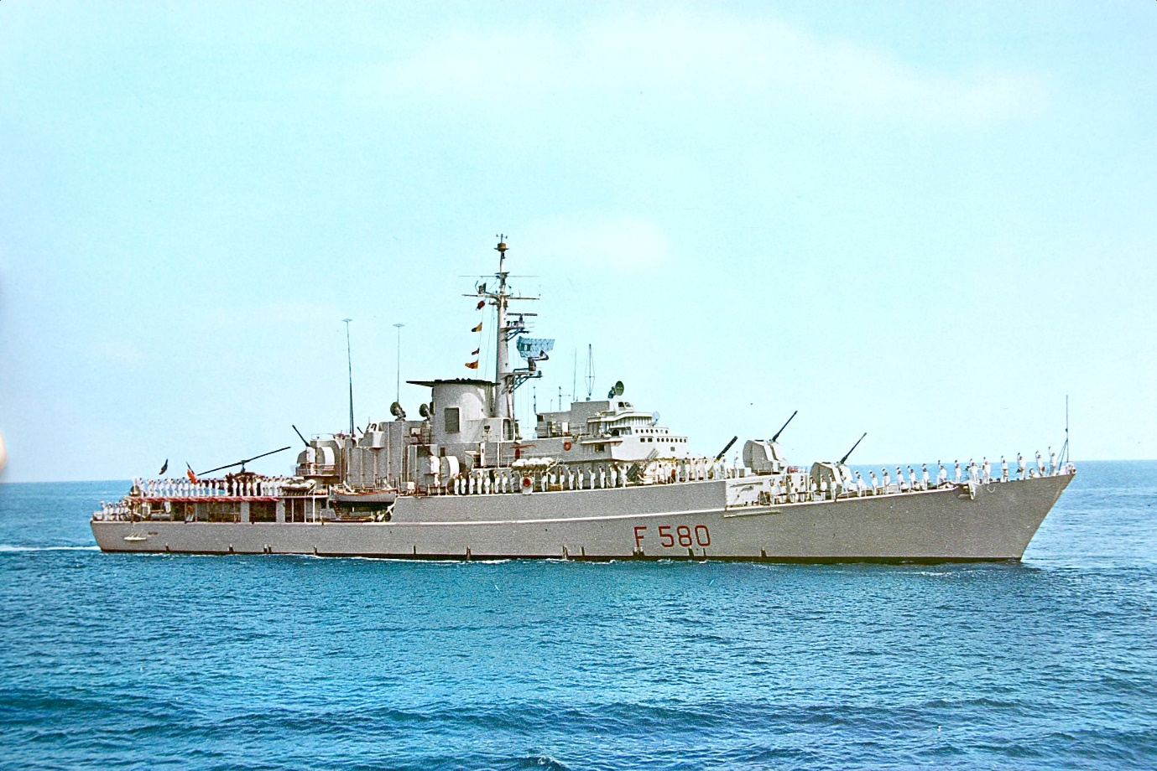

**Minerva Class**: This is a class of coastal ASW ship that are probably better described as a Corvette due to their small size of 1,200 tons. They all carry a single Oto-Melara 76mm gun, and onboard sonars and Torpedoes while four of them carry eight Aspide SAMs in an Albatross launcher and the other four carry six Otomat Mk2 SSM

|  |  |  |  |  |
| --- | --- | --- | --- | --- |
| Class | Pennant | Name | Task | Remarks |
| Minerva (Albatross) | F 551 | Minerva |  |  |
|  | F 552 | Urania |  |  |
|  | F 553 | Danaide |  |  |
|  | F 554 | Sfinge |  |  |
| Minerva (Otomat | F 555 | Driade |  |  |
|  | F 556 | Chimera |  |  |
|  | F 557 | Fenice |  |  |
|  | F 558 | Sibilla |  |  |

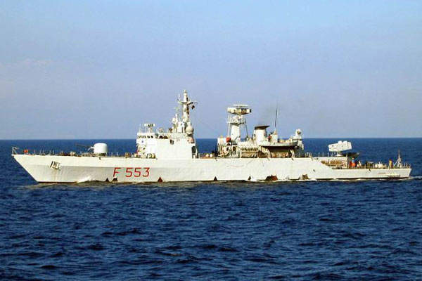

[**Cassiopea Class OPV**](https://www.militaryfactory.com/ships/detail.asp?ship_id=cassiopea-class-patrol-vessel-italian-navy): These four ships are all less than five years old but are small at 1,500 tons and designed for long endurance cruising as opposed to fighting in a high intensity war zone. The only weapons are a single Oto-Melara 76mm gun, two 25mm cannon and some machine guns. They operate an AB-212 helicopter.

|  |  |  |  |  |
| --- | --- | --- | --- | --- |
| Class | Pennant | Name | Task | Remarks |
| Cassiopea | P 401 | Cassiopea |  |  |
|  | P 402 | Libra | Persian Gulf |  |
|  | P 403 | Spica | Indian Ocean |  |
|  | P 404 | Vega |  |  |

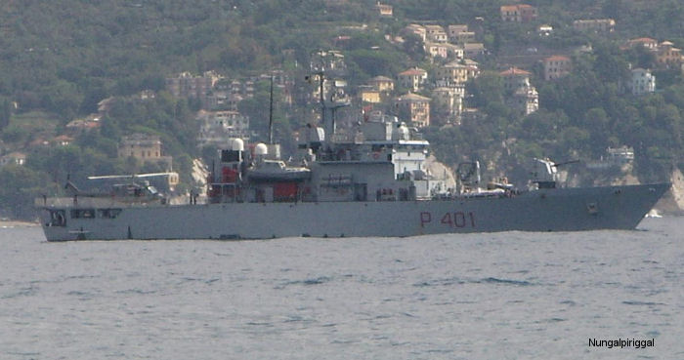

[**Sparviero-class patrol boat**](https://en.wikipedia.org/wiki/Sparviero-class_patrol_boat)**:** These little 60 ton Hydrofoil boats are more properly called Fast Attack Craft (FAC). They have a speed of 50 knots and carry two Otomat ASM missiles and a single Oto-Melara 76mm gun. With a crew of 10 they are hit and run weapon systems designed for the congested Adriatic Sea.

|  |  |  |  |  |
| --- | --- | --- | --- | --- |
| Class | Pennant | Name | Task | Remarks |
| Sparviero | P 420 | Sparviero | Reserve |  |
|  | P 421 | Nibbio |  |  |
|  | P 422 | Falcone |  |  |
|  | P 423 | Astore |  |  |
|  | P 424 | Grifone |  |  |
|  | P 425 | Gheppio |  |  |
|  | P 426 | Condor |  |  |

