**Mine Countermeasures Craft**

In addition to the new Min Hunters listed hear, the Italian Navy has about 30 older minesweepers of 1950’s vintage that were retired in the past decade or indeed are still in commission but not often used.

[**Lerici Class**](https://en.wikipedia.org/wiki/Lerici-class_minehunter#Lerici_class)**:** These four ships are classed as Mine Hunters and are equipped with Remotely Operated Vehicles, a hyperbaric chamber and specialist divers to actively hunt and destroy mines as opposed to the classic mine sweepers. They routinely serve one of the three Standing NATO Mine Countermeasures Groups (SNMCMG) but focus on SNMCMG 2 in the Adriatic with one ship supporting SNMCMG 3 at Djbouti.

|  |  |  |  |  |
| --- | --- | --- | --- | --- |
| Class | Pennant | Name | Task | Remarks |
| Lerici | M 5550 | Lerici | In Port |  |
|  | M 5551 | Sapri | In Port |  |
|  | M 5552 | Malazzo | SNMCMG3 | Djbouti |
|  | M 5553 | Vieste | SNMCMG2 | Adriatic |

**Gaeta Class:** Larger and moremodern than the Lerici class, they have essentially the same capabilities. The final two of the eight ships are still under construction but the fifth and sixth were launched ahead of their historic schedule.

|  |  |  |  |  |
| --- | --- | --- | --- | --- |
| Class | Pennant | Name | Task | Remarks |
| Gaeta | M 5554 | Gaeta | In Port |  |
|  | M 5555 | Termoli | SNMCMG2 | Adriatic |
|  | M 5556 | Alghero | In Port |  |
|  | M 5557 | Numana | SNMCMG2 | Adriatic |
|  | M 5558 | Crotone | Workups | Dec 93 |
|  | M 5559 | Viareggio | Fitting out | Jan 94 |
|  | M 5560 | Chioggia | Building | Mar 95 |
|  | M 5561 | Rimini | Building | Jun 95 |

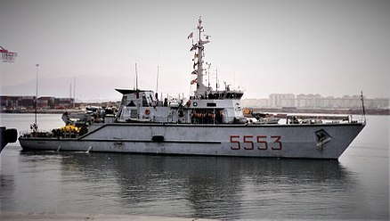

**Italian Amphibious Ships**

Italy has replaced all of its older post World War Two amphibious ships with three modern, state of the art LPD (Landing Platform Dock) of the ***San Giorgio*** class, complete with a new suite of Landing Craft.

[**San Giorgio Class**](http://www.military-today.com/navy/san_giorgio_class.htm)**:** These three vessels can lift about a battalion of marines each, with 36 vehicles or 30 tanks. They can operate 3x Sea King helicopters and several landing craft of varying size. The lead two ships can unload on the beach through bow doors and a ramp while the third cannot but has slighting more accommodation space. All three are available for the Northern Fury campaign, the labor problems encountered with ***San Giusto*** do not happen and she is commissioned in late 1993.

|  |  |  |  |  |
| --- | --- | --- | --- | --- |
| Class | Pennant | Name | Task | Remarks |
| San Giorgio | L 9892 | San Giorgio | In Port |  |
|  | L 9893 | San Marco | In Port |  |
|  | L 9894 | San Giusto | Training cruise | Adriatic |

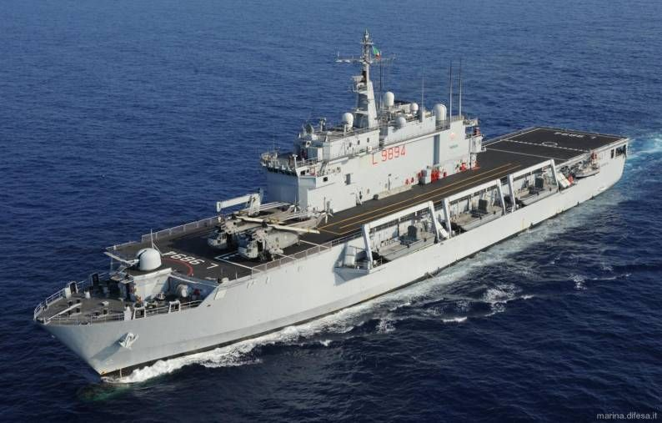

**Italian Support Ships**

Italy operates two small oilers of the ***Stromboli*** class. There are many port tenders and support barges but they are not critical to our purpose here.

[**Stromboli Class**:](https://en.wikipedia.org/wiki/Stromboli-class_replenishment_oiler) These two oilers are designed primarily to support small Italian task groups in the Mediterranean. They are small – 20% of the size of the big US AORs – but are capable of assisting combat ships to stay at sea long, which is their job. They carry diesel, a small amount of aviation fuel and about 300 tons of dry goods, certainly not enough to resupply the ***Giuseppe Garibaldi*** but adequate for an ASW Task Group.

|  |  |  |  |  |
| --- | --- | --- | --- | --- |
| Class | Pennant | Name | Task | Remarks |
| Stromboli | A 5327 | Stromboli | Adriatic |  |
|  | A 5329 | Vesuvio | In Port |  |

