**Italian Submarines**

[**Toti Class**](https://en.wikipedia.org/wiki/Toti-class_submarine): These four small submarines were the first built by Italy after World War Two. Roughly equivalent to the German Built Type 205, these are small, maneuverable, quiet, and pack a decent punch with six torpedoes. This class began to retire in 1991 but in Northern Fury, the two that retired are being held in ready reserve and can put to sea in less than 30 days.

|  |  |  |  |  |  |
| --- | --- | --- | --- | --- | --- |
| Class | Pennant | Ship | Location | Status | Remarks |
| Toti | S 505 | Attilio Bagnolini | La Spezia | Reserve |  |
|  | S 506 | Enrico Toti | Adriatic | Active | Patrol |
|  | S 513 | Enrico Dandolo | Taranto | Active | Tied up |
|  | S 514 | Lazzaro Mocenigo | La Spezia | Reserve |  |

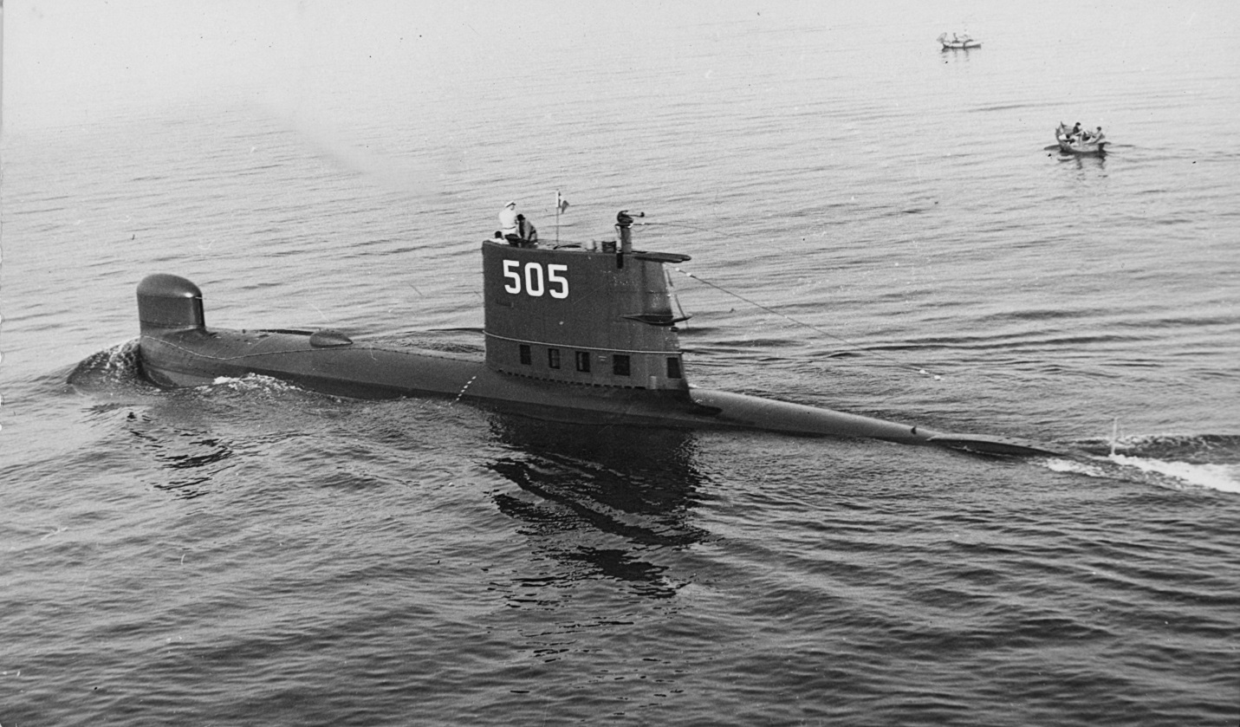

[**Sauro Class**](https://www.militaryfactory.com/ships/detail.asp?ship_id=sauro-class-diesel-electric-attack-submarine-italy#overview): The Sauro class was built in four batches of two boats each starting in the 1970’s. They have a better dive depth than the Toti class and are much larger, three times the displacement and ~50% larger with double the crew. Each batch has evolutionary improvements in sensors, crew accommodation, sound dampening and general operational capability. In Northern Fury the batch IV boats started construction about a year earlier than they did in real life and both are available for the campaign, with S 525 conducting her workup trials.

|  |  |  |  |  |  |
| --- | --- | --- | --- | --- | --- |
| Class | Pennant | Ship | Location | Status | Remarks |
| Sauro I | S 518 | Nazario Sauro | La Spezia | Active | Tied Up |
|  | S 519 | Carlo Feccia di Cossato | La Spezia | Active | Tied Up |
| Sauro II | S 520 | Leonardo da Vinci | Adriatic | Active | Patrol |
|  | S 521 | Guglielmo Marconi | La Spezia | Active | Tied Up |
| Sauro III | S 522 | Salvatore Pelosi | La Spezia | Active | Tied Up |
|  | S 523 | Giuliano Prini | Mediterranean | Active | Patrol |
| Sauro IV | S 524 | Primo Longobardo | Indian Ocean | Active | Patrol |
|  | S 525 | Gianfranco Gazzana Priaroggia | Mediterranean | Active | Workups |

