**Netherlands Air Force**

The Dutch Air Force has a single focus of defending the airspace of Western Europe and it is tied directly into the operations of 2nd Allied Tactical Air Force (2 ATAF). Although there are supporting elements there are two key segments to that role: The F-16; and Ground Based Air Defence (GBAD) in the form of Patriot and I-Hawk missile units.

**F-16**

As one of the four European nations using the F-16 they were key in the development of the Fokker assembly plant in Holland. In total 213 F-16A/B were acquired (177 single seat ‘A’ models, and 58 double seat ‘B’ versions). The first was delivered in 1979 and the last in 1992.

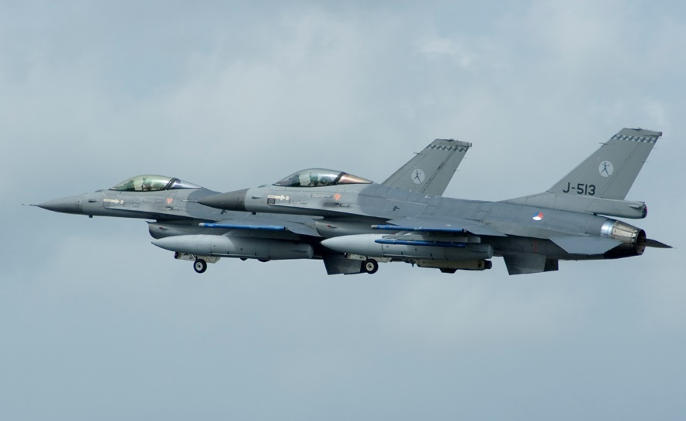As a result of the increased tensions in the Northern Fury storyline, upgrade of the older F-16s to the MLU (Mid Life Upgrade) standard, allowing them to use the Aim-120 AMRAAN missile and the AGM-65 Maverick missile began as soon as the last production model was complete. Approximately 42 ‘A’ models have been upgraded to the MLU standard and equip two Squadrons based at Volkel. Another modification for Dutch F-16s is the ability to operate the Orpheus Reconnaissance Pod, currently 306 Sqn is equipped for this task. No. 315 ‘Lion’ Squadron was tasked with deploying to Norway in times of emergency as a NATO AMF (ACE Mobile Force) unit.

In addition to a training squadron in Tucson Arizona, there is a test and evaluation unit stationed at Volkel. Each operational squadron maintains some ‘B’ model twin seat versions for readiness and refresher training.

|  |  |  |  |  |  |
| --- | --- | --- | --- | --- | --- |
| Sqn | Name | Location | No. | Type | Remarks |
| 306 | Hawk | Volkel | 18 | F-16A Recon | +4x F-16B |
| 311 | Eagle | Volkel | 20 | F-16A MLU | +4x F-16B |
| 312 | Bonzo | Volkel | 20 | F-16A MLU | +4x F-16B |
| 313 | Tiger | Twenthe | 20 | F-16A | +4x F-16B |
| 314 | Redskins | Gilze-Rijen | 20 | F-16A | +4x F-16B |
| 315 | Lion | Twenthe | 16 | F-16A | +4x F-16B |
| 316 | Falcon | Eindhoven | 20 | F-16A | +4x F-16B |
| 322 | Polly Parrot | Leeuwarden | 20 | F-16A | +4x F-16B |
| 323 | Diana | Leeuwarden | 20 | F-16A | +4x F-16B |

**F-5A**

Although the NF-5 was retired from service in 1992, the Netherlands Air Force maintains them in ready reserve. 105 aircraft (75 single seat and 30 double seat) are in storage ready to mobilize. It will likely only take 2-3 weeks to organize reserve pilots into new squadrons.

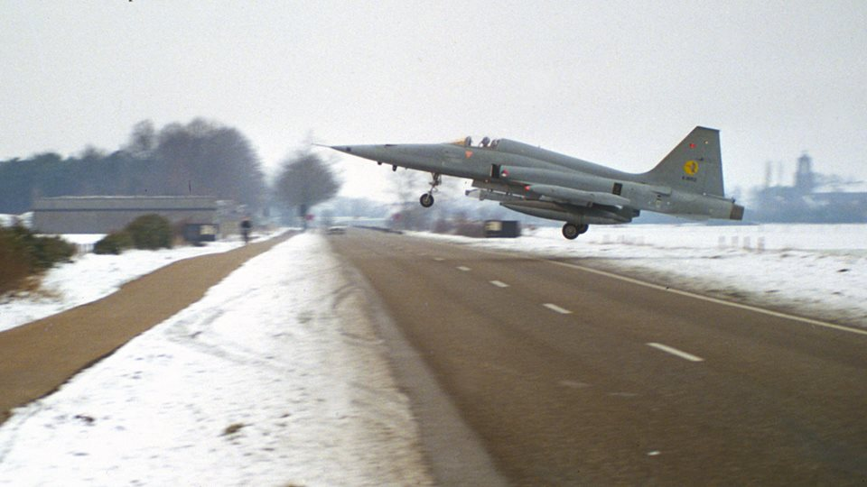

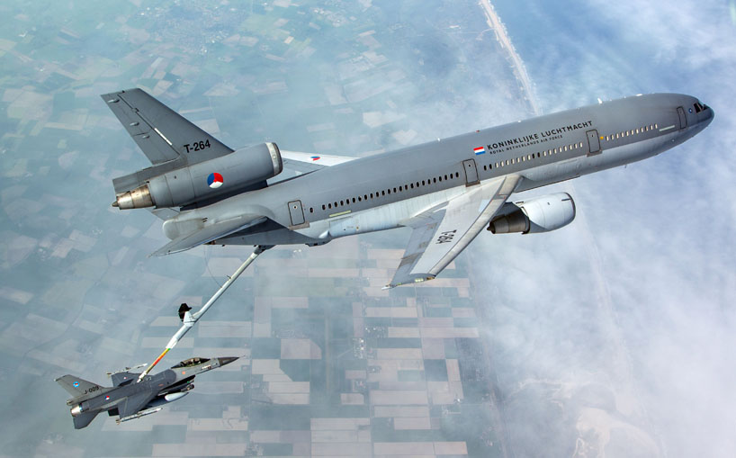**KDC-10**

Historically the Dutch Air Force received its two KC-10 aerial refuelling aircraft in 1995 but the requirement was identified in 1992 and there were several delays in converting the civilian pattern DC-10 airliners to military refuelling standard. In Northern Fury, the delays were avoided and the two aircraft were delivered to 334th ‘Pegasus’ Squadron at Eindhoven in late 1994.

**C-130 Hercules**

Also at Eindhoven is 336 Squadron operating 4x C-130H in the transport role.

**Ground Based Air Defence (GBAD)**

The other element fielded by the Netherlands Air Force is GBAD. Each airbase (seven) has an Air Defence (AD) Squadron consisting of 3x I-Hawk missile launchers, 3x Bofors 40L70 gun systems and local ‘Flycatcher’ radars. Additionally, there are two AD Groups with four squadrons, two each of the older I-HAWK (6 launchers per Squadron), and the newer Patriot missile systems (5 launchers per Squadron). Although only 160 Patriot missiles were purchased, a factory in the Netherlands will produce ~2000 missiles for the US so supply in an emergency should not be a problem.

I-HAWK

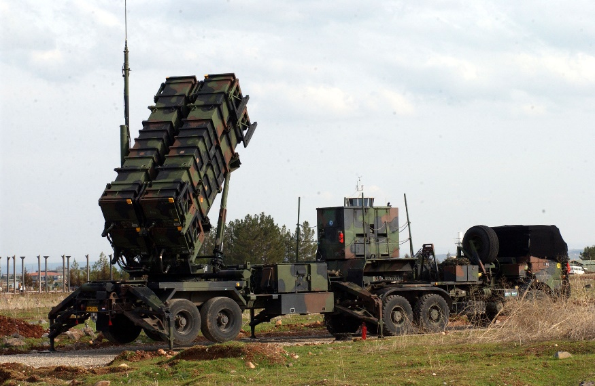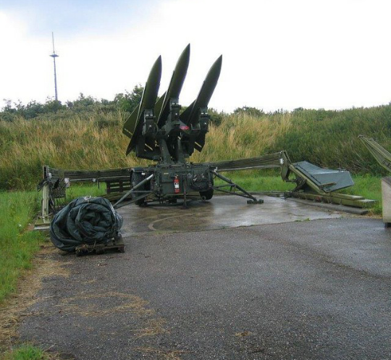

Patriot