**Netherlands**

The Netherlands Army was mainly deployed in a single corps organization. The three Dutch mechanized infantry divisions were organized along streamlined Brigade Group structures without divisional troops. The corps troops organizations, particularly artillery and engineer were quite robust and extensive allowing for very flexible grouping based on the mission assigned. Although each mechanized division has a Panzer Brigade, and the other two Brigades in each division have a Panzer Battalion, the armored punch of the corps comes from the attached German Panzer division.

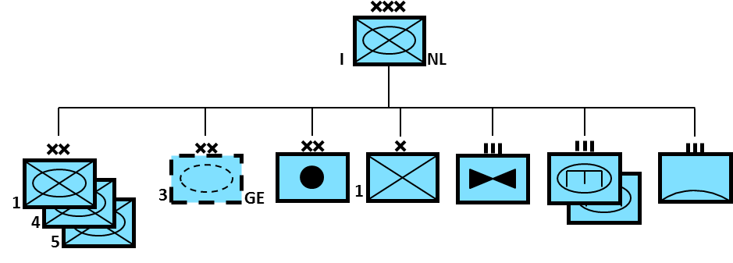

The other key element of the Netherlands ground forces are the Marines. This is a unique organization which does not normally operate as a unit, but in separately tasked battalion sized ‘Groups’.

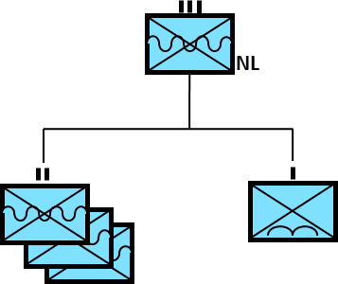

Both the 1st Group and the Parachute Company would normally be assigned to work with the British 3rd Commando Bde. These troops were trained for mountain and arctic warfare and would routinely deploy in Northern Norway.

The 2nd Group was dispersed throughout Dutch colonies in the Caribbean and West Indies, primarily providing local security but also able to form into a strike force if necessary.

The 3rd Group were reservists, formerly enrolled as marines this unit would initially provide security at naval bases but would then develop several Marine Battalions or a Marine Regiment for deployment.

It should be noted that the Netherlands navy lacks any amphibious capability. Except for small landing craft and boats, the Marines must rely on amphibious transport from other nations – primarily the British RN but they also train with the French and Italian navies.

[**Leopard 2**](http://www.tanks-encyclopedia.com/coldwar/West_Germany/Leopard-2.php)

The Dutch are the second largest operator of the Leopard 2, with 445 of them in the inventory. Starting in 1993, many (eventually 330) were upgraded to the Leopard 2A5 standard with improved armor. Representing about half of the tanks in service, the 4th Division was equipped entirely with the Leopard 2 while the Panzer Bde in the 5th Division also had them.

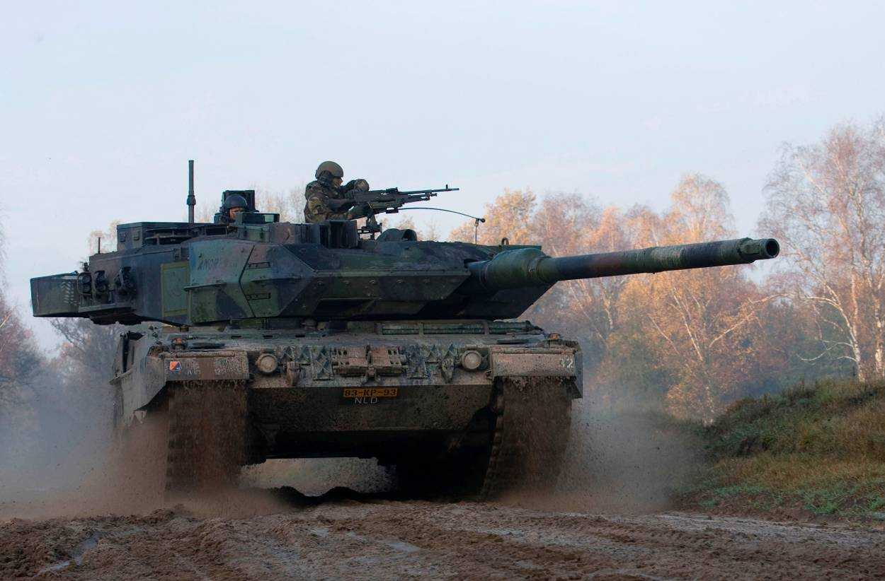

[**Leopard 1**](http://www.tanks-encyclopedia.com/coldwar/West_Germany/Leopard-I.php)

The other half of the operational tanks on the Netherland’s roster were Leopard 1V’s, the ‘V’ standard had a better fire control system then the original tank. The 468 Main Battle Tanks (MBTs) were used primarily in the 1st Division and the Panzerinfantrie Brigades of the 5th Division. Also many Leopard 1 variants were used, including the Bridge-layer and the Armored Recovery Vehicles (ARV).

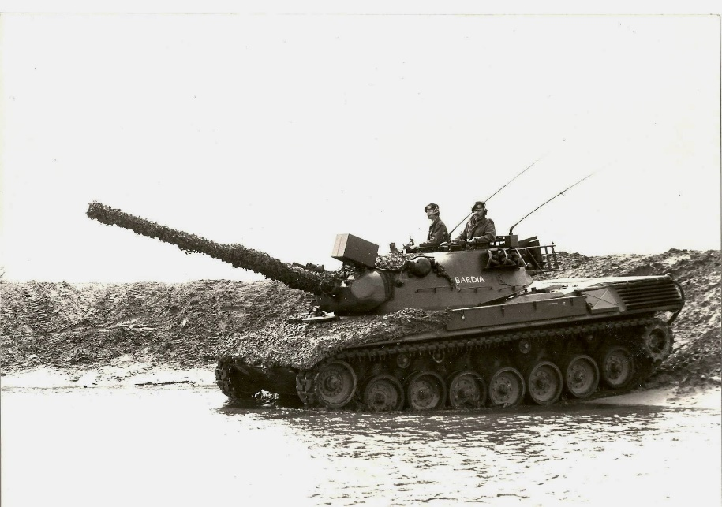

**Infantry Fighting Vehicles (IFV)**

Although there were about 500 M113’s and up to 900 YP-408’s (an 8-wheeled Dutch design from the 50’s) in the Netherlands Army, the most important IFV was the [YPR-765](http://www.tanks-encyclopedia.com/coldwar/Netherlands/YPR-765.php). Although they were derived from the M113, the basic version was equipped with a 25mm cannon and firing ports so infantry inside the vehicle could use their weapons. 2,079 of these vehicles were used but that includes several command variants, 119 Anti Tank variants (PRAT) with TOW missiles and other specialist vehicles. All of the regular army Panzerinfantrie units were equipped with the YPR-765.

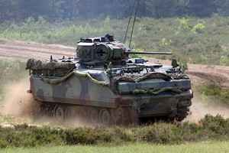

[**Lynx (M113 C&V)**](http://www.tanks-encyclopedia.com/coldwar/canada/M113_LYNX.php)

For reconnaissance work the Dutch use the M113 based Lynx vehicle but have added a 25mm Oerlikon turret. There are 250 of these in service amongst the Reconnaissance battalions in each division and at corps level.

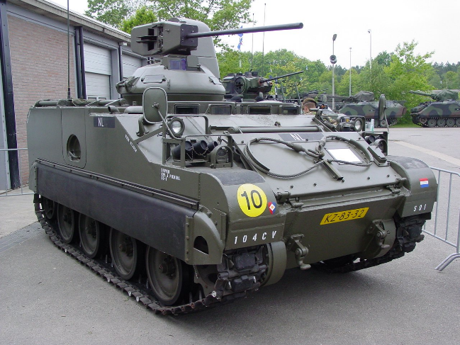

**Artillery**

The Netherlands Corps has extensive artillery firepower including an artillery battalion of 20 M109’s (Self Propelled (SP) 155mm howitzers) in each of the nine brigades and a Corps Artillery Group of Division size.

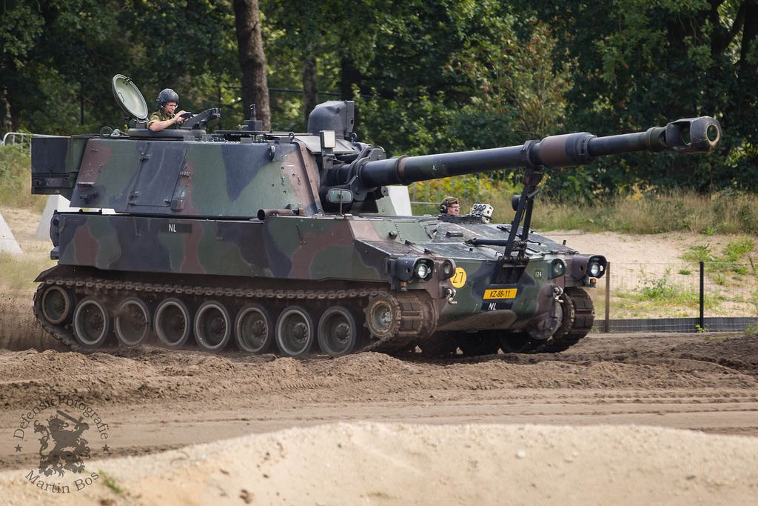

Within the Corp Artillery organization were three ‘Groups’ of Brigade size: 101st with two batteries of Multiple Launch Rocket Systems (MLRS) using 22 launchers, and a battalion of six Lance Missiles launchers. The other two ‘Groups’ were General Support (GS) tubed artillery units: The 102nd had five battalions of M110 SP 203mm (8”) howitzers and a battalion of M109s; the 104th Group (Reserve) had five battalions of towed 155mm guns, the M114/39.

In total the inventory included:

* 22 Multiple Launch Rocket Systems (MLRS);
* 6 MGM-52 Lance; (not retired)
* 76 M110A2 203 mm SP howitzers;
* 222 M109 155 mm self-propelled howitzers (A2 & A3 variants);
* 123 M114 155 mm towed howitzers.

**Note:** Historically only 82 of the M114’s had been upgraded to the 39 Caliber barrel. but in Northern Fury all 123 were. In addition to a 4th battery added to each battalion in 104th Group, two of the retired (in 1990) battalions were retained. The Lance missiles was retired in 92 but has been retained here.

**Air Defence**

All air defence units are retained at corps, there are six battalions, three reserve and three regular.

All air defence in the army is light and tactical, leaving the more stationary missile units to the air force. The regular battalions consisting of PRTL (Gepard twin 35mm mounded on a Leopard 1 chassis) and Stinger MANPADs missiles, are affiliated with the divisions but could be re-tasked based on need while the reserve elements equipped with Stinger and 40mm towed guns, are retained to protect vital points in the rear area.

Equipment:

* 81 PRTL (Gepard)
* 81 Bofors 40mm AA gun
* 160 Stinger MANPADs

