**The Netherlands** 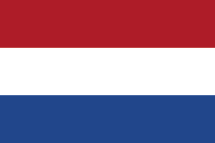

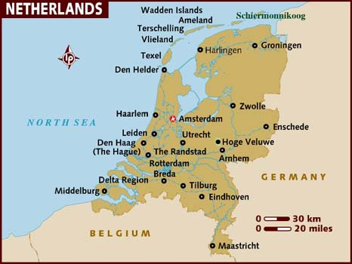

**The Netherlands:** One of the twelve original members of NATO, The Netherlands are both a continental and a maritime power. In addition to their commitments to Europe, they have legacy colonies that both rely on the mother country for protection and draw and provide resources. The Dutch are a critical element in the Land, Sea and Air defences of Europe.