**Netherlands Navy**

The Royal Netherlands Navy dates back to the 16th century where it was one of the most powerful in the world and maintained its skill by fighting against most of its European neighbours. Today it’s a much more modest force but carries on long standing traditions of duty and seamanship. Based largely on Frigates this very capable navy has some excellent ships.

[**Tromp Class**](http://www.seaforces.org/marint/Netherlands-Navy/Frigate/Tromp-class.htm)

Built to be Task Group (TG) Flagships, these two area air defence ships would be classed as Destroyers in most other navies. At 4000 tons and carrying both long range ‘Standard’ and short range ‘Sea Sparrow’ Surface to Air Missiles (SAM) for air defence, these ships could simultaneously protect the TG and themselves. Commissioned in 1975 & 76 they are approaching their mid life point in Northern Fury.

|  |  |  |  |  |
| --- | --- | --- | --- | --- |
| Pennant | Ship | Status | Location | Task |
| F801 | Tromp | Refit | Amsterdam | Dry Dock |
| F806 | De Ruyter | Active | North Sea | High Readiness |

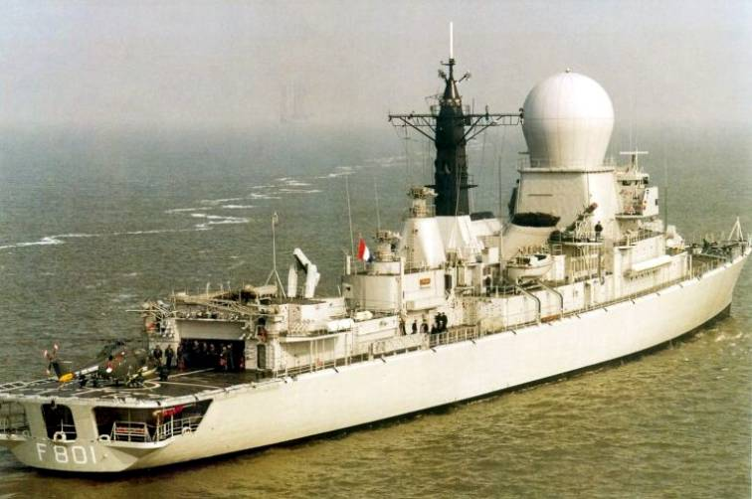

[**Karel Doorman Class**](http://www.seaforces.org/marint/Netherlands-Navy/Frigate/Karel-Doorman-class.htm)

These multi-purpose ships are emerging from the building yards as war starts. The lead ship in the class was commissioned in 1991, while the 6th ship was rushed into service in December of 1993, the 7th is fitting out and should be commissioned in several months, leaving only the last of the class on the sidelines. Although not overly capable in any one role, these ships provide very effective and modern sensors to a TG and, like most Frigates, make an excellent life support system for an Anti-Submarine Warfare (ASW) helicopter, in this case the Westland Lynx.

|  |  |  |  |  |
| --- | --- | --- | --- | --- |
| Pennant | Ship | Status | Location | Task |
| F827 | [Karel Doorman](https://en.wikipedia.org/wiki/Belgian_frigate_Leopold_I_(F930)) | Active | Baltic | Patrol |
| F829 | [Willem van der Zaan](https://en.wikipedia.org/wiki/Belgian_frigate_Louise-Marie_(F931)) | Active | Mediterranean | Cruise |
| F830 | [Tjerk Hiddes](https://en.wikipedia.org/wiki/HNLMS_Tjerk_Hiddes_(F830)) | Active | North Sea | Training |
| F831 | [Van Amstel](https://en.wikipedia.org/wiki/HNLMS_Van_Amstel_(F831)) | Active | North Sea | Port Call London |
| F832 | [Abraham van der Hulst](https://en.wikipedia.org/wiki/HNLMS_Abraham_Van_Der_Hulst_(F832)) | Active | Rotterdam | Maintenance |
| F833 | [Van Nes](https://en.wikipedia.org/wiki/HNLMS_Van_Nes_(F833)) | Active | North Sea | STANAVFORLANT |
| F834 | [Van Galen](https://en.wikipedia.org/w/index.php?title=HNLMS_Van_Galen_(F834)&action=edit&redlink=1) | Fitting out | Amsterdam |  |
| F828 | [Van Speijk](https://en.wikipedia.org/wiki/HNLMS_Van_Speijk_(F828)) | Building | Amsterdam |  |

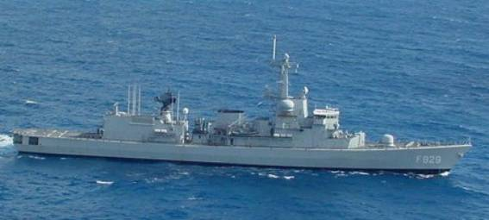

[**Kortenaer Class**](http://www.seaforces.org/marint/Netherlands-Navy/Frigate/Kortenaer-Standard-class.htm)

This class of 10 ships were similar to the German *Bremen* frigates and focused primarily an ASW patrol and escort duties. Slightly larger than the Karel Doorman these ships carried two helicopters, but otherwise had a similar armament but older sensors.

|  |  |  |  |  |
| --- | --- | --- | --- | --- |
| Pennant | Ship | Status | Location | Task |
| F807 | [Kortenaer](http://www.seaforces.org/marint/Netherlands-Navy/Frigate/F-807-HNLMS-Kortenaer.htm) | Active | North Sea | Training |
| F808 | [Callenburgh](http://www.seaforces.org/marint/Netherlands-Navy/Frigate/F-808-HNLMS-Callenburgh.htm) | Active | West Pacific | Port Call NZ |
| F809 | [Van Kinsbergen](http://www.seaforces.org/marint/Netherlands-Navy/Frigate/F-809-HNLMS-Van-Kinsbergen.htm) | Active | Den Helder | Tied up |
| F810 | [Banckert](http://www.seaforces.org/marint/Netherlands-Navy/Frigate/F-810-HNLMS-Banckert.htm) | Active | Caribbean | Patrol |
| F811 | [Piet Heyn](http://www.seaforces.org/marint/Netherlands-Navy/Frigate/F-811-HNLMS-Piet-Heyn.htm) | Active | Den Helder | Tied up |
| F816 | [Abraham Crijnssen](http://www.seaforces.org/marint/Netherlands-Navy/Frigate/F-816-HNLMS-Abraham-Crijnssen.htm) | Refit | Rotterdam | Dry Dock |
| F823 | [Philips van Almonde](http://www.seaforces.org/marint/Netherlands-Navy/Frigate/F-823-HNLMS-Philips-van-Almonde.htm) | Active | Den Helder | Tied up |
| F824 | [Bloys van Treslong](http://www.seaforces.org/marint/Netherlands-Navy/Frigate/F-824-HNLMS-Bloys-van-Treslong.htm) | Active | Atlantic | Transit from US |
| F825 | [Jan van Brakel](http://www.seaforces.org/marint/Netherlands-Navy/Frigate/F-825-HNLMS-Jan-van-Brakel.htm) | Active | South Atlantic | Port Call Buenos Aires |
| F826 | [Pieter Florisz](http://www.seaforces.org/marint/Netherlands-Navy/Frigate/F-826-HNLMS-Pieter-Florisz.htm) | Active | Den Helder | Tied up |

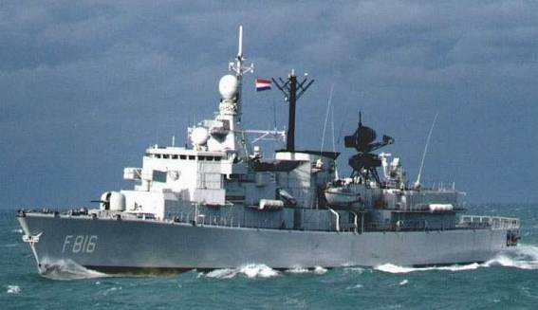

[**Jacob van Heemskerck Class**](http://www.seaforces.org/marint/Netherlands-Navy/Frigate/Jacob-van-Heemskerck-class.htm)

These two ships were based on the Kortenaer class but modified to replace the ASW helicopters with the same AD capabilities as the Tromp class with 40 ‘Standard’ medium range SAMs and 24 ‘Sea Sparrow’ point defence SAMs. The lack of helicopters meant that these ships needed to pair up with a Kortenaer class to have ASW protection, but they could perform the role of an AD Destroyer from the hull of a Frigate.

|  |  |  |  |  |
| --- | --- | --- | --- | --- |
| Pennant | Ship | Status | Location | Task |
| F812 | [Jacob van Heemskerck](http://www.seaforces.org/marint/Netherlands-Navy/Frigate/F-812-HNLMS-Jacob-van-Heemskerck.htm) | Active | Den Helder | Tied up |
| F813 | [Witte de With](http://www.seaforces.org/marint/Netherlands-Navy/Frigate/F-813-HNLMS-Witte-de-With.htm) | Active | North Sea | Training |

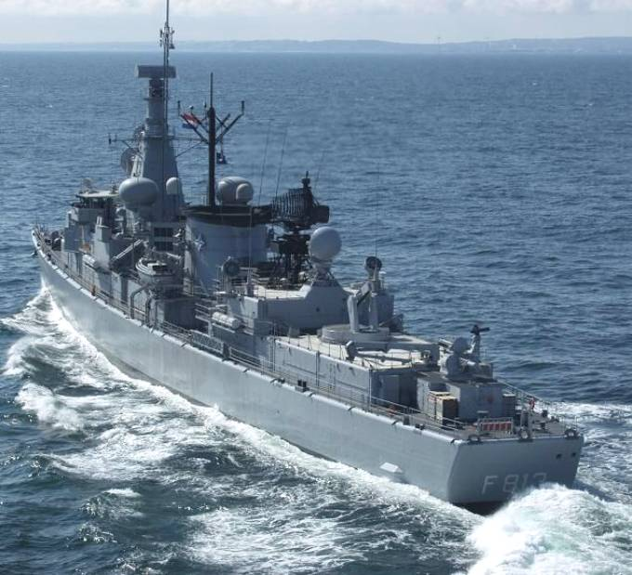

[**Alkmaar class Minehunter**](https://en.wikipedia.org/wiki/Tripartite-class_minehunter)

This is the Dutch version of the Tripartite class. Conceived and built together with the French and Belgians this class of ship is the modern mainstay of NATO’s mine hunting force. The Netherlands has 15 of these vessels. NATO has three ‘Standing NATO Mine Countermeasures Groups’ (SNMCMG): SNMCMG-1 normally remains in northern Europe and is stationed in the English Channel. SNMCMG-2 is in the Mediterranean and is usually operating in the Adriatic off of Croatia. Finally, SNMCMG-3 (only in the Northern Fury world) is stationed in Djibouti and patrols the entrance to the Red Sea.

|  |  |  |  |  |
| --- | --- | --- | --- | --- |
| Pennant | Ship | Status | Location | Task |
| M850 | Alkmaar | Active | Den Helder | Tied up |
| M851 | Delfzijl | Active | Den Helder | Tied up |
| M852 | Dordrecht | Active | Ostend | SNMCMG1 |
| M853 | Haarlem | Active | Den Helder | Tied up |
| M854 | Harlingen | Active | Den Helder | Tied up |
| M855 | Scheveningen | Active | Ostend | SNMCMG1 |
| M856 | Maasluis | Active | Den Helder | Tied up |
| M857 | Makkum | Active | Den Helder | Tied up |
| M858 | Middelburg | Active | Ostend | SNMCMG1 |
| M859 | Hellevoetsluis | Active | Ostend | SNMCMG1 |
| M860 | Schiedam | Active | Den Helder | Tied up |
| M861 | Urk | Active | Den Helder | Tied up |
| M862 | Zierikzee | Active | Mediterranean | SNMCMG2 |
| M863 | Vlaardingen | Active | Mediterranean | SNMCMG2 |
| M864 | Willemstad | Active | Mediterranean | SNMCMG3 |

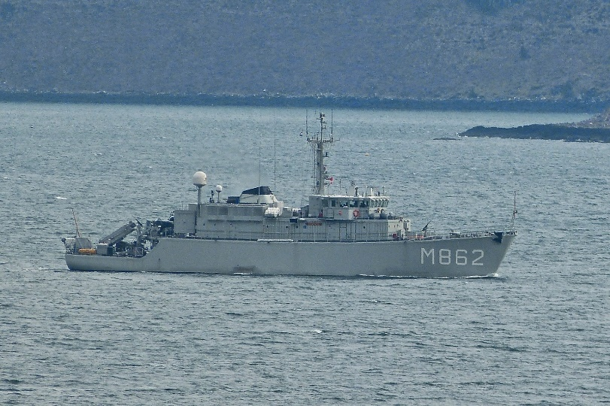

**AOR (Fast Replenishment Ships)**

In 1994 the Dutch Navy had two replenishment ships. HNLMS Poolster was about to go out of service later in 1994 and HNLMS Zuidekruis which was based on the Poolster’s design but was 10 years newer. These two ships provided underway replenishment for the remainder of the navy and other NATO navies as well.

|  |  |  |  |  |
| --- | --- | --- | --- | --- |
| Pennant | Ship | Status | Location | Task |
| A835 | [Poolster](https://en.wikipedia.org/wiki/HNLMS_Poolster_(A835)) | Active | Den Helder | Tied up |
| A832 | [Zuiderkruis](https://en.wikipedia.org/wiki/HNLMS_Zuiderkruis_(A832)) | Active | Den Helder | Tied up |

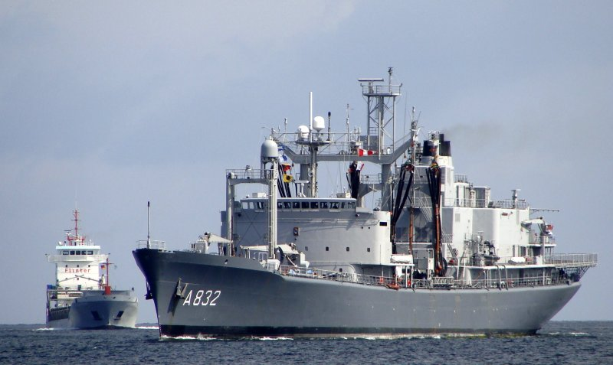

**Submarines**

Due to increased tensions, the last of the Walrus class boats was accelerated into service, being commissioned in Jan instead of July of 1994. All other classes were retired including the two Zwaardvis class boats which were decommissioned early.

[**Walrus Class**](http://www.seaforces.org/marint/Netherlands-Navy/Submarine/Walrus-class.htm)

These four boats are excellent blue water SSKs and are extremely quiet due to an advanced tail configuration. These boats are fast, quiet and deadly.

|  |  |  |  |  |
| --- | --- | --- | --- | --- |
| Pennant | Ship | Status | Location | Task |
| S802 | [Walrus](https://en.wikipedia.org/wiki/HNLMS_Walrus_(1985)) | Active | North Sea | Patrol |
| S803 | [Zeeleeuw](https://en.wikipedia.org/wiki/HNLMS_Zeeleeuw_(1987)) | Active | Atlantic | Patrol |
| S808 | [Dolfijn](https://en.wikipedia.org/wiki/HNLMS_Dolfijn_(1990)) | Active | Den Helder | Tied up |
| S810 | [Bruinvis](http://www.shipsnostalgia.com/gallery/showphoto.php?photo=953057) | Fitting out | Den Helder | Tied up |

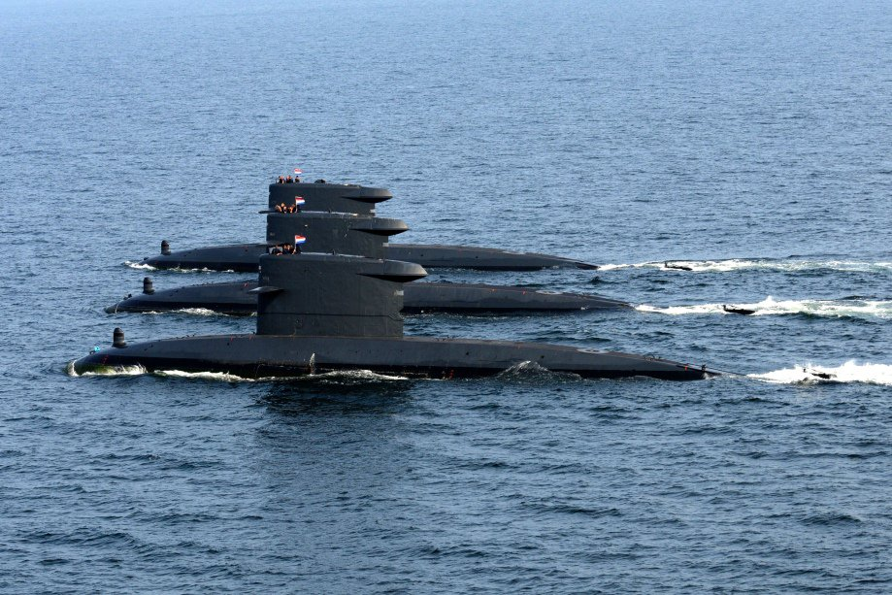

**Maritime Aviation**

**P-3C Orion**

The Royal Netherlands Navy operates two P-3C Maritime Patrol Aircraft (MPA) squadrons, a total of 13 were acquired. Both 320 and 321 Squadrons operate out of Valkenburg. Although each Sqn operates six aircraft, there are two permanently located at Curacao in the Caribbean and two more permanently located an NAS Sigonella in the Mediterranean.

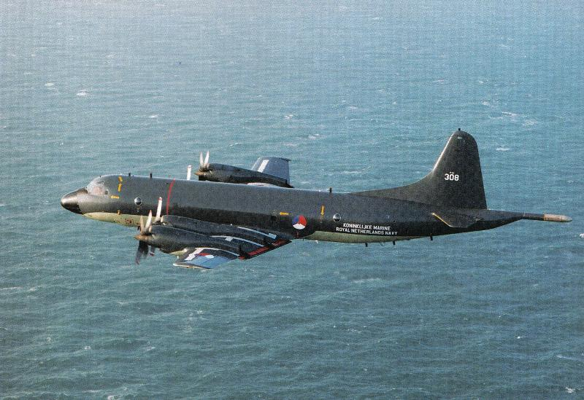

**Lynx**

Three different versions of this helicopter are employed: Six Mk.25 (SH-14A) are used for utility and SAR missions, three have been upgraded to the (SH-14B) model. For shipborne ASW work, 18 Mk.27, upgraded to the Mk.81/SH-14C standard with a Magnetic Anomaly Detector (MAD) are used. The SH-14C are capable of carrying out the SAR task as well.

