**Norwegian Air Force**

The Norwegian Air Force manages all air activity for the Army, Navy, and Coast Guard as well as conducting traditional Air Force tasks. The Primary fighter aircraft is the F-16. Although not part of the Norwegian Air force, a flight of 2 or 3 NATO E-3A AWACS are semi-permanently stationed an on task at Orland.

[**F-16 Falcon**](http://www.f-16.net/f-16_users_article12.html)

Norway is one of four European countries that invested heavily into the F-16 Falcon project, purchasing 60 single seat ‘A’ models and 12 dual seat ‘B’ versions. Each of the four Squadrons conduct patrols in North Norway on a rotational bases and regularly deploy to dispersal bases throughout the country. A unique feature of Norwegian F-16s is the ability to fire the AGM-119 ‘Penguin 3’ anti-ship missile, a critical capability to defend the long and vulnerable coastline. Historically the first MLU (Mid life Upgrade) aircraft, able to fire the Aim-120 Air to Air missile arrived in 1995; however, that has been advanced by a year in Northern Fury and 338 Squadron has four of the improved aircraft on its roster. The 12 ‘B’ model aircraft are concentrated at Regge but routinely deploy to the operational squadrons.

At the start of Northern Fury, 331 Sqn from Bodo is forward based at Bardufoss with 4 additional ‘B’ model aircraft, elements of 4-6 aircraft are dispersed to Banak, Tromso and Evenes and they are maintaining a 24/7 Combat Air Patrol(CAP).

|  |  |  |  |  |  |
| --- | --- | --- | --- | --- | --- |
| Sqn | Name | Location | No. | Type | Remarks |
| 331 | Lion | Bodo | 16+4 | F-16A | +4 F-16B |
| 332 | Eagle | Regge | 16 | F-16A |  |
| 334 | Cola | Bodo | 16 | F-16A |  |
| 338 | Tiger | Orland | 12+4 | F-16A | +4 MLU |

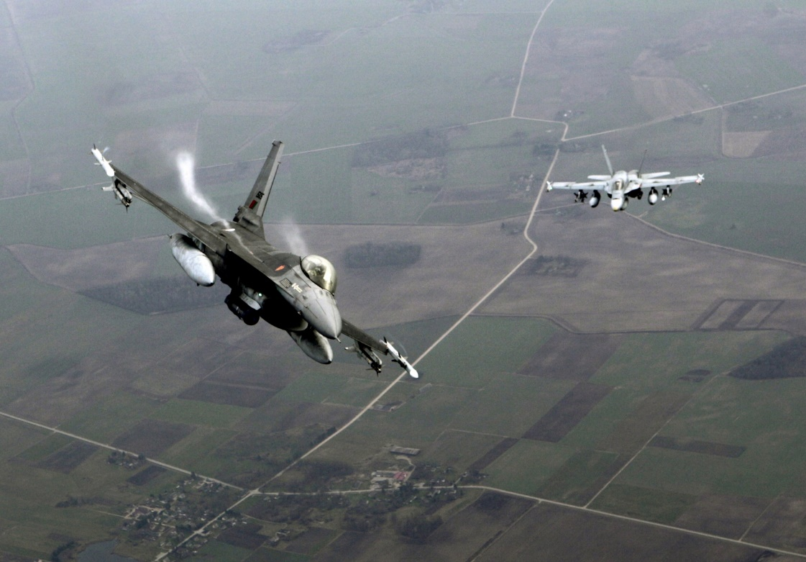

[**F-5 Tiger II**](https://fas.org/man/dod-101/sys/ac/f-5.htm)

Although Norway was in the process of retiring the F-5 Freedom Fighter, increased tensions changed that plan. Historically by 1994 the only F-5s remaining were 718 Sqn at the Fighter training school (14x F5B), 717 Reconnaissance Sqn (16x RF-5A) and 336 Sqn with 24x F-5A focusing on ground attack. In Northern Fury however, two further squadrons remain active in 1992. Although dated these aircraft were available and airworthy so were used to fill a gap.

|  |  |  |  |  |  |
| --- | --- | --- | --- | --- | --- |
| Sqn | Name | Location | No. | Type | Remarks |
| 336 | Tigers | Rygge | 24 | F-5 Tiger II |  |
| 339 | Jager | Orland | 24 | F-5 Tiger II |  |
| 340 | Fox | Gardermoen | 24 | F-5 Tiger II |  |
| 717 | Raven | Rygge | 16 | RF-5 Tiger II | Recon |
| 718 | Night Owl | Sola | 14 | F-5B Tiger II | Training |

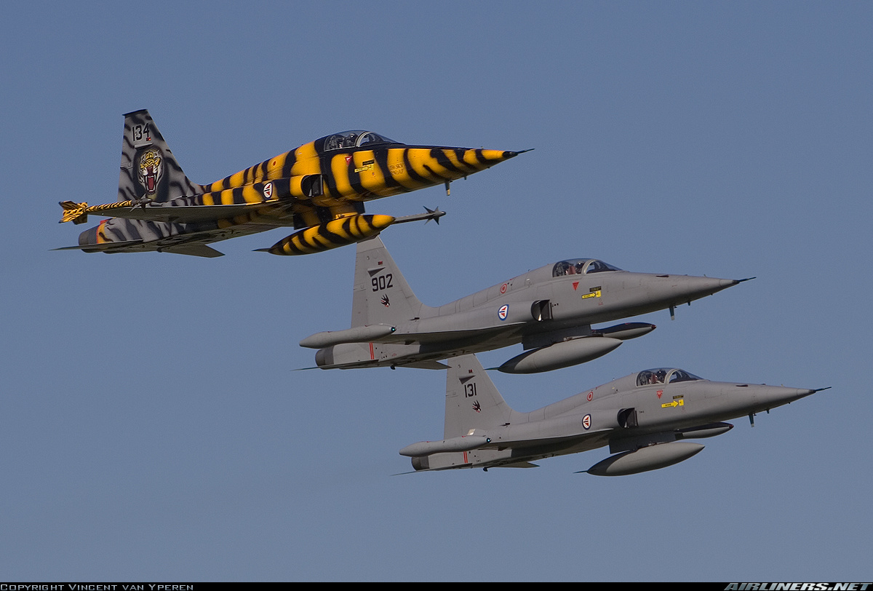

**Falcon 20**

Also under the control of 717 Sqn at Regge were two Falcon 20 Electronic Warfare (EW) aircraft. These were civilian pattern Dassaut Falcon executive jets, heavily modified and sold to several air forces as a stop-gap area EW platform. The programme was quite successful.

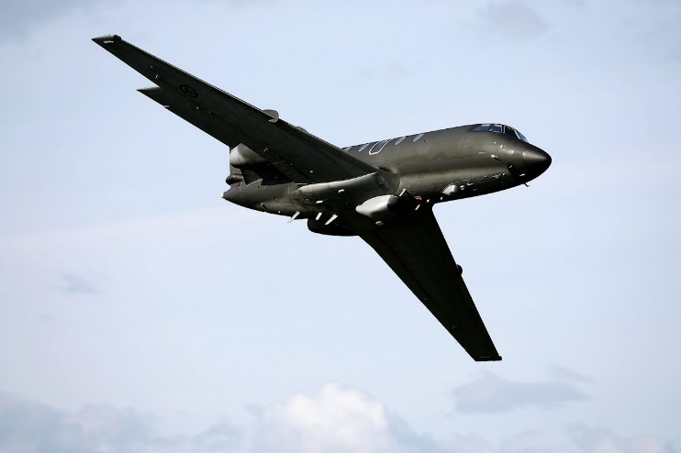

**P-3C & P-3N Orion**

These Maritime Patrol Aircraft (MPA) were operated by No. 333 ‘Hawks’ Sqn out of Andoya. The four P-3C’s were standard Anti-Submarine Warfare (ASW) versions while the two P-3N were modified to operate for the Coast Guard and were unable to carry weapons, did not have a Magnetic Anomaly Detector or Sonobuoys and was only able to conduct area surveillance and other non-military missions.

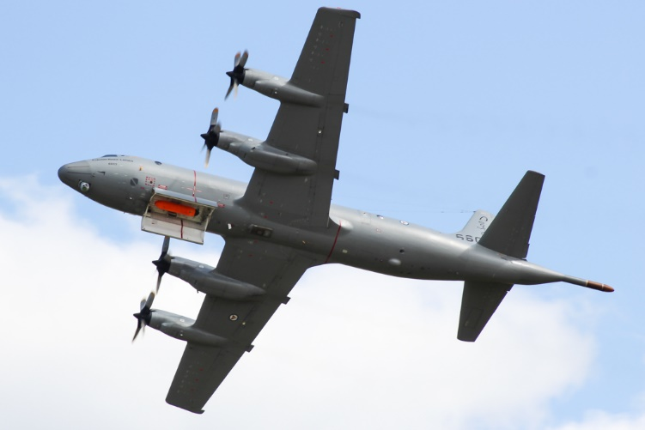

**C-130 Hercules**

No. 335 Sqn flying out of Gardermoen air base operated six C-130H Hercules conducting routine transport tasks for all branches of the service including the Coast Guard.

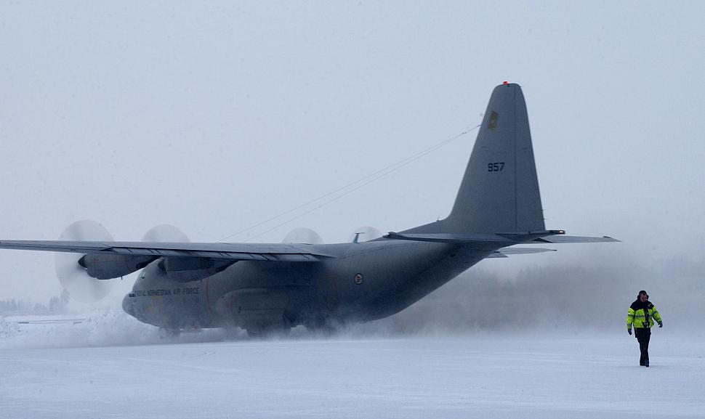

**Sea King**

Operated for the Coast Guard the Mk43B Sea Kings are primarily for SAR and air ambulance missions but can also be used for maritime patrol and utility tasks. No. 330 ‘Viking’ Sqn operates 12 aircraft and are dispersed in groups of two or three throughout Norway as required by the Coast Guard.

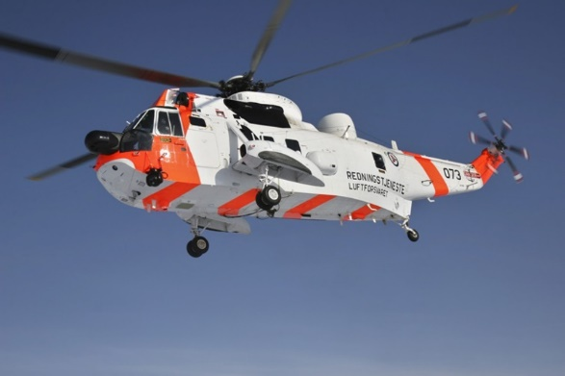

**Lynx**

Operated by No.337 Sqn primarily from Bardufoss but deployed to various bases, these six Mk86 Lynx are meant for SAR and patrol work but also conduct may other tasks, they are not armed. They spend two weeks at a time on board the Nordkapp class OPVs as well as conducting routine rescue and utility work.

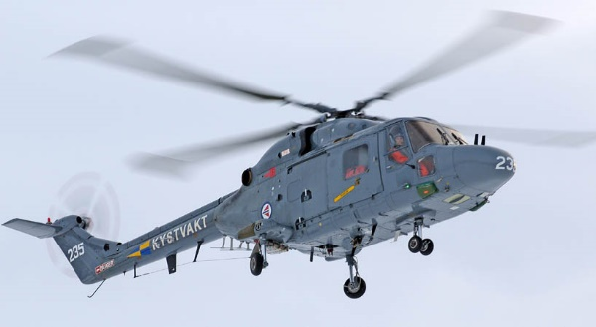

**Bell 412**

Primarily used for army transport the 12 ‘Twin Huey’ operated by 441 Sqn are based at Gardermoen air base.

