**Norwegian Army**

The Norwegian Army is small, only 19,000 permanent force and much of these are conscripts, but with a ready reserve of 146,000 and regular mobilization training, the ability to rapidly expand to a potent force is credible. Northern Fury has the Norwegian Army progressing slowly towards the goals of its 1974 Defence Commission proposal for reorganization. Also with the Olympics ongoing and the increased tension, some units are at a higher state of readiness and several reserve battalions are fully mobilized. Because of the focus on Norway in the Northern Fury Storyline, more detail is provided here than for other countries.

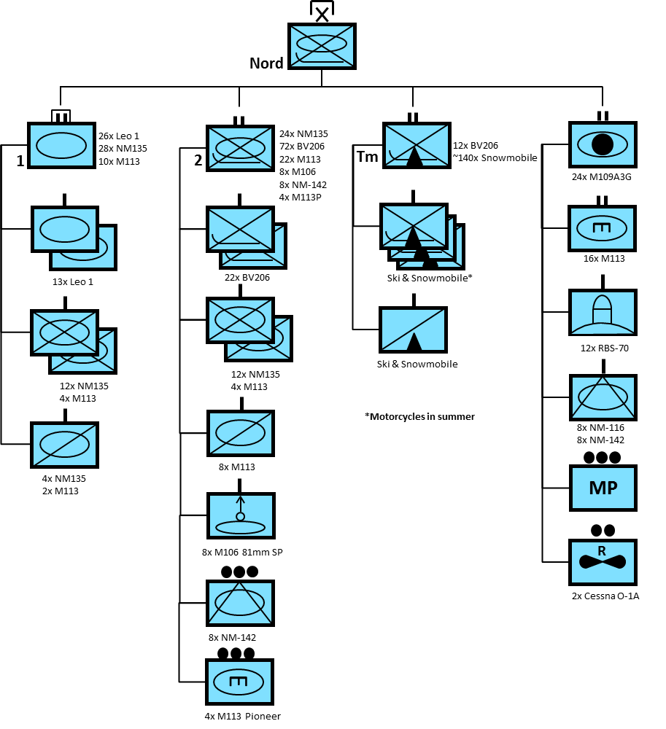

**Brigade Nord**

This is a very unique organization stationed in the Bardufoss area of northern Norway. Each of the three combat arms battalions in Brigade Nord is tailored for well-practiced and specific tasks, but they are also designed for maximum flexibility and rapid changes of the situation.

**1st Panzer Bn**

Although named as a Panzer or ‘tank’ battalion, this unit is actually a homogeneous mix of infantry and armor. Designed to provide a counter-moves force to the ground commander, it can just as easily block restricted terrain using its tanks as mobile bunkers. The Leopard 1 however is meant for rapid movement and this is how the unit was intended; allowing the less mobile infantry and home guard units to slow an advancing enemy while the Panzers attack vulnerabilities.

**2nd Mechanized Bn**

This large battalion is a cross between the traditional Norwegian battalions (Type 78) and the evolving Type 90 that was called for in the defence review. Although the unit now has four instead of three rifle companies, only two are mechanized while the others remain mounted in BV206 over-snow vehicles. Supporting elements within the battalion are all M113 base variants including mortar carriers, TOW anti-armor vehicles, the pioneer/engineer platoon and the reconnaissance (Cavalry) squadron.

**Telemark Bn**

This unit, established in 1993 historically evolved to be a mechanized deployable unit for peace support and COIN operations. Its original design however, as the [name suggests](https://en.wikipedia.org/wiki/Telemark_skiing), was much different. This unit was meant to become a highly skilled mountain infantry unit, counterbalancing the more heavily mechanized 2nd Battalion. Eventually it will receive some improved BV206 variants for deploying mortars and TOW anti-tank missiles. Currently in Northern Fury, the unit gains mobility by using snowmobiles and skis in the winter, light trucks and motorcycles in the summer.

**Army**

The remainder of the Norwegian Army is much more traditionally organized, but due to its unique geography, small population base and rugged terrain, each organization has its differences. Starting in the North and moving South these formations are:

**6th Division Finmark**

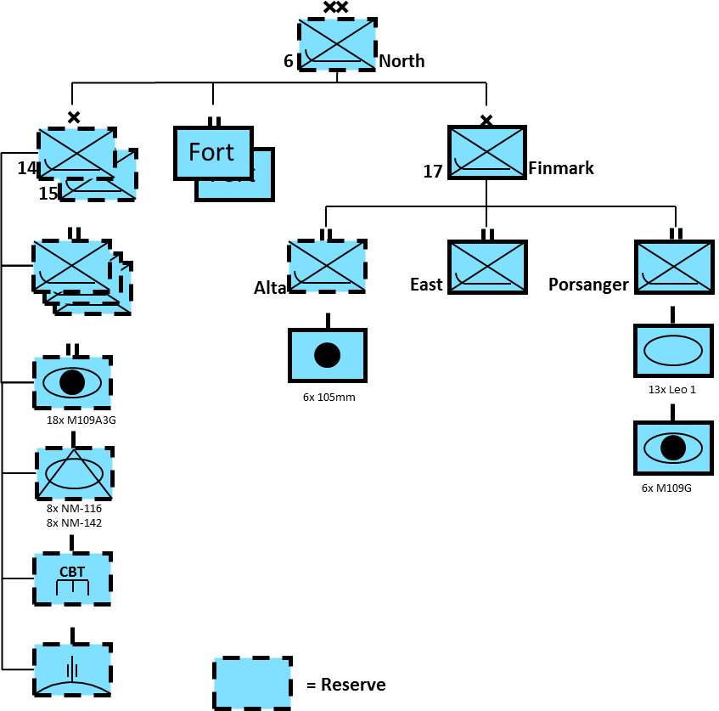

A mix of Permanent Force, Reserves and Fortress units, the HQ is also located in Bardufoss. Brigade Nord, responds to national priorities and does not belong to this formation but trains with it regularly. In the early hours of Northern Fury, the 105mm artillery battery features prominently as does the East Finmark Battalion (Östre Finnmark Defense Bn).

**4th Division Trondheim**

Although 12 & 13 Brigades are a mix of Permanent Force and Reserve, they’ve been mobilized to provide security for the Olympics in Lillehammer. 12 Brigade is a good example of a ‘Type 90’ Brigade with an armoured battalion and two infantry battalions, each with four companies.

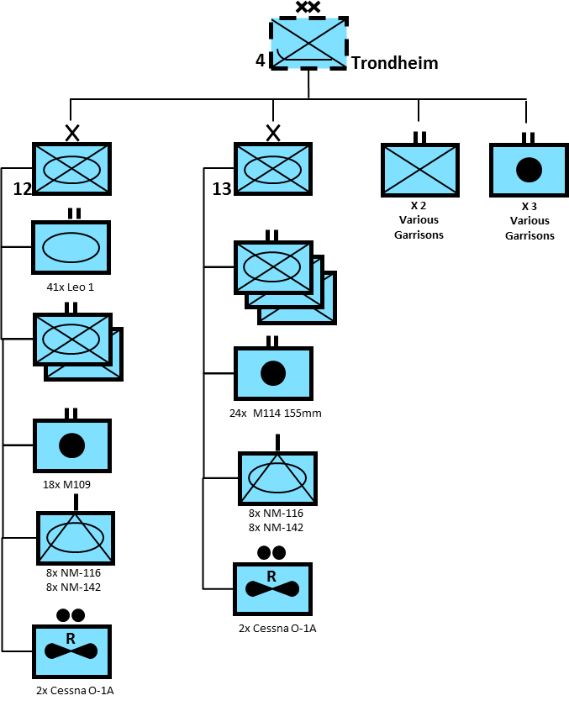

**V Brigade (Brigade West) Bergan**

Another permanent force brigade, part way to the ‘Type 90’ standard, ‘V’ Brigade would likely form the nucleus of a division in wartime.

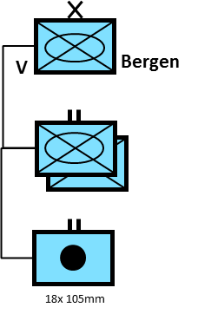

**1st Division South**

This formation has the largest concentration of units in the Army. Brigade Sud (South) represents the Permanent Force element while four reserve brigades and 14 independent garrisons round out the structure. In all likelihood these forces would form two divisions in wartime. Most of the trade schools are also located in this area.

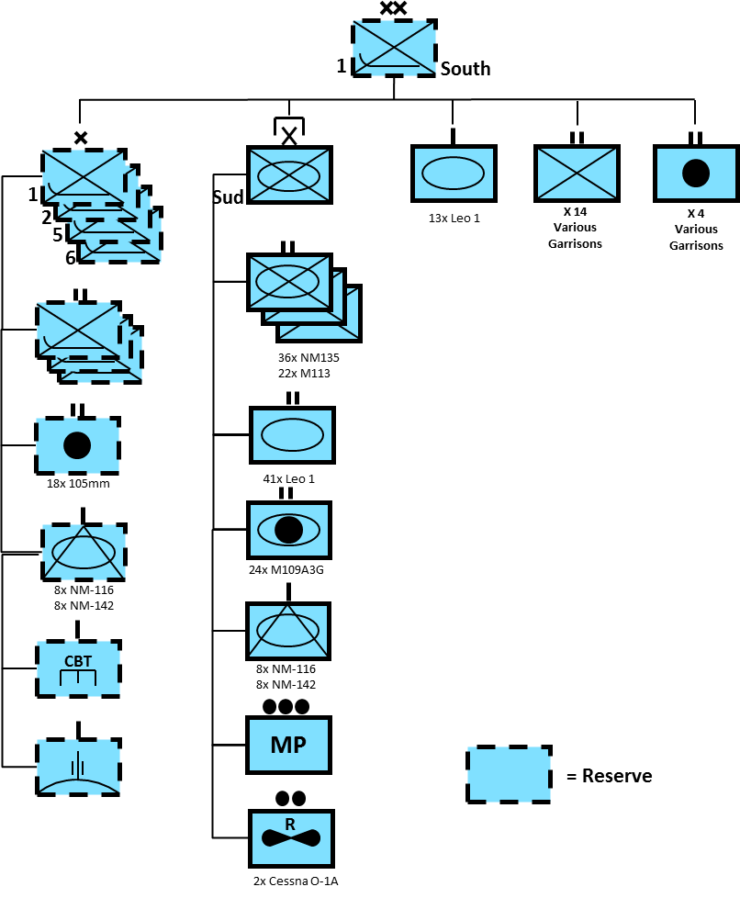

**2nd Division Oslo**

Finally the Oslo area has another concentration of units. The Kings Guard is a mix between Reserve and Permanent Force but is mobilized for ceremonial duties during the Olympics.

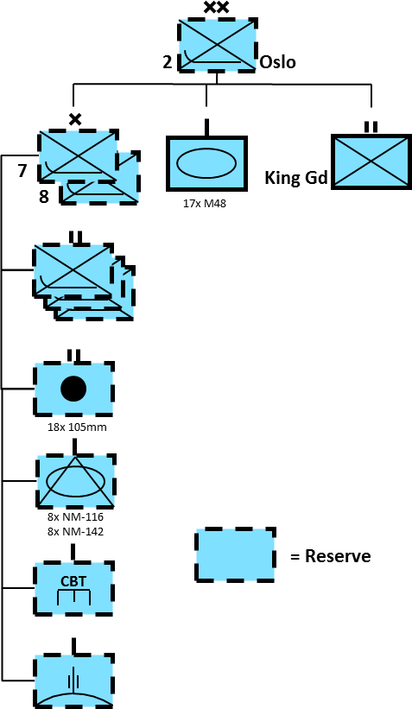

**Equipment:**

[**Leopard 1**](http://www.tanks-encyclopedia.com/coldwar/West_Germany/Leopard-I.php)

Like many other nations, Norway decided to purchase the Leopard 1 Main Battle Tank (MBT). A total of 172 MBTs were acquired in addition to several specialist vehicles; 14 Armored Recovery Vehicles (ARV), 9 Armored Vehicle Launched Bridges (AVLB) and 22 Armored Engineering Vehicles (AEV).

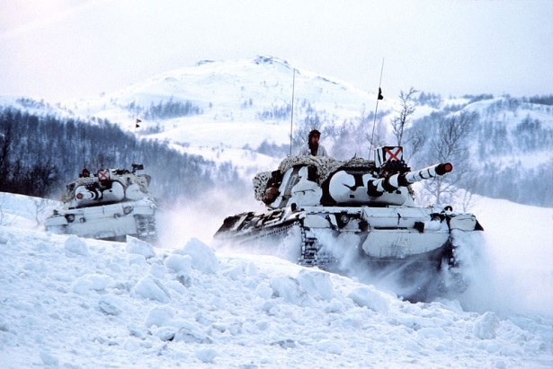

[**M48A5 Patton**](https://en.wikipedia.org/wiki/M48_Patton)

Norway first acquired the M48 Patton in 1963 when 38 of them were delivered from the US, these were upgraded in the mid 80’s to the M48A5 standard with a 105mm gun. Also in 1986 an additional 17 were purchased and used as an independent squadron in the Oslo area. The original tanks were retired 1993 when the last of the Leopard 1’s were put into service but they remain available in reserve.

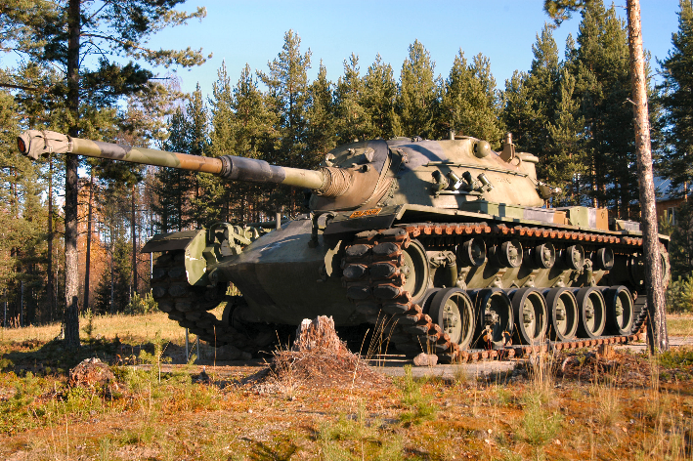

[**NM-116 Super Chaffee**](http://sturgeonshouse.ipbhost.com/topic/1021-nm-116-norwegian-super-chaffee/)

72 M24 Chaffee light tanks were upgraded between 1973 and 1977 and deployed as ‘Tank Destroyers’ with a low velocity 90mm D-925 gun from France, and many other improvements. Attached to the Anti Tank units in Infantry Brigades it could fire High Explosive (HE), Smoke, and High Explosive Anti-Tank (HEAT) rounds. The HEAT was used to kill tanks and light armored vehicles while the smoke and HE provided excellent support to infantry units. Although retired in 1994, they remain in service for Northern Fury.

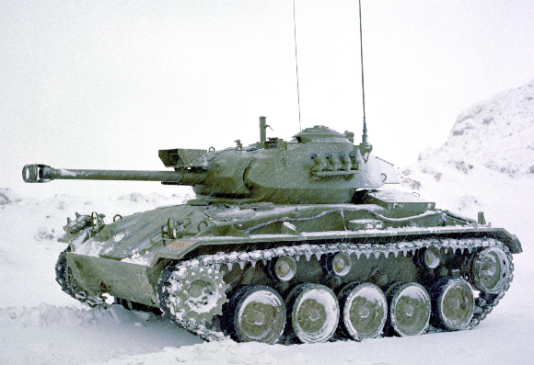

[**NM-135**](https://en.wikipedia.org/wiki/NM135)

This is a modified M113 APC, it has a 20mm autocannon, smoke dischargers and is used as an early and inexpensive Infantry Combat Vehicle (ICV). Some 100 of these were produced by modifying existing M113’s but in Northern Fury the total is increased to ~140. This would imply a corresponding reduction of the ~300 M113’s available but more M113s could easily be purchased if required.

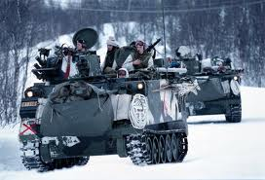

[**BV206**](https://www.army-technology.com/projects/bv2065/)

The Norwegian Army uses over 1000 of these versatile light vehicles. Primarily employed as an infantry section vehicle, some have been modified to carry mortars and TOW anti-tank missiles, as well as command posts and for several other tasks. The video at this [link](https://www.youtube.com/watch?v=uqzXueZS9NI) demonstrates the all terrain maneuverability.

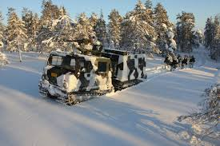

**NM-142**

These are M113 vehicles with an early TOW under armor system very similar to the US M901. Norway has 100 of these variants and they work very closely with the NM-116 in the Anti-Tank companies of Infantry Brigades.

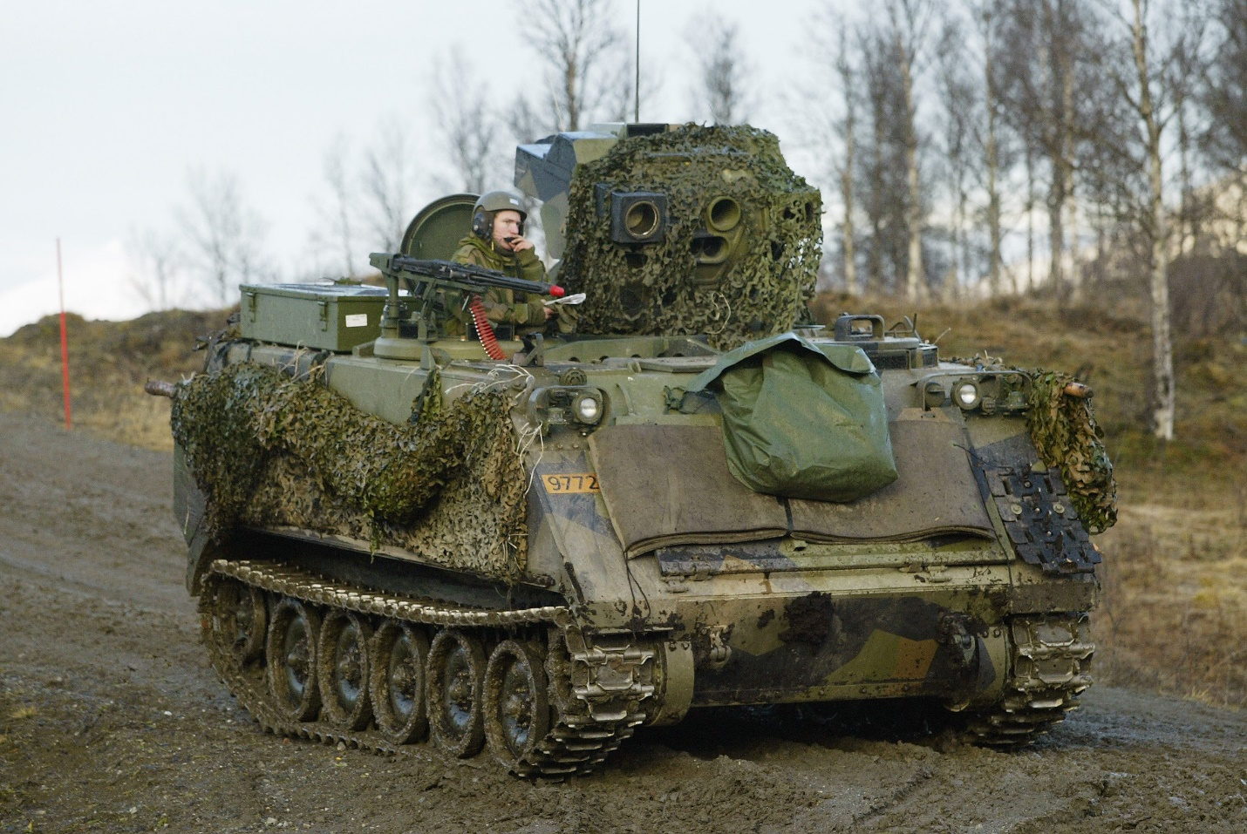

**Artillery**

The Norwegian Army had several artillery systems:

* Hundreds of 81mm Mortars
* 97x M-30F1 107mm Mortars
* 28 M106A1 107mm Self Propelled (SP) Mortars
* 220x M101 105mm Howitzers
* 126x M109A3GN 155mm SP Howitzers
* 48x M114/39 155mm towed Howitzers (39 calibre barrel)
* ~100x M114/23 155mm towed Howitzers (23 calibre barrel) in reserve.

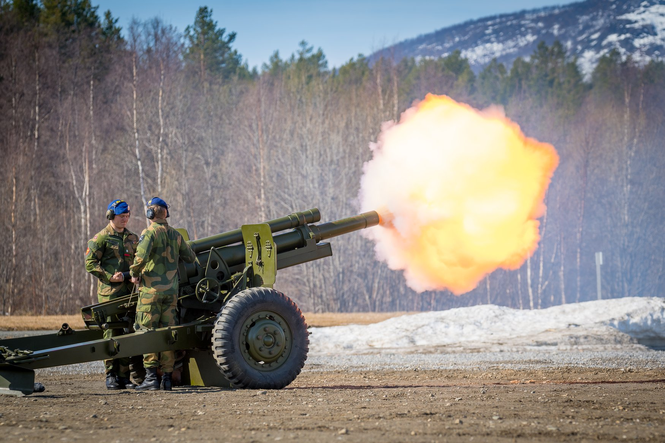

**Air Defense Systems**

Several different Air Defense systems were in use. The RBS-70 was very modern and in the Permanent Force units.

* 108x RBS-70 SAMs
* 132x M1 40mm AA guns
* Numerous Bofors 40L60 and 40L70 AA guns
* 20mm KK-202 towed AA guns
* 12.7mm Quad towed MGs

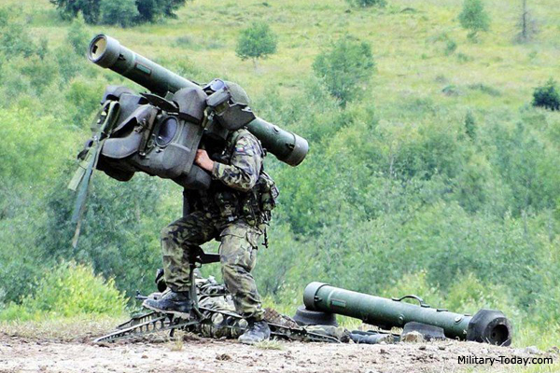

**Cessna O-1A Bird Dog Spotter Aircraft**

Very few militaries still used fixed wing spotter aircraft in 1994 but the Norwegian maintained 17 venerable Cessna Bird Dogs for artillery spotting.

