**Norwegian Navy**

Norway‘s Navy is small but built specifically to operate within the confined and turbulent waters of the North Sea along its long rocky and mountainous coastline. Over 1000 miles (1750Km) stretch from the North Cape to Stavanger in the south, causing Norway opt for many smaller ships as opposed to a few larger and more expensive vessels.

[**Oslo Class**](https://en.wikipedia.org/wiki/Oslo-class_frigate): Although the largest and most capable ships in the Norwegian Navy, they are small Frigates by most standards (1,700 tons). Built in the 1960’s they’ve recently been modernized (late 80‘s) and are capable of a wide range of general duties. These ships do not have a helicopter but rely on shore based maritime aircraft to support them. They carry 6x Penguin Anti-Ship Missiles (ASM) and an 8 cell Sea Sparrow launcher, a short-range Surface to Air missiles (SAM) with 24 missiles in total. For Anti-submarine warfare (ASW) they have torpedoes and both hull and variable depth active sonar.

|  |  |  |  |  |  |
| --- | --- | --- | --- | --- | --- |
| Class | Pennant | Ship | Location | Status | Remarks |
| Oslo | F 300 | Oslo | Trondheim | Active |  |
|  | F 301 | Bergen | Tromso | Active | High readiness |
|  | F 302 | Trondheim | Trondheim | Active | Patrol |
|  | F 303 | Stevanger | Tromso | Active | High readiness |
|  | F 304 | Narvik | Bergen | Active | Maintenance |

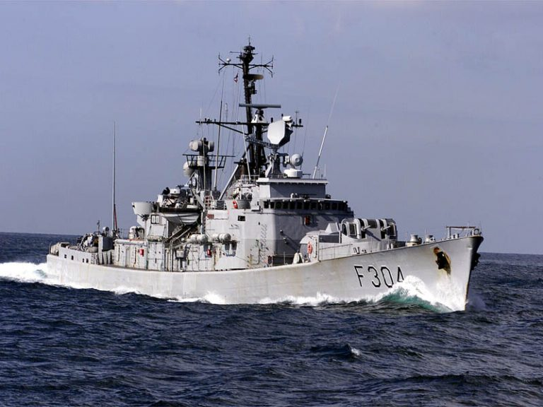

**Sleipner Class**: Dating from the same era as the Oslo class but largely obsolete with the exception of an improved sonar installed in the late 80‘s. The two Sleipner class Corvettes are used as training ships and were due for retirement in 1993, but due to the increased threat in the Northern Fury world, they were retained in service.

|  |  |  |  |  |  |
| --- | --- | --- | --- | --- | --- |
| Class | Pennant | Ship | Location | Status | Remarks |
| Sleipner | F 310 | Sleipner | Bergen | Active | Training |
|  | F 311 | Æger | Oslo | Active | Training |

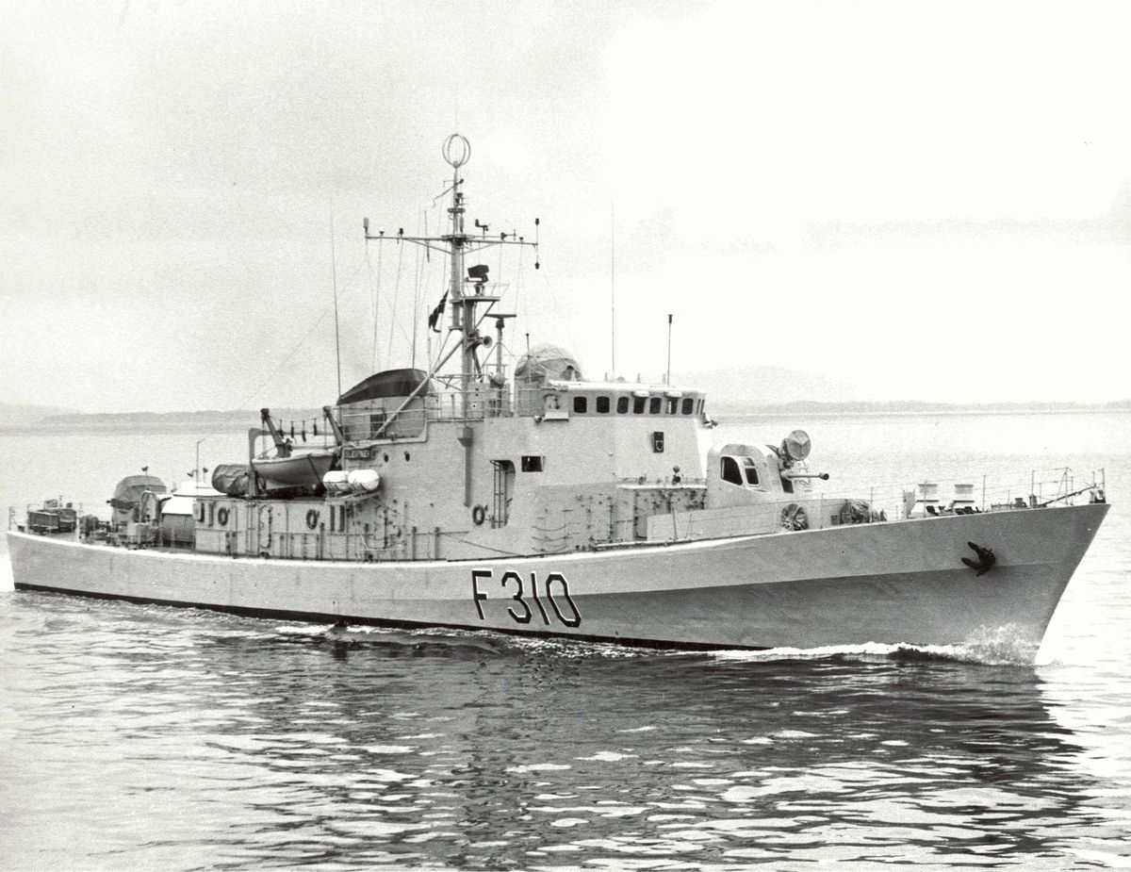

**Fast Attack Craft (FAC)**: The most potent arm of the Norwegian Navy is its fleet of small, fast and deadly FACs. These boats use the rugged and mountainous coastline for radar shielding while waiting to ambush passing targets. Using their speed and missiles to deal a lethal blow then running back into cover. Operating in small groups they use these hit and run tactics is their main means of survival.

[**Storm Class**](https://en.wikipedia.org/wiki/Storm-class_patrol_boat): A class of 20 boats that displace only 138 tons each, carry six Penguin I Anti-Ship Missiles (ASM), and have a 76mm gun and 40mm auto-cannon. With only a 20-man crew they can deploy quickly and travel at over 30 knots.

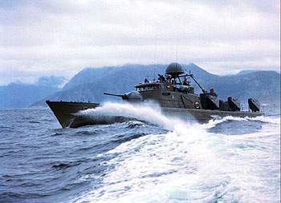

[**Snogg Class**](https://en.wikipedia.org/wiki/Sn%C3%B8gg-class_missile_torpedo_boat): Only six boats of this class were built, and they only carry four Penguin I ASMs, but also four Torpedoes and one 40mm auto-cannon. They are about the same size as the Storm class, have a crew of 19 and a speed of over 30 knots.

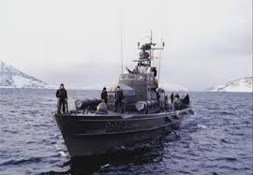

[**Hauk Class**](https://en.wikipedia.org/wiki/Hauk-class_patrol_boat): Larger (160 tons) and faster (32.5 knots) than the older boats, the 14 Hauk class carry six Penguin II missiles which have a longer range and better seeker head than the original missile. These boats also carry Mistral SAMs, a 40mm auto-cannon and two Torpedoes.

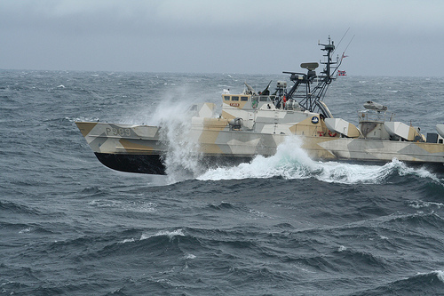

|  |  |  |  |  |  |
| --- | --- | --- | --- | --- | --- |
| Class | Pennant | Ship | Location | Status | Remarks |
| Storm | P 960 | Storm | North Cape |  | 6 Penguin I |
|  | P 961 | Blink |  |  |  |
|  | P 962 | Glimt |  |  |  |
|  | P 963 | Skjold | Narvik |  |  |
|  | P 964 | Trygg |  |  |  |
|  | P 965 | Kjekk |  |  |  |
|  | P 966 | Djerv | Narvik |  |  |
|  | P 967 | Skudd |  |  |  |
|  | P 968 | Arg |  | Maintenance |  |
|  | P 969 | Steil |  |  |  |
|  | P 970 | Brann | Narvik |  |  |
|  | P 971 | Tross | Narvik |  |  |
|  | P 972 | Hvass |  |  |  |
|  | P 973 | Traust | North Cape |  |  |
|  | P 974 | Brott |  |  |  |
|  | P 975 | Odd |  |  |  |
|  | P 976 | Pil |  |  |  |
|  | P 977 | Brask | North Cape |  |  |
|  | P 978 | Rokk | Narvik |  |  |
|  | P 979 | Gnist |  |  |  |
| Snogg | P 980 | Snøgg | Narvik |  | 4 Penguin I |
|  | P 981 | Rapp | North Cape |  |  |
|  | P 982 | Snar |  |  |  |
|  | P 983 | Rask | North Cape |  |  |
|  | P 984 | Kvikk |  |  |  |
|  | P 985 | Kjapp | North Cape |  |  |
| Hauk | P 986 | Hauk |  |  | 6 Penguin II |
|  | P 987 | Ørn |  |  |  |
|  | P 988 | Terne | North Cape |  |  |
|  | P 989 | Tjeld |  |  |  |
|  | P 990 | Skarv | North Cape |  |  |
|  | P 991 | Teist |  |  |  |
|  | P 992 | Jo |  |  |  |
|  | P 993 | Lom | Narvik |  |  |
|  | P 994 | Stegg |  | Maintenance |  |
|  | P 995 | Falk | Narvik |  |  |
|  | P 996 | Ravn |  |  |  |
|  | P 997 | Gribb | North Cape |  |  |
|  | P 998 | Geir |  |  |  |
|  | P 999 | Erle |  |  |  |

**Submarines: T**he proximity to the Soviet Union, the confined waters and rugged coastlines, mean that the key method of defence is stealth and ambush. The numerous FAC listed above are one method of achieving this tactic, Hunter/Killer submarines (SSK) are another.

[**Ula Class**](http://www.military-today.com/navy/ula_class.htm): Built in Germany and known as the Type 210, these have several improvements over the very popular Type 209 boats. All six were commissioned between 1989 and 1992 and therefore are some of the most modern submarines available at the start of Northern Fury. These are very stealthy and dangerous SSKs which would give any enemy surface combatants pause to consider the dangers of Norwegian waters.

|  |  |  |  |  |  |
| --- | --- | --- | --- | --- | --- |
| Class | Pennant | Ship | Location | Status | Remarks |
| Ula | S 300 | Ula | Bergen | Active | Tied Up |
|  | S 301 | Utsira | North Cape | Active | Patrol |
|  | S 302 | Ulstein | Norwegian Sea | Active | Patrol |
|  | S 303 | Utvaer | Bergen | Active | Tied Up |
|  | S 304 | Uthaug | Bergen | Active | Tied Up |
|  | S 305 | Uredd | North Sea | Active | Patrol |

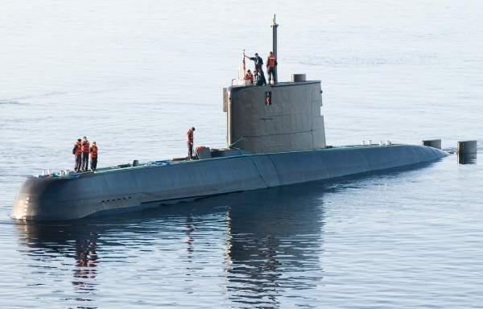

[**Kobben Class**](https://en.wikipedia.org/wiki/Kobben-class_submarine): These submarines were also built in Germany as the Type 207 and were an improved version of the Type 205 used by Germany and Denmark. In total 15 boats were delivered to Norway between 1964 and 1967, but due to age, accidents and decommissioning, only 8 remain in service at the start of Northern Fury.

|  |  |  |  |  |  |
| --- | --- | --- | --- | --- | --- |
| Class | Pennant | Ship | Location | Status | Remarks |
| Kobben | S 314 | Sklinna | Bergen | Active | Tied Up |
|  | S 306 | Skolpen | Bergen | Refit | Ready |
|  | S 308 | Stord | North Sea | Active | Patrol |
|  | S 309 | Svenneer | Bergen | Active | Tied Up |
|  | S 315 | kaura | Bergen | Active | Tied Up |
|  | S 316 | Kinn | Norwegian Sea | Active | Patrol |
|  | S 318 | Kobben | North Cape | Active | Patrol |
|  | S 319 | Kunna | Norwegian Sea | Active | Patrol |

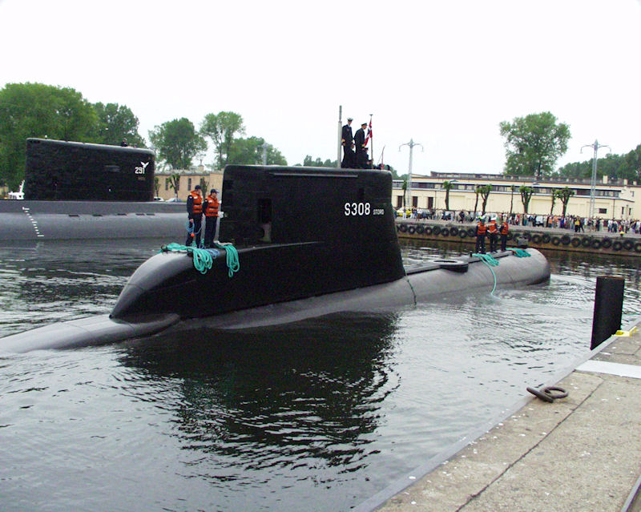

**Norwegian Coast Guard**: The Coast Guard is part of the Norwegian Navy and takes responsibility for fisheries and shipping inspection, customs and law enforcement, boarder control, environmental protection as well as search and rescue. The wide ranging scope of duties keeps this very small force quite busy. Much of the day to day work coastal work is handled by ten small patrol ships of less than 1000 tones, seven of them are chartered and each is armed with a 40mm Bofors gun. The one class of larger ships is the **Nordkapp** class.

[**Nordkapp Class**](http://www.wikiwand.com/en/Nordkapp-class_offshore_patrol_vessel): These three Outer Coast Guard Ships, otherwise called Offshore Patrol Vessels (OPV), are 3300 tones and twice the size of the Oslo class Frigates, but have fewer weapons or sensors. Having strengthened hulls to withstand limited ice crushing, or ice browsing they are well suited to northern waters. Although they only carry a 57mm gun and machine guns, in wartime they can be fitted with Depth Charges, Penguin anti-ship missiles, torpedoes, 20mm guns and Mistral SAMs. The peacetime crew is 52 plus 6 for the air detachment, but its wartime establishment is 76 and there is bunk space for 109. They each carry a Lynx helicopter, primarily for SAR and one is almost continually patrolling in the area of the North Cape.

|  |  |  |  |  |  |
| --- | --- | --- | --- | --- | --- |
| Class | Pennant | Ship | Location | Status | Remarks |
| Nordkapp | W320 | Nordkapp | North Cape | Active | Patrol |
|  | W321 | Senja | Oslo | Active | Tied up |
|  | W322 | Andenes | North Sea | Active | Patrol |

