**Portuguese Navy**

The Portuguese Navy (*Marinha de Guerra Portuguesa)* traces its history back to the 12th Century through colonial exploration to the modern day. Unfortunately, most of Portugal’s ships lightly armed and designed for overseas duties in a low threat environment, although they were effective in exerting influence in former colonies they are rather anemic by European and North Atlantic standards. A agreement with Britain to purchase the Rover Class fleet support tanker (RFA Blue Rover) was not executed in the Northern Fury world, leaving the Portuguese Navy dependent on others for at sea replenishment.

**Vasco Da Gama Class**:

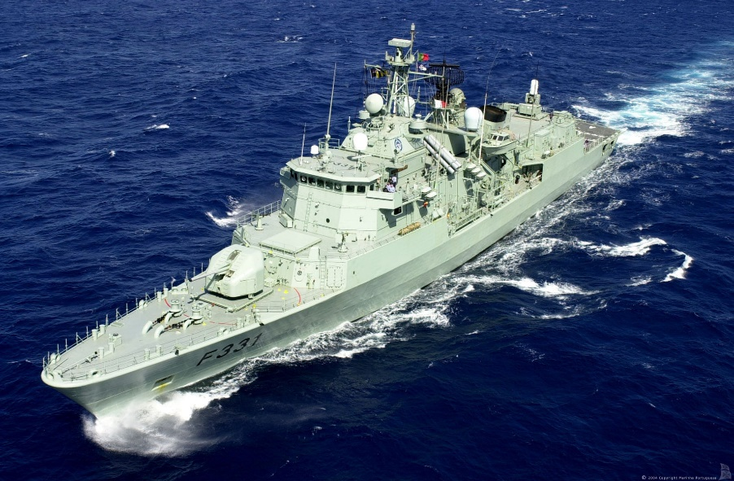As an exception to the rule, these three ships were commissioned in 1991 and 92, and are based on the German MEKO 200 design. They are capable patrol ships but lack variable depth sonar or area air defence systems. They carry two Lynx helicopters, Harpoon Missiles and Sea Sparrow short range air defence. All are based in Lisbon.

|  |  |  |
| --- | --- | --- |
| **Pennant** | **Name** | **Location** |
| F330 | [*Vasco da Gama*](https://en.wikipedia.org/wiki/NRP_Vasco_da_Gama_(F330)) | Gibralter |
| F331 | [*Álvares Cabral*](https://en.wikipedia.org/wiki/NRP_%C3%81lvares_Cabral_(F331)) | Lisbon |
| F332 | [*Corte-Real*](https://en.wikipedia.org/wiki/NRP_Corte-Real_(F332)) | Azors |

Vasco Da Gama Class

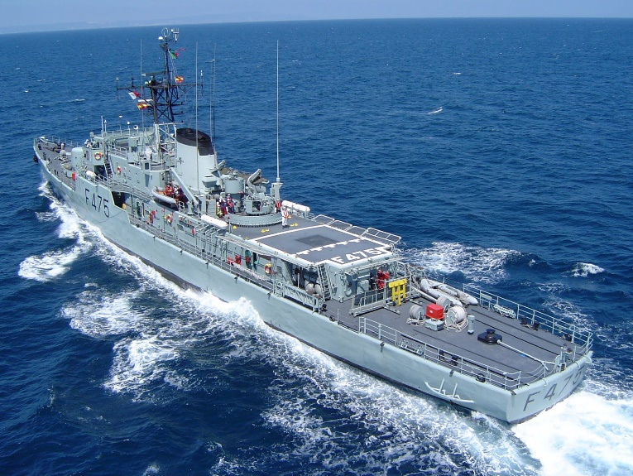[**João Coutinho class**:](http://www.military-today.com/navy/joao_coutinho_class.htm)These 25-year-old ships were small and inexpensive to operate, but with the correlation that they were very poorly equipped in either weapons or sensors. Meant as a Patrol Frigate (most references call them Corvettes), they spent much of their life traveling the globe.

João Coutinho class

|  |  |  |
| --- | --- | --- |
| **Pennant** | **Name** | **Location** |
| F471 | *António Enes* | Lisbon |
| F475 | *João Coutinho* | Azors |
| F476 | *Jacinto Cândido* | Lisbon |
| F477 | *General Pereira D'Eça* | Eastern Med |
| F484 | *Augusto de Castilho* | Lisbon |
| F485 | *Honório Barreto* | Pacific |

|  |  |  |
| --- | --- | --- |
| **Pennant** | **Name** | **Location** |
| F480 | *Comandante João Belo* | Lisbon |
| F481 | *Comandante Hermenegildo Capelo* | North Sea |
| F482 | *Comandante Roberto Ivens* | Refit |
| F483 | *Comandante Sacadura Cabral* | Lisbon |

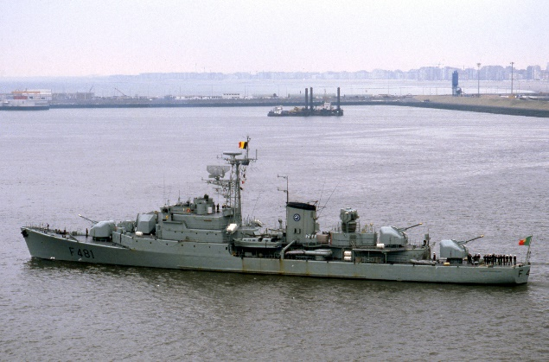[**João Belo-class frigate**](https://en.wikipedia.org/wiki/Jo%C3%A3o_Belo-class_frigate)**:** Another class of small Frigates, although these are better equipped that the F 471 class, their weapons suite is still quite anemic by 1994 standards. The third 100mm gun has been removed from F 480 during her mid life refit, as will the others as they proceed through the process over the next few years.

João Belo-class

|  |  |  |
| --- | --- | --- |
| **Pennant** | **Name** | **Location** |
| F486 | *Baptista de Andrade* | Gibraltar |
| F487 | *João Roby* | Lisbon |
| F488 | *Afonso Cerqueira* | Pacific |
| F489 | *Oliveira e Carmo* | Lisbon |

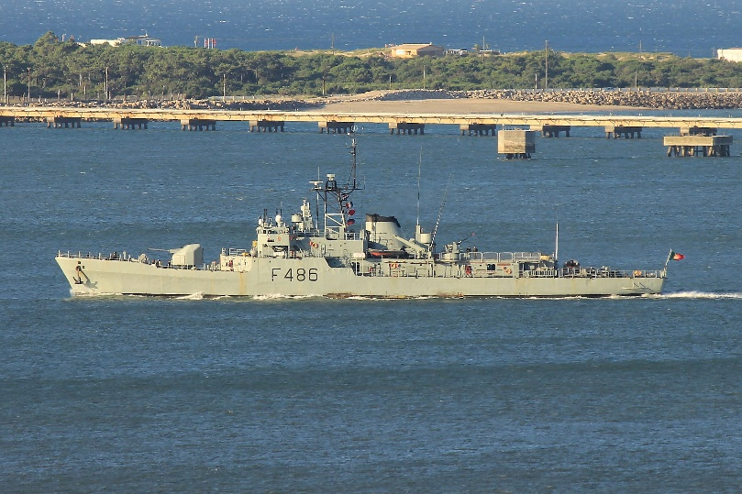[**Baptista de Andrade class**](http://www.military-today.com/navy/baptista_andrade_class.htm)**:** The four ships of this class are quite similar to the João Coutinho class, although the Baptista class is slightly better armed and equipped, the Portuguese navy liked the Coutinho class better. The original intent of this class is somewhat of a mystery, there is a good chance that they were destined to be delivered to South Africa during the Arms Embargo that was preventing any modernization, that obviously did not happen. Another effort to sell the ships to Columbia fell through in 1977 as well.

Baptista de Andrade class

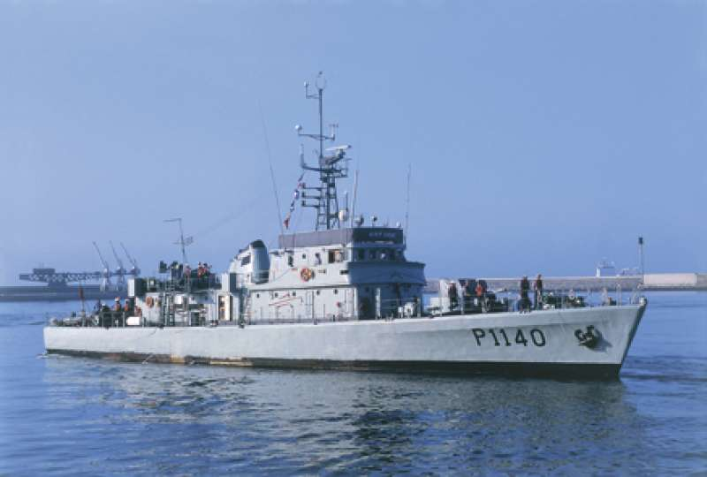**Cacine class Patrol Boats:** Primarily to conduct fisheries patrols in home waters, these small (300 Ton) lightly armed vessels are capable of their duties and efficient to operate.

Cacine class

|  |  |  |
| --- | --- | --- |
| **Pennant** | **Name** | **Location** |
| P-1140 | *Cacine* | Lisbon |
| P-1141 | *Cunene* | Lisbon |
| P-1142 | *Mandovi* | Porto |
| P-1143 | *Rovuma* | Porto |
| P-1144 | *Cuanza* | Porto |
| P-1145 | *Geba* | Porto |
| P-1146 | *Zaire* | Faro |
| P-1147 | *Zambeze* | Faro |
| P-1160 | *Limpopo* | Faro |
| P-1161 | *Save* | Faro |

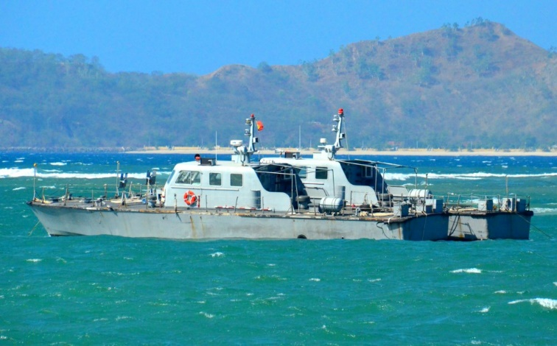Albatroz Class Patrol Boats: Originally meant to patrol the waters in Portuguese colonies, the only ones remaining over seas in 1994 are two in East Timor. The other four have been pulled out of the former African colonies and have taken up duties in the Lisbon area.

Albatroz Class

|  |  |  |
| --- | --- | --- |
| **Pennant** | **Name** | **Location** |
| P-1012 | *Albatroz* | East Timor |
| P-1163 | *Açor* | East Timor |
| P-1164 | *Andorinha* | Lisbon |
| P-1165 | *Águia* | Lisbon |
| P-1166 | *Condor* | Lisbon |
| P-1167 | *Cisne* | Lisbon |

**Albacora Class**

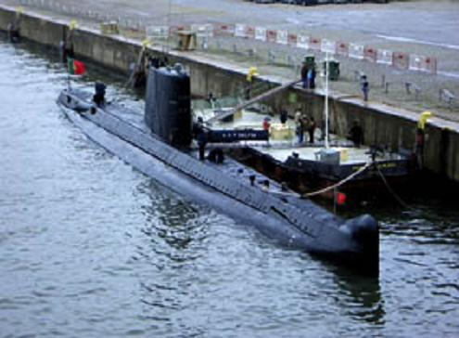The first submarines to serve in the Portuguese Navy, the Albacora class were based on the French Daphne class. These boats were able to patrol both coastal and deep ocean areas. A fourth submarine of this class was sold to the Pakistani Navy in 1975.

Albacora Class

|  |  |  |
| --- | --- | --- |
| **Pennant** | **Name** | **Location** |
| S 163 | Albacora | Atlantic |
| S 164 | Barracuda | Lisbon |
| S 166 | Delfim | Lisbon |