**Turkish Air Force**

The Turkish Air Force maintains a large but mixed inventory, with over 550 aircraft in operations, about 380 of which are combat types.

[**F-16**](http://www.f-16.net/f-16_users_article21.html)

After receiving the first eight examples from the US under the Peace Onyx I program Turkey builds its own F-16 under licence. The first batch was F-16 Block 30 (34 ‘C’ & 9 ‘D’) airframes in 1987/90 - a mirror of the Greek Peace Xenia I program. TUSAS Aerospace Industries (TAI) continued to produce F-16 Block 40 to fill out the full order of 132 airframes by adding 102 ‘C’ and 15 more ‘D’ to the inventory. The F-16 has almost completely replaced the F-104G and most of the F-5A fleet taking over both the air superiority and ground support tasks.

|  |  |  |  |  |  |
| --- | --- | --- | --- | --- | --- |
| Sqn | Name | Wing | Location | AC | Type |
| 141 | Wolf | 4 AJU | Murted | 18 | F-16 Bl 40 |
| 142 | Gazelle | 4 AJU | Murted | 18 | F-16 Bl 30 |
| 143 | Oncel | 4 AJU | Murted | 18 | F-16 Bl 30 |
| 161 | Bat | 6 AJU | Bandirma | 18 | F-16 Bl 40 |
| 162 | Harpoon | 6 AJU | Bandirma | 18 | F-16 Bl 40 |
| 181 | Panther | 8 AJU | Diyarbakir | 18 | F-16 Bl 40 |
| 191 | Cobra | 9 AJU | Belikesir | 18 | F-16 Bl 40 |
| 192 | Tiger | 9 AJU | Belikesir | 18 | F-16 Bl 40 |

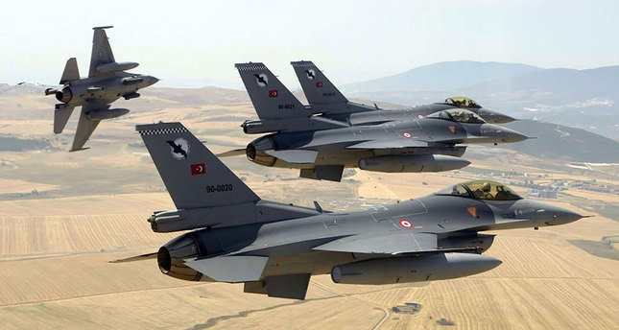

[**F-4 Phantom**](https://en.wikipedia.org/wiki/McDonnell_Douglas_F-4_Phantom_II)

The F-4 was widely used in the Turkish Air Force, primarily for Air Superiority but also for reconnaissance and now, with the F-16 arriving, it is taking up the ground support role.

|  |  |  |  |  |  |  |  |
| --- | --- | --- | --- | --- | --- | --- | --- |
| Sqn | | Name | Wing | Location | AC | Type | Remarks |
| 111 | Panther | | 1 AJU | Eskişehir | 18 | F-4E |  |
| 112 | Devil | | 1 AJU | Eskişehir | 18 | F-4E |  |
| 113 | Light | | 1 AJU | Eskişehir | 16 | RF-4E | Recce |
| 131 | Dragon | | 3 AJU | Konya | 18 | F-4E |  |
| 171 | Corsair | | 7 AJU | Malatya | 18 | F-4E |  |
| 172 | Hawk | | 7 AJU | Malatya | 18 | F-4E |  |
| 173 | Dawn | | 7 AJU | Malatya | 16 | RF-4E | Recce |

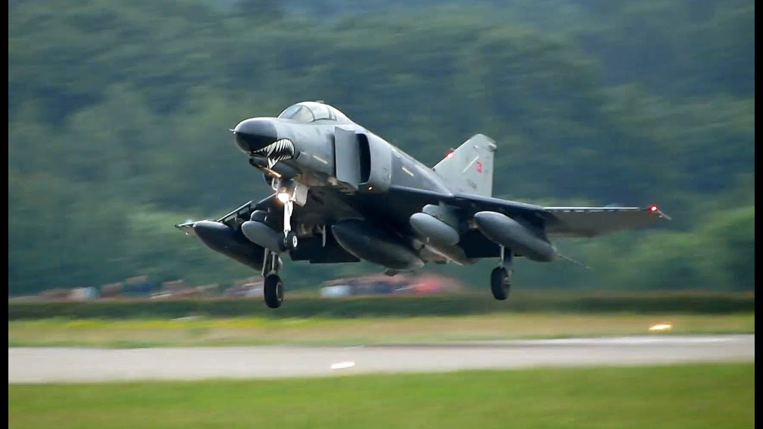

[**F-5 Freedom Fighter**](http://www.the-northrop-f-5-enthusiast-page.info/AirForces/TurkeyAF.html)

Turkey retained over 100 F-5A/B but did not receive additional airframes from Canada, Norway and the Netherlands in the late 80s and early 90s as they did historically; therefore, these aircraft are nearing the end of their usable life. The 133rd Filo is the air demonstration team, the ‘Turkish Stars’.

|  |  |  |  |  |  |  |
| --- | --- | --- | --- | --- | --- | --- |
| Sqn | Name | Wing | Location | AC | Type | Remarks |
| 132 | Daggar | 3 AJU | Konya | 18 | F-5A |  |
| 133 | Turkish Stars | 3 AJU | Konya | 24 | F-5A | Demo |
| 151 | Bronze | 5 AJU | Merzifon | 18 | F-5A |  |
| 152 | Raider | 5 AJU | Merzifon | 18 | F-5A |  |
| 184 | Sage | 5 AJU | Merzifon | 18 | RF-5A | Recce |

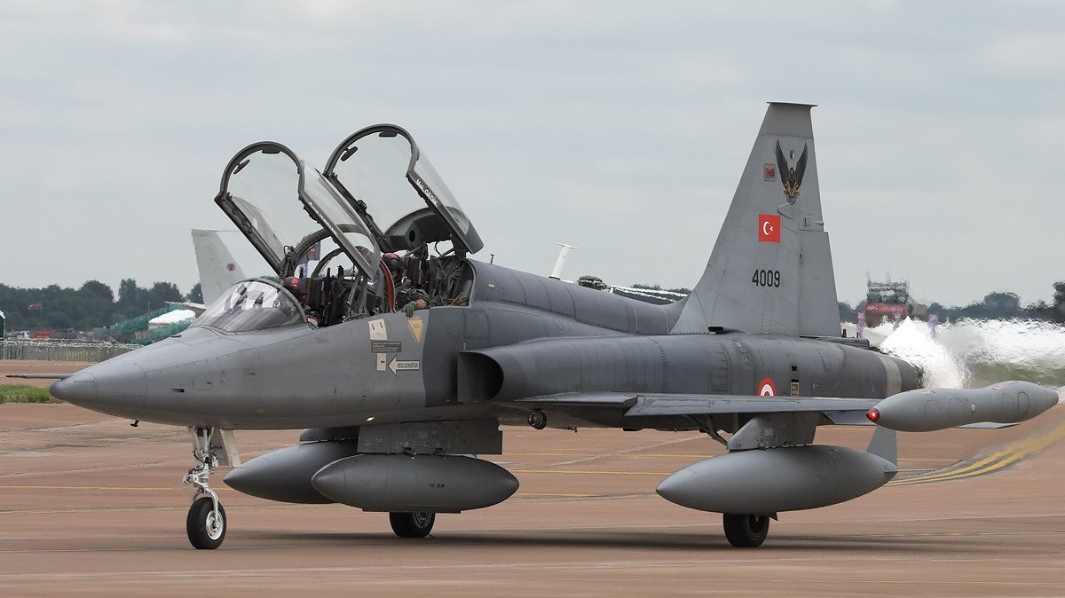

[**F-104 Starfighter**](https://en.wikipedia.org/wiki/Lockheed_F-104_Starfighter)

One squadron of F-104 Freedom Fighters remains in service but is planned to retire later in 1994.

|  |  |  |  |  |  |  |
| --- | --- | --- | --- | --- | --- | --- |
| Sqn | Name | Wing | Location | AC | Type | Remarks |
| 182 | Hawk | 8 AJU | Diyarbakir | 18 | CF-104D |  |

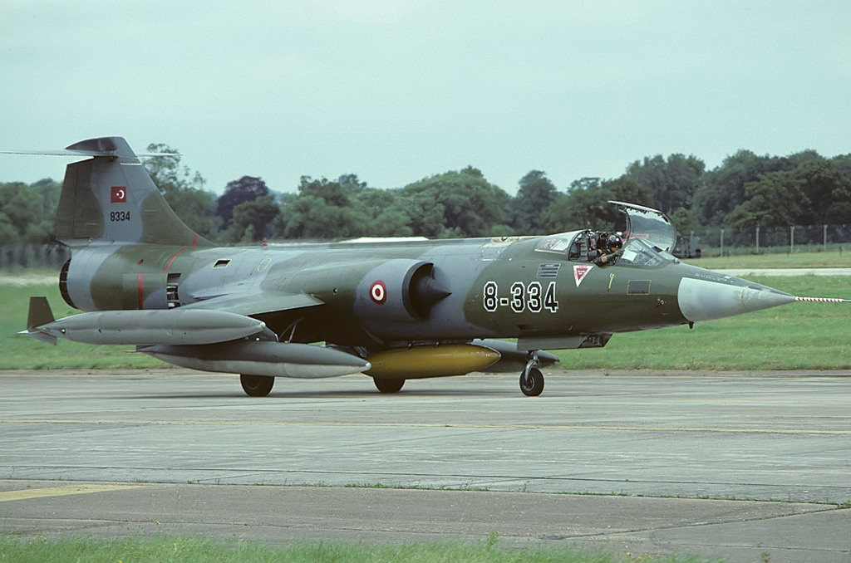

**Transport Aircraft**

Turkey’s geography demands a fairly large air transport fleet, primarily provided by three main types and augmented by a small fleet of executive jets. The CN-235s are just coming into service and 36 of an eventual 52 have been delivered, in addition to the squadrons listed here, these are distributed amongst all other wings and bases to provide liaison and Sea Air Rescue (SAR) flights.

|  |  |  |  |  |  |  |
| --- | --- | --- | --- | --- | --- | --- |
| Sqn | Name | Wing | Location | AC | Type | Remarks |
| 211 | Globetrotter | 11 ATU | Ankara | 12 | CN-235 | Various types |
| 212 | Eagle | 11 ATU | Ankara | 6 | C.550/G.555 | VIP |
| 221 | Breeze | 11 ATU | Ankara | 10 | C-160 |  |
| 222 | Flame | 11 ATU | Ankara | 7 | C-130 |  |
| 223 | Wing | 11 ATU | Ankara | 10 | C-160 |  |

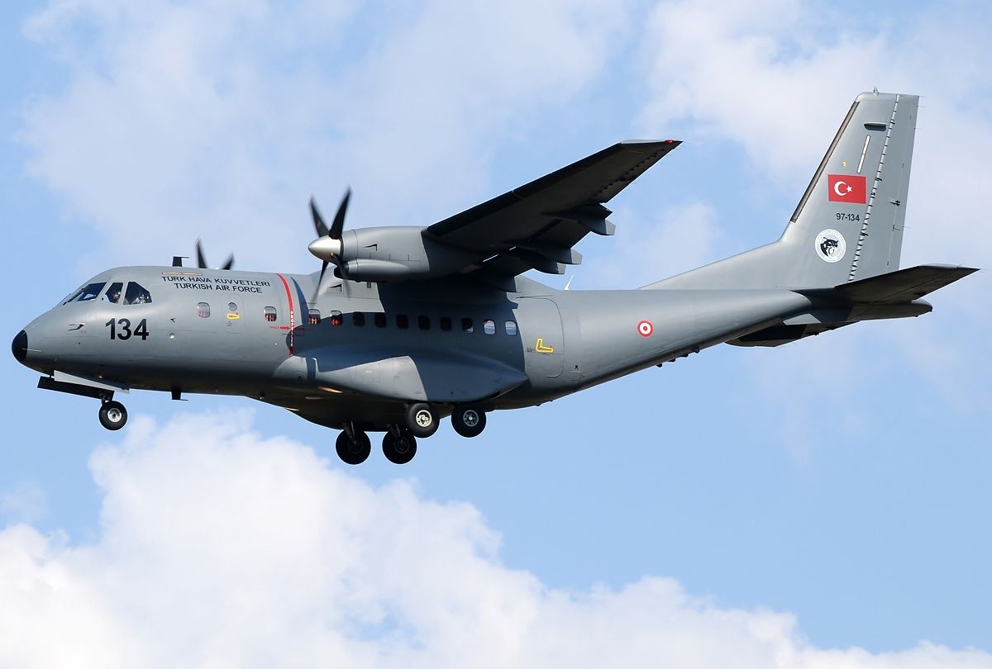

**Training Aircraft**

Turkey has a large flight training wing located near Izmir that conducts the full gamut of flight training.

|  |  |  |  |  |  |  |
| --- | --- | --- | --- | --- | --- | --- |
| Sqn | Name | Wing | Location | AC | Type | Remarks |
| 121 | Bee | ATC | Cigli | 20 | T-38A | Advanced Flight Trg |
| 122 | Scorpion | ATC | Cigli | 24 | T-37A | Basic Flight Trg |
| 123 | Chick | ATC | Cigli | 40 | SF-260D | Initial Flight Trg |
| 124 | Pioneer | ATC | Cigli |  | various | instructor Trg |
| 125 | Panther | ATC | Cigli | 4 | CN-235 | Multi engine Trg |
| 203 | Aegean | ATC | Cigli | 4 | CN-235 | SAR Training |

