**Turkish Army**

The Turkish Army is the second largest in NATO, although technologically it lags well behind many other alliance members. There are 525,000 full time personnel in the Army with a further 950,000 available in reserve; probably 700,000 of those are ready for immediate recall. Structurally there are four Army level commands and ten Corps. 1st Army in Thrace and 3rd Army in the Caucasus are the largest and maintain the highest readiness and 1st Army holds the most armor. 2nd Army will induct most of the reserve formations and reinforce east or west as needed while 4th Army conducts rear area and civil defence tasks. Additionally, there are 110,000 Gendarmerie which will fall under Army control in wartime, consisting of 67 ‘regiments’ which will likely fall under the control of 4th Army or come under command of the National HQ.

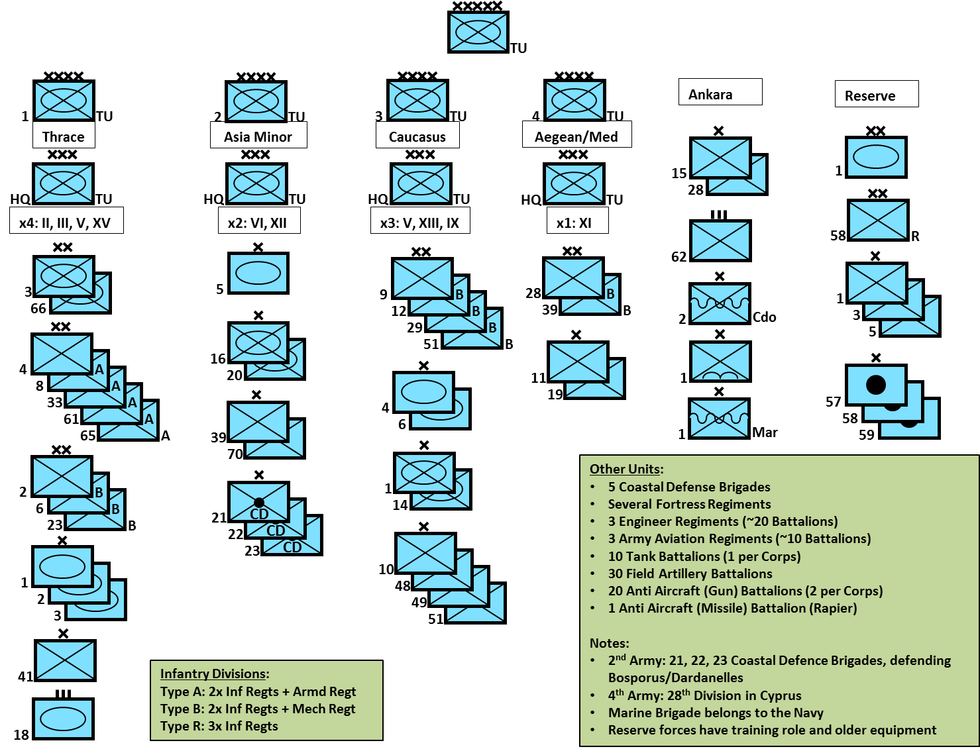

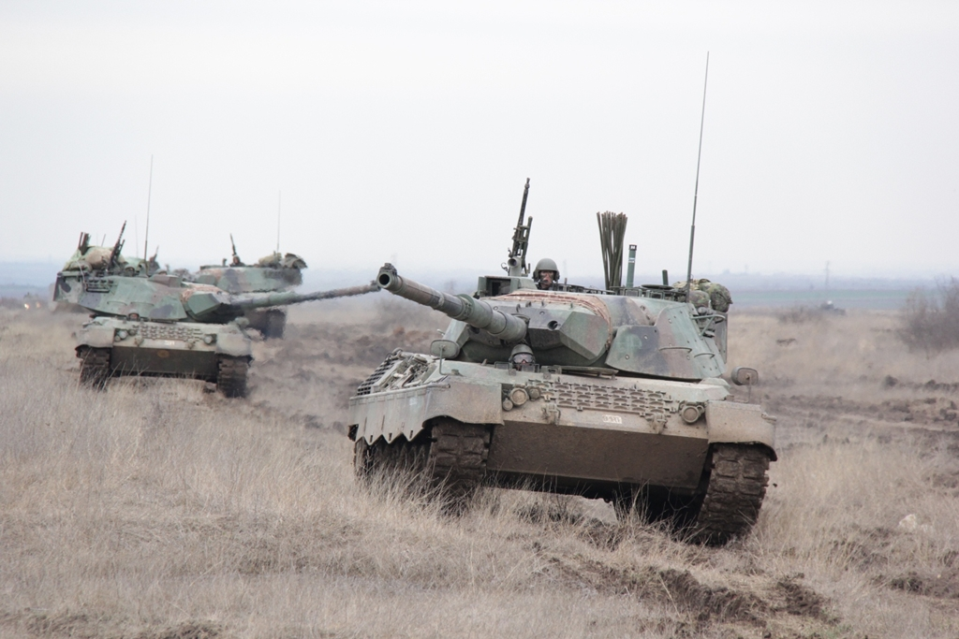

**Main Battle Tank (MBT)**

**Leopard 1**: The Turkish Army operates 397 Leopard 1s in two versions: 227 Leopard 1A3, the last of which are being received at war start in Feb 94 a few months quicker than actually happened; and 170 Leopard 1T which is a local upgrade to the original tanks received in the early 80s. The Leopards are used primarily in the 1st Army’s armored brigades and reconnaissance units.

**M60 Patton**: Turkey uses 932 M60’s in its army, primarily in the mechanized and Corps Tank Battalions. 658 are the A3TTS version with upgraded thermal sights while the remainder (274) are the A1 RISE version with upgraded engines and suspension system.

**M48 Patton**: Turkey is one of the largest users of the M48, they have several versions in service:

* ~2000x M48A1 (Reserve)
* 180x M48T5
* 1289x M8A5T1: 105mm gun, night vision, fire control system, engine improvements
* 758x M48A5T2: Same as above plus thermal imaging and laser rangefinder

The M48 are used primarily in reserve and training organizations.

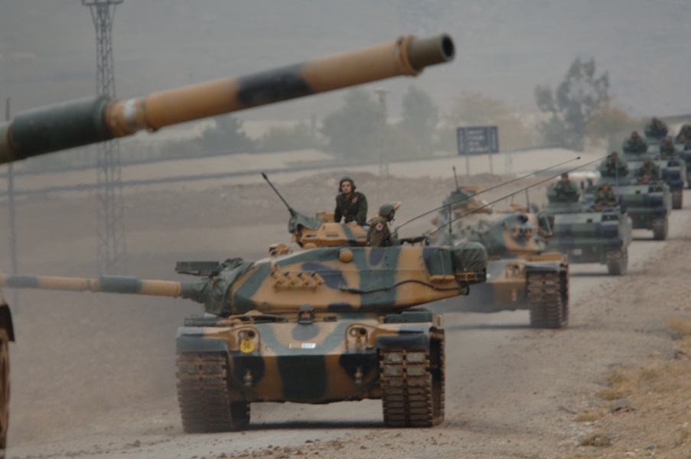

**M47 Patton**: Turkey holds 1347 modernized M47s in reserve.

**Infantry Fighting Vehicle (IFV)**

**ACV-15:** This is an upgraded design of the M113 which was in production in Turkey from 1992 until 1997. Based on 35% of the eventual production numbers, for Northern Fury these variants are in service:

* 500x AAPC (Advanced APC) with single man turret with .50 Cal and 7.62mm MGs
* 250x AIFV (Advanced IFV) with 20mm cannon in a 2 man turret
* Some ATV (Armored TOW vehicle) with two TOW missiles – only 48 produced so perhaps none, perhaps all.
* 60x AMV (Armored Mortar vehicle)

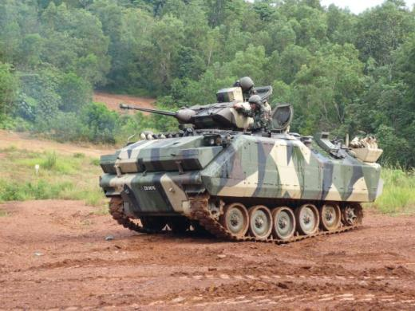

**Armored Personnel Carriers (APC)**

**M113**: Over 3500 of these are in service many variants, main ones listed here:

* 3,200x M113A3 personnel carrier
* 180x M106, 120mm mortar carrier
* 10x M125, 81mm mortar carrier
* 160 xM113 TOW carrier

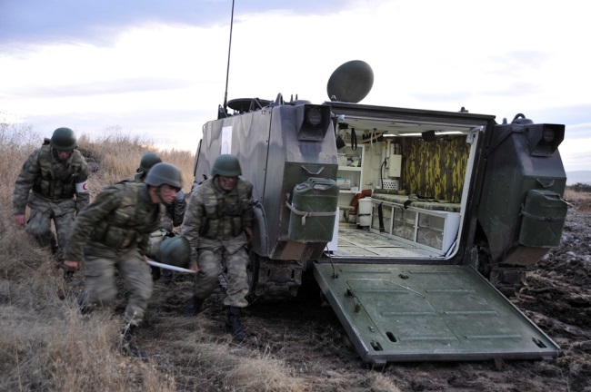

**Artillery**: There is a wide range of artillery systems in use, many of the older US systems have undergone extensive modernization with Germany’s assistance, in particular the M52 SP guns were upgraded from 105mm to 155mm, changed the engine and added a digital fire control system.

* 100x M116, 75mm pack howitzer
* 830x M101A1, 105mm towed howitzer
* 15x Skoda, 105mm towed howitzer
* Some R Metal 105mm towed howitzer
* Some Krupp 105mm towed howitzer
* 26x M108, 105mm SP howitzer (modernized)
* 128 Skoda 150mm towed howitzer
* 150x M59, 155mm towed howitzer
* 535x M114, 155mm towed howitzer
* 362x M52T, originally a 105mm SP, now a 155mm/39 SP howitzer (modernized earlier than historic)
* 222x M44T, 155mm SP howitzer (modernized)
* 36x M107, 175mm SP howitzer
* 162x M115, 203mm towed howitzer
* 220x M110, 203mm SP howitzer
* 81x M55, 203mm SP howitzer
* 100+x T-107, Chinese designed, locally produced towed MLR (Type 63)
* 24x RA-740, Locally designed and produced 70mm MLR
* 12x M270 MLRS

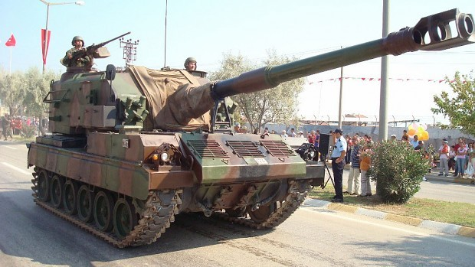

**Air Defence:** A wide range of air defence gun systems are in use with very few SAMs and the out-dated Redeye MANPADS.

* 160x M45, 12.7m Quad towed AAA
* 423x 20mm Rheinmetall towed AAA
* 439x 20mm Oerlikon towed AAA
* 260x twin 35mm towed AAA
* 800x Bofors L60/70 40mm towed AAA
* 100 M51 75mm towed AA Gun
* 100 M117/118 90mm towed AA Gun
* 262 M42A1 Duster SPAAG
* 12x Rapier SAM in Army service
* 24x Rapier SAM in Air Force service
* 789 Redeye Manpads
* 128 Nike Hercules

