**Turkey** 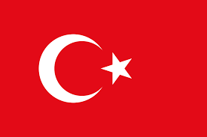

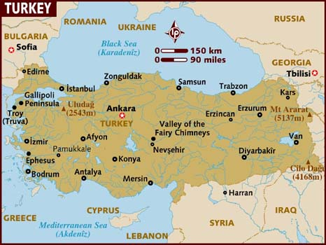

Turkey became a member of NATO in 1952 in conjunction with is geographic neighbor and long term rival Greece. Turkey is a large country with a large population and the only NATO country not in Europe proper but in Asia, except the small area (3% of Turkish land mass) variously called European Turkey or Eastern Thrace or Turkish Thrace. The Turkish military is also quite large; the second largest in NATO and it borders both the Soviet Union and Bulgaria. Turkey also controls the entrance to the Black Sea through the two important straights, the Bosporus and Dardanelles, thus limiting the USSR’s ability to influence the Mediterranean. Strategically then, Turkey is the key to southern Europe and essential to NATO’s ability to control its southern flank , no doubt a significant factor in NATO’s meek reaction to the Turkish invasion of Cyprus in 1974.

Turkey’s relationship with Greece has been a constant source of friction but it is difficult to say how this would develop under the pressures of conflict. The multi-national NATO command structure was not built to put eithers troops, ships or air elements under command of the other. Turkey retaining command of its land forces as Allied Land Forces South Eastern Europe (LANDSOUTHEAST) headquartered in Izmir, and reporting directly to Allied Forces Southern Europe (AFSouth); Sixth Allied Tactical Air Force (6 ATAF) also in Izmir and Commander North Eastern Mediterranean (COMEDNOREAST) in Ankara. Greece had equivalent commands all reporting to Naples.