**Turkish Navy**

The Turkish Navy, similar to the Greek was a casualty of increased tensions. Historically the Turks started to receive cast off US Knox class Frigates in 1993, not to mention plans for several Oliver Hazard Perry class later in the decade. Of course these ships were not forthcoming because the USN was holding onto them. The Germans did sell Turkey their old Koln class Frigates (Classified as destroyers in Turkey), but the general lack of hulls available meant holding onto three Yucetepe class ships which are already well beyond their usable life.

**Destroyers**

**Ex Gearing Class**: Ten of the original 13 Gearing class Destroyers received from the US in the 1970s and early 80s remain in service. Some of these are World War Two veterans and are approaching 50 years old, although tired they have been modernized and Turkey holds ships that generally fall into three sub classes. The Fleet Rehabilitation and Modernization (FRAM) program produced two main variants: The FRAM I ships of the Yucetep Class focused on Anti-Surface warfare (ASuW) while the one remaining FRAM II ship and the two of the Alcitepe (Carpenter) class focused on Anti-Submarine Warfare (ASW) operations.

|  |  |  |  |  |
| --- | --- | --- | --- | --- |
| Class | Pennant | Name | Status | Remarks |
| Yucetepe | D 345 | Yucetepe | Tied Up |  |
|  | D 347 | Savastepe | Tied Up |  |
|  | D 349 | Kilic Ali Pasa | Tied Up |  |
|  | D 350 | Piyale Pasa | Tied Up |  |
|  | D 351 | Mareşal Fevzi | Tied Up |  |
|  | D 352 | Gayret | On Patrol | Black Sea |
|  | D 352 | Adatepe | On Patrol | Mediterranean Sea |
| Kocatepe | D 354 | Kocatepe | On Patrol | Mediterranean Sea |
| Alcitepe | D 346 | Alcitepe | Tied Up |  |
|  | D 347 | Anittepe | On Patrol | Black Sea |

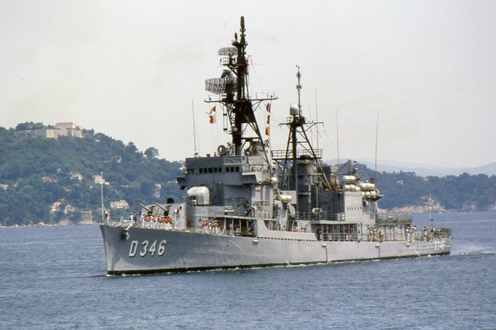

**Gelibolu Class**: These two Ex Koln class ships arrived from Germany in the 1980s. Turkey ended up purchasing four of this six ship class originally commissioned in the 60s, because one was destroyed in a fire and another was used for spare parts. The two ships in service provide important and reliable ASW work to augment the fleet of aging Gearings. These ships do not have missiles and rely on guns only for defence, but their ASW suites are reasonable.

|  |  |  |  |  |
| --- | --- | --- | --- | --- |
| Class | Pennant | Name | Status | Remarks |
| Gelibolu | D 360 | Gelibolu | Tied Up |  |
|  | D 361 | Gemlik | On Patrol | Sea of Marmar |

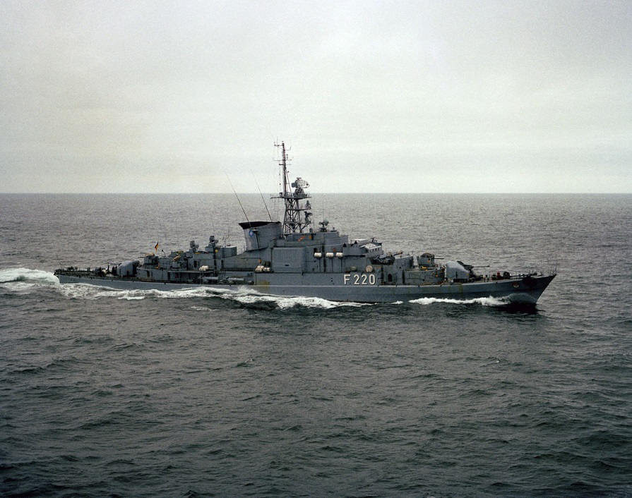

**Frigates**

**Yavuz Class** **(MEKO 200)**: This modern class is a German designed modular warship with several variations, in three basic configurations (MEKO 140, 200, 360), the MEKO 200 is the most prolific with six nations either operating or building the design. The Turkish Navy’s Yavuz Class are large (3,000 tons) capable and well-rounded ships with Harpoon ASMs, Sea Sparrow air defence missiles, 3x Oerlikon Sea Zenith 25mm Close In Weapons Systems (CIWS), a 5” gun and facilities for an AB-212 ASW helicopter. The four ships were delivered in 1987-89 with two being built in Germany and the last two in Turkey. Plans to build another four of these ships are maturing for later in the decade.

|  |  |  |  |  |
| --- | --- | --- | --- | --- |
| Class | Pennant | Name | Status | Remarks |
| Yavuz | F 240 | Yavuz | Tied Up |  |
|  | F 241 | Turgutreis | Tied Up |  |
|  | F 242 | Fatih | On Patrol | Black Sea |
|  | F 243 | Yildrim | On Patrol | Mediterranean Sea |

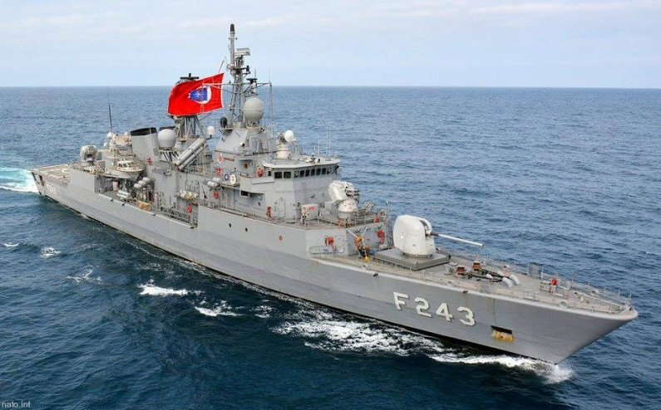

**Fast Attack Craft**

[**Dogan, Ruzgar Class**](http://www.navalanalyses.com/2014/06/dogan-ruzgar-and-yildiz-class-fast.html): These two classes are almost identical, they are high speed (40 Knots), well-armed craft that are primarily built for the defence of the Bosporus approaches. Equipped with up to eight Harpoon Surface to Surface Missiles (SSM) for anti-shipping attack, an OTO Melara 76mm gun and twin 35mm AAA as well as electronic and physical countermeasures, these are very powerful craft.

|  |  |  |  |  |
| --- | --- | --- | --- | --- |
| Class | Pennant | Name | Status | Remarks |
| Dogan | P 340 | Dogan | Active |  |
|  | P 341 | Marti | Active |  |
|  | P 342 | Tayfun | Active |  |
|  | P 343 | Volkan | Active |  |
| Ruzgar | P 344 | Ruzgar | Active |  |
|  | P 345 | Poyraz | Active |  |
|  | P 346 | Gurbet | Active |  |
|  | P 347 | Firtina | Active |  |

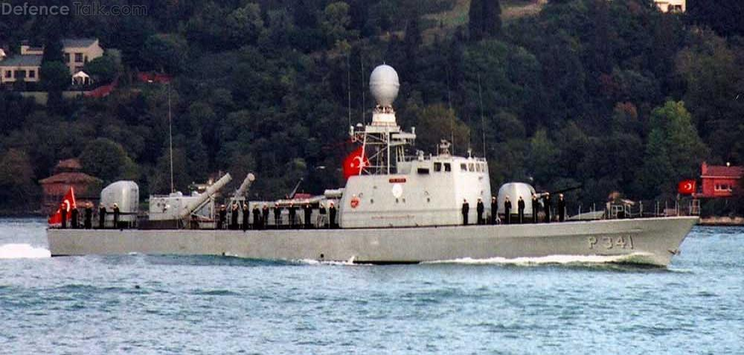

[**Kartal Class**](http://www.navalanalyses.com/2014/07/kartal-class-fast-attack-crafts-of.html): Based on the German Zobel class torpedo boats, nine were built in Germany in 1968-70, however one was lost (P 325 Meltem) in a collision with a Soviet navy ship in 1985. Armed with four Penguin Mk 2 missiles and two torpedoes along with two 40mm auto cannons for self-defence, these boats could move in at 40 knots and engage targets out to 34 Km range, impressive for such a small boat.

|  |  |  |  |  |
| --- | --- | --- | --- | --- |
| Class | Pennant | Name | Status | Remarks |
| Kartal | P 321 | Denizkusu | Active |  |
|  | P 322 | Atmaco | Active |  |
|  | P 323 | Sahin | Active |  |
|  | P 324 | Kartal | Active |  |
|  | P 326 | Pelikan | Active |  |
|  | P 327 | Albatros | Active |  |
|  | P 328 | Simsek | Active |  |
|  | P 329 | Kasirga | Active |  |

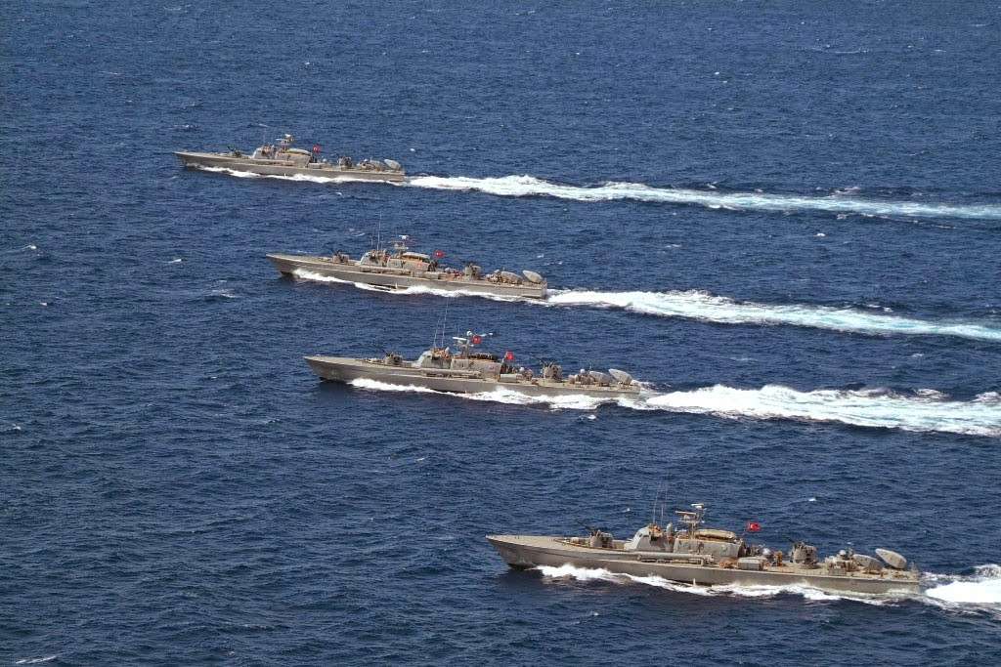

**Amphibious Vessels:**  All of these ships have pennant numbers prefixed with NL, indicating that they have a secondary role of mine layer (N) in addition to their primary role of landing ship (L)

[**Osman Gazi LST**](http://www.navalanalyses.com/2014/10/osman-gazi-class-landing-ship-minelayer.html): These two ships (the second was historically canceled) were accelerated into service with the second being accepted in commission as Northern Fury commences. This is a capable Landing Ship which can carry 900 troops and 15 tanks. It has 20mm and 40mm self-defence AAA.

**Bey Class LST**: Three Turkish built vessels that can carry 600 troops and 11 tanks and 2 Landing Craft

**Bayraktar/Ertuğrul  Class LST**: These two Ex-US Terrebonne Parish class vessels can carry 400 troops and 10 tanks.

**LCT**: Six Ex British LCT Mk IV, 31 Ex French EDIC type LCT, 15 Ex US LCU, 30 Ex-US LCM-8 and about 16 Ex Turkish built LCTs.

|  |  |  |  |  |
| --- | --- | --- | --- | --- |
| Class | Pennant | Name | Status | Remarks |
| Osman Gazi LST | NL-125 | Osman Gazi |  |  |
|  | NL-126 | Orhan Gazi |  |  |
| Bey Class LST | NL-122 | Çakabey |  |  |
|  | NL-123 | Sarucabey |  |  |
|  | NL-124 | Karamürselbey |  |  |
| Bayraktar | NL-120 | Bayraktar |  |  |
|  | NL-121 | Sancaktar |  |  |
| LCT/LCU/LCM |  | 98 various types |  |  |

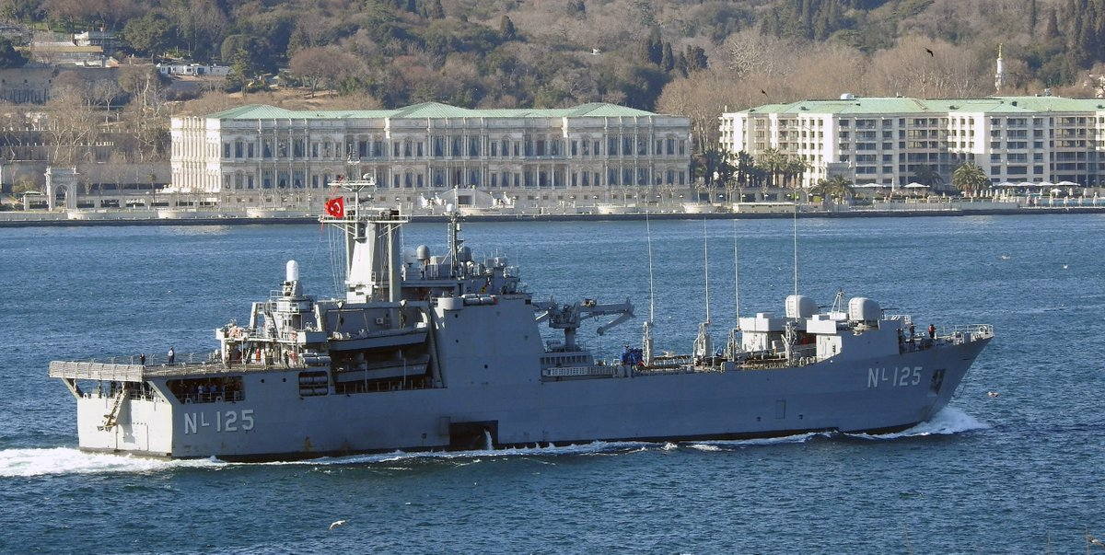

**Ex US LSM 1**: In addition to the landing ships listed above these five 1,000 ton ships are converted specifically for mine laying.

|  |  |  |  |  |
| --- | --- | --- | --- | --- |
| Class | Pennant | Name | Status | Remarks |
| Ex US LSM 1 | N 101 | Mordoğan |  |  |
|  | N 102 | Meriç |  |  |
|  | N 103 | Marmaris |  |  |
|  | N 104 | Mersin |  |  |
|  | N 105 | Mürefte |  |  |

**Mine Sweepers**: Turkey does not have any Mine Hunters but has a variety of older mine sweepers of US, French and Canadian origin some received third hand from other users. The primary role is to keep the shipping channel through the Bosporus and Dardanelles open.

|  |  |  |  |  |
| --- | --- | --- | --- | --- |
| Class | Pennant | Name | Status | Remarks |
| Cape Class | M 500 | Foça |  | Ex US MSI-15 |
|  | M 501 | Fethiye |  | Ex US MSI-16 |
|  | M 502 | Fatsa |  | Ex US MSI-17 |
|  | M 503 | Finike |  | Ex US MSI-18 |
| Adjutant Class | M 507 | Seymen |  | Ex Belgian De Panne |
|  | M 508 | Selçuk |  | Ex French Pavot |
|  | M 509 | Seyhan |  | Ex French Renoncule |
| MSC 268 Class | M 510 | Samsun |  | Ex US MSC-268 |
|  | M 511 | Sinop |  | Ex US MSC-270 |
|  | M 512 | Sürmene |  | Ex US MSC-271 |
|  | M 513 | Seddülbahír |  | Ex US MSC-272 |
| MSC 294 Class | M 514 | Silifke |  | Ex US MSC-304 |
|  | M 515 | Saros |  | Ex US MSC-305 |
|  | M 516 | Sigacik |  | Ex US MSC-311 |
|  | M 517 | Sapanca |  | Ex US MSC-312 |
|  | M 518 | Sariyer |  | Ex US MSC-315 |
| Mercure Class | M-520 | Karamürsel |  | Ex- French Worms |
| (German Vegesack) | M-521 | Kerempe |  | Ex- French Detmold |
|  | M-522 | Kilimli |  | Ex- French Siegen |
|  | M-523 | Kozlu |  | Ex- French Hameln |
|  | M-524 | Kuşadası |  | Ex- French Vegesack |
|  | M-525 | Kemer |  | Ex- French Passau |
| Bay Class | M 532 | Tirebolu |  | Ex Canadian Comox |

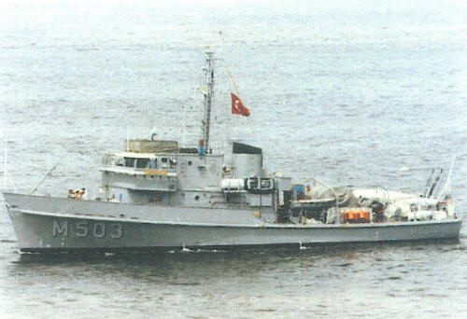

**Submarines**:

Turkey operates a sizable submarine force but only the Atilay (Type 209/1200) class can be considered modern and capable. The remainder hail from the Post World War Two era and are ready for retirement. A more modern class yet, the Preveze (Type 209/1400) class is due to start entering service later in 1994, this will allow the older boats to be put to rest. Turkey is destined to be the largest operator of the Type 209 boats in the world but they are not yet there in 1994.

**Atilay Class**: These are German Type 209/1200 boats; quiet, small, efficient and maneuverable. Armed with torpedoes, mines and/or Harpoon SSMs these are perfect submarines for the confined waters of the Black or Aegean Sea.

|  |  |  |  |  |
| --- | --- | --- | --- | --- |
| Class | Pennant | Name | Status | Remarks |
| Atilay | S 347 | Atilay | Tied Up |  |
|  | S 348 | Saldiray | On Patrol | Black Sea |
|  | S 349 | Batiray | Tied Up |  |
|  | S 350 | Yildiray | Tied Up |  |
|  | S 351 | Doganay | On Patrol | Black Sea |
|  | S 352 | Dolunay | On Patrol | Mediterranean Sea |

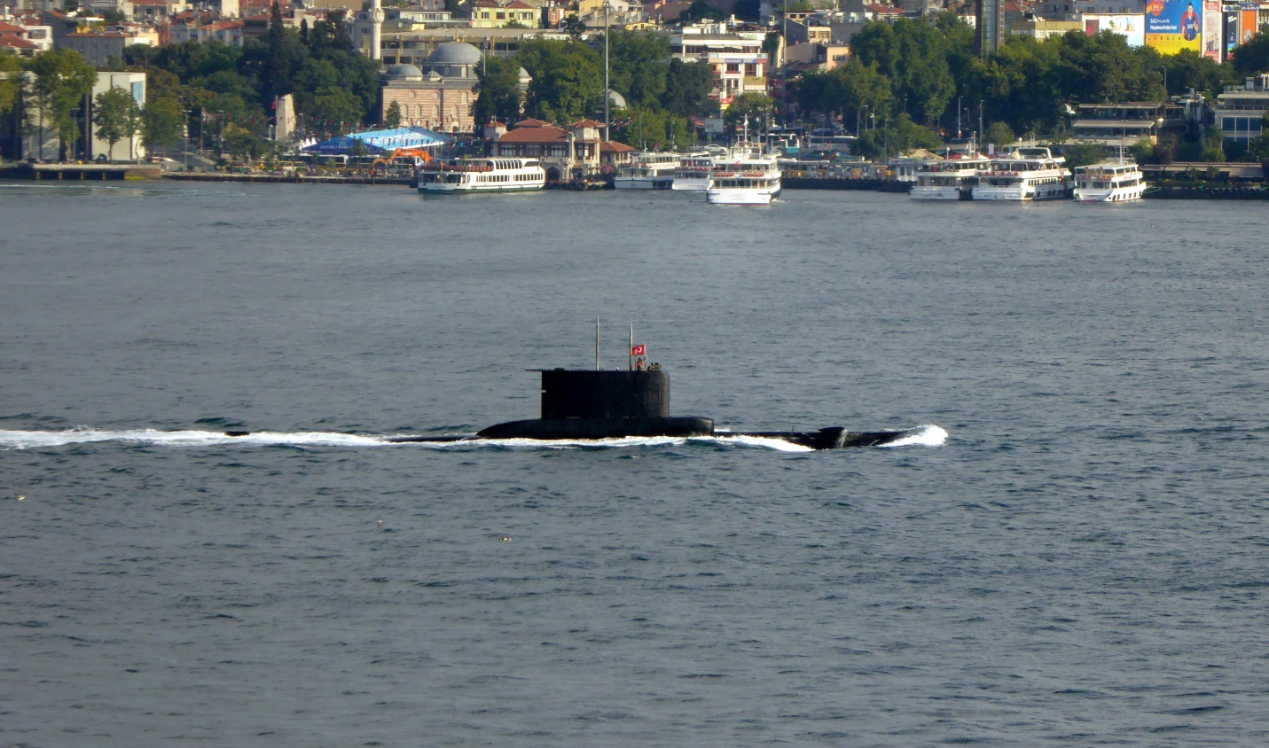

**Guppy/Tang Class**: There are three older classes of submarine in operation. Two versions of the GUPPY (Greater Underwater Propulsion Power System) class and the Tang class, all ex-USN boats built in the early 1950s. All of these boats were developments on World War Two German designs and were evolutionary in nature. For our purposes they have about the same capabilities, the Tang is a derivative of the GUPPY types and is therefore slightly more capable but also larger. None can hope to survive long in a modern conflict with capable ASW forces.

|  |  |  |  |  |
| --- | --- | --- | --- | --- |
| Class | Pennant | Name | Status | Remarks |
| Tang | S 342 | Hizirreis |  | Ex-USS Tang (SS-563) |
|  | S 343 | Pirireis |  | Ex-USS Gudgeon (SS-567) |
| Guppy III | S 333 | Ikinci Inonu |  | Ex-USS Corporal (SS-346) |
|  | S 341 | Canakkale |  | Ex-USS Cobbler (SS-344) |
| Guppy IIA | S 335 | Burakreis |  | Ex-USS Sea Fox (SS-402) |
|  | S 336 | Muratreis |  | Ex-USS Razorback (SS-394) |
|  | S 338 | Ulucalireis |  | Ex-USS Thornback (SS-418) |
|  | S 340 | Cerbe |  | Ex-USS Trutta (SS-421) |
|  | S 346 | Birinci Inonu |  | Ex-USS Threadfin (SS-410) |

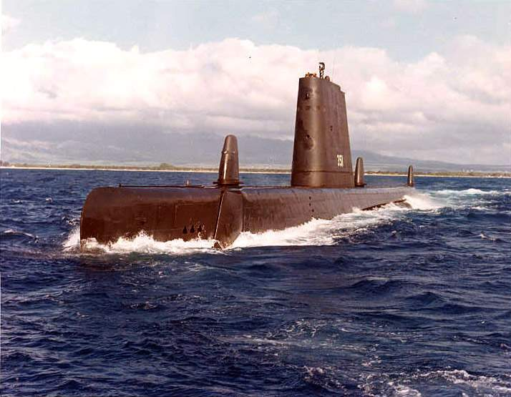

**Service Ships**: The Turkish Navy has one replenishment Oiler in service and one building. This ship allows the Turkish Navy to venture beyond its traditional patrol areas and complete tasks world-wide. The Akar class carries 16,000 tons of fuel and a small amount of dry goods.

|  |  |  |  |  |
| --- | --- | --- | --- | --- |
| Class | Pennant | Name | Status | Remarks |
| Akar AO | A-580 | Akar |  |  |
|  | A-595 | Yarbay Kudret Gungor | Building | Commission in 1995 |

