***HMS Ark Royal* CVG**

*HMS Ark Royal (Noah's Ark)* commenced a patrol of Indian Ocean two months ago, operating with Combined Task Force 150 (CTF 150) on counter piracy and freedom of navigation duties. In Mid January, HMS Cardiff’s attached Helicopter crashed on deck and was a total write off, the ship completed repairs at Diego Garcia and is now enroute to rendezvous with the carrier. Last week the carrier was tasked with conducting a port call at Cape Town South Africa and is on its way back north to the Somali coast. RFA Fort Victoria is returning from Bahrain with a full load of provisions and a new helicopter for Cardiff.

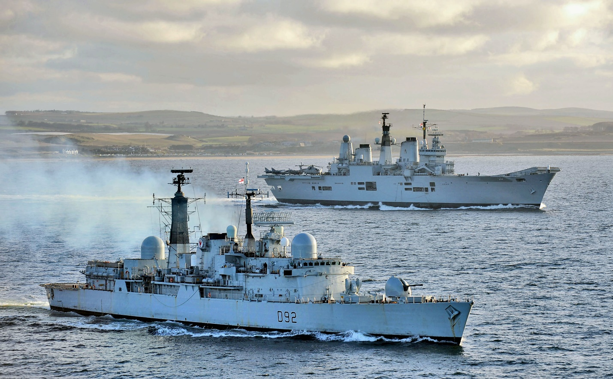

* R 07 HMS Ark Royal
  + 801 NAS 8x Sea Harrier FA.2
  + No.1 Sqn RAF 6x Harrier GR.7 (for Training with USMC)
  + 814 NAS 4x Sea King HAS.6
  + 849C NAS 2x Sea King AEW.2A
  + 771A NAS 2x Sea King HAR.3
* D 98 HMS York (Type 42 Batch 3)
  + 815 NAS 1x Lynx HAS.3
* F 94 HMS Brave (Type 22 Batch 2)
  + 815 NAS 2x Lynx HAS.3

Operating independently:

* D 108 HMS Cardiff (Type 42 Batch 1) – returning from repairs at Diego Garcia
* A 387 RFA Fort Victoria – enroute from Bahrain to link up with the carrier
  + 845 NAS 1x Sea King HAR.3
  + 845 NAS 1x Sea King HC.4
  + 815 NAS 1x Lynx HAS.3 for HMS Cardiff
* F 71 HMS Scylla (Type 12I Batch 3A SW)
  + 815 NAS 1x Lynx HAS.2

