**Royal Navy Aircraft Carriers**

Although the RN had more true aircraft carriers than any other NATO country beside the United States at the end of the second world war and through much of the Cold War, the three Invincible Class ships, by any measurement must be considered light carriers when compared to American Fleet Carriers. Indeed, they are slightly more than half the displacement of American Wasp and Tarawa class Amphibious Assault ships, with a similar air group capacity. However, designed for Sea Control as opposed to power projection, these ships were very capable and often acted as flagships for NATO task groups.

[**Invincible Class**](http://www.military-today.com/navy/invincible_class.htm)

The three carriers in this class were commissioned in the early 80’s and are quite modern and capable ships with Sea Dart missiles and Phalanx Close in Weapons Systems (CIWS). They generally carry a mixed air group of 10-12 Sea Harriers and 8-10 Sea King helicopters but this air group is often changed, increased or decreased based on the threat and task at hand. RAF Harriers are often carried whenever amphibious or land based operations are supported. With the three ships in the fleet, the RN counted on having two at sea nearly continuously while the third undergoes refit. At the start of Northern Fury, HMS Illustrious is returning to the UK to commence refit while Invincible is at sea in home waters working up its crew after her own overhaul. Ark Royal is departing South Africa for a tour up the east coast of Africa to rejoin the Anti-Piracy task force in the Gulf of Aden.

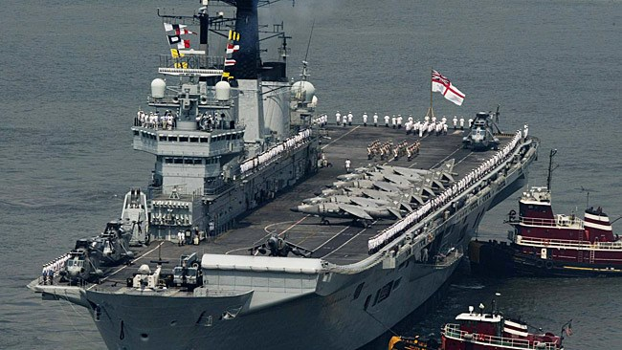

|  |  |  |  |
| --- | --- | --- | --- |
| Pennant | Name | Location | Remarks |
| R05 | Invincible | South of Ireland | Training |
| R06 | Illustrious | Eastern Med | Returning to UK |
| R07 | Ark Royal | South Indian Ocean | Tour of IO |