**Royal Navy Destroyers**

By 1994 the RN had streamlined its Destroyer fleet to just two types; a singleton **Type 82** Bristol class, and 12 **Type 42** Sheffield class in three different batches. The main purpose of British Destroyers is to provide Area Air Defense (AAD) but the Type 42 also has Exocet anti-ship (ASM) missiles for surface action and helicopter facilities to enhance its capability in the Anti-Submarine Role (ASW) role.

[**HMS Bristol – Type 82**](https://en.wikipedia.org/wiki/Type_82_destroyer): The Type 82 proved to be too large, expensive and limited in capability for the British government of the day, and the class was terminated after only one ship, HMS Bristol (D-23). She proved to be a good AAD ship with her Sea Dart Surface to Air missiles (SAM) but was 50% larger with almost twice as many crew for the more well rounded Type 42s. She is stationed in home waters with the task of AD escort for HMS Invincible (R-05).

|  |  |  |  |  |  |  |
| --- | --- | --- | --- | --- | --- | --- |
| Class | Pennant | Ship | Status | Location | Task | Remarks |
| Type 82 | D23 | Bristol | Active | Atlantic | Escort R05 |  |

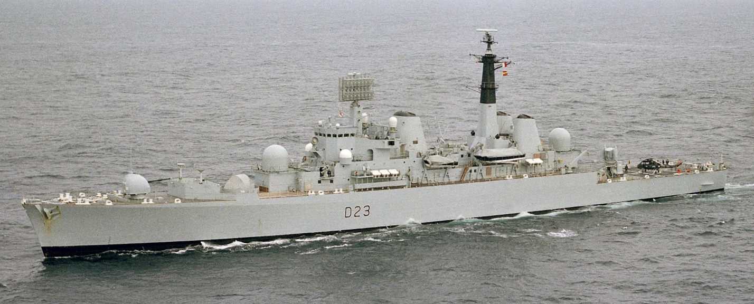

[**Type 42**](http://www.hazegray.org/navhist/rn/destroyers/type42/): Although this is a versatile design with a wide range of capabilities, its debut in combat was inauspicious.  Seven ships of this class deployed to the Falklands in 1982, two were sunk – ***HMS Sheffield*** and ***HMS Coventry***, while ***HMS Glasgow*** was disabled by a bomb which did not explode but knocked out her engines.   As a result, the Batch 3 ships are larger and displace 20% more than the other two Batches, they have better sea keeping, a larger Sea Dart Magazine, better countermeasures, and many other improvements.  All ships were refitted with an improved radar. All ships carry a single Lynx ASW helicopter, 4x Exocet ASM, a 4.5-inch gun, two Phalanx Close in Weapons System (CIWS) among other systems. ***HMS Gloucester*** became the first ship to shoot down an ASM (an Iraqi Silkworm) while protecting the US Battleship ***USS Missouri*** during the Persian Gulf war.

|  |  |  |  |  |  |  |
| --- | --- | --- | --- | --- | --- | --- |
| Class | Pennant | Ship | Status | Location | Task | Remarks |
| Type 42 B1 | D80 | Sheffield | Sunk |  |  |  |
|  | D86 | Birmingham | Active | Atlantic | Independent |  |
|  | D87 | Newcastle | Active | Atlantic | Independent |  |
|  | D118 | Coventry | Sunk |  |  |  |
|  | D88 | Glasgow | Active | Mediterranean | Escort R06 |  |
|  | D108 | Cardiff | Active | Indian | Escort R07 |  |
| Type 42 B2 | D89 | Exeter | Active | Atlantic | Escort R05 |  |
|  | D90 | Southampton | Active | Mediterranean | Independent |  |
|  | D92 | Liverpool | Active | S Atlantic | Falklands |  |
|  | D91 | Nottingham | Active | Indian | Independent |  |
| Type 42 B3 | D95 | Manchester | Active | Atlantic | Tied up | Minor refit |
|  | D98 | York | Active | Indian | Escort R07 |  |
|  | D96 | Gloucester | Active | Atlantic | Escort R05 |  |
|  | D97 | Edinburgh | Active | Mediterranean | Escort R06 |  |

