**Royal Navy Frigates**

The Royal Navy essentially developed Anti-Submarine Warfare during the First and early years of the Second World War, and that is where they remain strong.  In addition to building some of the best ASW platforms in the world, the gathering threat from a resurgent Soviet Union compelled the RN to save a number of older Frigates from the breakers yard. Although this helped plug some gaps, the world wide commitments are stretching the RN quite thin, and it’s their hard working Frigates which are filling the pressure.

[**Leander Class – Type 12**](https://en.wikipedia.org/wiki/Leander-class_frigate): This is the most numerous and longest serving class of Frigates built by the British in the post Second World war era.  Although very successful when new; by 1994 they were quite dated, and are only suitable for secondary roles. Built in three batches the 26 ships of this class received various mid-life upgrades to improve capability but historically all were retired by the mid 90’s.  In Northern Fury, 17 of these ships remain on active service from six different batches or modification sets. Over time sensors and weapons changed considerably. Some key capabilities noted in the table are:

* Gun = Twin 4.5in guns
* Ikara is a missile witch launches an ASW torpedo to a range of 10 nautical miles and drops it into the sea, ideally directly above the target submarine.
* SeaCat is an early short range SAM (4 miles) 24 or 32 missiles carried
* SeaWolf is more modern short range SAM (4 miles) 24 missiles carried
* Exocet = 4x Exocet ASMs carried
* TA = Type 2031 Passive only Towed Array Sonar System (TASS)
* Lynx = Lynx HAS.2 ASW helicopter

|  |  |  |  |  |  |
| --- | --- | --- | --- | --- | --- |
| Class/Batch | Pennant | Ship | Location | Status | Remarks |
| Type 12 B1A | F114 | Ajax | Atlantic | Tied up | Ikara/SeaCat/No Gun |
|  | F18 | Galatea | Atlantic | Tied up | Ikara/SeaCat/No Gun |
| Type 12 B1B | F10 | Aurora | Atlantic | Tied up | Ikara/SeaCat/No Gun |
|  | F39 | Naiad | Atlantic | Tied up | Ikara/SeaCat/No Gun |
|  | F15 | Euryalus | Atlantic | Tied up | Ikara/SeaCat/No Gun |
|  | F38 | Arethusa | Atlantic | Convoy | Ikara/SeaCat/TA/No Gun |
| Type 12 B2 | F52 | Juno | Mediterranean | Independent | Training/Gun/SeaCat |
| Type 12 B2A | F28 | Cleopatra | Atlantic | Tied up | Exocet/SeaCat/TA/Lynx/No Gun |
|  | F42 | Phoebe | Atlantic | Tied up | Exocet/SeaCat/TA/Lynx/No Gun |
|  | F40 | Sirius | Atlantic | Convoy | Exocet/SeaCat/TA/Lynx/No Gun |
|  | F45 | Minerva | Atlantic | Tied up | Exocet/SeaCat/Lynx/No Gun |
| Type 12 B2B | F56 | Argonaut | Atlantic | Convoy | Exocet/SeaCat/TA/Lynx/No Gun |
| Type 12 B3 | F57 | Andromeda | Mediterranean | Independent | Exocet/SeaWolf/Lynx/Gun |
|  | F58 | Hermione | Atlantic | AO Escort | Exocet/SeaWolf/Lynx/Gun |
|  | F75 | Charybdis | Atlantic | Tied up | Exocet/SeaWolf/Lynx/Gun |
|  | F60 | Jupiter | South Atlantic | Independent | Exocet/SeaWolf/Lynx/Gun |
|  | F71 | Scylla | Indian | Independent | Exocet/SeaWolf/Lynx/Gun |

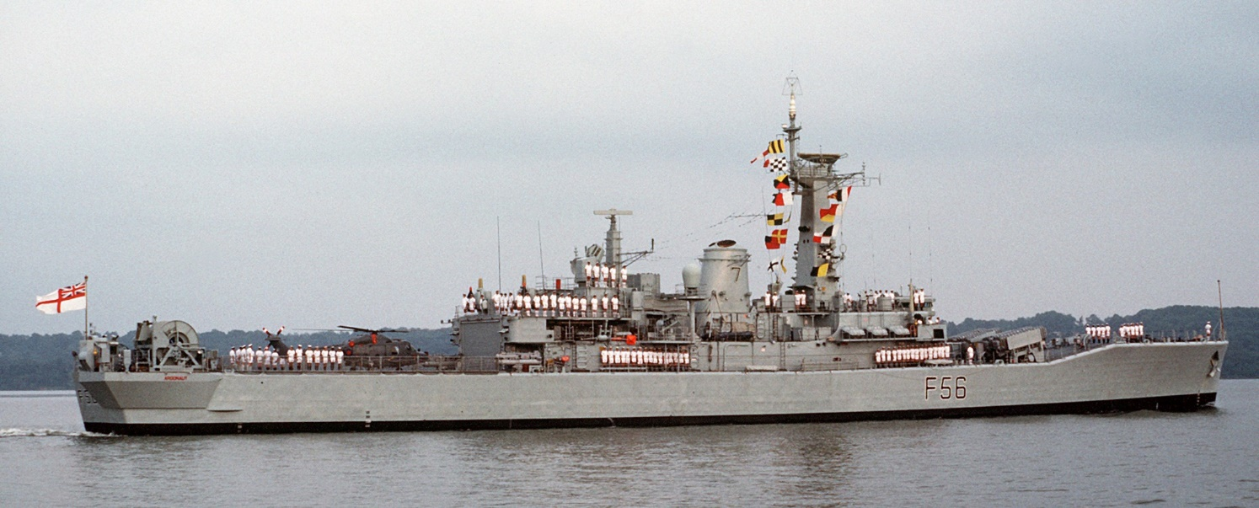

[**Type 21** **Amazon class**](https://en.wikipedia.org/wiki/Type_21_frigate): Seven of the eight ships in this class deployed to the Falkland Islands campaign, were they proved excellent at shore bombardment but not much else.  They were poor Air Defense ships and quite loud and dated as ASW ships.  Two were sunk in that campaign, ***F170 Antelope***and ***F184 Ardent***.  Historically the remaining six of this class were sold to Pakistan in 1993-94, this sale was canceled and the ships retained as general purpose escorts.

|  |  |  |  |  |  |
| --- | --- | --- | --- | --- | --- |
| Class/Batch | Pennant | Ship | Location | Status | Remarks |
| Type 21 | F169 | Amazon | Atlantic | Active | Amphib escort |
|  | F170 | Antelope | Sunk |  |  |
|  | F172 | Ambuscade | Atlantic | Active | Amphib escort |
|  | F173 | Arrow | Atlantic | Active | Amphib escort |
|  | F171 | Active | Atlantic | Active | Convoy escort |
|  | F174 | Alacrity | Atlantic | Active | Convoy escort |
|  | F184 | Ardent | Sunk |  |  |
|  | F185 | Avenger | Atlantic | Active | Amphib escort |

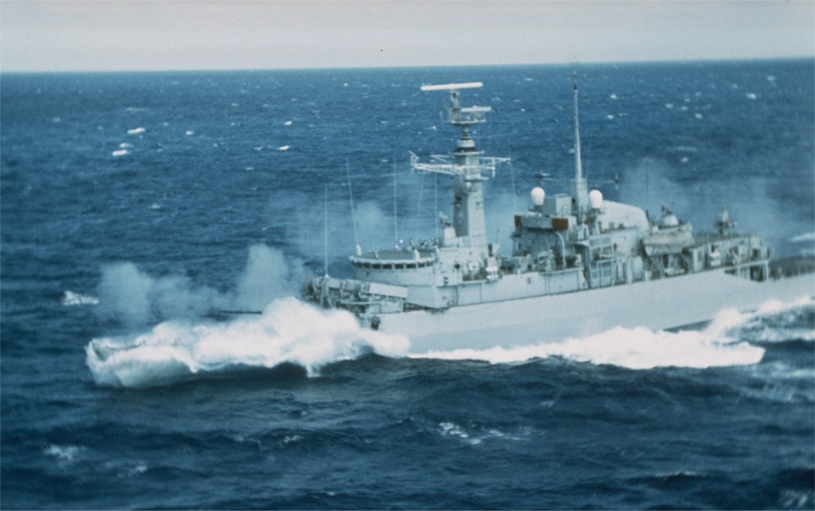

[**Type 22** **Broadsword Class**](https://en.wikipedia.org/wiki/Type_22_frigate): This much improved class consists of 14 ships in three batches.  Primarily ASW platforms, these are capable general purpose ships. Batch 3 is significantly improved due to the experience from the Falklands war, and the four ships of this batch were commissioned to replace four ships of other classes lost in that war.

|  |  |  |  |  |  |
| --- | --- | --- | --- | --- | --- |
| Class/Batch | Pennant | Ship | Location | Status | Remarks |
| Batch 1 | F88 | Broadsword | Atlantic | Active | Independent |
|  | F89 | Battleaxe | Mediterranean | Active | Escort R06 |
|  | F90 | Brilliant | Indian | Active | Tied Up |
|  | F91 | Brazen | Atlantic | Active | Tied Up |
| Batch 2 | F92 | Boxer | Mediterranean | Active | Escort R06 |
|  | F93 | Beaver | Atlantic | Active | Independent |
|  | F94 | Brave | Indian | Active | Escort R07 |
|  | F95 | London | Atlantic | Active | Escort R05 |
|  | F96 | Sheffield | Atlantic | Active | Escort R05 |
|  | F98 | Coventry | Persian Gulf | Active | Independent |
| Batch 3 | F99 | Cornwall | Atlantic | Active | Tied Up |
|  | F85 | Cumberland | Mediterranean | Active | Escort R06 |
|  | F86 | Campbeltown | Atlantic | Active | Escort R05 |
|  | F87 | Chatham | Pacific | Active | Independent |

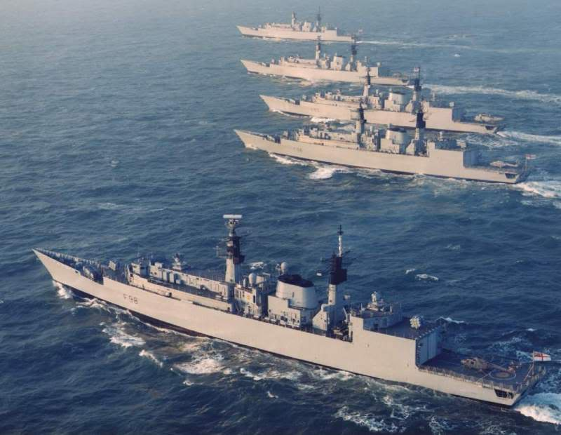

[**Type 23 Duke Class**](https://en.wikipedia.org/wiki/Type_23_frigate): These Frigates are very capable, well balanced ships capable of operating independently or as a key ASW, AAW or ASuW ship within a Task Force. They are one of the best ASW platforms in the world. Nine are available in Northern Fury, three being accelerated into service and commissioning 6-8 months earlier than they did historically. These ships are a valuable addition to any NATO task force.

|  |  |  |  |  |  |
| --- | --- | --- | --- | --- | --- |
| Class/Batch | Pennant | Ship | Location | Status | Remarks |
| Type 23 | F 230 | Norfolk | Atlantic | Active | STANAVFORLANT |
|  | F 233 | Marlborough | Indian | Active | Independent |
|  | F 231 | Argyll | Persian Gulf | Active | Independent |
|  | F 229 | Lancaster | Indian | Active | Escort R07 |
|  | F 234 | Iron Duke | Mediterranean | Active | Escort R06 |
|  | F 235 | Monmouth | Mediterranean | Active | Independent |
|  | F 236 | Montrose | Atlantic | Active | Escort R05 |
|  | F 237 | Westminster | Caribbean | Active | Independent |
|  | F 238 | Northumberland | Atlantic | Workups |  |

