**Royal Navy**

Great Britain’s Royal Navy, with over 450 years of history is the UK’s Senior Service. Over it’s history it has fought both against and along side most other navies in NATO. Although still a potent force by 1994, after three decades of budgetary constriction, the RN is only a shadow of its former self. Maintaining a full suite of naval capabilities from strategic ballistic missile submarines, through aircraft carriers, an active amphibious force and global logistics, the RN is stretched thin and in some areas only held together by tradition, training and pride.

The recent war experience in the Falklands gave British politicians and budget conscious bureaucrats a lesson in the cost of neglect. Thus with the increased tension in Europe, the Navy has managed to convince government to infuse it with much needed capital in the form of new build and retained ships. Unfortunately, not much of the new build production has reached the fleet, but readiness is high and capabilities have been moderately improved.

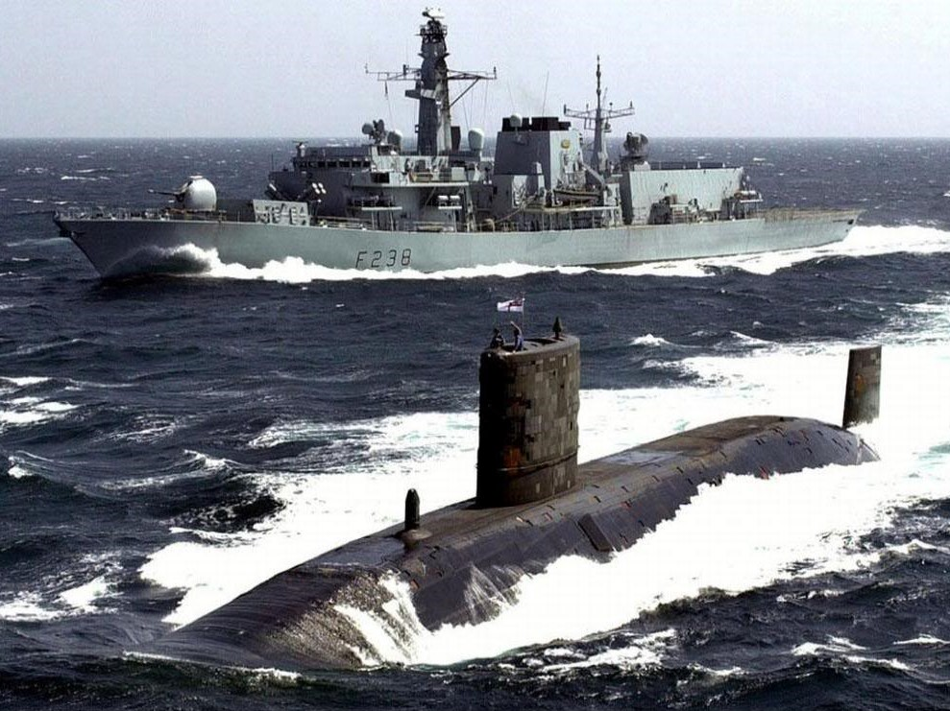

Global commitments to support the vestiges of a colonial empire have the RN deployed in every corner of the planet, you are likely to see British ships in all campaigns portrayed in Northern Fury.