**Royal Navy Patrol Craft**

**Patrol Craft**

[**HMS Endurance (A171)**](https://en.wikipedia.org/wiki/HMS_Endurance_(A171))

As the only ‘Ice Patrol’ ship in the RN, the Endurance is a Class 1 Icebreaker which spends 18 out of every 24 months in the southern oceans patrolling between the Falkland Islands, Antarctica and other British possessions in the region. She has assisted the British Antarctic Survey team by performing hydrographic surveys as well as environmental studies and also featuring in several BBC documentaries. Her two Lynx HAS.3 helicopters are modified to operate in polar conditions.

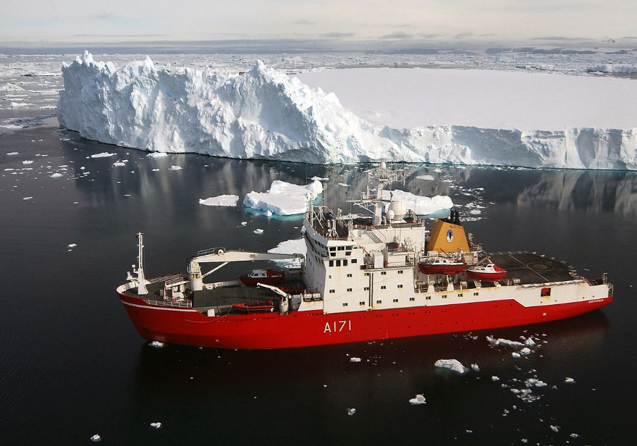

[**Castle Class**](http://www.armedforces.co.uk/navy/navycastleclass.htm)

These two ships share their time by conducting fisheries and environmental patrols in the North Sea and as Guard ship in the Falklands. They are able to accommodate a Sea King helicopter, 120 troops for a short time and act as minelayers. They are also equipped with a detergent spraying apparatus for dispersing oil slicks.

|  |  |  |  |
| --- | --- | --- | --- |
| Pennant | Name | Status | Location |
| P258 | HMS Leeds Castle | Active | North Sea |
| P265 | HMS Dumbarton Castle | Active | Falklands |

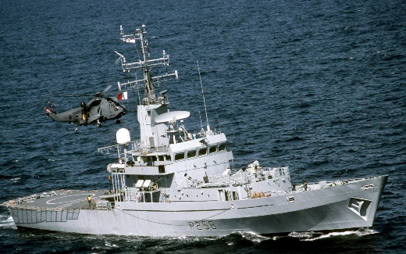

[**Island Class**](https://en.wikipedia.org/wiki/Island-class_patrol_vessel)

Primarily procured for fisheries patrol, these vessels also patrol the North Sea oil and gas fields. They are lightly armed and can carry a small detachment of Royal Marines. The class has suffered much criticism over the years as being too small, too under equipped and too expensive for their role.

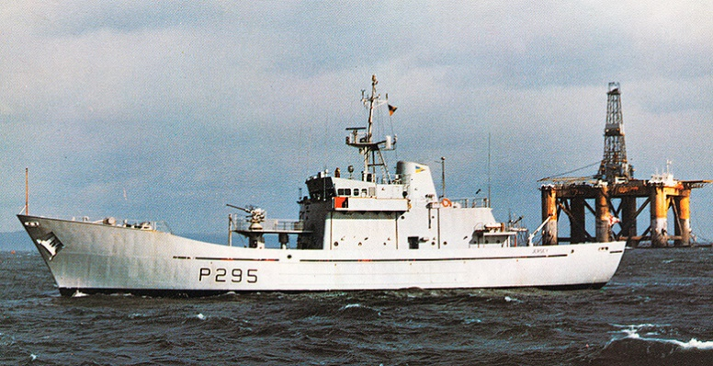

|  |  |  |  |
| --- | --- | --- | --- |
| Pennant | Name | Status | Location |
| P296 | HMS Jura | Active | North Sea |
|  | FPV Westra | Active | Scotland, civilian operated |
| P277 | HMS Anglesey | Active | Shetlands |
| P278 | HMS Alderney | Dry dock | Glasgow |
| P295 | HMS Jersey | Active | English Channel |
| P297 | HMS Guernsey | Active | Irish Sea |
| P298 | HMS Shetland | Active | North Sea |
| P299 | HMS Orkney | Active | Hebrides |
| P300 | HMS Lindisfarne | Active | Plymouth |

[**Peacock Class**](https://en.wikipedia.org/wiki/Peacock-class_corvette)

The five vessels in this class were constructed specifically for duty in Hong Kong. They had the seakeeping ability to remain at sea during a Typhoon and were fully air conditioned for operating in a tropical climate. They perform a multitude of tasks including drug interdiction and support to search and rescue. They are equipped with a decompression chamber, two RHIBs and maintained a small detachment of Royal Marines.

|  |  |  |  |
| --- | --- | --- | --- |
| Pennant | Name | Status | Location |
| P239 | HMS Peacock | Active | Hong Kong |
| P240 | HMS Plover | Active | Hong Kong |
| P241 | HMS Starling | Active | Hong Kong |
| P242 | HMS Swallow | Active | Hong Kong |
| P243 | HMS Swift | Active | Hong Kong |

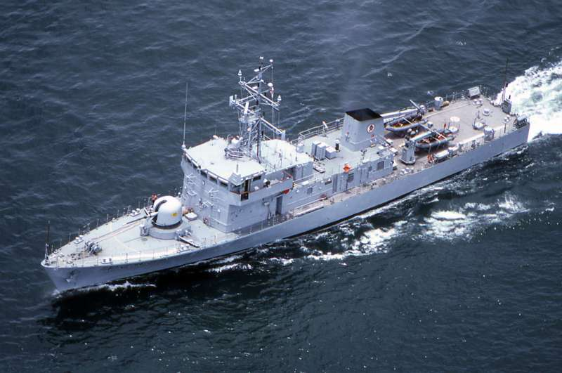

[**Bird Class**](https://en.wikipedia.org/wiki/Bird-class_patrol_vessel)

Another disappointing class of patrol vessels. These five boats were never used as intended due to very poor sea keeping. They were slow, poorly armed, difficult to handle in any sort of weather and universally despised. Two remained in the training role while three were based in Northern Ireland.

|  |  |  |  |
| --- | --- | --- | --- |
| Pennant | Name | Status | Location |
| P260 | HMS Kingfisher | Active | Northern Ireland |
| P261 | HMS Cygnet | Active | Northern Ireland |
| P262 | HMS Petrel | Active | Dartmouth |
| P263 | HMS Sandpiper | Active | Dartmouth |
| P264 | HMS Redpole | Active | Northern Ireland |

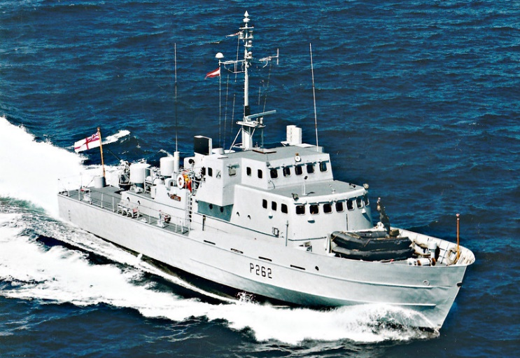

**Mine Craft**

**HMS Wilton (M1116)**

Due for retirement later in 1994, this ship was the first in the world to be constructed with glass reinforced plastic to give her a low magnetic signature. After an active 20-year career, technology in mine hunting has moved on, but she still has equipment that may be useful. She is currently at Dartmouth on training duty.

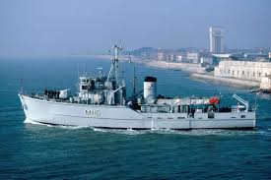

[**River Class**](https://en.wikipedia.org/wiki/River-class_minesweeper)

The 12 vessels of this MCM (Mine Countermeasures) class were designed to sweep for deep sea mines laid by Soviet submarines. Two of them operating together would tow the Wire Sweep Mark 9 (WS 9) along the seabed at great depth, cutting the mooring lines. Historically this class, with the exception of one was operated by the RN Reserve but was withdrawn from service in 1993; in Northern Fury they remain.

|  |  |  |  |
| --- | --- | --- | --- |
| Pennant | Name | Status | Location |
| M2003 | HMS Waveney | Reserve | South Wales |
| M2004 | HMS Carron | Reserve | Bristol |
| M2005 | HMS Dovey | Reserve | Clyde |
| M2006 | HMS Helford | Reserve | Northern Ireland |
| M2007 | HMS Humber | Reserve | London |
| M2008 | HMS Blackwater | Active | Rosyth |
| M2009 | HMS Itchen | Reserve | Wessex |
| M2010 | HMS Helmsdale | Reserve | Tay |
| M2011 | HMS Orewell | Reserve | Newcastle |
| M2012 | HMS Ribble | Reserve | London |
| M2013 | HMS Spey | Reserve | Northern Ireland |
| M2014 | HMS Arun | Reserve | Northern Ireland |

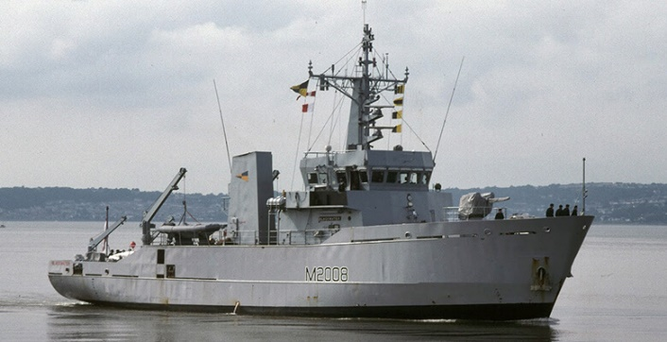

[**Hunt Class**](https://en.wikipedia.org/wiki/Hunt-class_mine_countermeasures_vessel)

The Hunt class demonstrate the evolution from a mine sweeper such as the River class to a true mine hunter. Equipped with two Remote Operated Submersible Vehicles (ROV) and mine hunting sonar, they patrol a suspected area to find mines, detach or disarm them then destroy them. These vessels will often deploy with NATO mine countermeasures task forces and there are currently six of 13 craft in the Persian Gulf.

|  |  |  |  |
| --- | --- | --- | --- |
| Pennant | Name | Status | Location |
| M29 | HMS Brecon | Active | Portsmouth |
| M30 | HMS Ledbury | Active | Bahrain |
| M31 | HMS Cattistock | Active | Bahrain |
| M32 | HMS Cottesmore | Active | Portsmouth |
| M33 | HMS Brocklesby | Active | Portsmouth |
| M34 | HMS Middleton | Active | Portsmouth |
| M35 | HMS Dulverton | Active | Bahrain |
| M36 | HMS Bicester | Active | Bahrain |
| M37 | HMS Chiddingforld | Active | Portsmouth |
| M38 | HMS Atherstone | Active | Bahrain |
| M39 | HMS Hurworth | Active | Bahrain |
| M40 | HMS Berkeley | Active | Portsmouth |
| M41 | HMS Quorn | Active | Portsmouth |

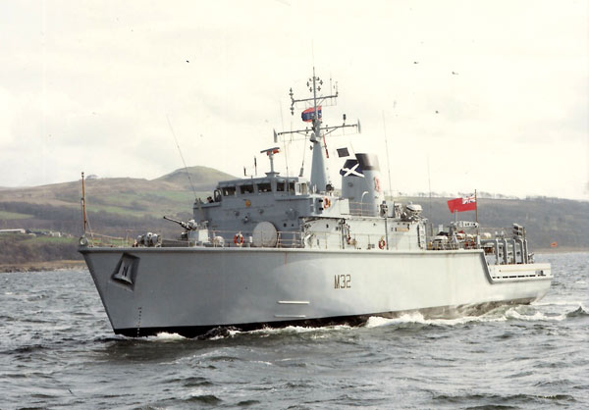

[**Sandown Class**](https://en.wikipedia.org/wiki/Sandown-class_minehunter)

The first five of these advanced MCM are in service by 1994. These vessels have a more cabable ROV, better sonars and a wider range of mine hunting equipment to complement the Hunt and River classes. The Sandown is currently in the Persian Gulf and one of these craft will be stationed there on a rotational basis until the mission is complete.

|  |  |  |  |
| --- | --- | --- | --- |
| Pennant | Name | Status | Location |
| M101 | HMS Sandown | Active | Bahrain |
| M102 | HMS Inverness | Active | Faslane |
| M103 | HMS Cromer | Active | Faslane |
| M104 | HMS Walney | Active | Faslane |
| M105 | HMS Bridport | Active | Faslane |

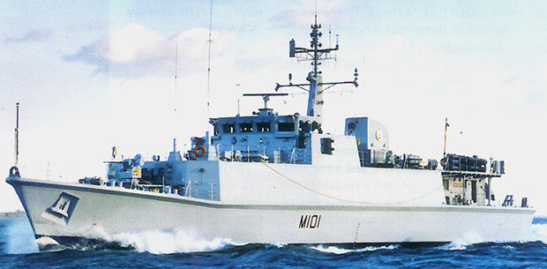

[**PAP ROV**](http://www.deagel.com/Protection-Systems/PAP-Mark-5_a002091001.aspx)

The RN uses PAP Mark 4 in the Hunt class MCMs and the PAP Mark 5 in the Sandown Class. These ROV remain tethered to the mother vessel and actively hunt for mines. Once they find a mine they can either set an explosive charge to blow the mine up in place or cut the tether and let the mine float to the surface where it will be engaged with deck guns from the MCM.

