**USAF Fighter & Multi-Roll**

By 1994 the USAF had almost slimed its front line fighter inventory down to two basic airframes, the F-15 Eagle and Strike Eagle, and the F-16 Falcon. In Northern Fury however, three squadrons of updated F-4E Phantoms lingered on in the Air National Guard (ANG).

[**F-15A/C Eagle**](https://fas.org/man/dod-101/sys/ac/f-15.htm)

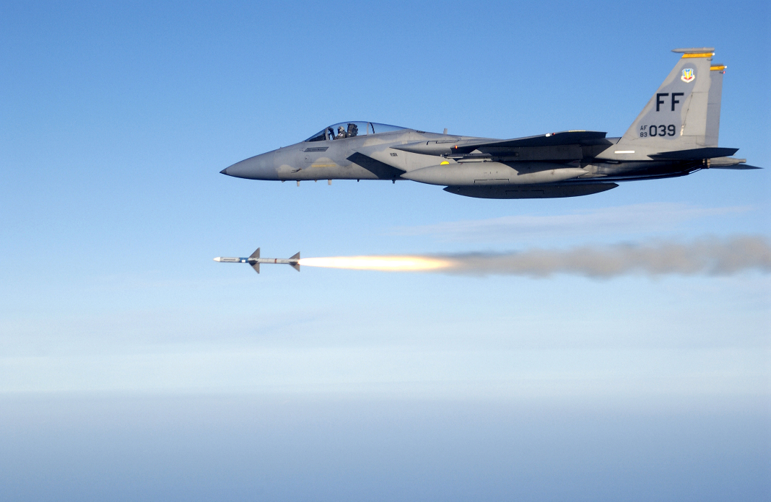

The F-15 is an all weather, highly maneuverable air superiority fighter. Arguably the best air superiority aircraft in the world, none have been lost in air combat. In 1994 there are two basic variations on the Eagle, the F-15A which is limited to the original suite of weapons that were developed for the aircraft in the early ‘70s, and the F-15C which is able to use a much more modern Aim-120 AMRAAM air to air missile. It should be noted that the twin seat trainer versions are the ‘B’ and the ‘D’ models and each squadron has two or three of these for continuation and certification training. The link above has many more details as does the [wiki](https://en.wikipedia.org/wiki/McDonnell_Douglas_F-15_Eagle) and many other pages. By the beginning of Northern Fury almost all F-15A are in the ANG, while the regular air force is equipped with the F-15C with one exception; the 57th Fighter Squadron (FS) stationed at Keflavik Iceland. All of the F-15C on active service have undergone the MSIP (Multistage Improvement Program) upgrade. Northern Fury uses the same number of airframes that were originally produced, however in the real world the squadron size had been reduced to 18 aircraft, a couple squadrons had been deactivated and many older F-15A had been retired to the bone-yard. The chart below gives a comparison of where the aircraft were in real life and where they are in Northern Fury[1]:

|  |  |  |  |  |
| --- | --- | --- | --- | --- |
|  | Northern Fury | | Real History | |
|  | F-15A/B | F-15C/D | F-15A/B | F-15C/D |
| Production | 412 | 470 | 412 | 470 |
| W/O | 51 | 23 | 51 | 23 |
| Retired | 100 |  | 225 | 22 |
| Storage | 30 |  | 14 | 100 |
| Other | 20 | 2 | 20 | 10 |
| ATEC | 36 | 12 | 12 | 48 |
| AF Mat C | 7 | 7 |  | 15 |
| ANG | 168 |  | 90 |  |
| ACC |  | 192 |  | 126 |
| USAFE |  | 90 |  | 36 |
| PacAF |  | 144 |  | 90 |
| Total | 412 | 470 | 412 | 470 |

Squadron distribution in Northern Fury remains relatively consistent with history but two regular Squadrons due to deactivate in 1994 (32nd FS and 43rd FS) are not planning to do so, and one additional ANG Squadron is in the mix due to the shortage of F-16s (112th FS). One other minor change is that Bitburg AB in Germany did not close so the 53rd FS remained there instead of moving to Spangdahlem AB. The most substantive change is the retention of 24 aircraft per squadron vice the historic reduction to 18; the exception is 57th FS which had never been at 24. Squadron dispositions are listed below:

|  |  |  |  |  |  |  |
| --- | --- | --- | --- | --- | --- | --- |
| Sqn | Name | Wing | Location | No. | Type | Remarks |
| 1 FS | Fighting Furies | 325th | Tyndall AFB, FL | 24 | F-15A/C | ATEC |
| 2 FS | American Beagles | 325th | Tyndall AFB, FL | 24 | F-15A | ATEC |
| 12 FS | Dirty Dozen | 3rd | Elmendorf AFB, AL | 24 | F-15C | PacAF |
| 19 FS | Fighting Gamecocks | 3rd | Hickam Field, HI | 24 | F-15C | PacAF |
| 27 FS | Fighting Eagles | 1st | Langley AFB, VA | 24 | F-15C | ACC |
| 32 FS | Wolfhounds | 32nd | Soesterberg AB, Ger | 24 | F-15C | USAFE |
| 43 FS | American Hornets | 3rd | Elmendorf AFB, AL | 24 | F-15C | PacAF |
| 44 FS | Vampires | 18th | Kadena AB, Japan | 24 | F-15C | PacAF |
| 53 FS | Tigers | 32nd | Bitburg AB, Ger | 24 | F-15C | USAFE |
| 54 FS | Leopards | 3rd | Elmendorf AFB, AL | 24 | F-15C | PacAF |
| 57 FS | Black Knights | 35th | Keflavik AFB, Iceland | 18 | F-15C | Not MSIP |
| 58 FS | Gorillas | 33rd | Eglin AFB, FL | 24 | F-15C | ACC |
| 59 FS | Golden Pride | 33rd | Eglin AFB, FL | 24 | F-15C | ACC |
| 60 FS | Fighting Crows | 33rd | Eglin AFB, FL | 24 | F-15C | ACC |
| 67 FS | Fighting Cocks | 18th | Kadena AB, Japan | 24 | F-15C | PacAF |
| 71 FS | Iron Men | 1st | Langley AFB, VA | 24 | F-15C | ACC |
| 94 FS | Hat in the Ring | 1st | Langley AFB, VA | 24 | F-15C | ACC |
| 95 FS | Boneheads | 325th | Tyndall AFB, FL | 24 | F-15C | ACC |
| 101 FS | Tigers | 102nd | Otis, MA | 24 | F-15A | ANG |
| 110 FS | Lindbergh's Own | 131st | Whiteman AFB, MI | 24 | F-15A | ANG/NORAD |
| 112 FS | Stingers | 180th | Toledo, OH | 24 | F-15A | ANG |
| 123 FS | Redhawks | 142nd | Portland, OR | 24 | F-15A | ANG/NORAD |
| 128 FS | Wildcats | 116th | Dobbins, GA | 24 | F-15A | ANG/NORAD |
| 199 FS | Mai Tai's | 154th | Hickam Field, HI | 24 | F-15A | ANG/PacAF |
| 390 FS | Wild Boars | 366th | Mtn Home AFB, ID | 24 | F-15A | ACC |
| 461st FS | Deadly Jesters | 56th | Luke AFB, AZ | 24 | F-15A | ATEC |
| 493 FS | Grim Reapers | 48th | Lakenheath AB, UK | 24 | F-15A | USAFE |

[**F-15E Strike Eagle**](http://www.af.mil/About-Us/Fact-Sheets/Display/Article/104499/f-15e-strike-eagle/)

The unquestionable success of the F-15 as an air-to-air platform predictably led to a derivative able to conduct air-to-ground missions. The F-15E Strike Eagle can do everything that the F-15C can do, but has a rear seat for a Weapon Systems Officer (WSO) and is optimally configured for a deep strike into enemy territory using terrain following radar and precision munitions. It has a powerful integrated electronic countermeasures (ECM) system, conformal fuel tanks for added range and plenty of weapon stations. Historically production trickled off in ‘92 to just 3 aircraft but at its peak in ’87 and ’88, and again 1991, 42 aircraft were produced. Northern Fury has this production maintained through ’89 and ’90 (an increase from 35 each year) and continuing into ‘93. Overall increasing the production by 100 aircraft. Factoring in attrition there are now 301 Strike eagles available which translates to one additional wing (6th Tactical Fighter Wing at Mountain Home AFB, ID) and the continuation of 550th FS as the conversion training unit into mid 1994.

|  |  |  |  |  |  |  |
| --- | --- | --- | --- | --- | --- | --- |
| Sqn | Name | Wing | Location | No. | Type | Remarks |
| 90 FS | Pair-O-Dice | 3rd | Elmsdorf AFB, AL | 24 | F-15E | PacAF |
| 333 FS | Lancers | 4th | Seymore Johnson AFB, NC | 24 | F-15E |  |
| 334 FS | Fighting Eagles | 4th | Seymore Johnson AFB, NC | 24 | F-15E |  |
| 335 FS | Chiefs | 4th | Seymore Johnson AFB, NC | 24 | F-15E |  |
| 336 FS | Rocketeers | 4th | Seymore Johnson AFB, NC | 24 | F-15E |  |
| 391 FS | Bold Tigers | 366th | Mountain Home AFB, NC | 24 | F-15E |  |
| 329 FS | Scorpions | 6th | Mountain Home AFB, NC | 24 | F-15E | New Wing |
| 330 FS | Desert Hawks | 6th | Mountain Home AFB, NC | 24 | F-15E | New Wing |
| 331 FS | Rapiers | 6th | Mountain Home AFB, NC | 24 | F-15E | New Wing |
| 492 FS | Madhatters | 48th | Lakenheath AB, UK | 24 | F-15E | USAFE |
| 494 FS | Panthers | 48th | Lakenheath AB, UK | 24 | F-15E | USAFE |
| 550 FS | Silver Eagles | 56th | Luke AFB, AZ | 24 | F-15E | Deactivating |

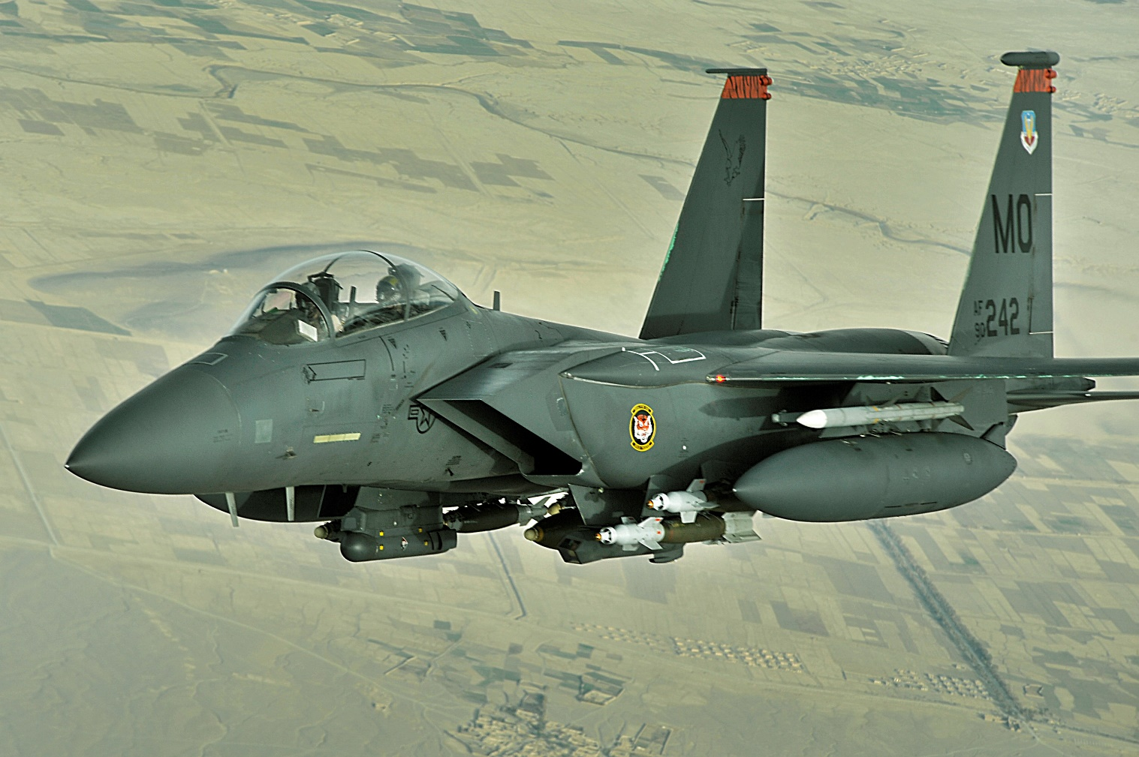

**[F-16 Falcon](https://fas.org/man/dod-101/sys/ac/f-16.htm)**

The F-16 is the most numerous and versatile fighter in the USAF inventory. First entering service in 1978, there are numerous variations to the basic airframe, the details can be found at this [site](http://www.f-16.net/f-16_versions.html). In general terms variants were produced in ‘Block’ numbered groups indicating major upgrades. Historically the late ‘80s and early ‘90s saw a massive downsizing and sell-off of this ubiquitous and adaptable fighter. Many went to the Air Guard, many went into long term preservation and yet more were sold to allies. In Northern Fury the 1988 level of production (180/year) was maintained right through 1993 and is planned to continue for at least 3 more years. Factoring in a slightly higher level of attrition, this production results in an additional 442 airframes being available, most at the Block 40/42 and 50/52 standard. Combined with retaining some older aircraft in the Air Guard, not retiring the F-16ADF, and canceling several foreign sales a net increase of 15x F-16 Squadrons is available. The aircraft in use by the USAF in Northern fury are:

* **F-16A** – Over 800 of these were built from 1978 through 1983, in the mid ‘80s about 520 were converted to the ‘Air Defence Fighter’ (ADF) version for NORAD and the remainder were shunted to secondary roles or preserved. One squadron used for training ANG pilots is still equipped with these aircraft, 40 more are undergoing refit to ADF and about 150 are in storage.
* **F-16ADF** – these are upgraded ‘A’ models to the Block 15 standard, and specially optimized for the US ANG intercept mission for NORAD. These are the only US F-16s that fire the [Aim-7 Sparrow](http://www.f-16.net/f-16_armament_article10.html) missile. About 520 were modified for this role, which due to the shortage of new aircraft was about 250 more than historically exited, and more are being converted.
* **F-16C/D Block 25** – This was the earliest version of the ‘C’ model and had a better radar, a glass cockpit, improved fire control computer and many other improvements. Fundamentally this looked like the ‘A’ model but was able to fire the much more capable [Aim-120 AMRAAM](http://www.f-16.net/f-16_armament_article3.html) and [AGM-65 Maverick](http://www.f-16.net/f-16_armament_article4.html). With 280 (vice 244 in real history) of this Block produced it is resident in three ANG Squadrons, three training Squadrons and one European based regular squadron. This leave 33 in storage after 49 have been written off through accidents and other losses.
* **F-16C/D Block 30/32** – There are two main upgrades in this block, first and foremost is the ‘common engine bay’ and two improved engines. The General Electric F110 (Block 30) which equips 75% of the production run and the Prat & Whitney F100 (Block 32). The later Block 30s have a larger engine intake, commonly called the ‘Big Mouth’. The second major improvement is better target processing. All were later retrofitted with a [LANTERN](http://www.f-16.net/f-16_armament_article2.html) Pod for terrain following and targeting and the ability to engage targets with [HARM](https://fas.org/man/dod-101/sys/smart/agm-88.htm) missiles. Northern Fury only increases this version by 20 airframes bringing the available number to 489 minus the 49 which were written off. No ANG squadrons have yet received this aircraft which equips 11 regular squadrons, one of them a training squadron. About 100 of these machines are in storage.
* **F-16C/D Block 40/42** – This version has a fully integrated LANTERN Pod giving the aircraft full day/night capabilities. Also improved were the ECM systems and cockpit controls. The first major production year was 1988 and the increase in Northern Fury production takes hold in 1989, so production of this version is 760 vice the historic 454. After removing 53 for crashes and accidents, a total of 25 squadrons including three training squadrons are equipped with this aircraft.
* **F-16C/D Block 50/52** – The last version equipping the USAF in Northern Fury has improved engines, avionics, radar and ECM. These aircraft are destined to replace the Wild Weasel in the Suppression of Enemy Air Defence (SEAD) role. Production began in late 1991 and continues at an increased pace. By the start of Northern Fury there are 304 available after removing 33 due to attrition. There are none in the training system but 11 front line squadrons are equipped with this version.

|  |  |  |  |  |  |  |
| --- | --- | --- | --- | --- | --- | --- |
| Sqn | Name | Wing | Location | No. | Type | Remarks |
| 4 FS | Fightin' Fuujins | 388th | Hill AFB, UT | 24 | F-16C Blk 40 |  |
| 10 FS | Fighting Tenth | 50th | Hahn AFB, Ger | 24 | F-16CJ Blk 50 | USAFE |
| 13 FS | The Panther Pack | 35th | Misawa AB, Japan | 24 | F-16CJ Blk 50 | PacAF |
| 14 FS | Samurais | 35th | Misawa AB, Japan | 24 | F-16CJ Blk 50 | PacAF |
| 17 FS | Hooters | 363rd | Shaw AFB, SC | 24 | F-16C Blk 42 |  |
| 18 FS | Blue Foxes | 354th | Eielson AFB, AL | 24 | F-16C Blk 40 | PacAF |
| 22 FS | Stingers | 36th | Bitburg AB, Ger | 24 | F-16CJ Blk 50 | USAFE |
| 23 FS | Fighting Hawks | 52nd | Spangdahlem AB, Ger | 24 | F-16CJ Blk 50 | USAFE |
| 33 FS | Falcons | 363rd | Shaw AFB, SC | 24 | F-16C Blk 42 |  |
| 34 FS | Rams | 388th | Hill AFB, UT | 24 | F-16C Blk 40 |  |
| 35 FS | Panton | 8th | Kunsan AB, S Korea | 24 | F-16C Blk 30 | PacAF |
| 36 FS | Flying Fiends | 51st | Osan AB, S Korea | 24 | F-16C Blk 42 | PacAF |
| 61 FS | Top Dawgs | 56th | Luke AFB, AZ | 24 | F-16C Blk 25 | ATEC |
| 62 FS | Spikes | 56th | Luke AFB, AZ | 24 | F-16C Blk 25 | ATEC |
| 63 FS | Panthers | 56th | Luke AFB, AZ | 24 | F-16C Blk 25 | ATEC |
| 68 FS | Lightning Lancers | 81st | RAF Alconbury, UK | 24 | F-16C Blk 40 | USAFE |
| 69 FS | Werewolves | 81st | RAF Alconbury, UK | 24 | F-16C Blk 40 | USAFE |
| 70 FS | White Knights | 347th | Moody AFB, GA | 24 | F-16C Blk 42 |  |
| 72 FS | Falcons | 56th | Luke AFB, AZ | 24 | F-16C Blk 30 | ATEC |
| 74 FS | Flying Tigers | 23rd | Kunsan AB, S Korea | 24 | F-16C Blk 30 | PacAF |
| 80 FS | Headhunters | 8th | Kunsan AB, S Korea | 24 | F-16C Blk 40 | PacAF |
| 89 FS | Rhino's | 906th | Wright Patterson, OH | 24 | F-16C Blk 40 |  |
| 93 FS | Makos | 482nd | MacDill AFB, FL | 24 | F-16C Blk 32 | AF Reserve |
| 107 FS | Red Devils | 127th | Selfridge, MI | 18 | F-16ADF | ANG |
| 111 FS | Ace in the Hole | 147th | Huston, TX | 18 | F-16ADF | ANG, NORAD |
| 114 FS | Eager Beavers | 142nd | Portland, OR | 18 | F-16ADF | ANG, NORAD |
| 119 FS | Jersey Devils | 177th | Atlantic Cty, NJ | 18 | F-16ADF | ANG, NORAD |
| 120 FS | Colorado Cougars | 140th | Buckley, CO | 24 | F-16CJ Blk 25 | ANG |
| 121 FS | Capital Guardians | 113th | Andrews AFB, ML | 18 | F-16ADF | ANG, NORAD |
| 124 FS | Hawkeyes | 132nd | Des Moines, IO | 18 | F-16ADF | ANG, NORAD |
| 125 FS | Tulsa Vipers | 138th | Tulsa, OK | 18 | F-16ADF | ANG, NORAD |
| 127 FS | Dragons | 184th | McConnell AFB, KS | 18 | F-16ADF | ANG |
| 134 FS | Green Mountain Boys | 158th | Burlington, VT | 18 | F-16ADF | ANG |
| 136 FS | New York's Finest | 107th | Niagara, NY | 18 | F-16ADF | ANG |
| 149 FS | Gen’men from Richmond | 192nd | Langley, VA | 18 | F-16ADF | ANG, NORAD |
| 152FS | Warhawks | 162nd | Tucson, AZ | 24 | F-16A | ANG/ATEC |
| 157 FS | Swamp Fox | 169th | Columbia, SC | 18 | F-16ADF | ANG |
| 159 FS | Boxin' Gators | 125th | Jacksonville, FL | 18 | F-16ADF | ANG |
| 160 FS | Snakes | 187th | Montgomery, AL | 18 | F-16ADF | ANG |
| 161 FS | Jayhawks | 184th | McConnell AFB, KS | 24 | F-16C Blk 52 | ANG |
| 162 FS | Sabers | 178th | Springfield, OH | 24 | F-16C Blk 25 | ANG |
| 169 FS | Marksmen | 182nd | Peoria, IL | 18 | F-16ADF | ANG |
| 170 FS | Fighting Illini | 183rd | Springfield, IL | 18 | F-16ADF | ANG |
| 171 FS | Michigan Six Pack | 191st | Selfridge, MI | 18 | F-16ADF | ANG |
| 174 FS | The Bats | 184th | Sioux City, IO | 18 | F-16ADF | ANG |
| 175 FS | Fightin' Lobos | 114th | Sioux Falls, SD | 18 | F-16ADF | ANG, NORAD |
| 176 FS | Badger Air Militia | 128th | Truax Field, WI | 18 | F-16ADF | ANG, NORAD |
| 177 FS | Jayhawkers | 184th | McConnell AFB, KS | 24 | F-16CJ Blk 25 | ANG |
| 178 FS | Happy Hooligans | 119th | Fargo, ND | 18 | F-16ADF | ANG |
| 179 FS | Bulldogs | 148th | Duluth, MN | 18 | F-16ADF | ANG |
| 182 FS | Lonestar Gunfighters | 149th | San Antonio, TX | 18 | F-16ADF | ANG, NORAD |
| 184 FS | Flying Razorbacks | 188th | Fort Smith, AR | 18 | F-16ADF | ANG, NORAD |
| 186 FS | Charlie Chickens | 122nd | Great Falls, MN | 18 | F-16ADF | ANG, NORAD |
| 188 FS | Enchilada Air Force | 150th | Albuquerque, NM | 18 | F-16ADF | ANG, NORAD |
| 194 FS | Griffins | 144th | Fresno, CA | 18 | F-16ADF | ANG, NORAD |
| 198 FS | Bucaneros | 156th | Carolina, PR | 18 | F-16ADF | ANG |
| 302 FS | Sun Devils | 944th | Luke AFB, AZ | 24 | F-16CJ Blk 52 |  |
| 306 FS | The Gunners | 31st | Aviano AB, Italy | 24 | F-16C Blk 40 | USAFE |
| 307 FS | Stingers | 347th | Moody AFB, GA | 24 | F-16C Blk 40 | 16 a/c in P Gulf |
| 308 FS | Emerald Knight | 347th | Moody AFB, GA | 24 | F-16C Blk 40 |  |
| 309 FS | Wild Ducks | 363rd | Shaw AFB, SC | 24 | F-16C Blk 40 |  |
| 310 FS | Tophats | 56th | Luke AFB, AZ | 24 | F-16C Blk 42 | ATEC |
| 311 FS | Sidewinders | 58th | Holloman AFB, NM | 24 | F-16C Blk 42 | ATEC |
| 313 FS | Lucky Puppies | 50th | Hahn AB, Ger | 24 | F-16CJ Blk 50 | USAFE |
| 314 FS | Warhawks | 58th | Holloman AFB, NM | 24 | F-16C Blk 42 | ATEC |
| 389 FS | Thunderbolts | 366th | Mtn Home AFB, ID | 24 | F-16CJ Blk 50 |  |
| 414 FS | Agressors | 57th | Nellis AFB, AZ | 24 | F-16C Blk 32 |  |
| 421 FS | Black Widows | 388th | Hill AFB, UT | 24 | F-16C Blk 40 |  |
| 425 FS | Black Widows | 58th | Holloman AFB, NM | 24 | F-16A | ATEC |
| 457 FS | Spads | 301st | Carswell AFB, TX | 24 | F-16C Blk 30 | AF Reserve |
| 465 FS | Okies | 507th | Tinker AFB, FL | 24 | F-16C Blk 40 |  |
| 466 FS | Diamondbacks | 419th | Hill AFB, UT | 24 | F-16C Blk 30 | AF Reserve |
| 480 FS | Warhawks | 52nd | Spangdahlem AB, Ger | 24 | F-16C Blk 30 | USAFE |
| 496 FS | The World’s Finest | 50th | Hahn AB, Ger | 24 | F-16CJ Blk 50 | USAFE |
| 512 FS | Dragons | 86th | Ramstein AB, Ger | 24 | F-16CJ Blk 50 | USAFE |
| 526 FS | Black Knights | 86th | Ramstein AB, Ger | 24 | F-16CJ Blk 50 | USAFE |
| 527 FS | Agressors | 81st | RAF Alconbury, UK | 24 | F-16C Blk 30 | USAFE |
| 555 FS | Triple Nickel | 31st | Aviano AB, Italy | 24 | F-16CJ Blk 25 |  |
| 612 FS | Fighting 612th | 401st | Nellis AFB, AZ | 24 | F-16C Blk 40 |  |
| 613 FS | Squids | 401st | Nellis AFB, AZ | 24 | F-16C Blk 40 |  |
| 614 FS | Lucky Devils | 401st | Nellis AFB, AZ | 24 | F-16C Blk 40 |  |
| 704 FS | Outlaws | 924th | Bergstrom AFB, TX | 24 | F-16C Blk 30 | AF Reserve |
| 706 FS | Cajuns | 926th | NAS New Orleans | 24 | F-16C Blk 30 | AF Reserve |
| Demo | Thunderbirds | 57th | Nellis AFB, AZ | 24 | F-16C Blk 32 | Air Demo Tm |

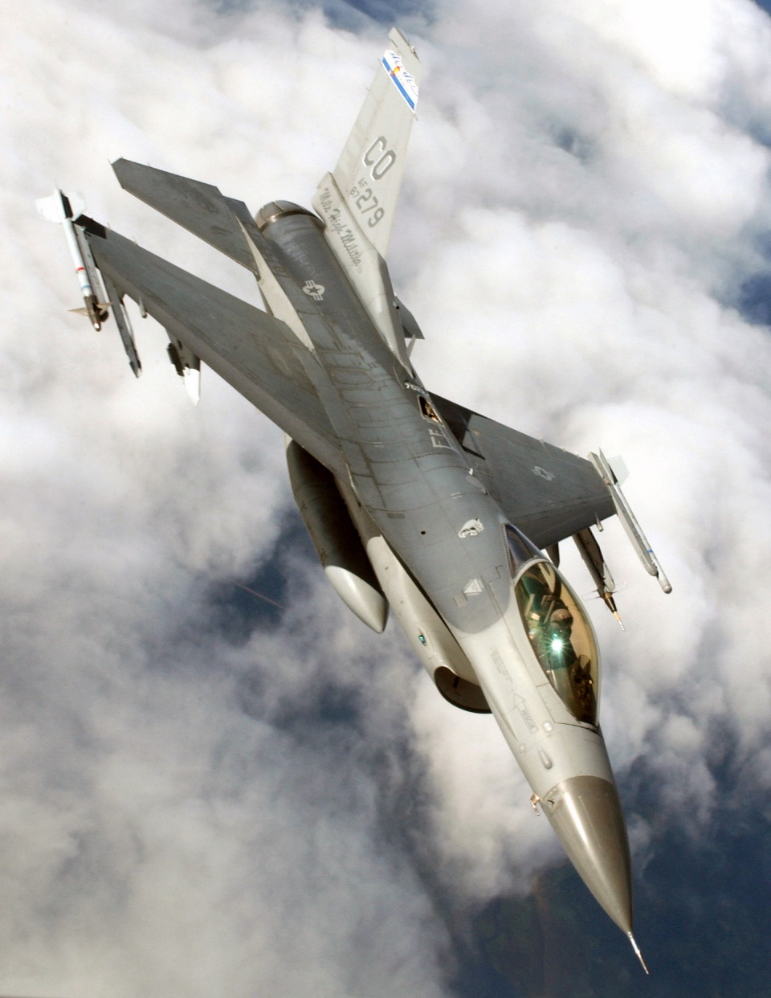

[**F-4E Phantom**](https://en.wikipedia.org/wiki/McDonnell_Douglas_F-4_Phantom_II)

Although this venerable fighter served well into the late ‘90s in the Wild Weasel and Reconnaissance roles, the pure fighter version within the USAF was supposed to retire in 1992. The shortage of F-16s caused by the retention of squadrons in Europe has meant that in Northern Fury there are still some F-4Es remaining in the Air National Guard. About 100 F-4Es were converted to carry a wider range of ordinance, including Laser Guided Paveway II bombs, they are still capable of conducing Air-to-Air combat but are heavily outclassed by the latest Soviet fighters. Three ANG squadrons retain the Phantom which will likely serve into 1996 before there are enough F-16s available to retire them. Additionally, a squadron of this type operated by ATEC trains German Luftwaffe crews.

|  |  |  |  |  |  |  |
| --- | --- | --- | --- | --- | --- | --- |
| Sqn | Name | Wing | Location | No. | Type | Remarks |
| 20 FS | Silver Lobos | 49th | Holloman AFB, NM | 24 | F-4E | ATEC |
| 113 FS | Racers | 181st | Hulman, IN | 24 | F-4E | ANG |
| 138FS | Boys from Syracuse | 181st | Syracuse, NY | 24 | F-4E | ANG |
| 163 FS | Blacksnakes | 181st | Fort Wayne, IN | 24 | F-4E | ANG |

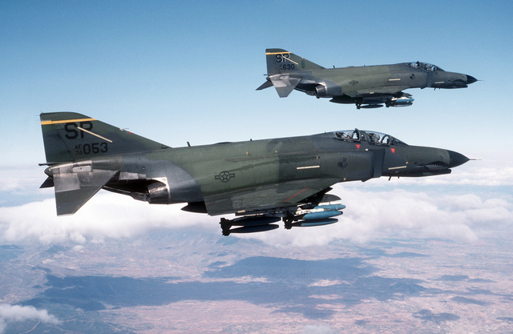

1. The total production figures are derived from: Donald & Lake, The Encyclopedia of World Military Aircraft, Aerospace Publishing 2000, had 355 ‘A’ and 57 ‘B’ totaling 412 plus 408 ‘C’ and 62 ‘D’ totaling 470. The production numbers at the FAS link are similar but do not seem to include F-15B production of 57.