**Special Operations Aircraft**

The AFSOC fleet of aircraft is small but highly specialized. Hurlburt Field in Florida is the home of this command which runs its own school as well as a test and evaluation organization. Both of these facilities allow the command to remain very agile in adopting new technologies and fitting them to their aircraft rapidly.

[**AC-130A/H/U Spector/Spooky Gun-ship**](https://fas.org/man/dod-101/sys/ac/ac-130.htm)

These are one of the most unique aircraft in the USAF inventory. A converted C-130, these very complex airframes have side firing 20mm and 30mm auto cannons (24mm Gatling gun for the AC-130U ‘Spooky’) and a 105mm howitzer, converted for precision fire. Both the Spector and, more so the Spooky have extensive electronic and physical countermeasures available for self-protection and jamming of enemy air defence. The 13 remaining AC-130As are the oldest Hercules airframes in the USAF inventory, but have had extensive strengthening to keep them operational and are flown by the 711th Special Operations Squadron (SOS) Air Reserve. After the loss of an AC-130H in the Gulf War, the order for new AC-130Us was increased to 13. Historically the Spooky underwent an extensive testing period before being accepted for operations, in Northern Fury, that testing was undertaken while the aircraft were on the operational squadron, 8 of the eventual 13 have been delivered with the remainder arriving at a rate of one per month.

|  |  |  |  |  |  |  |
| --- | --- | --- | --- | --- | --- | --- |
| Sqn | Name | Wing | Location | No. | Type | Remarks |
| 4th SOS | Ghostriders | 16th SOW | Hurlburt Field FL | 8 | AC-130U |  |
| 16th SOS | Spectre | 16th SOW | Hurlburt Field FL | 10 | AC-130H |  |
| 717th SOS | White Nights | 552nd | Duke Field FL | 13 | AC-130A | Air Reserve |

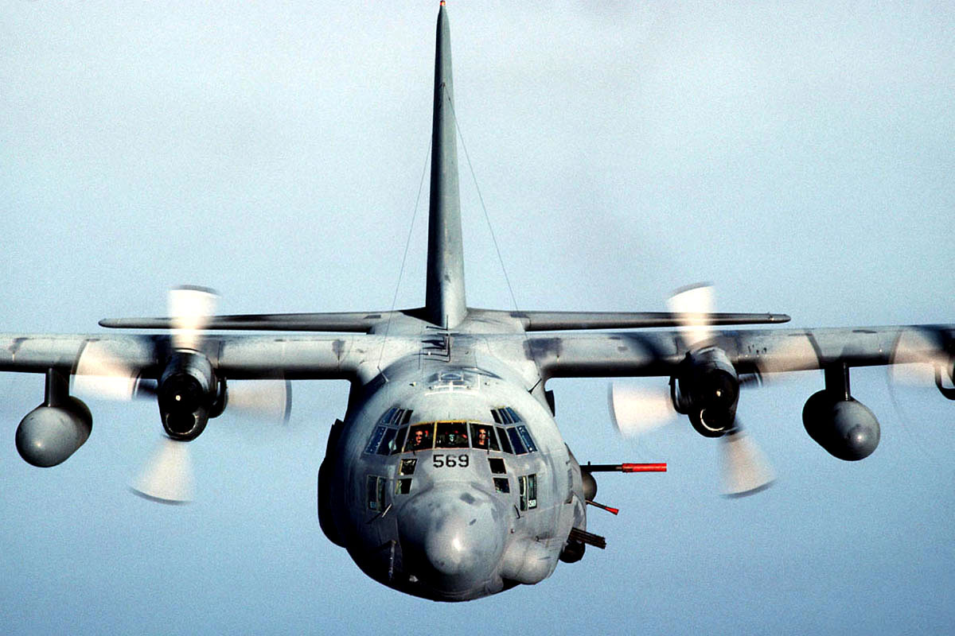

[**MC-130P**](https://fas.org/man/dod-101/sys/ac/mc-130p.htm) **Combat Shadow**

The Combat Shadow flies low altitude, high threat, penetration missions to provide air to air refueling for Combat Search and Rescue (CSAR) or other special mission aircraft, primarily helicopters. They can also drop small Para teams or cargo into a threat area. Historically these aircraft did not change designation from HC to MC until 1996, in Northern Fury they have already done so. There are 37 Combat Shadow in service, 5 in the Air Reserve; this is 9 aircraft more than actually existed in 1994.

|  |  |  |  |  |  |  |
| --- | --- | --- | --- | --- | --- | --- |
| Sqn | Name | Wing | Location | No. | Type | Remarks |
| 2nd SOS |  | 16th SOW | Hurlburt Field, FL | 8 | MC-130P |  |
| 5th SOS |  | 16th SOW | Hurlburt Field, FL | 5 | MC-130P | Air Force Reserve |
| 9th SOS | Night Wings | 16th SOW | Hurlburt Field, FL | 8 | MC-130P |  |
| 17th SOS | The Jackals | 353rd | Kadena AB, Japan | 6 | MC-130P |  |
| 67th SOS | Night Owls | 352nd | RAF Mildenhal, UK | 6 | MC-130P |  |
| 550th SOS | Wolfpack | 58th | Kirtland AFB, NM | 4 | MC-130P | ATEC |

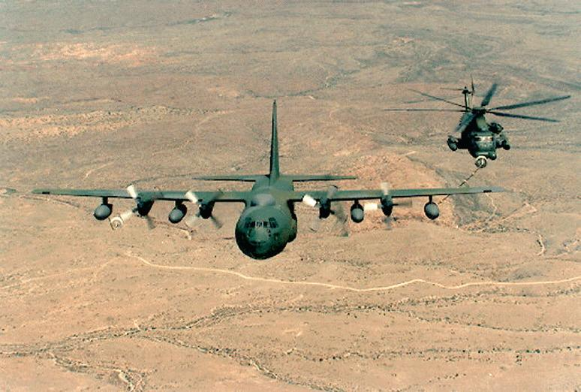

[**MC-130E/H Combat Talon I/II**](https://fas.org/man/dod-101/sys/ac/mc-130e.htm)

The Combat Talon conducts deep penetration air drop missions in a high threat environment. Using terrain mapping radar, terrain avoidance avionics, GPS and impressive ECM capabilities, in-flight refueling these aircraft specialize in low level long distance precision para drops deep in an opponent’s territory. Equipped with, a recovery system for retrieving a person from the ground or water, when a balloon is unfurled and the Combat Talon snatches the cable. AFSOC has an inventory of 24 ‘Combat Talon I’ and 24 ‘Combat Talon II’ aircraft, this is 10 more ‘Combat Talon I’ then existed in 1994.

|  |  |  |  |  |  |  |
| --- | --- | --- | --- | --- | --- | --- |
| Sqn | Name | Wing | Location | No. | Type | Remarks |
| 1st SOS | Anytime Anywhere | 353rd | Kadena AB, Japan | 5 | MC-130H | Combat Talon II |
| 6th SOS |  | 16 SOW | Hurlburt Field, FL | 12 | MC-130E | Combat Talon I |
| 7th SOS | Air Commandos | 352nd | RAF Mildenhall, UK | 5 | MC-130H | Combat Talon II |
| 8th SOS | Blackbirds | 16 SOW | Hurlburt Field, FL | 12 | MC-130E | Combat Talon I |
| 15th SOS | Global Eagles | 16 SOW | Hurlburt Field, FL | 11 | MC-130H | Combat Talon II |
| 550th SOS | Wolfpack | 58th | Kirtland AFB, NM | 3 | MC-130H | Combat Talon II |

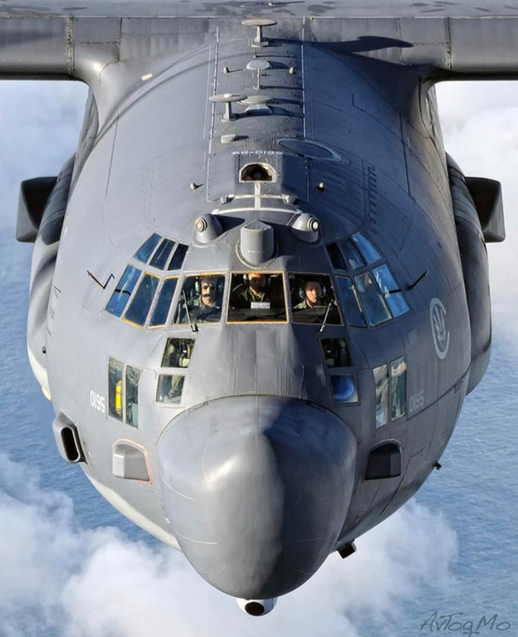

[EC-130E Commando Solo](http://www.af.mil/About-Us/Fact-Sheets/Display/Article/104535/ec-130j-commando-solo/) (note: link refers to the new EC-130**J** which did not exist in 1994)

This is a Psychological Operations aircraft that transmits programing and messages on radio, television, shortwave and military frequencies. There are six aircraft operated by 193rd Special Operations Squadron (SOS) of the Pennsylvania Air Guard.

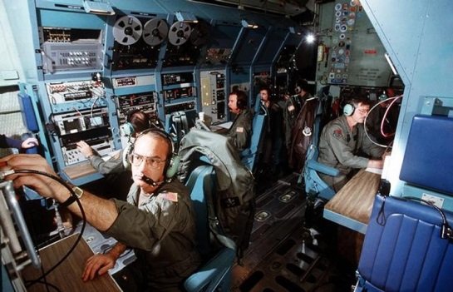

[**MH-53J Pave Low III**](http://www.americanspecialops.com/usaf-special-operations/aircraft/mh-53-pavelow/)

This is a heavy lift helicopter with impressive [capabilities](https://fas.org/man/dod-101/sys/ac/h-53.htm). The two main roles are Combat Search and Rescue (CSAR) and insertion/extraction of Special Forces teams. The ‘Pave Low’ is one of the few helicopters in the world that can be fueled while in flight, and it is the most powerful helicopter in the US military. Both the USN and USMC use the CH-53 but within the USAF, AFSOC is the only user. There are 41 of these aircraft in the inventory. A history of the Pave Low helicopters is [here](http://www.afsoc.af.mil/Portals/86/documents/history/AFD-131112-025.pdf).

|  |  |  |  |  |  |  |
| --- | --- | --- | --- | --- | --- | --- |
| Sqn | Name | Wing | Location | No. | Type | Remarks |
| 20th SOS | Green Hornets | 16 SOW | Hurlburt Field, FL | 12 | MH-53J |  |
| 21st SOS | Dust Devils | 352nd | RAF Mildenhall, UK | 12 | MH-53J |  |
| 31st SOS | Black Knights | 353rd | Osan AB, SK | 12 | MH-53J |  |
| 551st SOS | Owls | 58th | Kirtland AFB, NM | 5 | MH-53J | Air Reserve |

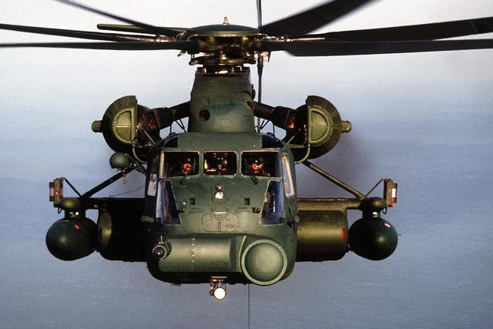

[**MH-60G Pave Hawk**](https://fas.org/man/dod-101/sys/ac/uh-60.htm)

A member of the UH-60 Blackhawk family of helicopters, the Pave Hawk augments the MH-53’s in both the CSAR mission and in delivering, supporting and extracting Special Forces teams. They have an all-weather radar, a retractable refueling probe and auxiliary fuel tanks to extend both the range and the acceptable conditions under which missions can be flown. 55th SOS ‘Night Hawks’ operate 10 of these helicopters from Hurlburt Field, Florida.

