**USAF Strike Aircraft**

The primary purpose of these aircraft are to deliver ordinance onto enemy targets, these targets can range from the very tactical, such as a tank or bunker up to the strategic level, such as the strike targeting Libya’s dictator Muammar Kaddafi in 1986. Alternatively, some references refer to these platforms as ‘Attack’ aircraft.

**[F-117 Nighthawk](https://fas.org/man/dod-101/sys/ac/f-117.htm)**

The ‘Stealth Fighter’ had its combat debut in Panama, but came into its own during the Gulf war where 36 of them were deployed. These aircraft are the first to use low observable technology and rely on their stealth to penetrate deep into enemy territory and conduct precision strikes with laser guided bombs. Based at Holloman AFB in New Mexico the 49th Fighter Wing fields two operational squadrons and a conversion training squadron. In total 59 aircraft were produced but only 52 of them are operational.

|  |  |  |  |  |  |  |
| --- | --- | --- | --- | --- | --- | --- |
| Sqn | Name | Wing | Location | No. | Type | Remarks |
| 7 FS | Screamin' Demons | 49th | Holloman AFB, NM | 12 | F-117A | Training Sqn |
| 8 FS | The Black Sheep | 49th | Holloman AFB, NM | 18 | F-117A |  |
| 9 FS | Flying Knights | 49th | Holloman AFB, NM | 18 | F-117A |  |

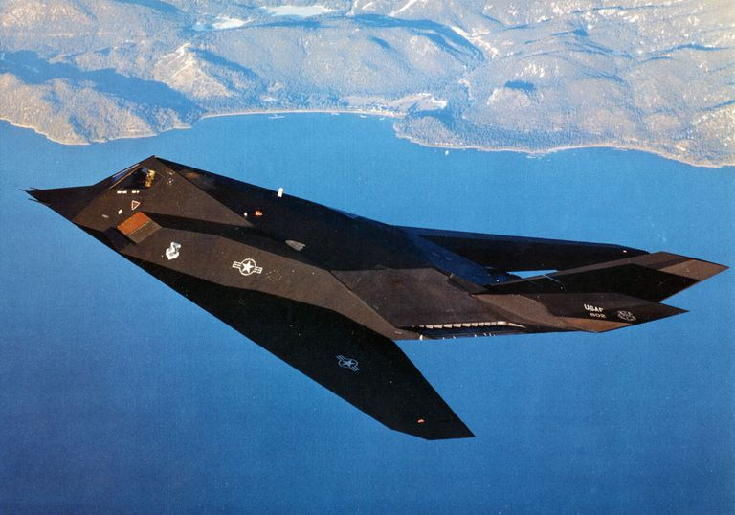

[**F-111F Aardvark**](https://fas.org/man/dod-101/sys/ac/f-111.htm)

The F-111 has a controversial history but proved its worth as a long range deep strike bomber during the Persian Gulf war and before that when bombing targets in Libya. This is high speed, long range, swept wing design with avionics that were very advanced when the ‘Varks’ were fielded in the 1960s. The FB-111 nuclear strike versions have been retired leaving two wings of tactical bombers, 38th Tactical Fighter Wing in the UK with the F-111E and the much improved F-111F in the 27th Tactical Fighter Wing at Cannon AFB.

|  |  |  |  |  |  |  |
| --- | --- | --- | --- | --- | --- | --- |
| Sqn | Name | Wing | Location | No. | Type | Remarks |
| 77 FS | All Aces, No Jokers | 38th | RAF Upper Heyford, UK | 24 | F-111E | USAFE |
| 78 FS | Bushmasters | 38th | RAF Upper Heyford, UK | 24 | F-111E | USAFE |
| 79 FS | Tigers | 38th | RAF Upper Heyford, UK | 24 | F-111E | USAFE |
| 428 FS | Buccaneers | 27th | Cannon AFB, MN | 32 | F-111E/F | Training Sqn |
| 522 FS | Fireballs | 27th | Cannon AFB, MN | 24 | F-111F |  |
| 523 FS | Crusaders | 27th | Cannon AFB, MN | 24 | F-111F |  |
| 524 FS | Hounds of Heaven | 27th | Cannon AFB, MN | 24 | F-111F |  |

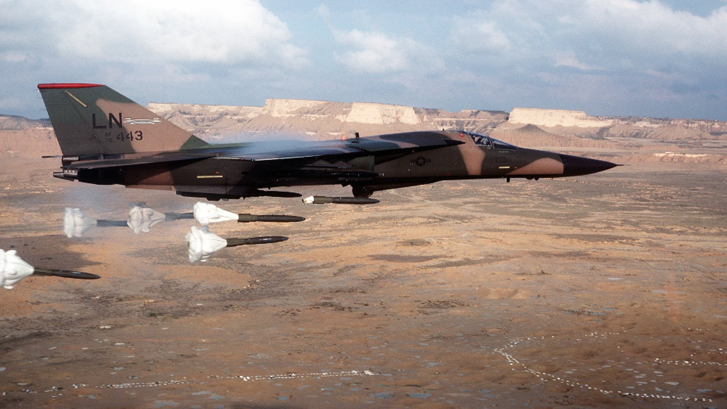

[**A-10/OA-10 Thunderbolt II**](https://fas.org/man/dod-101/sys/ac/a-10.htm)

This aircraft is not generally known by its official name but is universally called the ‘Warthog’. The A-10 is rugged, adaptable and survivable, but most importantly it is deadly. Specifically designed to conduct Close Air Support (CAS) missions in the dangerous and difficult area between friendly and enemy ground troops, the A-10 carries up to 16,000 lbs of ordinance and a 30mm Gatling gun. A derivative of the A-10 is the OA-10 which constitutes about 1/3rd of the fleet and is designed to be an airborne Forward Air Controller (FAC) used to guide other aircraft onto targets, otherwise it has all the same capabilities as the A-10 and looks very similar. The ‘Hogs’ have seen extensive active service in the Balkans and the Gulf War. Some extensive reshuffling has occurred with these squadrons since the Gulf War but 21 squadrons remain in service including 5 ANG and 2 Air Reserve.

|  |  |  |  |  |  |  |
| --- | --- | --- | --- | --- | --- | --- |
| Sqn | Name | Wing | Location | No. | Type | Remarks |
| 21 FS | Gamblers | 363rd | Shaw AFB, SC | 18 | A/OA-10 |  |
| 25 FS | Flying Elvises | 51st | Osan AB, S Korea | 18 | A/OA-10 | PacAF |
| 45 FS | Hoosier Hogs | 930th | Grissom AFB, IN | 18 | A/OA-10 |  |
| 47 FS | Dogcatchers | 442nd | Whiteman AFB, LA | 18 | A/OA-10 | Air Reserve |
| 55 FS | Shooters | 20th | RAF Bentwaters, UK | 18 | A/OA-10 | USAFE |
| 75 FS | Tiger Sharks | 23rd | Pope AFB, NC | 18 | A/OA-10 |  |
| 76 FS | Brown Birds | 23rd | Pope AFB, NC | 18 | A/OA-10 |  |
| 81 FS | Panthers | 20th | Spangdahlem AB, Ger | 18 | A/OA-10 | USAFE |
| 92 FS | Avengers | 20th | RAF Bentwaters, UK | 18 | A/OA-10 | USAFE |
| 103 FS | Black Hogs | 111th | Willow Grove | 18 | A/OA-10 | ANG |
| 104 FS | Fighting Orioles | 175th | Baltimore | 18 | A/OA-10 | ANG |
| 118 FS | Flying Yankees | 103rd | Bradley | 18 | A/OA-10 | ANG |
| 131 FS | Barnestormers | 104th | Barns | 18 | A/OA-10 | ANG |
| 172 FS | The Mad Ducks | 110th | Battle Creek | 18 | A/OA-10 | ANG |
| 303 FS | KC Hawgs | 442nd | Whiteman AFB, LA | 18 | A/OA-10 | Air Reserve |
| 354 FS | Bulldogs | 355th | Davis Monthan, AZ | 18 | A/OA-10 |  |
| 357 FS | Dragons | 355th | Davis Monthan, AZ | 18 | A/OA-10 |  |
| 358 FS | Lobos | 355th | Davis Monthan, AZ | 18 | A/OA-10 |  |
| 509 FS | Skulls | 10th | RAF Alconbury, UK | 18 | A/OA-10 | USAFE |
| 510 FS | Buzzards | 10th | RAF Bentwaters, UK | 18 | A/OA-10 | USAFE |
| 511 FS | Hogs | 10th | RAF Alconbury, UK | 18 | A/OA-10 | USAFE |

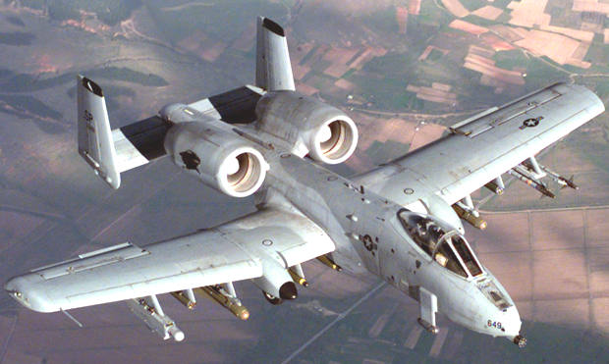

[**A-7D Corsair II**](http://www.aircraftinformation.info/art_A7.htm)

This aircraft was supposed to be retired in 1993 after 25 years in USAF service, and even longer service in the USN and USMC. Commonly known as the SLUF (Short Little Ugly …Fella), the other name for this workhorse was ‘Bomb Truck’ because of its ability to carry about 20,000 lbs worth of ordinance. The ‘D’ versions were passed on the ANG starting 1973 and by the mid ‘80s were exclusively flown the Air Guard as the A-10s filled regular squadrons. Although 459 of this version were produced they now only equip three ANG Squadrons in Tucson, Arizona. All of the remaining aircraft have had the LANA (Low Altitude Night Attack) upgrade and have Pave Penny laser targeting pods. (72 instead of the actual 47 were converted).

|  |  |  |  |  |  |  |
| --- | --- | --- | --- | --- | --- | --- |
| Sqn | Name | Wing | Location | No. | Type | Remarks |
| 148 FS | Kickin' Ass | 180th | Tucson, AZ | 18 | A-7D | ANG |
| 152 FS | Tigers | 180th | Tucson, AZ | 18 | A-7D | ANG |
| 195 FS | Warhawks | 180th | Tucson, AZ | 18 | A-7D | ANG |

