

**United States Army**

The United States Army is a large and powerful force, technologically advanced, generally well trained, and at a relatively high state of readiness. The 1980’s was a decade of change for the US Army. Coming out of the Viet Nam era, the new professional (vice conscript) force adopted new organizations, new training methods, new equipment, new tactics and overall a completely new concept of integration of combat power. The US Army of 1994 had been tested during Operation Desert Shield/Storm in Iraq and, although there was some improvement to make, proved to a great extent that the reforms had worked beyond the imagination of most.

The US Army in Europe through the latter part of the Cold war was the focus of the entire army structure. Led by 7th Army HQ, two full Corps (V & VII) were largely stationed in Germany with a third Corps (III Corps) based in the US but having pre-positioned equipment holdings in POMCUS (Prepositioning Of Materiel Configured in Unit Sets) sites. Although problematic due to maintenance, cost, security and standardization, this system was exercised rigorously in the annual REFORGER (REturn of FORces to GERmany) [Exercises](https://en.wikipedia.org/wiki/Exercise_Reforger). By 1989 the POMCUS system was set up to rapidly deploy six divisions, support elements and logistics to Germany, within 10 days, to reinforce the four divisions permanently stationed there. Historically this system came to a sudden end following the Gulf War, when VII Corps and over half of the forces in Germany were repatriated and rapidly deactivated.

In the Northern Fury world the US Army has experienced some difficulty obtaining consistent and clear government direction since the fall of the Berlin wall. The massive effort in the Gulf War was supposed to be the closing act to the Germany based VII Corps which, due to budgetary pressure to reduce spending, was due to deactivate in the early ‘90s. The increased tension from a resurgent Soviet Union has interrupted that plan mid stride – inconvenient for both military and budgetary planners. The end result is that some repatriation has occurred but some plans were canceled and others modified. The main points of impact are:

* 7th US Army HQ remains in Europe (double hatted as CENTAG HQ)
* The 18 Division structure established by the Reagan administration remains, therefore
  + 2nd Armored Division is not deactivated (planned for 1995)
  + 3rd Armored Division is not deactivated (in 1992)
  + 5th Infantry Division (Mech) is not deactivated (in 1992)
  + 6th Infantry Division (Light) is not deactivated (reduced to one Bde in 94, removed 98)
  + 7th Infantry Division (Light) is not deactivated (in 1994)
  + 8th Infantry Division (Mech) is not deactivated (in 1992)
  + 9th Infantry Division (Light) is not deactivated (in 1991)
  + Additionally all National Guard and Army Reserve ‘Training’ Divisions remain extant
* VII US Corps HQ remains in Europe but with a reduced staff and structure:
  + 1st Armored Division moved to the US with 3rd Brigade remaining in Germany
  + 3rd Infantry Division moved to the US with 3rd Brigade remaining in Germany
  + 77nd and 210th Artillery Brigades moved to the US with a POMCUS site in Germany
  + 7th Combat Engineer Brigade is transferred from VII Corps to 7th Army
  + 197th Infantry Brigade (REFORGER) is transferred to 7th Army as CENTAG reserve
  + 207th Military Intelligence Brigade is transferred to 7th Army for general support
* The ‘Berlin’ Brigade is due to deactivate in July of 1994.
* 56th Artillery Brigade, has exchanged its deactivated Pershing missile systems for M270 MLRS armed with MGM-140 ATacMS (Army Tactical Missile System) and remains a direct reporting unit to 7th Army HQ.
* The POMCUS program was expanded to include six more Brigade size sets of equipment; 2 for 1st Armored Division, 2 for 3rd Infantry Division, and 2 for the two artillery brigades.
* In order to maintain enhanced security in Kuwait, 187th Infantry Brigade Army Reserve has been activated. This is a unique structure as Battlegroup size elements from the standing army, National Guard and Reserve rotated through this Bde on an 8 month tour of duty. While in Kuwait they undergo a rigorous training program to enhance their combat capability.

It should also be noted that divisions based solely in the continental US (CONUS) except 82nd Airborne and 101st Air Assault Divisions, only had two active brigades. The third brigade was either National Guard or Army Reserve and these, although equipped the same as the active units, would take a minimum of 30 days to deploy.

During the turmoil of the post ‘Gulf War’ moves manning in the Army remained relatively constant. Although there was an initial dip in strength due to planned downsizing in 91-92, it has largely been made up in 93. The strength as of Jan 1994 is slightly smaller than its recent peak in the late ‘80s but about 200,000 more than historic - totals of the US Army is:

* Army: 755,000
* Army National Guard: 450,000
* Army Reserve: 582,000

**Structure**

Within the continental US (CONUS) there are six army level HQs (1st Army to 6th Army), these are primarily tasked a mobilization role in times of national crisis. They can be activated for operations such as 3rd Army in the Gulf war. The two active armies, 7th Army in Europe and 8th Army in Korea are on full operational status. Within CONUS all active duty units are assigned to Corps and most have a wartime deployment role. The Corps in CONUS are:

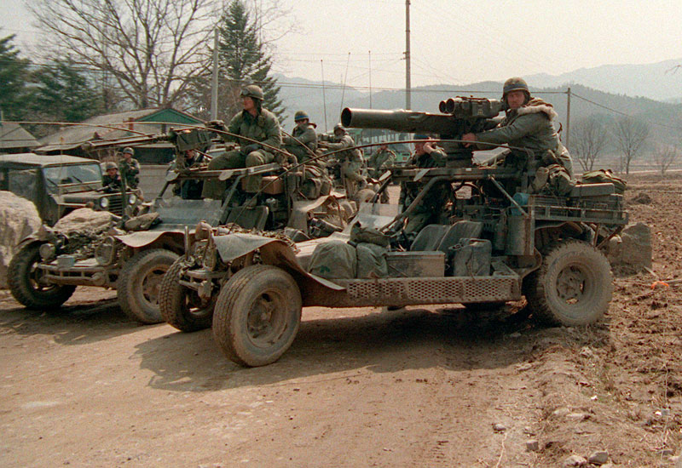**I Corps**

This is a small Corps charged with experimentation and development, but also has emergency deployment tasks. It is likely that I Corp would deploy to US Army Pacific, probably with 7th Infantry Division (ID), along with its artillery, aviation and air defence brigades. 9th ID is a very unique formation; it is the testbed light wheeled vehicles and rapid ground mobility. This division was earmarked to deploy to Northern Germany or Denmark, however its lightly armored infantry ((HMMWV or Desert Patrol Vehicles), combined with only having two tanks battalions (in its National Guard round-out brigade) may have precluded its employment on that front. Its high speed cross country mobility, on the other hand made the unit ideal for desert operations.

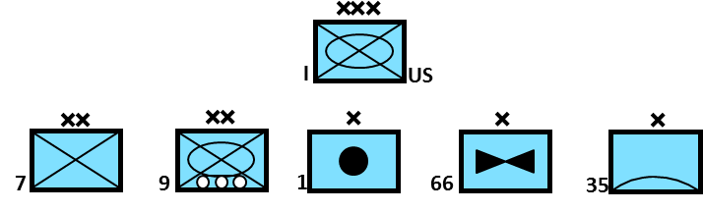

**III Corps**

The complete opposite of I Corps, this corps is a massive organization which is destined for Europe in its entirety. An initial glance at the organization is misleading however. III Corps, in addition to its own formations, is a holding organization for 7th Army in Europe. Divisions tasked with rapidly reinforcing both Europe based Corps through REFORGER are held under command of III Corps for training and administration while in CONUS, their parent Corps have operational command however. III Corps will deploy to northern Germany and operate as part of NORTHAG (British Army on the Rhine) while formations supporting V & VII Corps will be under command of CENTAG (7th US Army).

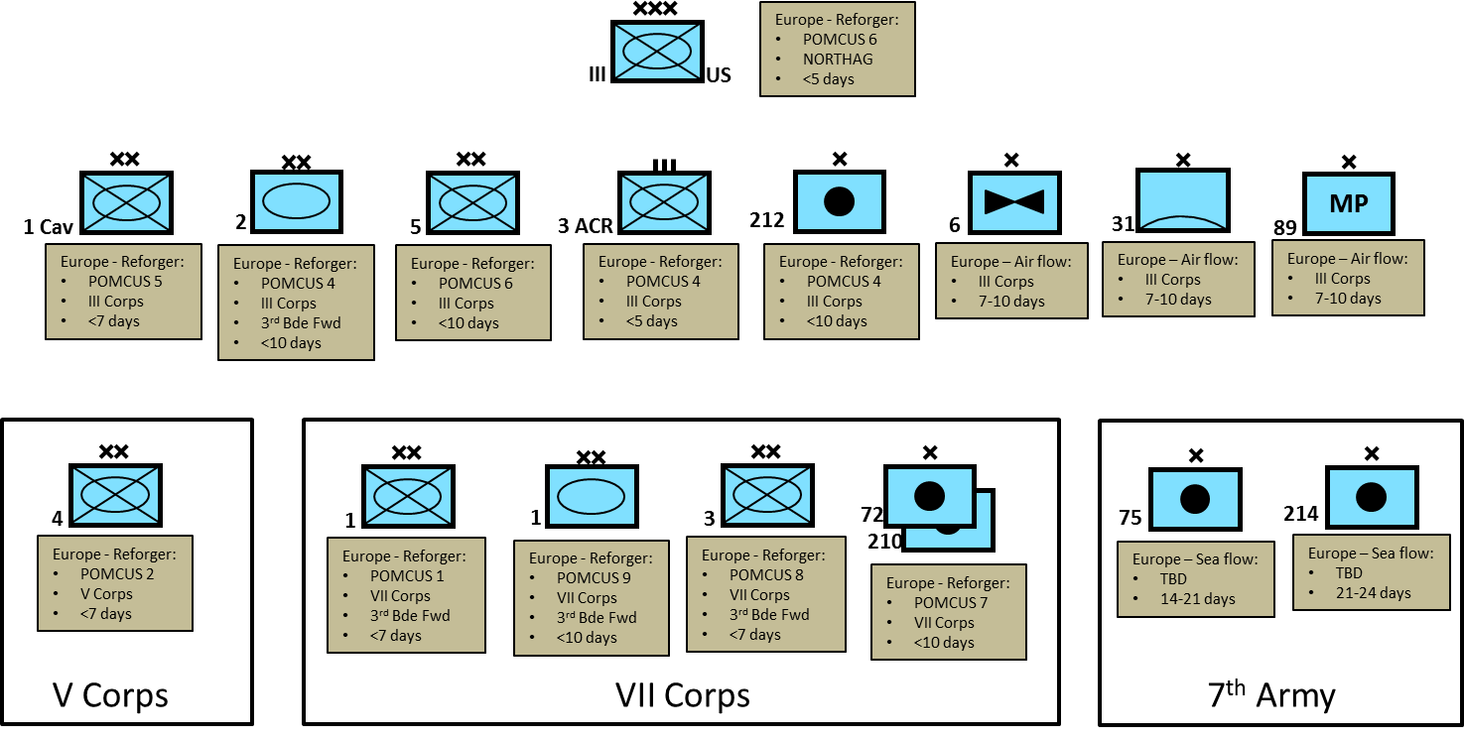

It is worth noting that the POMCUS policy was to move 6, now 8 divisions to Germany in less than 10 days: 1st Cav, 1st ID, 1st AD, 2nd AD, 3rd ID, 4th ID, 5th ID, 194th Armd Bde*, 197th Inf Bde*, 3 ACR, 212th FA Bde plus two more FA Bdes for Northern Fury. The last division (unless you count the three independent Bdes as a division) is 9th ID from I Corps, which would fly over in its entirety. The feasibility of all but the 9th ID deployment was well practiced, as discussed earlier, 9th ID was not well suited to the north German plain. (*From XVIII Airborne Corps below)

**XVIII Airborne Corps**

Commonly referred to as ‘America's Contingency Corps’ this organization has seen a lot of recent action and deployed to the Sini peninsula in 1982, Grenada in 1983, Panama in 1989 and the Gulf war in 1991. Similar to III Corps above, this formation is also charged with holding elements destined for Europe, but the main elements of the corps are its three rapid deployment divisions, each one unique. 82nd Airborne Division has a battalion task force on 24 hours notice to move anywhere on the globe, at all times, and the remainder of a brigade moving within 3 days. The 101st Air Assault Division maintains an aviation brigade with over 320 helicopters; more than most nations operate. 10th Mountain Division is capable of moving by air to anywhere in the world within 10 days. 10th Mountain has a National Guard round-out brigade but both of the other divisions are fully manned standing army units.

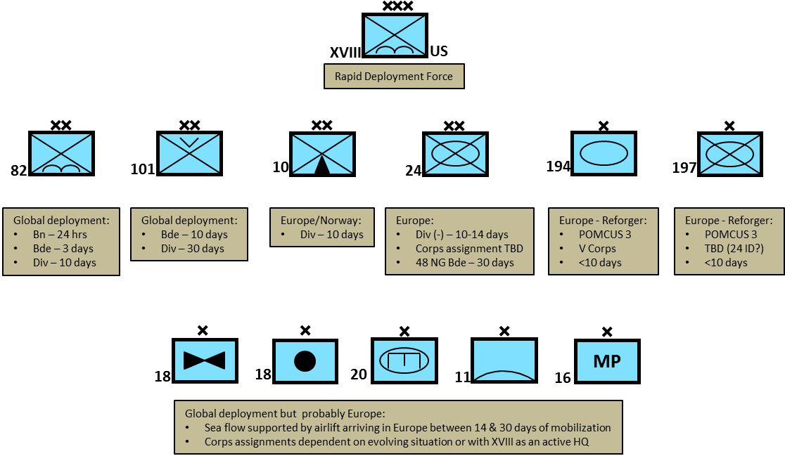

**US Army Europe**

Commanded by 7th Army HQ, also acting as NATO CENTAG, these two Corps and supporting units have been the focal point of US Army training and development since the end of the Korean War. After the post-Gulf War reductions this force is at its lowest point in terms of manning since 1950, with only two fully manned divisions, six independent or forward positioned brigades and two armored cavalry regiments. Given 10 days to mobilize, 7th Army or CENTAG would be a powerful force indeed, with 10 American, 7 German, 3 French and one Canadian division at its disposal. Ten days is a long time in a modern conflict however.

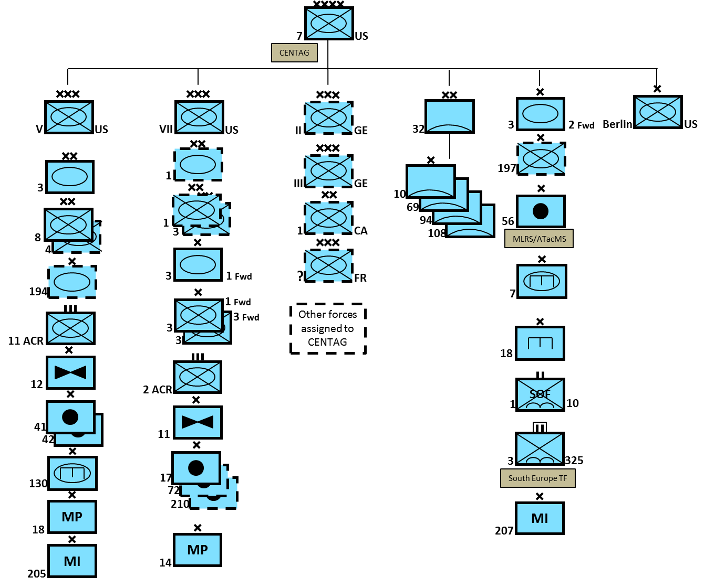

**US Army Pacific**

US Army Pacific is a diverse and dispersed organization. Commanded by Commander 8th Army with his HQ in South Korea and having forces in Alaska, Hawaii and Japan, this army relies very heavily on its allies and the USAF to add armor and firepower to the fight.

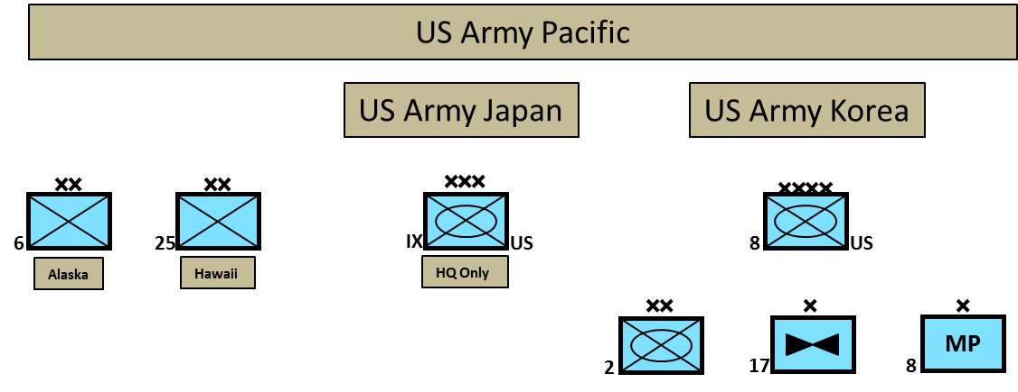

**US Army South**

The 193rd Infantry Brigade is the only regular army unit in this command. The primary purpose of this brigade is security of the Panama Canal Zone, but it also assists the Panamanian Government and other US agencies in conducting counter insurgency and counter narcotics operations.

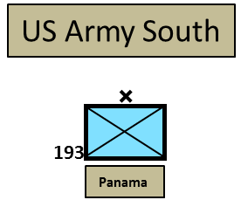

**US Army Kuwait**

In the three years following the Gulf War, tensions in the region have increased, primarily because Iran has become increasingly hostile towards the West and Iraq. In all likelihood this resurgent hostility is linked to improved Iranian relations with the Soviet Union. Therefore, in order to maintain enhanced security in Kuwait, the 187th Infantry Brigade, Army Reserve has been activated. The brigade is a shining example of the ‘Total Force’ concept within the US Army, the HQ, an infantry battalion, 5-5th Artillery Battalion HQ and one battery, Engineer Company and Cavalry Troop are from the Army Reserve. The regular army and the National Guard provide a battalion and an artillery battery each to the force. Each battalion rotates in for an 8-month tour of duty and mans in-place equipment, conducts an intensive training program and then returns home. The battalions rotate at 4 month intervals and routinely train with Kuwaiti and Saudi forces.

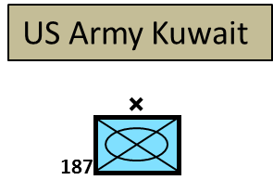

**US Army Special Operations Command**

The US Army Special Operations Command (USA SOC) is a relatively new organization, formed in 1989 when all Special Forces were place under the control of the United States Special Operations Command (SOCOM). This force, trains, equips, maintains and deploys Special Forces elements worldwide. Combined with US Navy and US Air Force Special Operations elements operating under the control of SOCOM, it can precipitate strategic effect with a comparatively minor force commitment.

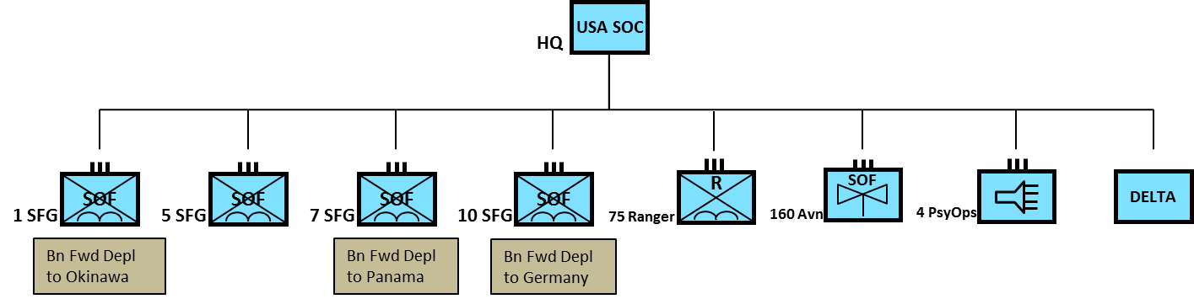

**US Army Reserve**

The Army Reserve is a force of 582,000 personnel, 1/3rd of the total strength of the army. Although the vast majority are ‘part time’ soldiers, they are well trained and equipped, subject to immediate recall and many have regular army experience. Part of the reserve structure are the 10 ‘Training Division’ HQs, their primary function is to be a focus for mobilization, training and equipping mobilized troops, and perhaps commanding those troops as a follow on formation, or providing replacements for battle losses. Another factor to consider when examining the diagram below, logistics units are not included, and a large portion of the Army Reserve are logistics units.

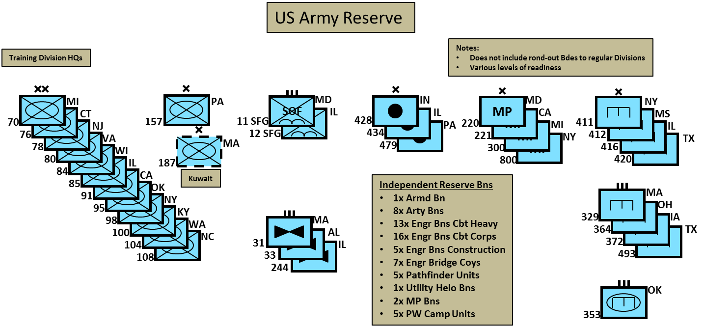

**The US Army National Guard**

The National Guard (NG) represents 25% of the deployable army and is a fundamental element in the ability of the US Army to succeed in battle. Over 60,000 National Guardsmen deployed to the Gulf War including two formed artillery brigades. The Gulf War also pointed out some shortcomings in NG readiness and a program has been put in place to rectify these. Some units are equipped with the latest generation of equipment while most use slightly older kit, but even that is the same or better than some NATO allies. Four of the NG division HQs, as well as the IX Corps HQ, at least one artillery brigade and probably several other elements have a follow on reinforcement role to NATO. Readiness levels have improved since the Gulf War as have training programs. Most units should be ready to deploy within 30-45 days of mobilization while some will take up to 60 days of training with some re-equipping. It is likely that more than 50,000 NG troops will deploy individually or in small units within the first 14 days of mobilization including up to five artillery brigades, two engineer brigades and one or two aviation brigades.

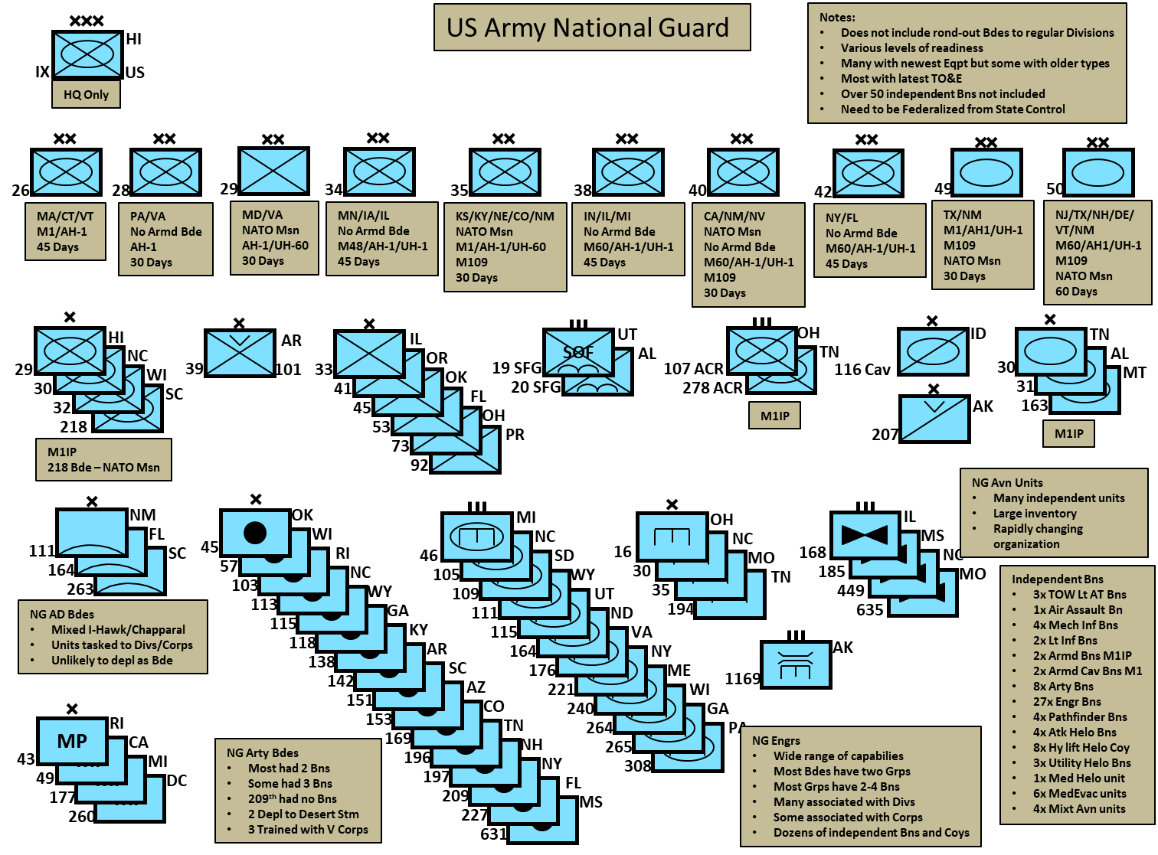

**Equipment**

**Main Battle Tank (MBT)**

[**M1**](https://fas.org/man/dod-101/sys/land/m1.htm): The extremely successful M1 Abrams MBT began production in 1979 and continued through 1985 when the last of 3,273 were produced for the US Army. This is a 61 ton tanks with a 105mm rifled gun, it can travel at 45 MPH (72 KPH) and has a range of 310 miles (500 Km). This is an excellent, reliable, well proven tank, it has the same gun as the Leopard 1, but is 50% heavier and has a shorter range. The main concern with this MBT is high fuel usage requiring additional logistic support. After sales to Kuwait and Saudi Arabia, upgrades to later variants and general attrition are factored in; there are 1630 basic M1s available to the US Army in 1994.

**M1IP**: This version has improved engine performance, efficiency, and better turret armor but in most other ways is the same as the M1. There were 894 produced in 1984.

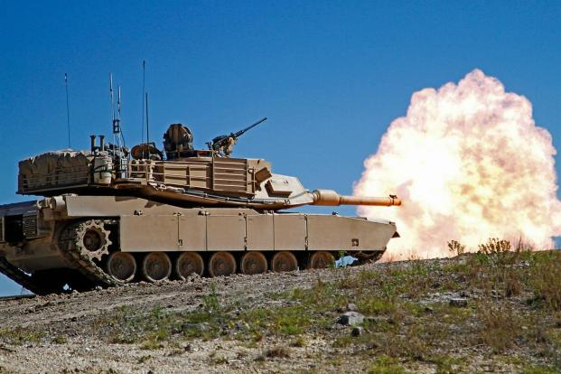**M1A1**: This tank, in addition to other improvements, replaced the gun with the 120mm Smooth bore cannon, the same gun that is on the Leopard 2. In comparison the M1A1 is heavier but achieves the same speed (42 MPH/68 KPH) over a longer distance 288 miles (463 Km) versus the Leopard 2 which achieves a range of 211 miles (340 Km). By 1992 there were 4,976 M1A1s produced.

**M1A2**: Although 190 were produced by 1994, there were about 1000 M1s upgraded to a similar configuration as the M1A1 in particular upgrading the gun. They also had a second thermal site for the commander allowing rapid engagement subsequent targets at night or in obscured conditions. Total available in early 1994 is 1,190.

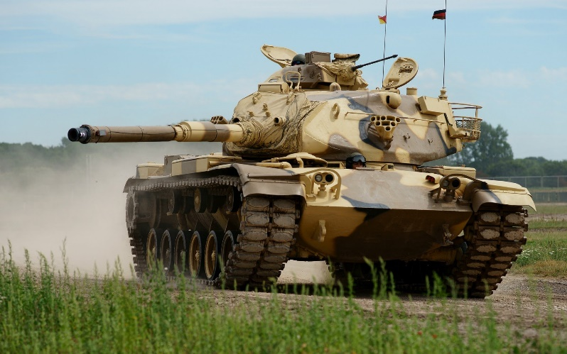[**M60A3**](http://www.tanks-encyclopedia.com/coldwar/US/M60_Patton.php): Built in the 1980s, the latest version of the ‘Patton’ MBT carried the same British made L7, 105mm riffled gun as the M1 Abrams, with a fire control system that produced a 70% hit probability of another tank at 2000 meters. By the time production stopped over 1700 of these tanks had been built and another 1700 older models had been converted to this standard.

**Disposition of MBTs**

As the M1A2 Abrams continues to be produced, an ongoing program is cascading newer MBTs across the entire army. Formations assigned to REFORGER have a higher requirement as they need to provide a fill set of equipment to the POMCUS site, while maintaining a partial set for training in CONUS. Formation assigned to 7th Army Europe, both permanently stationed and REFORGER units require approximately 5,300 MBTs, 1,800 of which will cascade to NG units upon mobilization. Other active army users such as I Corps, 24th ID and PACOM require another 500 MBTs. All of these units are also equipped with the M1A1 or M1A2 Abrams MBTs. Army Reserve elements, NG independent armored battalions and brigades as well as the armored battalions in independent infantry brigades and armored cavalry regiments are equipped with the M1IP. The remaining formations are a mix of basic M1 MBTs and M60A3s.

**Armored support vehicles**

All armored support vehicles are based on the M60 chassis. Although some support vehicles based on the M1 are in development, they are several years from fielding. These are spread throughout the force:

* 312 x M728 Combat Engineer Vehicle (CEV)
* 400 x M60 Armored Vehicle Launched Bridge (AVLB)
* 1,427 x M88A1 Armored Recovery Vehicles (ARV)
* 896 x M88 upgraded to A1 standard

[**M2 Bradley Infantry Fighting Vehicle (IFV)**](https://fas.org/man/dod-101/sys/land/m2.htm)

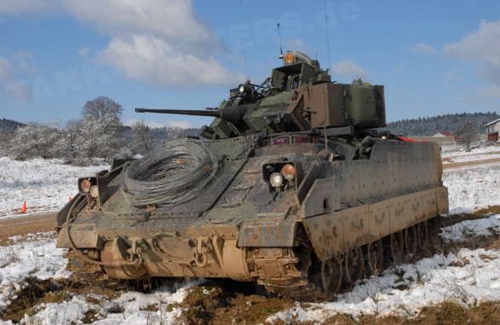The Bradley is the standard infantry vehicle in the mechanized forces of the US Army. It is armed with a 25mm ‘Bushmaster’ chain gun, has a crew of three and carries six soldiers able to dismount to clear the enemy. By 1994 initial production was complete and upgrading older versions to meet the latest standard was underway, this is several months faster then happened historically. In total 4,641 M2s were built with over half being built to the A2 ‘high survivability’ standard. All but the first 1,600 A0 variants also carried a TOW 2 missile launch system. M2 disposition is roughly equivalent to the M1A2 laydown, with Germany based units and POMCUS sites having the latest A2 variants and CONUS based units, Reserve or NG having the A0.

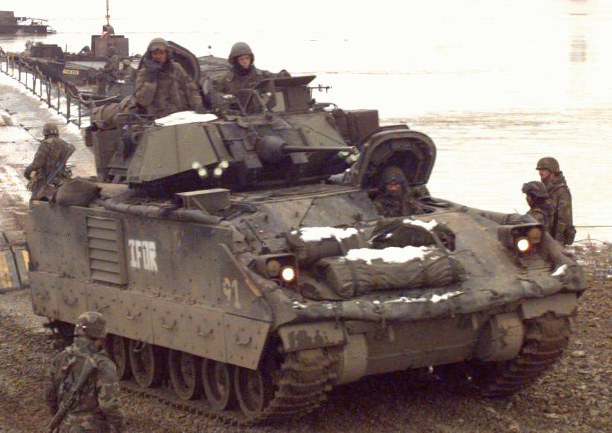[**M3 Bradly Cavalry Fighting Vehicle (CFV)**](http://www.military-today.com/apc/m3_bradley.htm)

Almost identical to the M2 in appearance, the M3 only carries two dismounts, with the remainder of the space used for extra radios, storage and ammunition for the TOW missile systems. In all, 2,083 CFVs were built and issued to all armored cavalry units, including NG units. These had the same variant details as the M2 and once again, Germany has the latest equipment while the older variants requiring refit are in CONUS.

[**M113 Armored Personnel Carrier (APC) Family**](https://fas.org/man/dod-101/sys/land/m113.htm)

This versatile and reliable family of vehicles has been in use for over 30 years in the US Army and has found its way into over 50 other armies around the world. Some 34,000, primarily the standard ‘Battlefield Taxi’ variant were produced for the US, while over 80,000 were produced worldwide. These vehicles are used in virtually every mechanized unit in the army and are often pushed into roles they were not designed for. In 1994 the following are in the inventory:

* Approximately 16,000 x A1, A2 or A3 variant standard troop carrier.
* 1,600 x M113A4 Armored Medical Evacuation Vehicle (AMEV)
* 1950 x M106 mortar carriers with 107mm (4.2in) mortars.
* 1275 x M125 mortar carriers with 81mm mortars.
* 4000+ x M548 ammunition carrier.
* 5000+ x M577 command post vehicle.
* 3300 x M901 Self Propelled (SP) TOW-2 missile launchers.
* 1000+ x M981 Fire Support Team Vehicle (FIST V)
* 600 x M730A2 Guided Missile Equipment Carrier (Chaparral)

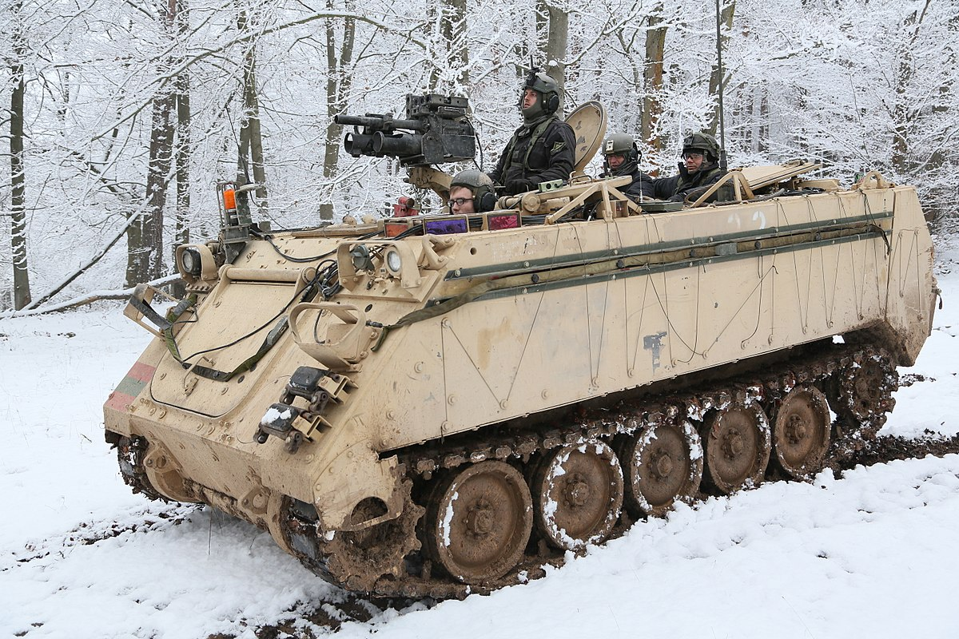

**Artillery**

The US Army has vast quantities of artillery systems to outfit the 48 artillery brigades across the force. Each division has a DivArty Bde generally consisting of a 155mm battalion with 18 guns working as Close Support each maneuver brigade, plus a battery of MLRS (M270 Multiple Launch Rocket System) and a target acquisition battery in General Support. 82nd and 101st divisions have 105mm Close Support battalions and a 155mm General Support Battalion. The 30 independent brigades have a wide range of configurations and are meant to provide the Corps and Army commanders flexibility by supporting the main effort divisions with extra fire power. Key artillery systems are:

* 1100+ x [M101](https://fas.org/man/dod-101/sys/land/m101a1.htm) & [M102](https://fas.org/man/dod-101/sys/land/m102.htm) towed 105mm howitzers.
* 150 x [M119](https://fas.org/man/dod-101/sys/land/m119.htm) (Light Gun) towed, air portable 105mm howitzers.
* 2,400+ x [M109A2](https://fas.org/man/dod-101/sys/land/m109.htm)/A3/A4 SP 155mm howitzers.
* <100 x M109A6 [Paladin](https://fas.org/man/dod-101/sys/land/m109a6.htm) SP Autonomous howitzers (24th ID).
* 1000+ x [M198](https://fas.org/man/dod-101/sys/land/m198.htm) towed 155mm howitzers.
* 526 x [M114](https://fas.org/man/dod-101/sys/land/m114.htm) towed 155mm howitzers.
* 1046 x [M110A2](https://fas.org/man/dod-101/sys/land/m110a2.htm) SP 203mm howitzers.
* 750+ x M270 SP [MLRS](https://fas.org/man/dod-101/sys/land/m270.htm) (replacing all Lance and Pershing systems)
* 35- x MGM-52 [Lance](https://en.wikipedia.org/wiki/MGM-52_Lance) SSMs, conventional warheads only, retiring.

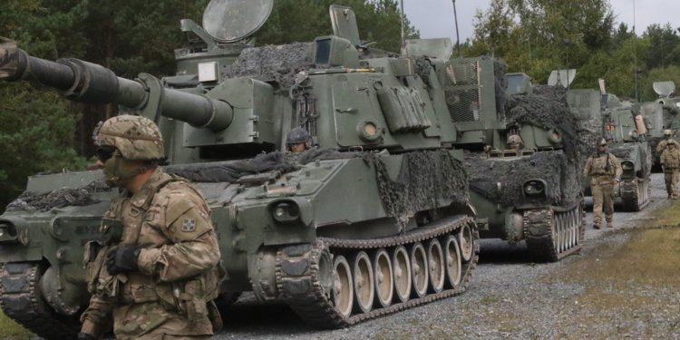

**Air Defence systems**

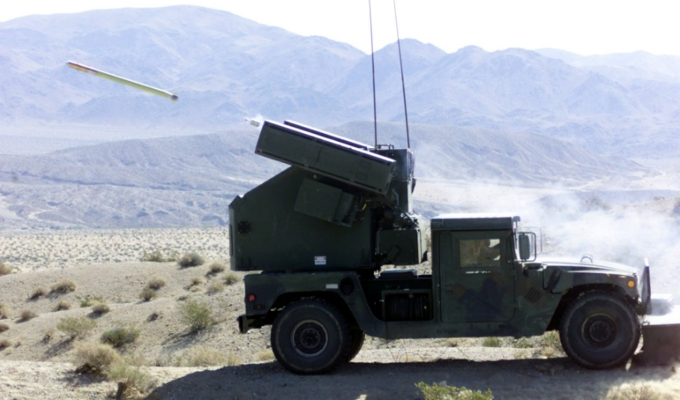The 10 Air Defence Artillery (ADA) brigades across the army are allocated roughly one per Corps with additional brigades under army control. There are some independent units supporting fixed installations. Each brigade is unique and task tailored for the rolls and responsibilities it has been given. Generally, US Army ADA is focused on the High Level and the Very Low Level air defence threats, leaving medium level threats to other nations or NATO air forces to deal with. The systems in inventory are:

* 220 x [M167](https://en.wikipedia.org/wiki/M167_VADS) towed 20mm Vulcan.
* 360 x [M163](https://en.wikipedia.org/wiki/M163_VADS) SP 20mm Vulcan.
* 1060 x [Stinger](https://fas.org/man/dod-101/sys/land/stinger.htm) missile launchers (13,000 missiles).
* 500+ x [Avenger](https://fas.org/man/dod-101/sys/land/avenger.htm) HUMMWV mounted Stinger missile launcher.
* 600 x [Chaparral](https://fas.org/man/dod-101/sys/land/m730.htm) SP.
* 500+ x [MIM-104 Patriot](https://en.wikipedia.org/wiki/MIM-104_Patriot) SP High level missile system
* 400+ x [I-Hawk](https://en.wikipedia.org/wiki/MIM-23_Hawk#I-Hawk:_MIM-23B) towed High level missile system