**Expeditionary Support Group (ESG) Kearsarge**

ESG Kearsarge has been on patrol in the Mediterranean for the past two months. At war start she is off the coast of Egypt conducting a training exercise with British and other NATO forces based on or near Cyprus. As far as ESGs go the escort for this one is quite weak, *USS Bainbridge* a 30-year-old CGN, a non-VLS Spruance, a Farragut class DDG and a Knox class frigate; however, with the *USS Eisenhower CVBG* also operating in the Mediterranean and the *USS Iowa* BB group nearby this is considered an acceptable risk. Unfortunately, the Bainbridge was forced to detach 10 days ago for a major engineering failure in its fresh water system and had to return to Rota Spain for repairs. As war starts the Eisenhower is also at the other side of the Med.

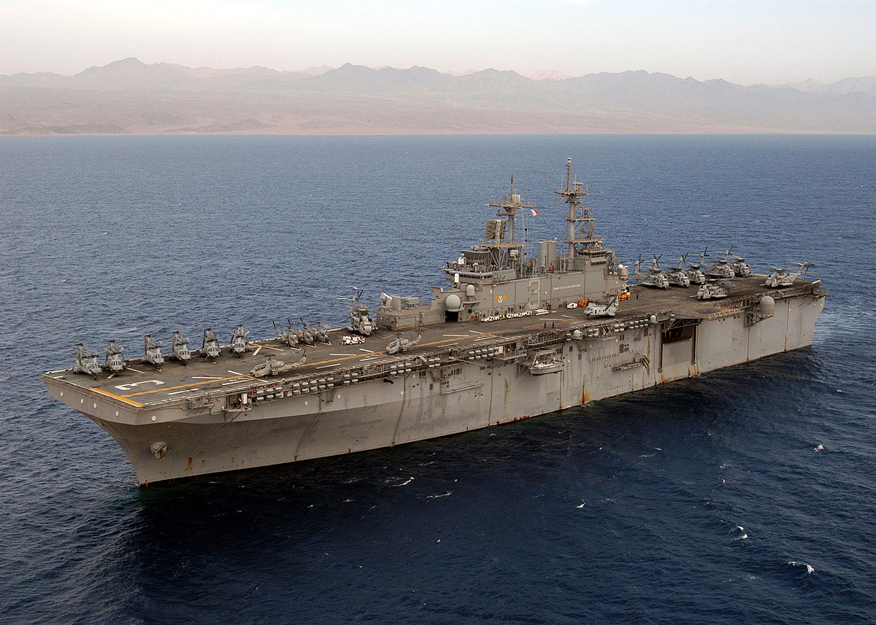

LHD 3 USS Kearsarge, in 1994 she is less than one-year-old and one of the most capable amphibious ships in the USN

ESG Kearsarge

* LHD 3 USS Kearsarge
  + Elem VMA-331 – 6x AV-8B Harrier II+
  + Elem HMLA-467 – 6x AH-1W and 4x UH-1N
  + HMM-264 – 12x CH-46E
  + Elem HMH-461 – 4x CH-53E
* CGN 25 USS Bainbridge (Detached)
* DDG 43 USS Dahlgren
* DD 983 USS John Rodgers
  + Elm HSL-60 – 2x SH-60B
* FF 1079 USS Bowen
  + Elem HSL-32 – 1x SH-2G
* LPD 14 USS Trenton
* LSD 46 USS Tortuga
* LST 1181 USS Sumter
* LST 1197 USS Bristol County (Detached)
* 22nd MEU (Special Operations Capable)

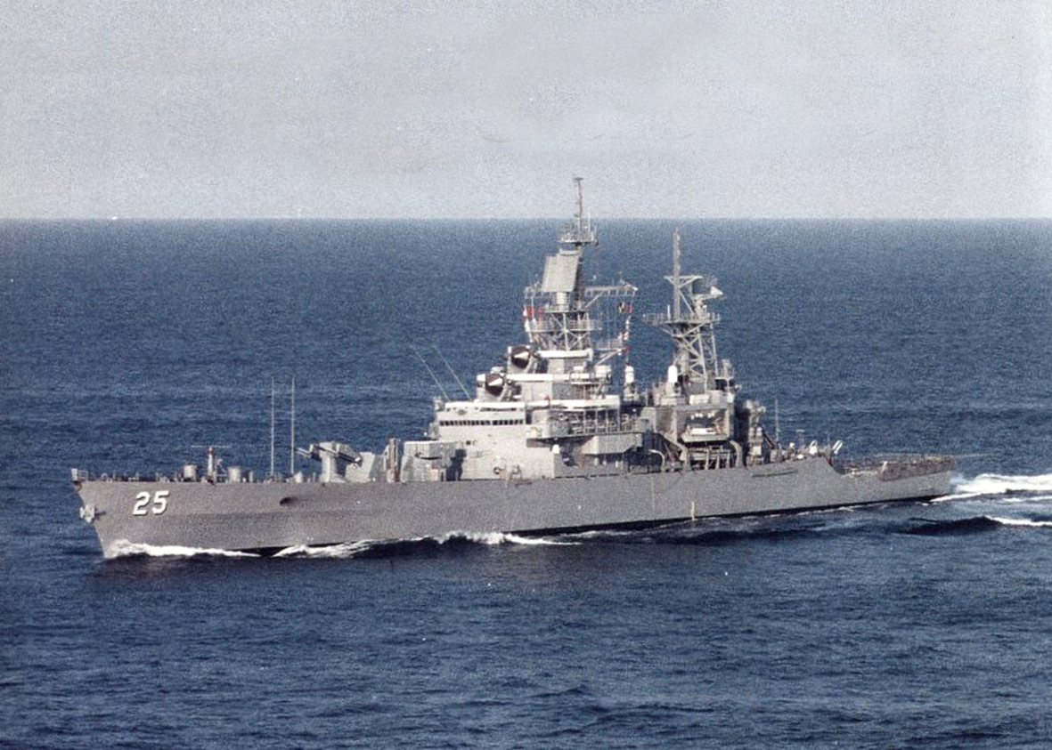

*CGN 25 USS Bainbridge*, a unique ship based on the Leahy class cruiser, she was commissioned as a nuclear powered destroyer (DLGN) but was reclassified to cruiser in 1975. She is a ‘double ended’ air defence ship meaning she has two Terrier missile launchers and has undergone a New Threat Upgrade (NTU) making her a capable Air Defence ship, but has no guns – an awkward attachment to an amphibious group.

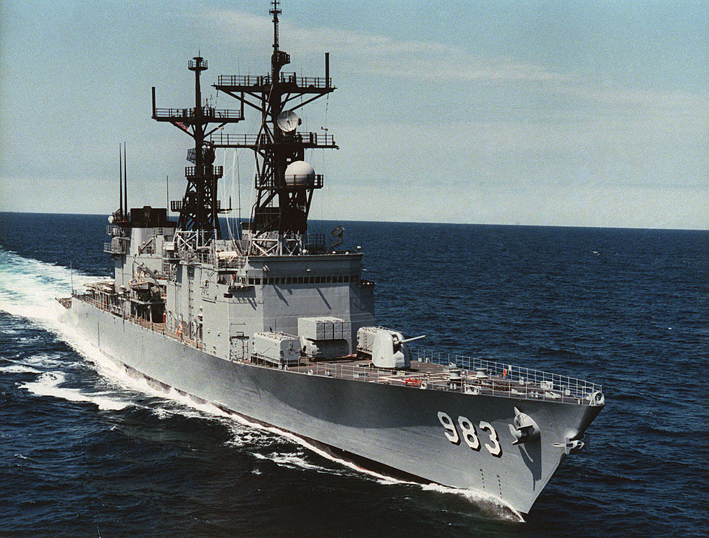

*DD 983 USS John Rodgers* is one of seven Spruance class destroyer not upgraded with a vertical launch system, instead she has an Armored Box Launcher (ABL) with 8 Tomahawk Land Attack Cruise Missiles (T-LAM). Her air defences are relatively weak with only Sea Sparrow for short range defence but her embarked helicopters provide significant flexibility and combined with her ASW capability she is a dangerous ship to any lurking submarines.

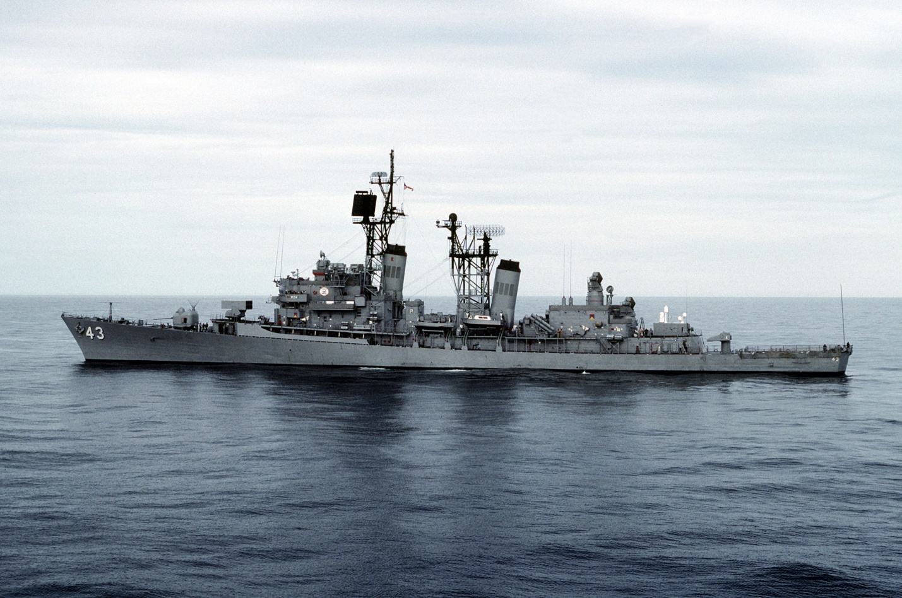

*DD 43 USS Dahlgren* is Farragut class destroyer which in Northern Fury has received the New Threat Upgrade (NTU). Now equipped with ‘Standard’ SM-2 missiles she is a capable air defence ship.

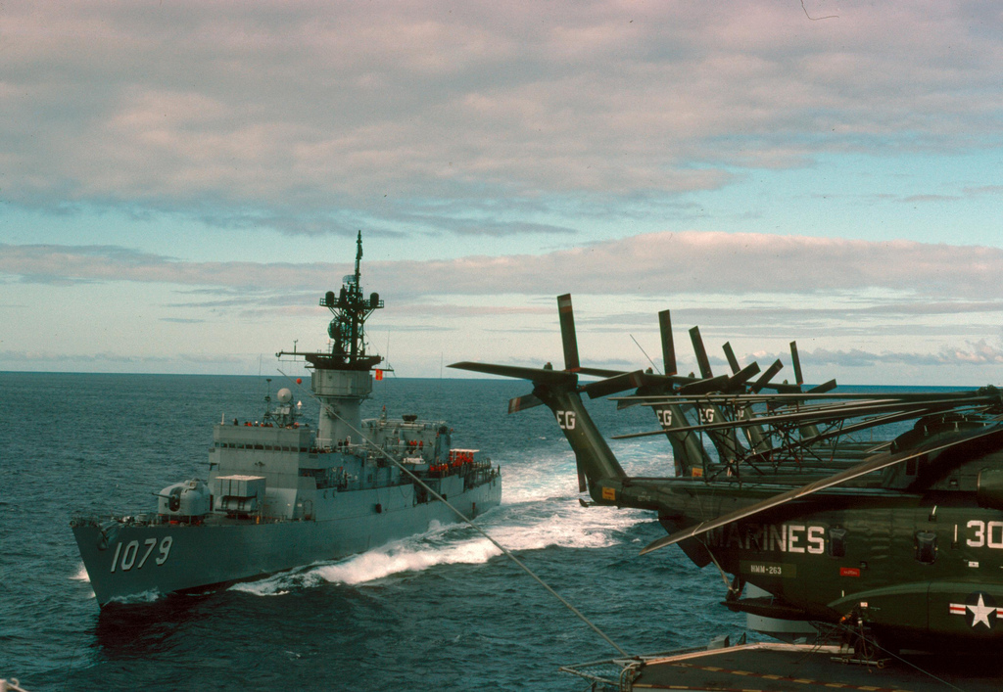

*FF 1079 USS Bowen* is Knox class frigate. She is a very basic version of this class and has had her Harpoon missiles removed to install a Phalanx CIWS.