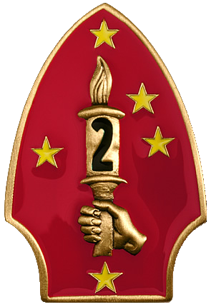

**2nd Marine Division**

**GCE**: The 2nd Marine Division forms the Ground Combat Element for II MEF’s operation to retake Iceland. The 2nd Marine Regiment is not involved directly in this operation, they have one Battalion (2/8 Marines) in the Mediterranean as 22nd MEU who will remain there until re-tasked, and one Battalion (1/8 Marines) acting as the II MEF reserve pre-positioned in Gander Newfoundland, while the remaining Battalion (3/8 Marines) secures the three airbases in Greenland.

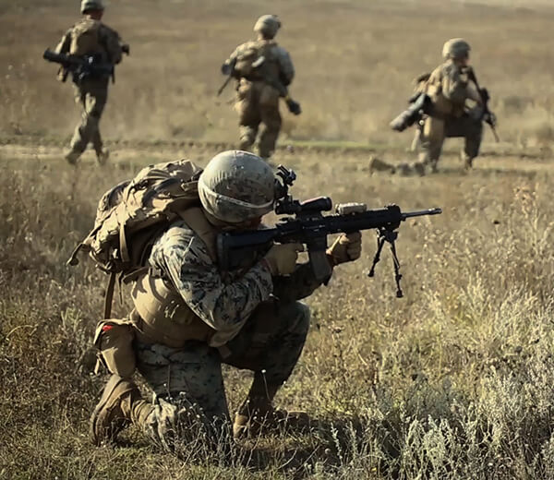

Commander 2nd Marine Division has grouped his forces into two powerful Regimental Landing Teams (RLT); reinforcement by 4th Marine Davison has allowed him to attach a Tank Battalion to each RLT while keeping 2nd Light Armored Infantry Battalion as his reserve. Amphibious support, Reconnaissance, Combat Engineers and Combat Service Support elements will support both RLTs but remain under Divisional control. For Artillery support, two M198 Batteries of 1/10th (a Bty is with the MEU in the Med) and the entire 5/10th (24 x M109) will be in General Support (GS) to the Division with the main task of Counter Battery.

**(-)**

**10**

**2/10**

**2**

**3/6**

**2/6**

**2**

**6**

**1/6**

**2**

**2**

**2**

**CBT**

**8**

**3/10**

**4**

**2/4**

**2/8**

**1/8**

**5/1010**

**(-)**

**1/10**

**2**

**D**

**2**

**CSS**

**Artillery**

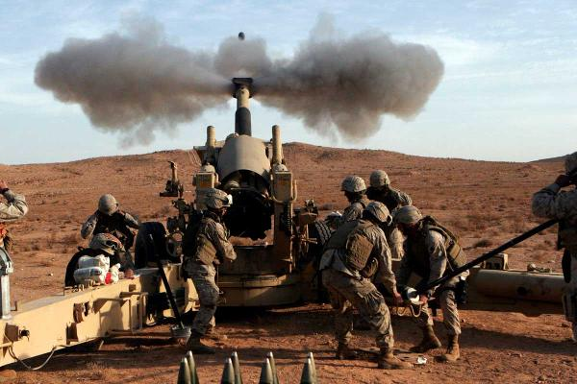

10th Marine Regiment has four Battalions of artillery. Three of the Battalions are designated as ‘Close Support’ to the three Marine Infantry Regiments and equipped with 24 M198 towed 155mm howitzers each; 2/10th and 3/10th Marines will land with their affiliated RCTs however, 1st Battalion will deploy to Iceland with two Batteries in the GS role (‘C’ and ‘I’ Batteries), ‘B’ Battery is in the Med with 22nd MEU and ‘A’ Battery is in Greenland waiting for transport if it is needed or possibly to deploy with the MEF reserve. The fourth Battalion (5/10th Marines) is equipped with 24 M109 Self Propelled Howitzers and will land as GS, these were historically retired in 90/91 but retained in Northern Fury, they are the A-3 variant and not the semi-autonomous A-6 Paladin used by the US Army.

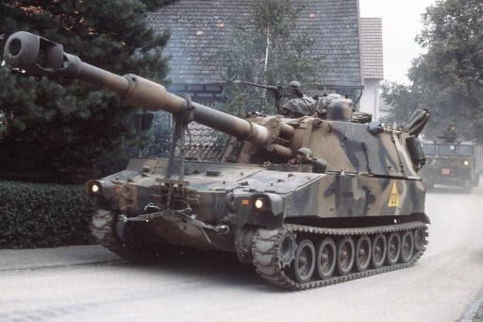

**Light Armored Vehicle (LAV-25)**

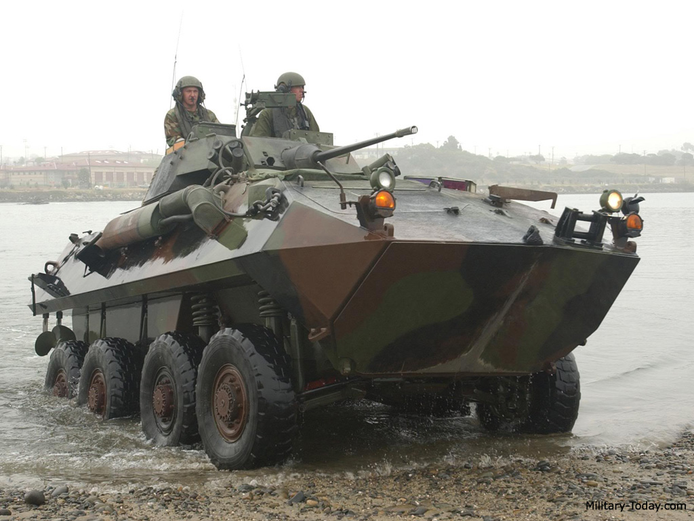

A new and evolving organization in the Division is the Light Armored Infantry Battalion with around 100 LAV-25 variants. 56 of them are the standard infantry carrier with the 25mm Gun.

2nd Light Armored Infantry (LAI) Battalion started life in 1984 as the 2nd Light Armored Vehicle (LAV) Battalion before adopting its current name in 1988. It is due to change again to the Light Armored Reconnaissance (LAR) Battalion later in 1994. The unit has 4 infantry companies with 56 Infantry LAVs, a TOW platoon with 16 LAV-TOW, 8 LAV-Mortar, 8 LAV Command posts, 6 LAV wreckers and 16 Logistics LAV variants.

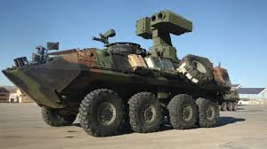

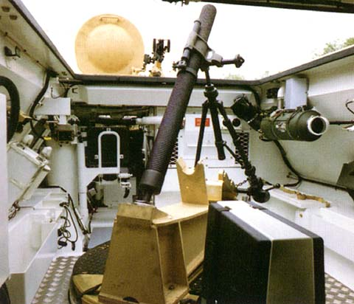

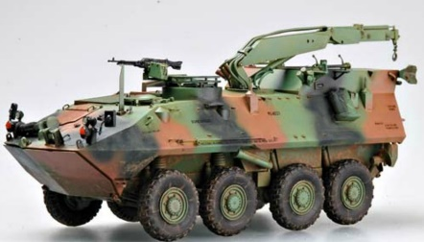

**Marine Armor**

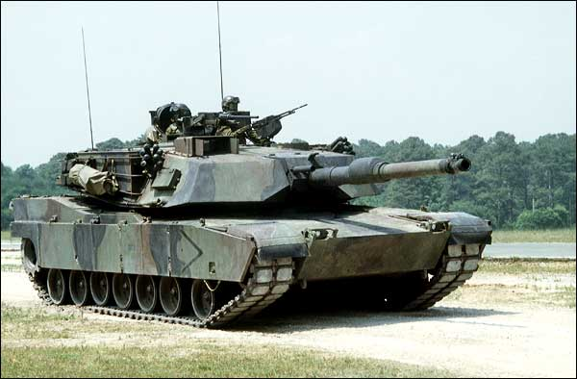

Both 2nd and 4th Tank Battalions are equipped with 70 M1A1 tanks and 72 TOW missile systems providing some heavy punch to the RLTs.

2nd Tank Battalion fought in the Gulf War with Viet Nam era M60 Tanks but exchanged them for the new M1A1s upon returning to the US. In addition to the 4 tank companies with 17 tanks each, there is an Anti-Tank company with 72 TOW mounted in HUMVEEs in 3 platoons of 24 each. Combined, this battalion gives significant direct fire capability to the Division.

4th Tank Battalion is part of the USMC reserve. It was the only USMC unit to deploy to the Gulf War with the M1 and is in need of a new Motto. The current Motto ’53 Days’ represents the time from activation to combat in the Korean war. In the Gulf War they were in action only 32 days after activation. In this war they were activated as a precaution on the 10th of Feb and will see combat on the 27th, a mere 17 days.

