**TG Hayler**

TG Hayler is tasked with providing a close screen to the Amphibious Force. This is a small but potent group consisting of two destroyers and two frigates.

TG Hayler

* DD 989 USS Deyo
  + Elem HSL-34 – 2x SH-60B
* DD 997 USS Hayler
  + Elem HSL-40 – 2x SH-60B
* FFG 10 Duncan
  + Elm HSL-32 – 2x SH-2G
* FFG 14 Sides
  + Elm HSL-74 – 2x SH-2F

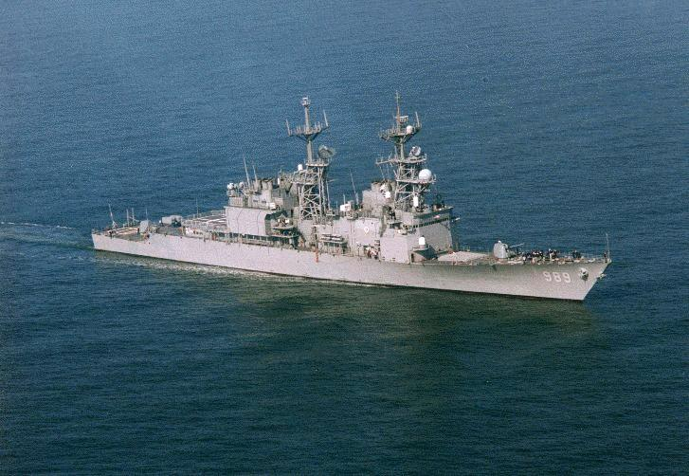

Both USS Deyo and USS Hayler are modernized Spruance class DDs with vertical launch systems and are very capable ASW Platforms.

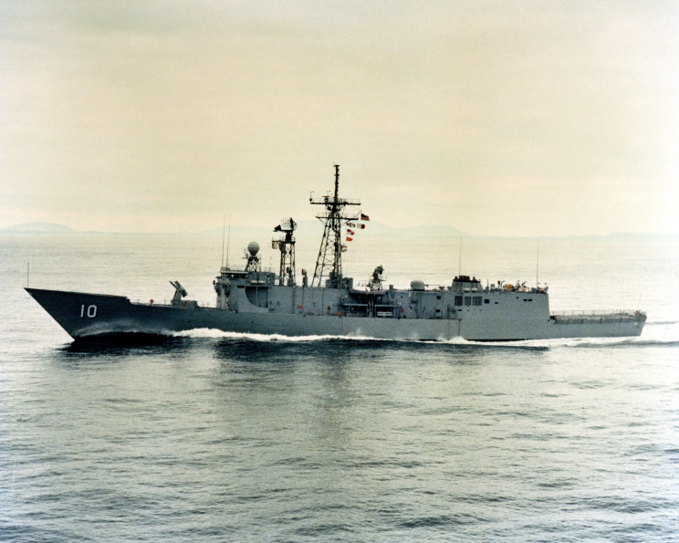

Both USS Sides and USS Duncan are ‘Short Hull’ Oliver Hazard Perry class FFGs, very capable and well balanced ships, but with the older SH-2 ASW helicopters.