**TG Mobile**

TG Mobile is transporting the support elements of 8th Marine Regiment and consists mainly of slower ships.

TG Mobile

* LKA-115 Mobile
* LST-1179 Newport
* LST-1180 Manitowok
* LST-1190 Boulder County
* LST-1191 Racine
* T-AOT 169 Sealift Arabian Sea
* FF-1195 Truett
  + Elm HSL-84 – 1x SH-2F

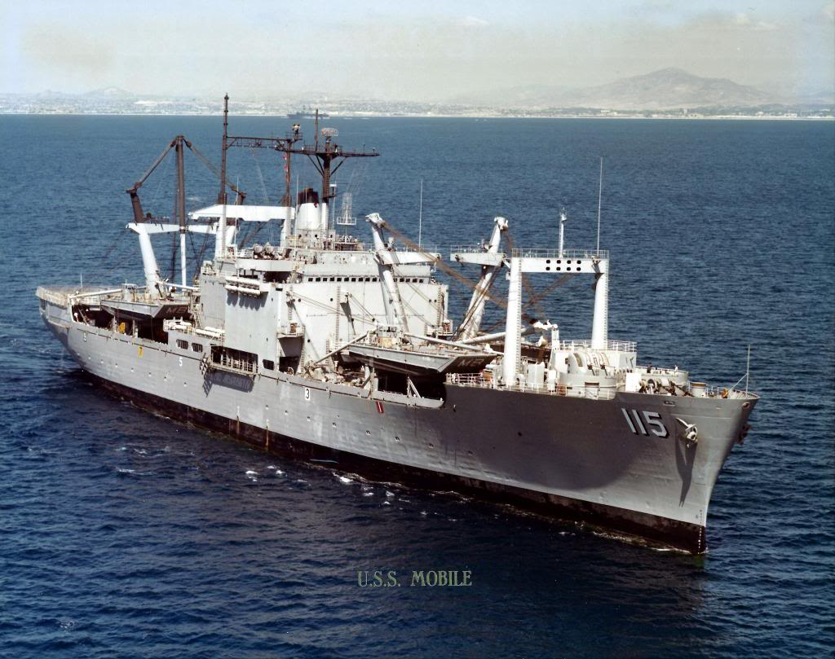

LKA-115 USNS Mobile