**TG Wasp**

TG Wasp is transporting the combat elements of 6th Marine Regiment.

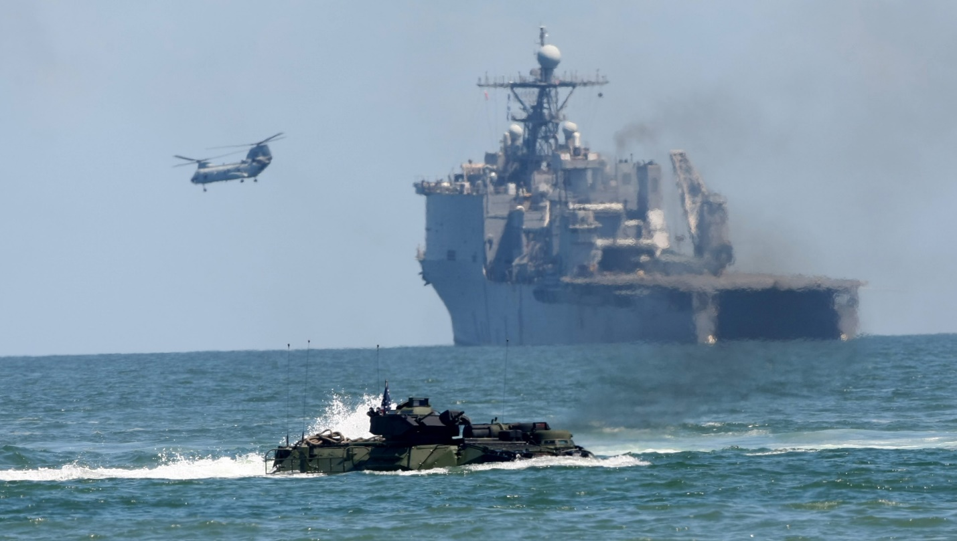

TG Wasp

* LHD-1 USS Wasp
  + VMA-231 – 14x AV-8B+
  + HMLA-269 – 12x AH-1W, 4x UH-1N
  + HMH-362 – 10x CH-53D
  + Elm HMM-162 – 4x CH-46E
  + Elm HM-14 – 2x MH-53E
* LHA-4 USS Nassau
  + Elem VMA-231– 4x AV-8B+
  + VMM-263 – 12x CH-46E
  + Elm HMLA-467 – 6x AH-1W
  + VMA-542 – 16x AV-8B
* LPH-2 USS Iwo Jima
  + Elm VMA-231– 4x AV-8B+
  + Elm HMH-362 – 4x CH-53D
  + Elm HMLA-269 – 2x AH-1W
  + HMM-162 – 8x CH-46E
  + Elm VMA-542 – 6x AV-8B
* CG-73 Port Royal
  + Elem HSL-36 – 2x SH-60B
* LPD-1 USS Raleigh
* LPD-12 USS Shreveport (Detached)
  + Elm HMM-264 – 2x CH-46E
* LPD-13 USS Nashville
* LSD-41 USS Whidbey Island
* LSD-43 USS Fort McHenry
  + Elem HMH-362 – 2x CH-53D
* LSD-44 USS Gunston Hall
  + Elem HMH-461 – 2x SH-53E
* DD-970 USS Caron
* FFG-21 USS Flatley (Detached)
  + Elem HSL-32 – 2x SH-60B

