**Expeditionary Support Group (ESG) Peleliu**

ESG Peleliu has been on patrol in the Indian Ocean with the primary task of watching the situation in Somalia unfold for the past five months. At war start she is returning from a port visit to Diego Garcia and while returning to the coast of Africa she is enabling the rotation of her two detached LSTs. These LSTs are tasked with maintaining a presence off Mogadishu in case a Non Combatant Evacuation (NEO) is required or if directed, troops need to be inserted back into the City. *FFG-51 USS Gary* is not part of the ESG but is part of the international force: CTF-150 providing maritime security along the coast of Somalia and the Gulf of Aden. The Gary will be attached to Under Command the ESG at war start.

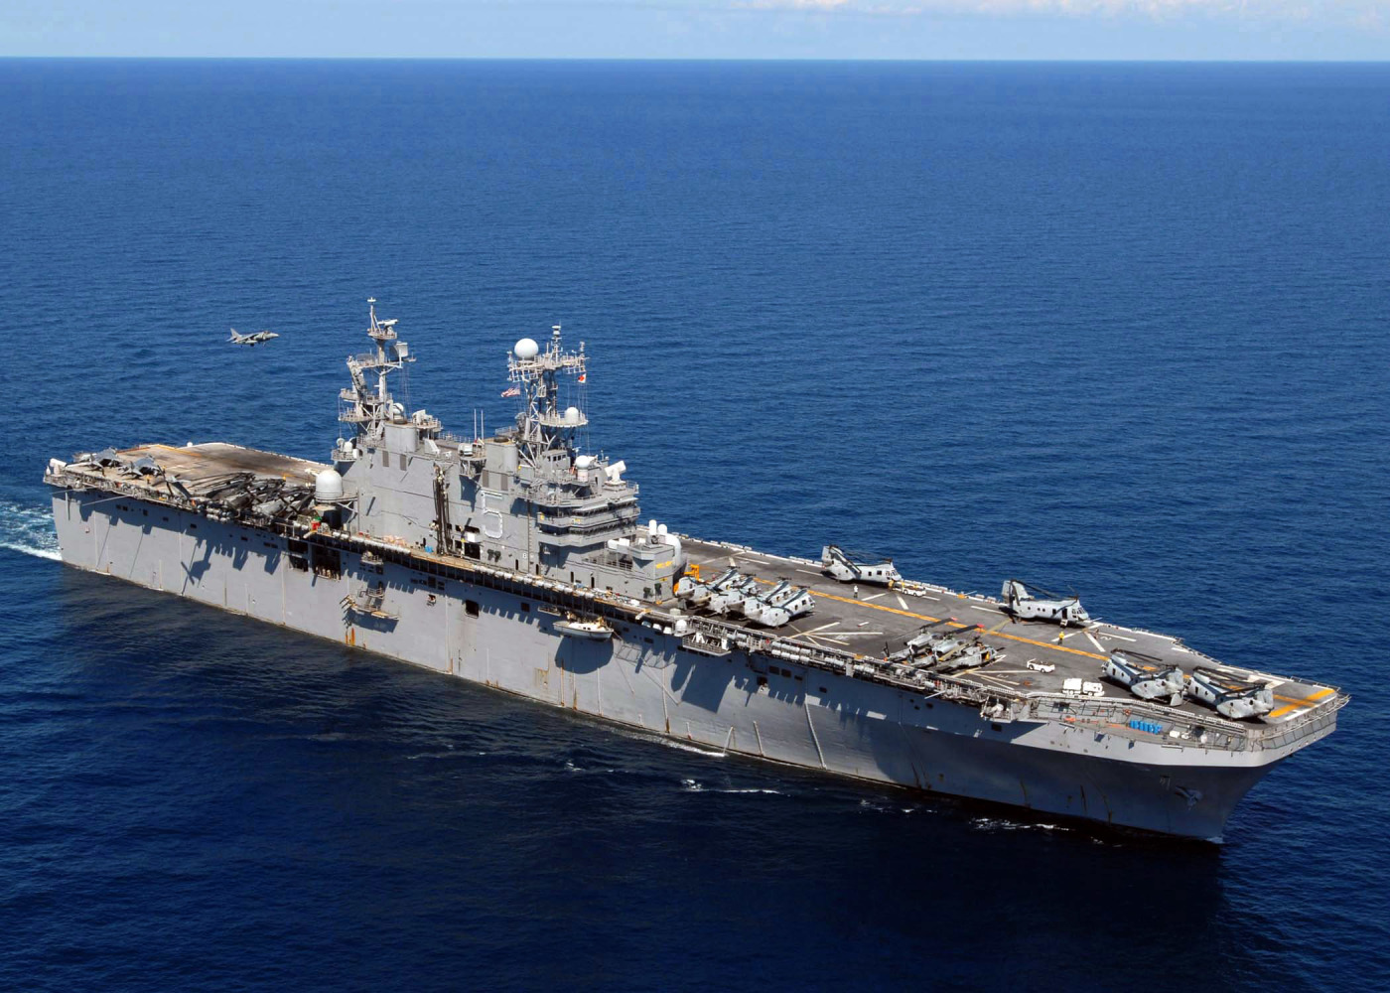

ESG Peleliu

* LHA 5 USS Peleliu
  + Elem VMA-311 – 6x AV-8B Harrier II+
  + Elem HMLA-267 – 4x AH-1W and 4x UH-1N
  + HMM-166 – 12x CH-46E
  + Elem HMH-463 – 4x CH-53D
* CG 34 USS Biddle
* DD 992 USS Fletcher
  + Elem HSL-43 – 2x SH-60B
* LPD 7 USS Cleveland
* LSD 39 USS Mount Vernon
* LST 1186 USS Cayuga (Detached)
* LST 1195 USS Barbour County (Detached)
* 13th MEU (Special Operations Capable)

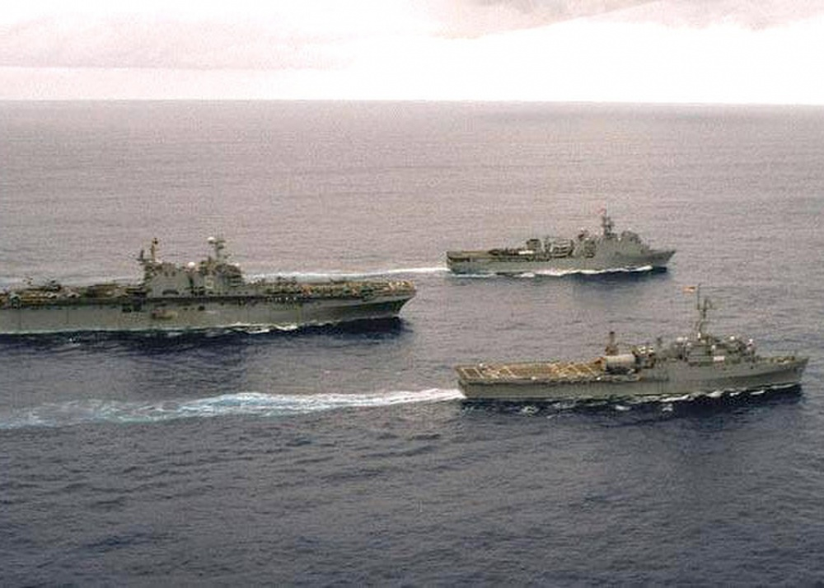

*LHA 5 USS Peleliu*, in this photo it is accompanied by *LPD 5 USS Ogden* and *LSD 42 USS Germantown*

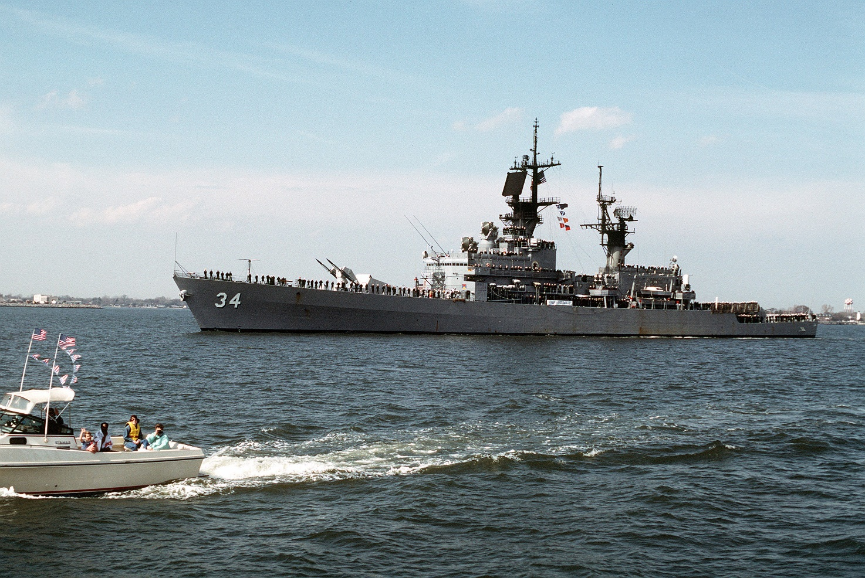

*CG 34 USS Biddle*, a Belknap class cruiser, the last conventionally powered cruiser constructed before the Ticonderoga class. She has undergone a New Threat Upgrade (NTU) making her a moderately capable Air Defence ship with modern radars and 50 ‘Standard’ SM-2 missiles fired from a twin rail launcher.

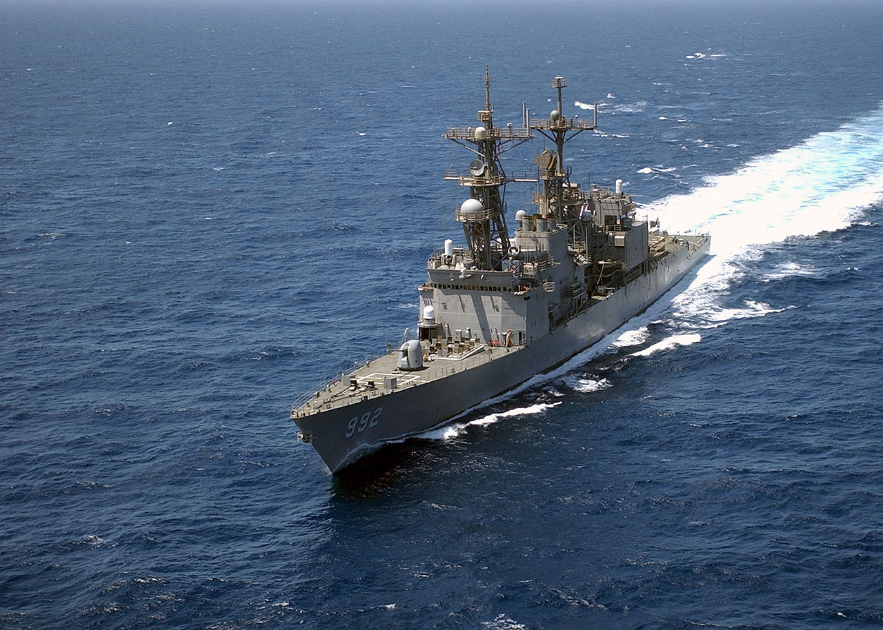

*DD 992 USS Fletcher* is a fully modernized Spruance class destroyer. She is one of the best ASW ships available and has a vertical launch system with 45 Tomahawk Land Attack Cruise Missiles (T-LAM). Her air defences are relatively weak but her embarked helicopters provide significant flexibility.

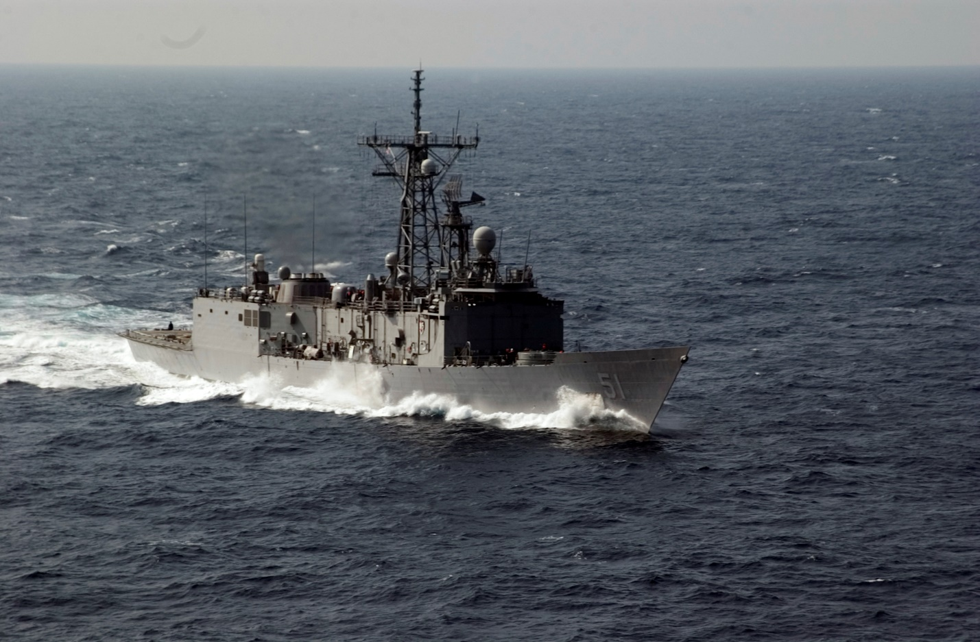

*FFG 51 USS Gary* is a ‘Long Hull’ Oliver Hazard Perry (OHP) class frigate with SH-60 helicopters. She is a very capable well rounded ship.