**Amphibious Support Ships**

Landing an army from the sea to operate inland is the most complex military operation there is. The USN during World War Two became experts at this type of power projection and as such developed, and continued to develop highly specialized naval vessels to enable amphibious assaults and maintain forces on a foreign and hostile shore with a sustainment system stretching back to US ports. What follows is a partial list of the types of ships involved. Not all of these ships are represented in Northern Fury scenarios but this will serve as background to describe many of the ‘non-combat’ elements that are required to conduct a landing. For more detailed study this is a link to the [1996 Sealift doctrine](https://fas.org/man/dod-101/sys/ship/docs/jp4_01_2.pdf) – note that this is not the latest publication but the one most applicable to Northern Fury.

**LKA:** [Amphibious Cargo Ships](https://fas.org/man/dod-101/sys/ship/lka-113.htm). The Charleston class are the latest in a long line of ships bearing the World War Two designation AKA (Attack Cargo Ship). While there were over 120 AKAs in the 40’s, the five Charleston class, commissioned between ‘68 and ’70 have been put in reserve several times but remain active as a testament to their versatility and capability to help Marines stay ashore. Equipped with a flight deck, cargo elevators, hoists and cranes, they can carry 8x LCM, 4x LCVP and over 5000 Tons of cargo of a size up to light vehicles. These ships will generally deploy with the lead elements of an Amphibious Force but remain in safe waters, once their LCMs are deployed they remain in the landing area as the LKA returns to port for more supplies.

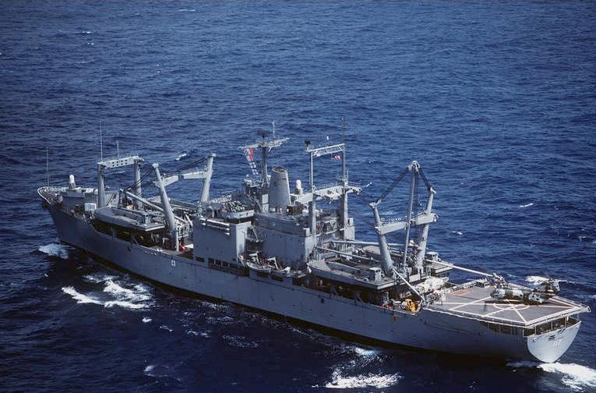

LKA 117 USS El Paso

|  |  |  |  |  |
| --- | --- | --- | --- | --- |
| Pennant | Name | Fleet | Home Port | Task |
| LKA-113 | [USS Charleston](https://en.wikipedia.org/wiki/USS_Charleston_(LKA-113)) | Atlantic | Norfolk | 6th Mar Regt |
| LKA-114 | [USS Durham](https://en.wikipedia.org/wiki/USS_Durham_(LKA-114)) | Pacific | Persian Gulf | Persian Gulf |
| LKA-115 | [USS Mobile](https://en.wikipedia.org/wiki/USS_Mobile_(LKA-115)) | Atlantic | Norfolk | 8th Mar Regt |
| LKA-116 | [USS St. Louis](https://en.wikipedia.org/wiki/USS_St._Louis_(LKA-116)) | Atlantic | Norfolk | Philippines |
| LKA-117 | [USS El Paso](https://en.wikipedia.org/wiki/USS_El_Paso_(LKA-117)) | Pacific | San Diego | 2 MEF |

**ACS**: [Auxiliary Crane Ship](https://fas.org/man/dod-101/sys/ship/tacs-4.htm). The primary purpose of these ships is to provide heavy lift cranes in the landing area, they are much more effective once a port is available but can operate their equipment at sea. These large ships have the additional capability to transport 711 standard sized containers of stores and supplies to the landing area.

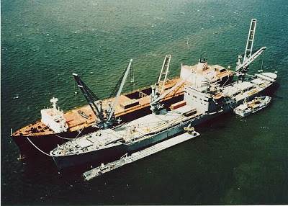

T-ACS 1 USNS Keystone State unloading a freighter

|  |  |  |  |  |  |
| --- | --- | --- | --- | --- | --- |
| Class | Pennant | Name | Fleet | Home Port | Task |
| Keystone State | T-ACS 1 | [Keystone State](https://en.wikipedia.org/wiki/SS_Keystone_State_(T-ACS-1)) | RRF | Alameda CA | 1 MEF |
|  | T-ACS 2 | [Gem State](https://en.wikipedia.org/wiki/SS_Gem_State_(T-ACS-2)) | RRF | Alameda CA | 1 MEF |
|  | T-ACS 3 | [Grand Canyon State](https://en.wikipedia.org/wiki/SS_Grand_Canyon_State_(T-ACS-3)) | RRF | Alameda CA | 1 MEF |
| Gopher State | T-ACS 4 | [Gopher State](http://fas.org/man/dod-101/sys/ship/tacs-4.htm) | Army MPS | Guam | I Corps |
|  | T-ACS 5 | [Flickertail State](http://fas.org/man/dod-101/sys/ship/tacs-4.htm) | MPS Sqn 3 | Cheatham Anx | 3 MEF |
|  | T-ACS 6 | [Cornhusker State](http://fas.org/man/dod-101/sys/ship/tacs-4.htm) | MPS Sqn 3 | Cheatham Anx | 3 MEF |
|  | T-ACS 7 | [Diamond State](http://fas.org/man/dod-101/sys/ship/tacs-4.htm) | MPS Sqn 1 | Houston | 2 MEF |
|  | T-ACS 8 | [Equality State](http://fas.org/man/dod-101/sys/ship/tacs-4.htm) | MPS Sqn 1 | Houston | 2 MEF |
|  | T-ACS 9 | [Green Mountain State](http://fas.org/man/dod-101/sys/ship/tacs-4.htm) | MPS Sqn 2 | Vancouver | Diego G |
|  | T-ACS 10 | [Beaver State](http://fas.org/man/dod-101/sys/ship/tacs-4.htm) | RRF | Portland | I Corps |

**AVB**: [Auxiliary Aviation Repair](https://fas.org/man/dod-101/sys/ship/tavb-3.htm). The primary purpose of these ships is to deliver fixed and rotary wing repair and maintenance equipment, supplies, and workshops for the Marine Air Wing to a secure port facility. The maintenance facility can either operate from on board the ship, at a nearby base or a combination of both configurations. These two ships are unique to the USMC.

|  |  |  |  |  |  |
| --- | --- | --- | --- | --- | --- |
| Class | Pennant | Name | Fleet | Home Port | Task |
| Write | T-AVB 3 | [Wright](http://fas.org/man/dod-101/sys/ship/tavb-3.htm) | Atlantic | Baltimore | 2 MEF |
|  | T-AVB 4 | [Curtiss](http://fas.org/man/dod-101/sys/ship/tavb-3.htm) | Pacific | Oakland | 3 MEF |

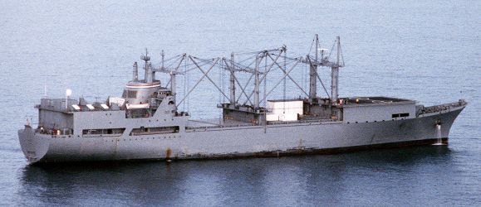

T-AVB-3 USNS Wright

**AH**: [Hospital Ship](https://fas.org/man/dod-101/sys/ship/tah-19.htm). These two hospital ships are designed to provide rapid and effective medial treatment facilities close an amphibious operation. These ships are not specifically designed to support the Marines but that is an obvious task for them. Each ship has 12 operating theaters and a 1000 bed holding facility with a wide range of medical capabilities.

|  |  |  |  |  |  |
| --- | --- | --- | --- | --- | --- |
| Class | Pennant | Name | Fleet | Home Port | Task |
| Mercy | T-AH-19 | [Mercy](https://en.wikipedia.org/wiki/USNS_Mercy_(T-AH-19)) | Pacific | Oakland |  |
|  | T-AH-20 | [Comfort](https://en.wikipedia.org/wiki/USNS_Comfort_(T-AH-20)) | Atlantic | Baltimore |  |

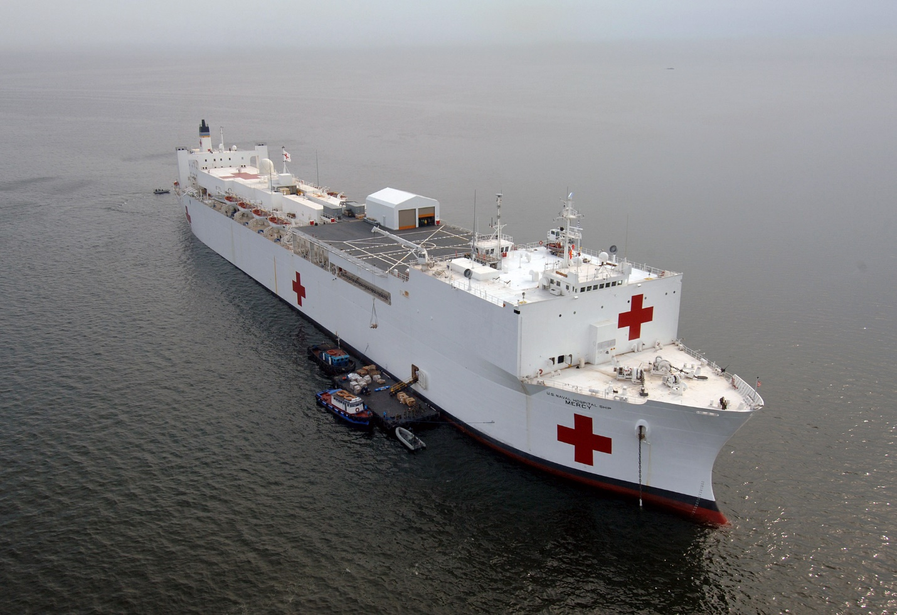

T-AH-19 USNS Mercy

**AOT:** Tankers. These tankers have limited ‘At Sea’ refueling capability, and have the ability to conduct ‘Logistics Over Shore’ – delivering fuel by pipeline to holding facilities ashore over a beach, this system is called OPDS (Offshore Petroleum Discharge System). In peacetime these ships keep far flung bases such as those in Antarctica and Tule Greenland replenished. In wartime they would first keep amphibious forces fueled and then pump various petroleum types (Diesel, Aviation fuel, Gasoline) ashore before returning to port for replenishment. These ships are not tied to home ports or generally assigned to fleets.

|  |  |  |  |
| --- | --- | --- | --- |
| Class | Pennant | Name | Task |
| Sealift | T-AOT-168 | Sealift Pacific |  |
|  | T-AOT-169 | Sealift Arabian Sea | 8th Mar Regt |
|  | T-AOT-170 | Sealift China Sea |  |
|  | T-AOT-171 | Sealift Indian Ocean |  |
|  | T-AOT-172 | Sealift Atlantic | 6th Mar Regt |
|  | T-AOT-173 | Sealift Mediterranean |  |
|  | T-AOT-174 | Sealift Caribbean |  |
|  | T-AOT-175 | Sealift Arctic |  |
|  | T-AOT-176 | Sealift Antarctic |  |
|  | T-AOT-181 | Potomac | Diego Garcia |
| Champion | T-AOT-1121 | [MV Gus W. Darnell](https://en.wikipedia.org/w/index.php?title=MV_Gus_W._Darnell_(T-AOT-1121)&action=edit&redlink=1) | 2 MEF |
|  | T-AOT-1122 | [USNS Paul Buck](https://en.wikipedia.org/wiki/USNS_Paul_Buck_(T-AOT-1122)) |  |
|  | T-AOT-1123 | [USNS Samuel L. Cobb](https://en.wikipedia.org/wiki/USNS_Samuel_L._Cobb_(T-AOT-1123)) |  |
|  | T-AOT-1124 | [Richard G. Matthiesen](https://en.wikipedia.org/wiki/USNS_Richard_G._Matthiesen_(T-AOT-1124)) |  |
|  | T-AOT-1125 | [Lawrence H. Gianella](https://en.wikipedia.org/wiki/USNS_Lawrence_H._Gianella_(T-AOT-1125)) |  |
| American Osprey | T-AOT-5074 | [American Osprey](https://fas.org/man/dod-101/sys/ship/taot-5075.htm) |  |
| Tonti | T-AOG 82 | [Chattahoochee](http://www.navsource.org/archives/09/20/2082.htm) | Gasoline only |

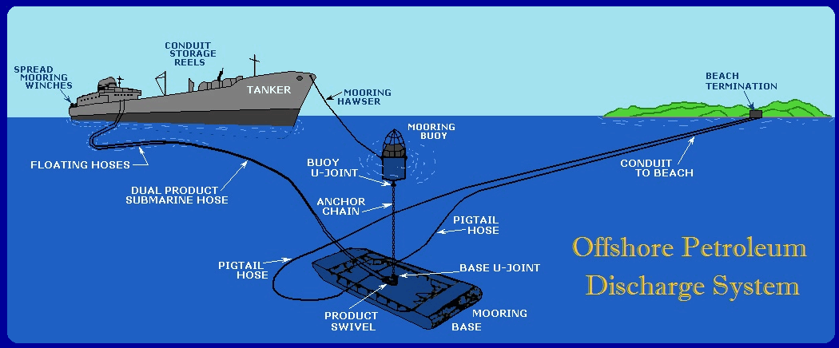

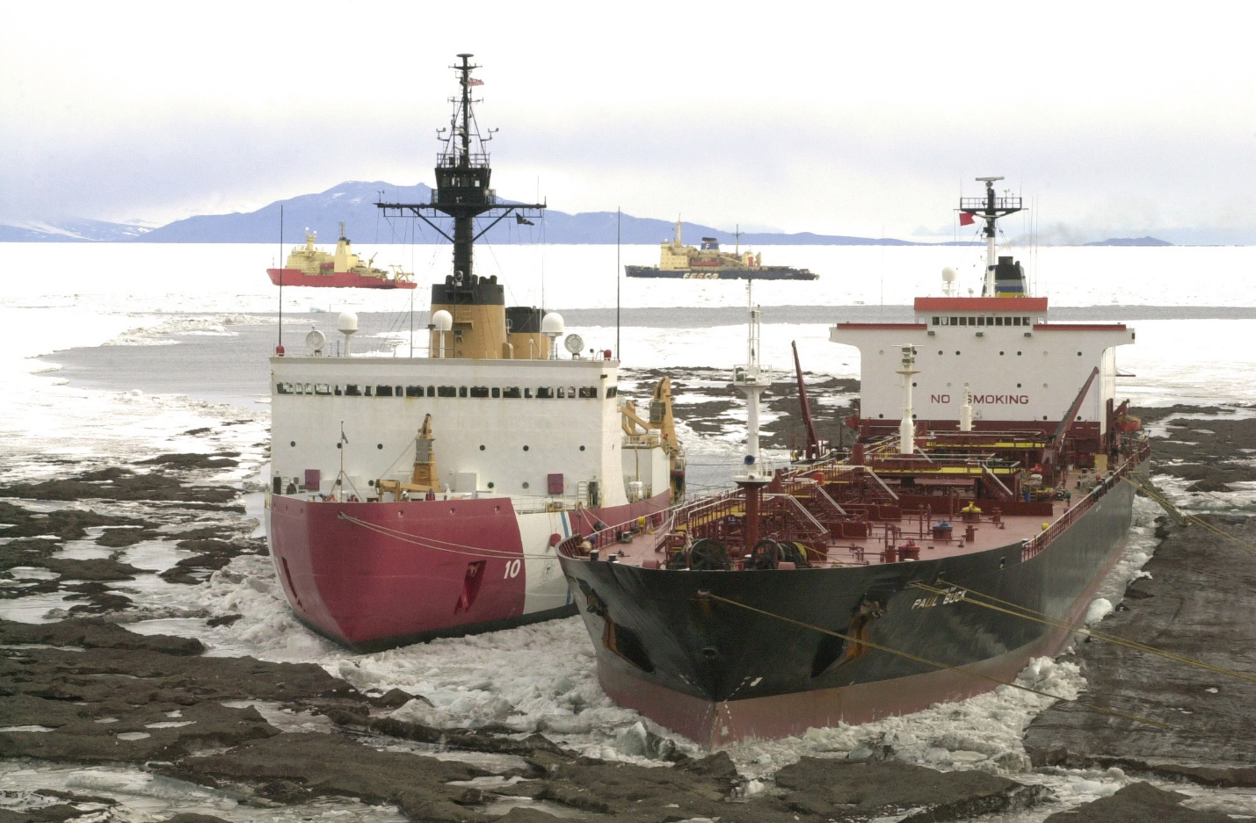

**T-AOT 1122 USNS Paul Buck delivering fuel in Antarctica**

**AK**: Cargo. There are a wide range of cargo ships employed by the USN, several with noteworthy delivery systems. For simplicity they will be listed in one section with notes and several phots to help explain the more interesting ships. To compensate for long distances and shortage of military infrastructure or facilities in certain areas many of these ships are positioned in Maritime Prepositioning Squadrons (MPS). MPS 1 is responsible for the Atlantic and Mediterranean Sea, MPS 2 is at Diego Garcia and MPS 3 is located in Guam and Saipan. Those noted as RRF are in the [Ready Reserve Force](https://www.marad.dot.gov/ships-and-shipping/strategic-sealift/office-of-ship-operations/ready-reserve-force-rrf/). The RRF ships must be ready to sail and receive cargo within 5-10 days, those at 5 days’ readiness maintain a skeleton crew.

**MCDS**: Mechanized Cargo Delivery System allows a dry cargo merchant ship to provide limited Underway Replenishment of naval vessels.

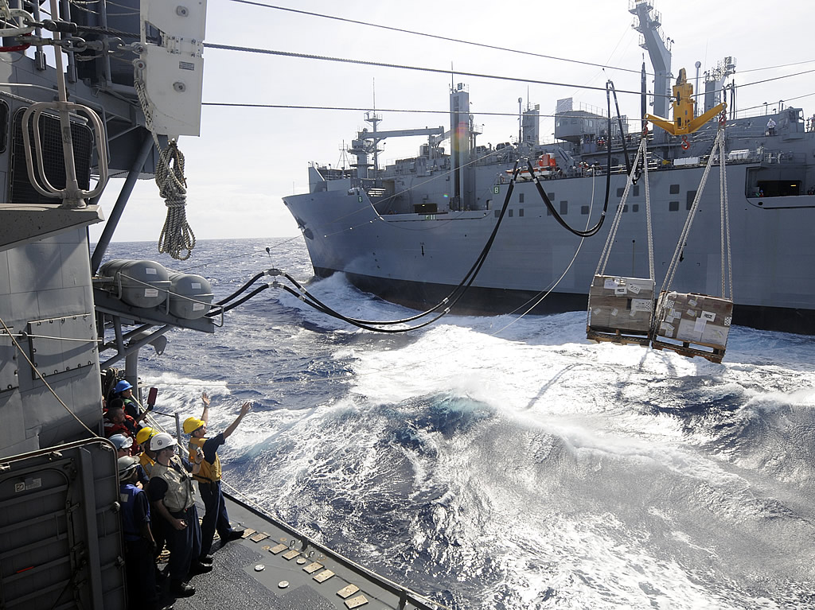

**MCDS**: Mechanized Cargo Delivery System

**LASH**: [Lighter Aboard Ship](http://www.logisticsglossary.com/term/lash-vessel/). These [ships](https://fas.org/man/dod-101/sys/ship/tak-2049.htm) hold a large number of standard sized barges or ‘Lighters’ which can quickly debark and be dispatched to a holding area for later unloading or moved with a tug to a different area (smaller port or upriver) allowing the ship to depart the landing area quickly or to load empty barges before departing.

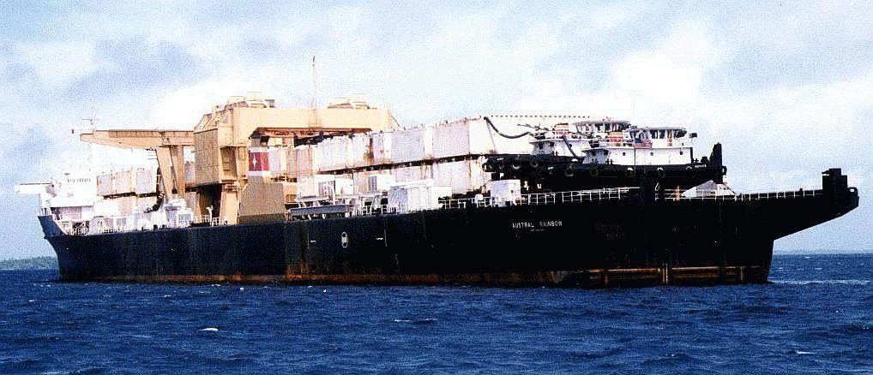

T-AK 1005 USNS Austral Rainbow with 75 LASH barges and two pusher boats

.

**Heavy Cargo:** Although most heavy lift ships are contracted for specific jobs, [**AK-9204 Strong Virginian**](https://fas.org/man/dod-101/sys/ship/takr-9025.htm) is part of MPS 2. Normally transporting a 500 bed containerized hospital, this photo shows, it is quite versatile.

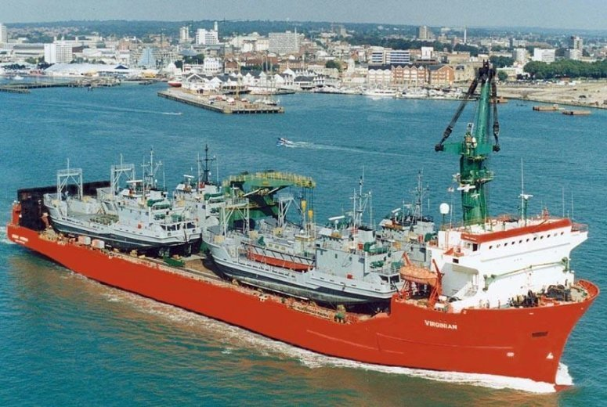

AK-9204 Strong Virginian

**RO-RO**: Roll On – Roll Off ships for rapid loading and unloading of vehicles such as the six [‘Cape’ Class](https://fas.org/man/dod-101/sys/ship/takr-roro.htm) ships shown here as part of the RRF in Charleston South Carolina:

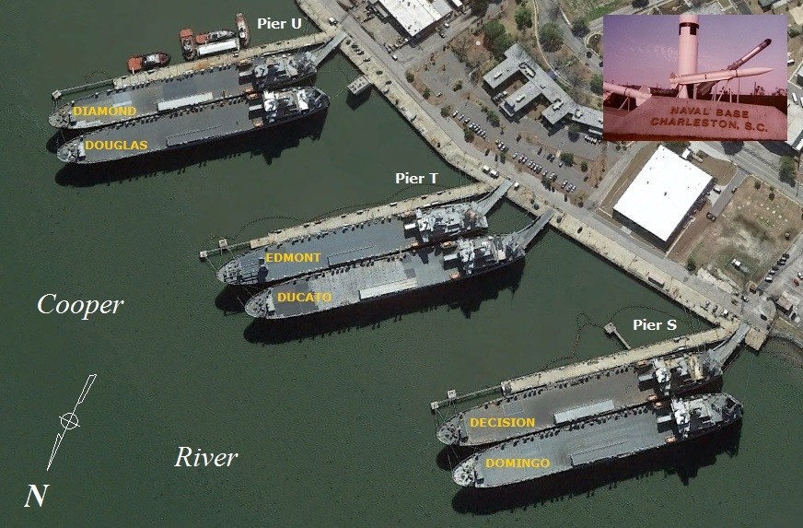

**Container ships** of various types some are also RO-RO such as [**T-AK 9301 Buffalo Soldier**](https://fas.org/man/dod-101/sys/ship/tak-9301.htm).

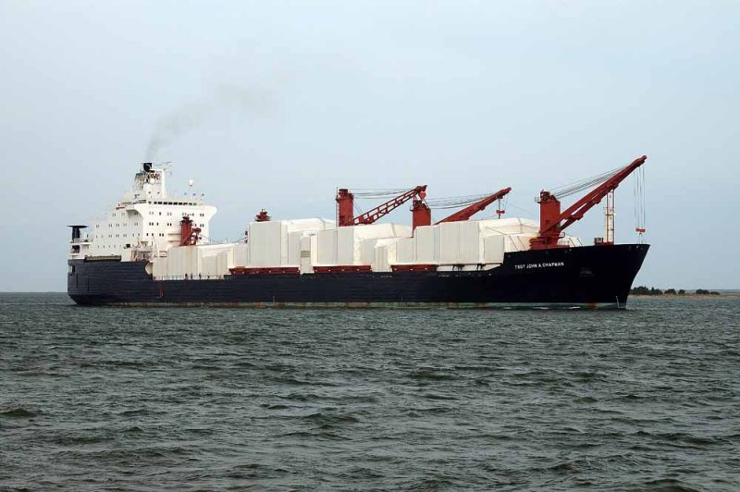

T-AK 9301 Buffalo Soldier

**Fast RO-RO:** These eight ships of the [Algol](https://fas.org/man/dod-101/sys/ship/takr-287.htm) class will cruise at 27 knots, a full 10 knots faster than other RO-RO ships and have a maximum speed of 33 knots. Their speed and capacity make them invaluable for the rapid movement of equipment to Europe. During the Gulf War each of these ships delivered the equivalent cargo of 116 World War Two Liberty ships, in an equivalent time.

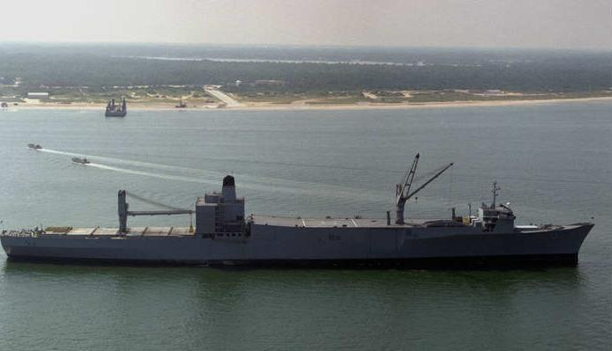

T-AKR 287 Algol

**Flo-Flo**: Float On – Float Off. [**T-AK 2062 American Cormorant**](https://fas.org/man/dod-101/sys/ship/tak-2062.htm)is used in MPS 2 at Diego Garcia to deliver small boats and LCUs as well as a floating crane to a landing area.

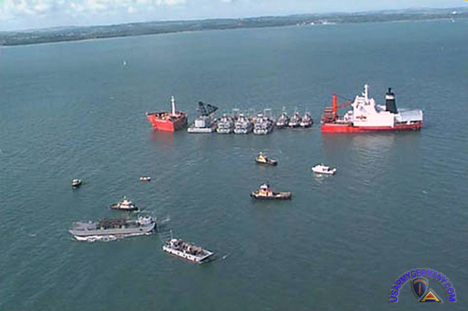

T-AK 2062 American Cormorant unloading.

Cargo Ship List:

|  |  |  |  |  |  |  |
| --- | --- | --- | --- | --- | --- | --- |
| Cargo | Cross | T-AK-285 | [Southern Cross](http://www.navsource.org/archives/09/13/130285.htm) | Atlantic | James River | RRF |
|  | Vega | T-AK-286 | [Vega](http://www.navsource.org/archives/09/13/130286.htm) | Atlantic | James River | RRF |
|  | Cleveland | AK-851 | [Cleveland](http://www.navsource.org/archives/09/13/130851.htm) | Pacific | Alameda CA | RRF, MCDS |
| Ammo | Austral Rainbow | AK 1005 | [Austral Rainbow](http://fas.org/man/dod-101/sys/ship/tak-1005.htm) | USAF MPS | Diego Garcia | 75 LASH,  2 Pusher Bts |
| Cargo | Cape N | AK-1014 | [Cape Nome](http://www.navsource.org/archives/09/13/131014.htm) | Atlantic | James River | RRF |
|  | Pioneer | AK-2016 | [Pioneer Commander](http://www.navsource.org/archives/09/13/132016.htm) | Atlantic | Beaumont Tx | RRF |
|  |  | AK-2018 | [Pioneer Contractor](http://www.navsource.org/archives/09/13/132018.htm) | Atlantic | Beaumont Tx | RRF |
|  |  | AK-2019 | [Pioneer Crusader](http://www.navsource.org/archives/09/13/132019.htm) | Atlantic | Beaumont Tx | RRF |
|  |  | AK-2033 | [Buyer](http://www.navsource.org/archives/09/13/132033.htm) | Atlantic | Beaumont Tx | RRF, MCDS |
|  | Gulf | AK-2035 | [Gulf Shipper](http://www.navsource.org/archives/09/13/132035.htm) | Atlantic | Beaumont Tx | RRF, MCDS |
|  |  | AK-2036 | [Gulf Trader](http://www.navsource.org/archives/09/13/132036.htm) | Atlantic | Beaumont Tx | RRF, MCDS |
|  | Green Valley | AK-2050 | [Green Wave](http://www.navsource.org/archives/09/13/132050.htm) | Atlantic | East Coast | Not LASH |
| LASH | Green Valley | T-AK 2049 | [Green Valley](http://fas.org/man/dod-101/sys/ship/tak-2049.htm) | Army MPS | Diego Garcia | 88 Barges |
|  |  | T-AK 2064 | [Green Harbour](http://fas.org/man/dod-101/sys/ship/tak-2049.htm) | Army MPS | Diego Garcia | 88 Barges |
|  |  | T-AK 9204 | [Jeb Stuart](http://fas.org/man/dod-101/sys/ship/tak-2049.htm) | Army MPS | Diego Garcia | 88 Barges |
| FloFlo | American Cormorant | T-AK 2062 | [American Cormorant](http://fas.org/man/dod-101/sys/ship/tak-2062.htm) | Army MPS | Diego Garcia |  |
| USMC PP | Cpl. Louis J. Haube, Jr. | T-AK 3000 | [CPL L. Hauge, Jr](http://fas.org/man/dod-101/sys/ship/tak-3000.htm) | MPS Sqn 2 | Diego Garcia |  |
|  |  | T-AK 3001 | [PFC William B. Baugh](http://fas.org/man/dod-101/sys/ship/tak-3000.htm) | MPS Sqn 2 | Diego Garcia |  |
|  |  | T-AK 3002 | [PFC J. Anderson, Jr](http://fas.org/man/dod-101/sys/ship/tak-3000.htm) | MPS Sqn 2 | Diego Garcia |  |
|  |  | T-AK 3003 | [1ST LT A. Bonnyman](http://fas.org/man/dod-101/sys/ship/tak-3000.htm) | MPS Sqn 2 | Diego Garcia |  |
|  |  | T-AK 3004 | [PVT Franklin J. Phillips](http://fas.org/man/dod-101/sys/ship/tak-3000.htm) | MPS Sqn 2 | Diego Garcia |  |
|  | Sgt. Matej Kocak | T-AK 3005 | [SGT Matej Kocak](http://fas.org/man/dod-101/sys/ship/tak-3005.htm) | MPS Sqn 1 | Europe |  |
|  |  | T-AK 3006 | [PFC E. A. Obregon](http://fas.org/man/dod-101/sys/ship/tak-3005.htm) | MPS Sqn 1 | Europe |  |
|  |  | T-AK 3007 | [MAJ S. W. Pless](http://fas.org/man/dod-101/sys/ship/tak-3005.htm) | MPS Sqn 1 | Europe |  |
|  | 2nd Lt. John P. Bobo | T-AK 3008 | [2ND LT John P. Bobo](http://fas.org/man/dod-101/sys/ship/tak-3008.htm) | MPS Sqn 1 | Europe |  |
|  |  | T-AK 3009 | [PFC D.T. Williams](http://fas.org/man/dod-101/sys/ship/tak-3008.htm) | MPS Sqn 3 | Guam |  |
|  |  | T-AK 3010 | [1ST LT B. Lopez](http://fas.org/man/dod-101/sys/ship/tak-3008.htm) | MPS Sqn 3 | Guam |  |
|  |  | T-AK 3011 | [1ST LT Jack Lummus](http://fas.org/man/dod-101/sys/ship/tak-3008.htm) | MPS Sqn 3 | Guam |  |
|  |  | T-AK 3012 | [SGT W. R. Button](http://fas.org/man/dod-101/sys/ship/tak-3008.htm) | MPS Sqn 3 | Guam | In PG |
| Bulk | Cape A | T-AK-5005 | Adventurer | Atlantic | James River | RRF |
|  |  | T-AK-5006 | [Aide](http://www.navsource.org/archives/09/13/135006.htm) | Pacific | Alameda CA | RRF |
|  |  | T-AK-5007 | Ambassador | Atlantic | James River | RRF |
|  |  | T-AK-5009 | [Cape Ann](http://navysite.de/ak/ak5009.htm) | Atlantic | James River | RRF |
|  |  | T-AK 5010 | [Cape Alexander](http://navysite.de/crew.php?action=ship&ship=ak_5010) | Atlantic | James River | RRF |
|  |  | T-AK 5011 | [Cape Archway](http://www.navsource.org/archives/09/13/135011.htm) | Atlantic | James River | RRF |
|  |  | T-AK 5012 | [Cape Alava](http://www.navsource.org/archives/09/13/135012.htm) | Atlantic | James River | RRF |
|  |  | T-AK 5013 | [Cape Avinof](http://www.navsource.org/archives/09/13/135013.htm) | Atlantic | James River | RRF |
|  |  | AK-5015 | [Agent](http://www.navsource.org/archives/09/13/135015.htm) | Pacific | Alameda CA | RRF |
| MCDS | Cape J | T-AK 5022 | [Cape John](http://www.navsource.org/archives/09/13/135022.htm) |  | Beaumont Tx | RRF |
|  |  | T-AK 5029 | [Cape Jacob](http://fas.org/man/dod-101/sys/ship/tak-5029.htm) | MPS Sqn 3 | Guam |  |
|  |  | T-AK 5075 | [Cape Johnson](http://www.navsource.org/archives/09/13/135075.htm) |  | James River | RRF, MCDS |
|  |  | T-AK 5077 | [Cape Juby](http://www.navsource.org/archives/09/13/135077.htm) |  | James River | RRF, MCDS |
|  | Cape C | T-AK 5036 | [Cape Chalmers](http://www.navsource.org/archives/09/13/135036.htm) |  | Charleston | RRF, MCDS |
|  |  | T-AK 5037 | [Cape Canso](http://www.navsource.org/archives/09/13/135037.htm) |  | James River | RRF, MCDS |
|  |  | T-AK 5038 | [Cape Charles](http://www.navsource.org/archives/09/13/135038.htm) |  | Charleston | RRF, MCDS |
|  |  | T-AK 5039 | [Cape Clear](http://www.navsource.org/archives/09/13/135037.htm) |  | Charleston | RRF, MCDS |
|  |  | T-AK 5040 | [Cape Canaveral](http://www.navsource.org/archives/09/13/135040.htm) |  | James River | RRF, MCDS |
|  |  | T-AK 5041 | [Cape Cod](http://www.navsource.org/archives/09/13/135041.htm) |  | Charleston | RRF, MCDS |
|  |  | T-AK 5042 | [Cape Carthage](http://www.navsource.org/archives/09/13/135042.htm) |  | James River | RRF, MCDS |
|  |  | T-AK 5043 | [Cape Catoche](http://www.navsource.org/archives/09/13/135043.htm) |  | Norfolk | RRF, MCDS |
|  | Cape B | T-AK 5056 | [Cape Breton](http://www.navsource.org/archives/09/13/135056.htm) |  | Alameda CA | RRF, MCDS |
|  |  | T-AK 5057 | [Cape Bover](http://www.navsource.org/archives/09/13/135057.htm) |  | Alameda CA | RRF, MCDS |
|  |  | T-AK 5058 | [Cape Borda](http://www.navsource.org/archives/09/13/135058.htm) |  | Alameda CA | RRF, MCDS |
|  |  | T-AK 5059 | [Cape Bon](http://www.navsource.org/archives/09/13/135059.htm) |  | Alameda CA | RRF, MCDS |
|  |  | T-AK 5060 | [Cape Blanco](http://www.navsource.org/archives/09/13/135060.htm) |  | Alameda CA | RRF, MCDS |
| LASH | Cape F | T-AK 5061 | [Cape Fear](http://navysite.de/ak/ak5061.htm) |  | Alameda CA | RRF, 89 Barges |
|  |  | T-AK 5070 | [Cape Flattery](http://www.navsource.org/archives/09/13/135070.htm) |  | Beaumont Tx | RRF, 89 Barges |
|  |  | T-AK 5071 | [Cape Florida](http://www.navsource.org/archives/09/13/135071.htm) |  | Beaumont Tx | RRF, 89 Barges |
|  |  | T-AK 5073 | [Cape Farewell](http://www.navsource.org/archives/09/13/135073.htm) |  | Beaumont Tx | RRF, 89 Barges |
|  |  | AK-9651 | [American Kestrel](http://www.navsource.org/archives/09/13/139651.htm) | MPS Sqn 2 | Diego Garcia | 77 Barges |
| Bulk | Northern Light | AK-5074 | [Cape Catawba](http://www.navsource.org/archives/09/13/135074.htm) |  | Norfolk | RRF |
|  |  | AK-5008 | [Banner](http://www.navsource.org/archives/09/13/135008.htm) |  | Alameda CA | RRF |
|  |  | AK-5016 | [Lake](http://www.navsource.org/archives/09/13/135016.htm) | Atlantic | James River | RRF |
|  |  | AK-5017 | [Pride](http://www.navsource.org/archives/09/13/135017.htm) | Atlantic | James River | RRF |
|  |  | AK-5018 | [Scan](http://www.navsource.org/archives/09/13/135018.htm) | Atlantic | James River | RRF |
|  |  | AK-5019 | [Courier](http://www.navsource.org/archives/09/13/135019.htm) | Atlantic | Beaumont Tx | RRF |
|  | Class D | AK-5026 | [Del Viento](http://www.navsource.org/archives/09/13/135026.htm) | Atlantic | Beaumont Tx | RRF |
|  |  | T-AK-5049 | [Del Monte](http://www.navsource.org/archives/09/13/135049.htm) | Atlantic | Beaumont Tx | RRF |
|  |  | AK-5050 | [Del Valle](http://www.navsource.org/archives/09/13/135050.htm) | Atlantic | Beaumont Tx | RRF |
|  | Gulf | AK-5044 | [Gulf Banker](http://www.navsource.org/archives/09/13/135044.htm) | Atlantic | Beaumont Tx | RRF |
|  |  | AK-5045 | [Gulf Farmer](http://www.navsource.org/archives/09/13/135045.htm) | Atlantic | Beaumont Tx | RRF |
|  |  | AK-5046 | [Gulf Merchant](http://www.navsource.org/archives/09/13/135046.htm) | Atlantic | Beaumont Tx | RRF |
|  | Cape G | T-AK-2039 | [Cape Girardeau](http://navysite.de/ak/ak2039.htm) | Pacific | Alameda CA | RRF |
|  |  | T-AK-5051 | [Cape Gibson](https://en.wikipedia.org/wiki/SS_Cape_Gibson_(AK-5051)) | Pacific | Alameda CA | RRF |
| Hy Cargo | Strong | [AK-9205](https://en.wikipedia.org/wiki/MV_Virginian_(T-AK_9205)) | [Strong Virginian](http://www.navsource.org/archives/09/13/139205.htm) | MPS Sqn 2 | Diego Garcia | 500 bed Hosp + Hy lift |
| Container | Buffalo Soldier | T-AK 9301 | [Buffalo Soldier](http://fas.org/man/dod-101/sys/ship/tak-9301.htm) | USAF MPS2 | Diego Garcia |  |
|  | Merlin | AK-9302 | American Merlin | MPS Sqn 2 | Diego Garcia | Container RoRo |
| Cargo | Noble Star | AK-9653 | [Noble Star](http://www.navsource.org/archives/09/13/139653.htm) | MPS Sqn 2 | Diego Garcia |  |
|  | Green Ridge | T-AK 9655 | [Green Ridge](http://fas.org/man/dod-101/sys/ship/green_ridge.htm) | MPS Sqn 2 | Diego Garcia | 500 bed Hosp + med supl |
|  | Advantage | T-AK-9682 | [Advantage](http://www.navsource.org/archives/09/13/139682.htm) | MPS Sqn 2 | Diego Garcia |  |
| Fast RORO | ALGOL | T-AKR 287 | [Algol](http://fas.org/man/dod-101/sys/ship/takr-287.htm) |  | New Orleans |  |
|  |  | T-AKR 288 | [Bellatrix](http://fas.org/man/dod-101/sys/ship/takr-287.htm) |  | New Orleans |  |
|  |  | T-AKR 289 | [Denebola](http://fas.org/man/dod-101/sys/ship/takr-287.htm) |  | Bayonne NJ |  |
|  |  | T-AKR 290 | [Pollux](http://fas.org/man/dod-101/sys/ship/takr-287.htm) |  | New Orleans |  |
|  |  | T-AKR 291 | [Altair](http://fas.org/man/dod-101/sys/ship/takr-287.htm) |  | Norfolk |  |
|  |  | T-AKR 292 | [Regulus](http://fas.org/man/dod-101/sys/ship/takr-287.htm) |  | New Orleans |  |
|  |  | T-AKR 293 | [Capella](http://fas.org/man/dod-101/sys/ship/takr-287.htm) |  | Baltimore |  |
|  |  | T-AKR 294 | [Antares](http://fas.org/man/dod-101/sys/ship/takr-287.htm) |  | Baltimore |  |
|  | Shughart | T-AKR-295 | [Shughart](http://navysite.de/akr/akr295.htm) | Atlantic | Baltimore |  |
|  |  | T-AKR-297 | [Yano](http://navysite.de/akr/akr297.htm) | Atlantic | Newport News |  |
|  |  | T-AKR-299 | [Soderman](http://navysite.de/akr/akr299.htm) | Atlantic | Baltimore |  |
|  | Gordon | T-AKR-296 | [Gordon](http://navysite.de/akr/akr296.htm) | Atlantic | Norfolk |  |
|  |  | T-AKR-298 | [Gilliland](http://navysite.de/akr/akr298.htm) | Atlantic | Norfolk |  |
| RORO | Cape Ducato | T-AKR-5051 | [Cape Ducato](https://en.wikipedia.org/wiki/MV_Cape_Ducato_(T-AKR-5051)) | Army APA | Charleston | RRF |
|  |  | T-AKR-5052 | [Cape Douglas](https://en.wikipedia.org/wiki/Cape_Ducato-class_vehicle_cargo_ship) | Army APA | Charleston | RRF |
|  |  | T-AKR-5053 | [Cape Domingo](https://en.wikipedia.org/wiki/Cape_Ducato-class_vehicle_cargo_ship) | Army APA | Charleston | RRF |
|  |  | T-AKR-5054 | [Cape Diamond](https://en.wikipedia.org/wiki/Cape_Ducato-class_vehicle_cargo_ship) | Army APA | Charleston | RRF |
|  |  | T-AKR-5055 | [Cape Decision](https://en.wikipedia.org/wiki/Cape_Ducato-class_vehicle_cargo_ship) | Army APA | Charleston | RRF |
|  | Comet | T-AKR-7 | [Comet](http://navysite.de/akr/akr7.htm) | Pacific | West coast | RRF |
|  | Meteor | T-AKR-9 | [Meteor](http://navysite.de/akr/akr9.htm) | Pacific | West coast | RRF |
|  | Cape I | T-AKR-10 | [Cape Island](https://en.wikipedia.org/wiki/SS_Cape_Island_(T-AKR-10)) | Atlantic | Jacksonville |  |
|  |  | T-AKR-11 | [Cape Intrepid](https://en.wikipedia.org/wiki/SS_Cape_Intrepid_(T-AKR-11)) | Atlantic | Jacksonville |  |
|  |  | T-AKR-5062 | [Cape Isabel](https://en.wikipedia.org/wiki/SS_Cape_Isabel_(T-AKR-5062)) | Atlantic | Jacksonville |  |
|  |  | T-AKR-5076 | [Cape Inscription](https://en.wikipedia.org/wiki/SS_Cape_Inscription_(T-AKR-5076)) | Atlantic | Jacksonville |  |
|  | Cape T | T-AKR-112 | [Cape Texas](https://en.wikipedia.org/wiki/MV_Cape_Texas_(T-AKR-112)) | Atlantic | Houston |  |
|  |  | T-AKR-113 | [Cape Taylor](https://en.wikipedia.org/wiki/MV_Cape_Taylor_(T-AKR-113)) | Atlantic | Houston |  |
|  |  | T-AKR-9711 | [Cape Trinity](https://en.wikipedia.org/wiki/MV_Cape_Trinity_(T-AKR-9711)) | Atlantic | Houston |  |
|  | Wm. M. Callaghan | T-AKR-1001 | [Wm. M. Callaghan](http://navysite.de/akr/akr1001.htm) | Pacific | Alameda CA | RRF |
|  | Cape O | T-AKR-2044 | [Cape Orlando](https://en.wikipedia.org/wiki/MV_Cape_Orlando_(T-AKR-2044)) | Pacific | Alameda CA |  |
| Hy Barge Lft | Cape M | T-AKR-5063 | [Cape May](http://navysite.de/akr/akr5063.htm) | Atlantic | Norfolk | 38 barges |
|  |  | T-AKR-5064 | [Cape Mendocino](http://www.navsource.org/archives/09/54/545064.htm) | Atlantic | Norfolk | 38 barges |
|  |  | T-AKR-5065 | [Cape Mohican](https://en.wikipedia.org/wiki/SS_Cape_Mohican_(T-AKR-5065)) | Pacific | Alameda CA | 38 barges |
| RORO | Cape H | T-AKR-5066 | [Cape Hudson](http://navysite.de/akr/akr5066.htm) | Pacific | San Francisco |  |
|  |  | T-AKR-5067 | [Cape Henry](http://navysite.de/akr/akr5067.htm) | Pacific | Alameda CA |  |
|  |  | T-AKR-5068 | [Cape Horn](http://navysite.de/akr/akr5068.htm) | Pacific | San Francisco |  |
|  | Cape E | T-AKR-5069 | [Cape Edmont](http://www.navsource.org/archives/09/54/545069.htm) | Atlantic | Charleston |  |
|  | Cape L | T-AKR-5077 | [Cape Lambert](http://www.navsource.org/archives/09/54/545077.htm) | Atlantic | Beaumont Tx |  |
|  |  | T-AKR-5078 | [Cape Lobos](http://www.navsource.org/archives/09/54/545078.htm) | Atlantic | Beaumont Tx |  |
|  | Cape K | T-AKR-5082 | [Cape Knox](https://en.wikipedia.org/wiki/MV_Cape_Knox_(T-AKR-5082)) | Atlantic | New Orleans |  |
|  |  | T-AKR-5083 | [Cape Kennedy](http://www.navsource.org/archives/09/54/545083.htm) | Atlantic | New Orleans |  |
|  | Cape V | T-AKR-9666 | [Cape Vincent](https://en.wikipedia.org/wiki/MV_Cape_Vincent_(T-AKR-9666)) | Atlantic | Beaumont Tx |  |
|  |  | T-AKR-9701 | [Cape Victory](https://en.wikipedia.org/wiki/MV_Cape_Victory_(T-AKR-9701)) | Atlantic | Beaumont Tx |  |
|  | Cape R | T-AKR-9678 | [Cape Rise](http://navysite.de/akr/akr9678.htm) | Atlantic | Portsmouth VA |  |
|  |  | T-AKR-9679 | [Cape Ray](http://navysite.de/akr/akr9679.htm) | Atlantic | Portsmouth VA |  |
|  |  | T-AKR-9680 | [Cape Race](http://navysite.de/akr/akr9960.htm) | Atlantic | Portsmouth VA |  |
|  | Cape W | T-AKR-9961 | [Cape Washington](http://www.navsource.org/archives/09/54/549961.htm) | Atlantic | Baltimore |  |
|  |  | T-AKR-9962 | [Cape Wrath](http://www.navsource.org/archives/09/54/549962.htm) | Atlantic | Baltimore |  |