**Carrier Support Aircraft**

The 4 aircraft types that round out the CVW on any aircraft carrier perform vital functions which enable the entire CVBG to survive and fight much more effectively.

[**E-2C Hawkeye**](https://en.wikipedia.org/wiki/Northrop_Grumman_E-2_Hawkeye)

This aircraft is the Navy’s AWACs (Airborne Warning and Control) aircraft.  Each CVW has a squadron of 4 of these highly capable aircraft. In Northern Fury 5 additional Hawkeye’s were needed for the additional CVW and this was achieved by maintaining older ‘Group 0’ aircraft in service until further ‘Group II’ become available. The end goal is to have 75 available to the fleet by 1998.

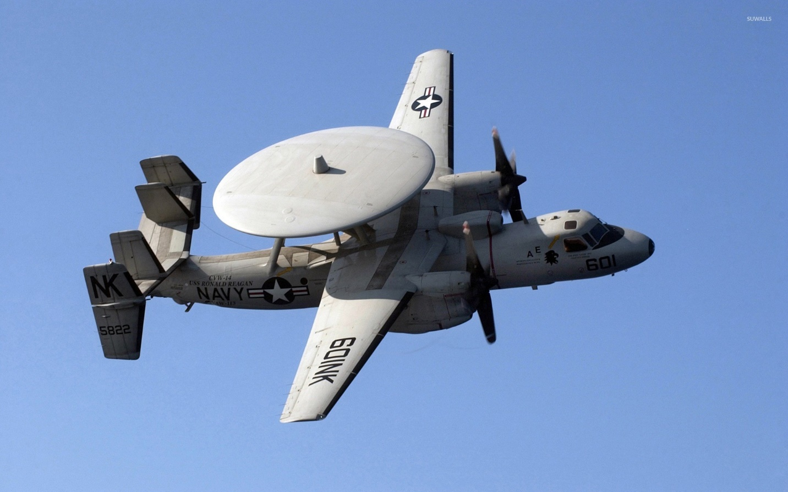

|  |  |  |  |  |  |
| --- | --- | --- | --- | --- | --- |
| Sqn | Name | CVW | No. | Type | Remarks |
| VAW-78 | Night Wolves | FRS | 6 | E-2C | NAS North Island |
| VAW-88 | Cotton Pickers | CVRW-30 | 5 | E-2C | NAS Whidbey Island |
| VAW-111 | Grey Berets | CVW-10 | 4 | E-2C | USS George Washington |
| VAW-112 | Golden Hawks | CVW-9 | 4 | E-2C | USS Nimitz |
| VAW-113 | Black Eagles | CAW-14 | 4 | E-2C | USS Carl Vinson |
| VAW-114 | Hormel Hogs | CVW-15 | 4 | E-2C | USS Kitty Hawk |
| VAW-115 | Liberty Bells | CVW-5 | 4 | E-2C | USS Independence |
| VAW-116 | Sun Kings | CVW-2 | 4 | E-2C | USS Constellation |
| VAW-117 | Wallbangers | CVW-11 | 4 | E-2C | USS Abraham Lincoln |
| VAW-120 | Greyhawks | FRS | 8 | E-2C | NAS Oceana |
| VAW-121 | Bluetails | CVW-7 | 4 | E-2C | USS JF Kennedy |
| VAW-122 | Steeljaws | CAW-6 | 4 | E-2C | USS Enterprise |
| VAW-123 | Screwtops | CVW-1 | 4 | E-2C | USS America |
| VAW-124 | Bear Aces | CVW-8 | 4 | E-2C | USS T Roosevelt |
| VAW-125 | Tigertails | CVW-17 | 4 | E-2C | USS Saratoga |
| VAW-126 | Seahawks | CVW-3 | 4 | E-2C | USS Eisenhower |
| VAW-127 | Seabats | CVRW-20 | 5 | E-2C | NAS Oceana |

[**C-2A-R Greyhound**](https://en.wikipedia.org/wiki/Grumman_C-2_Greyhound)

Although not the ‘Sexiest’ role in a CVW; Carrier Onboard Delivery or COD, is critical to the functioning of every CVBG.  The C-2 Greyhound is built on the same airframe as the E-2C Hawkeye and is the overworked ‘Pack Mule’ of the fleet, carrying high priority cargo, casualties, passengers and mail to and from the CVBG. The ‘R’ in the designation represents ‘Re-procured’ as the 39 aircraft built in the late 80’s, look very similar to those they replaced, but they were in fact much improved. All of the C-2A-R’s belong to two VRC squadrons, one on each coast and a detachment of 2 Greyhounds is normally attached to each deployed CVW.  There are 14 original C-2A’s in storage.

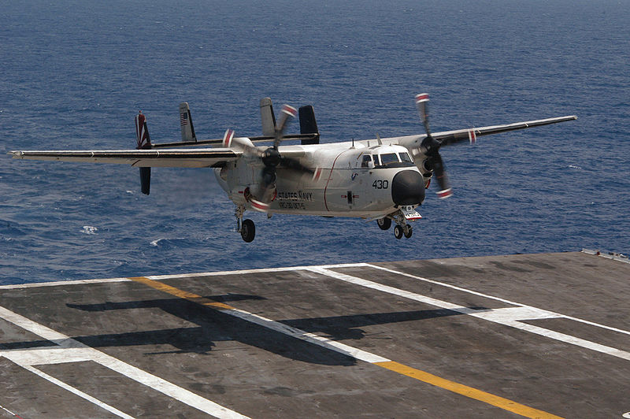

|  |  |  |  |  |  |
| --- | --- | --- | --- | --- | --- |
| Sqn | Name | CVW | No. | Type | Remarks |
| VRC-30 | Providers | Various | 14 | C-2A-R | NAS North Island |
| VRC-40 | Rawhides | Various | 18 | C-2A-R | NAS Norfolk |
| VRC-50 | Foo Dogs | Various | 7 | C-2A-R | NAS Cubi Point |
|  |  |  | 7 | US-3A | Modified S-3 |

[**EA-6B Prowler**](https://en.wikipedia.org/wiki/Northrop_Grumman_EA-6B_Prowler)

The EA-6B Prowler was an Electronic Warfare (EW) platform that could detect, classify, localize, supress and jam enemy electronic emissions. Equipped with jamming pods, or High-speed Anti-Radiation Missiles (HARM) or both, this aircraft was ideal for escorting strike packages in order to conduct Suppression of Enemy Air Defences (SEAD) missions, protecting other aircraft from enemy defensive Surface to Air Missiles (SAM) or detection by radar. A squadron of 4 or sometimes 5 of these valuable aircraft were part of each CVW.

|  |  |  |  |  |  |
| --- | --- | --- | --- | --- | --- |
| Sqn | Name | CVW | No. | Type | Remarks |
| VAQ-33 | Firebirds | FRS | 16 | EA-6B | NAS Key West |
| VAQ-130 | Zappers | CVW-3 | 4 | EA-6B | USS Eisenhower |
| VAQ-131 | Lancers | CVW-2 | 4 | EA-6B | USS Constellation |
| VAQ-132 | Scorpions | CVW-17 | 4 | EA-6B | USS Saratoga |
| VAQ-133 | Wizards | CAW-6 | 4 | EA-6B | USS Enterprise |
| VAQ-134 | Garudas | CVW-15 | 4 | EA-6B | USS Kitty Hawk |
| VAQ-135 | Black Ravens | CVW-11 | 5 | EA-6B | USS Abraham Lincoln |
| VAQ-136 | Gauntlets | CVW-5 | 4 | EA-6B | USS Independence |
| VAQ-137 | Rooks | CVW-1 | 4 | EA-6B | USS America |
| VAQ-138 | Yellow Jackets | CVW-9 | 4 | EA-6B | USS Nimitz |
| VAQ-139 | Cougars | CAW-14 | 4 | EA-6B | USS Carl Vinson |
| VAQ-140 | Patriots | CVW-7 | 4 | EA-6B | USS JF Kennedy |
| VAQ-141 | Shadowhawks | CVW-8 | 4 | EA-6B | USS T Roosevelt |
| VAQ-209 | Star Warriors | CVWR-20 | 4 | EA-6B | NAS Oceana |
| VAQ-309 | Axemen | CVWR-30 | 4 | EA-6B | NAS Whidbey Island |

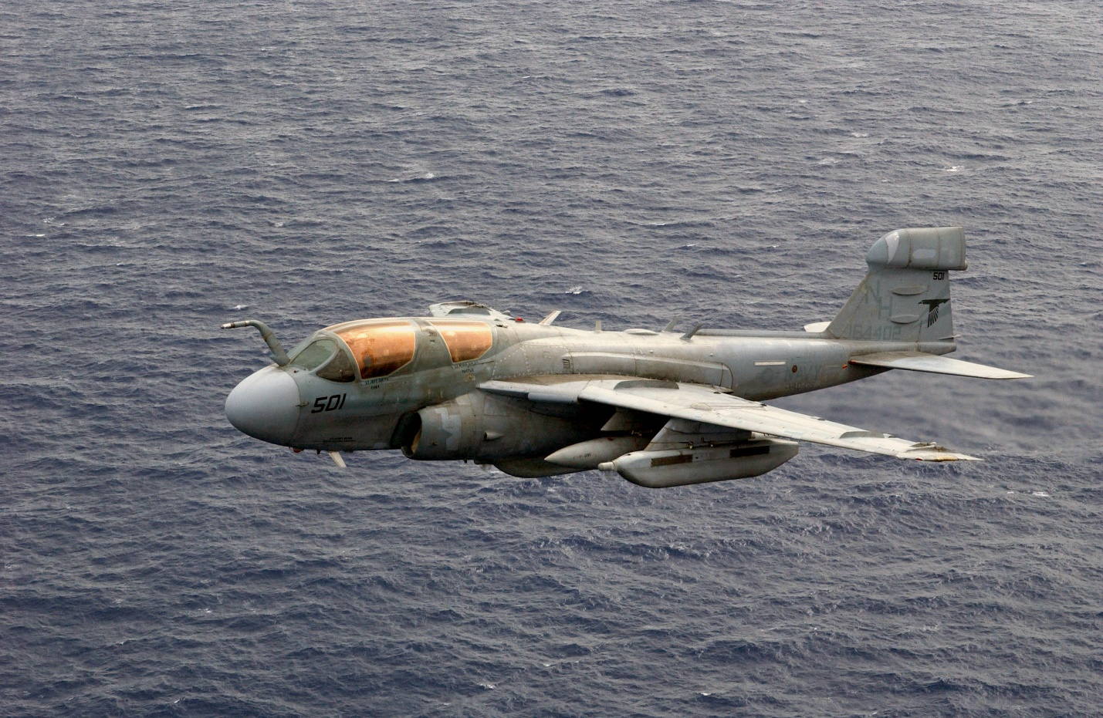

[**S-3B Viking**](https://en.wikipedia.org/wiki/Lockheed_S-3_Viking)

The S-3B Viking is an excellent ASW platform with modern electronics, computers and GPS navigation – a first for 1994. The S-3 platform is so versatile it has been adapted to the ES-3A Shadow detailed below, a cargo version (US-3A), a dedicated tanker (KS-3A- not adopted), the **Aladdin** for ground surveillance (6), and for several experimental designs such as **Gray Wolf** with multi-mode ISR systems, or the **Beartrap** ELINT versions. Therefore, this aircraft type is in high demand, so much so that the USN experimented with reducing the Squadron size from 10 to 6, but were forced to bring it up to 8 by 1991. There are simply not enough airframes however, and the constant demands mean that there are absolutely no spare Vikings in the fleet.

|  |  |  |  |  |  |
| --- | --- | --- | --- | --- | --- |
| Sqn | Name | CVW | No. | Type | Remarks |
| VS-21 | Redtails | CVW-5 | 8 | S-3B | USS Independence |
| VS-22 | Checkmates | CVW-3 | 8 | S-3B | USS Eisenhower |
| VS-24 | Scouts | CVW-8 | 8 | S-3B | USS T Roosevelt |
| VS-27 | Sea Wolves | CVW-10 | 8 | S-3B | USS George Washington |
| VS-28 | Gamblers | CAW-6 | 8 | S-3B | USS Enterprise |
| VS-29 | Dragonfires | CVW-11 | 8 | S-3B | USS Abraham Lincoln |
| VS-30 | Diamondcutters | CVW-17 | 8 | S-3B | USS Saratoga |
| VS-31 | Topcats | CVW-2 | 8 | S-3B | USS Constellation |
| VS-32 | Maulers | CVW-1 | 8 | S-3B | USS America |
| VS-33 | Screwbirds | CVW-9 | 8 | S-3B | USS Nimitz |
| VS-35 | Blue Wolves | CVW-14 | 8 | S-3B | USS Carl Vinson |
| VS-37 | Sawbucks | CVW-15 | 8 | S-3B | USS Kitty Hawk |
| VS-38 | Red Griffins | CVW-7 | 8 | S-3B | USS JF Kennedy |
| VS-41 | Shamrocks | FRS | 4 | S-3B | NAS Oceana |

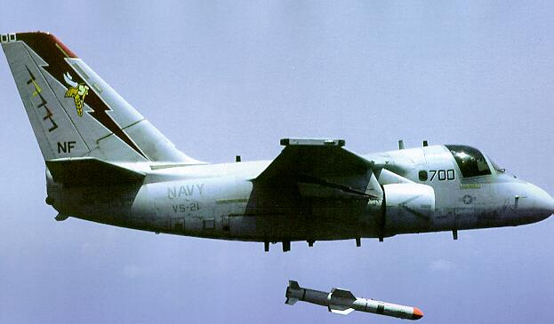

[**ES-3A Shadow**](https://fas.org/irp/program/collect/es-3_shadow.htm)

Another derivative of the S-3 is the highly successful ES-3A which was converted from the original S-3A airframes to fulfill the role of **ELINT** or Electronic Intelligence gathering.  Only 16 of these aircraft exist and they were produced between 1990 and 1992.  VQ-5 ‘Sea Shadows’ and VQ-6 ‘Black Ravens’ each fly 8 of these highly specialized aircraft, normally sending a pair to each deployed CVW.

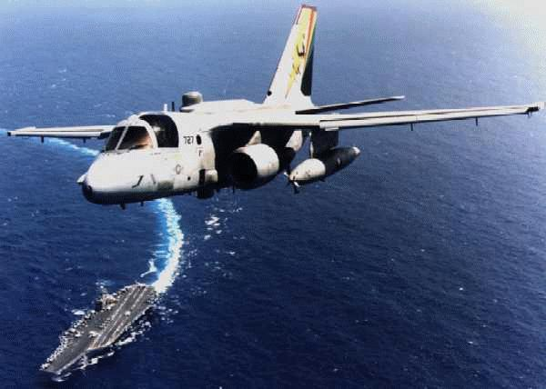

|  |  |  |  |  |  |
| --- | --- | --- | --- | --- | --- |
| Sqn | Name | CVW | No. | Type | Remarks |
| VQ-5 | Sea Shadows | Various | 8 | ES-3A | NAS North Island |
| VQ-6 | Black Ravens | Various | 8 | ES-3A | NAS Cecil Field |