NATO/US Navy/Naval Aviation/F-14

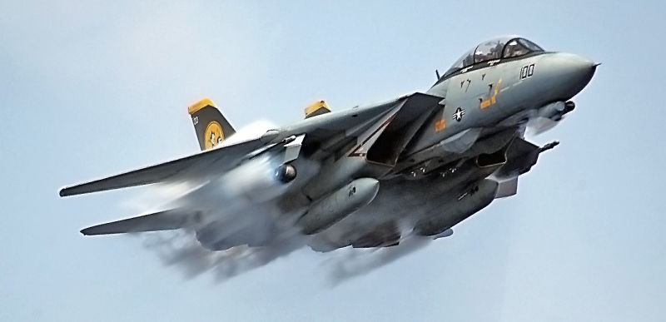

***F-14 Tomcat***

Designed in the 60’s, fielded in the 70’s, by 1994 the F-14 was beyond mid life.  Although an outstanding Air Superiority fighter, its prowess was based on its ability to carry the Aim-54 Phoenix long range missile designed to destroy Soviet bombers, and despite its size, it was a nimble dog-fighter.  The original Tomcat was big (61,000 lbs), expensive and limited in capabilities to a single role.

In the late ‘80’s USN embarked on a major upgrade program of its F-14 fleet in order to make it a more versatile, multi-role aircraft. The plan was for 137 new build F-14D, followed by 400 rebuilt F-14A to the new F-14D ‘Super Tomcat’ standard with an improved engine and a modern precision ground strike capability. (***not to be confused with Super Tomcat 21***). This plan was canceled after 162 airframes were delivered (37 new, remainder rebuilt). Nine squadrons are equipped with this version.

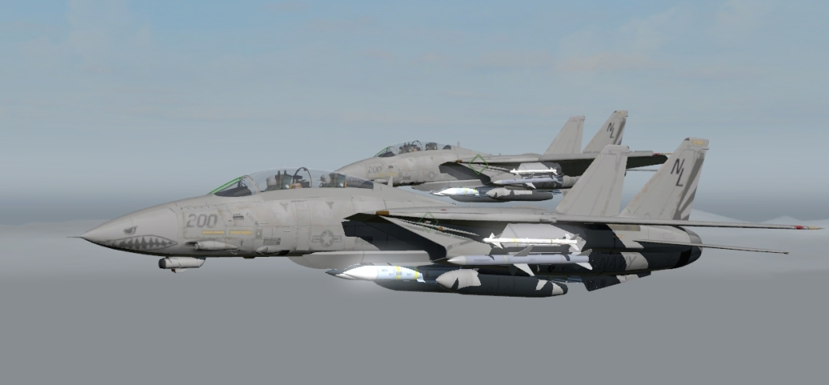

In the Northern Fury world there are some alterations to historical production facts:

* 478 F-14A models were built which is as actually happened.
* The F-14B was originally a mix of 67 rebuilt and 19 new production aircraft. However, in Northern Fury, because of the plans for the F-14D remain online, all of these aircraft are new build and production continued from 1987 until 1992 at the rate of 20 per year for a total of 120 Bombcats.
* The rebuild program to F-14D standard is closed but it was taking approximately six months with a production capacity of 8 per month.
* There are 29 Tomcat squadrons (VF) in the fleet, one more than there was historically.
* VF-101 ‘Grim Reapers’ on the East Coast, and VF-124 ‘Gunfighters’ on the West Coast, are the F-14 readiness Squadrons with a mix of A, B and D models. They conduct certification and qualification training. Each has about 35 airframes but that fluctuates as replacements are needed in the fleet and they draw new ones from the replacement pool or storage.

|  |  |  |  |  |  |
| --- | --- | --- | --- | --- | --- |
| Sqn | Name | CVW | No. | Type | Remarks |
| VF-1 | Wolfpack | CVW-2 | 12 | F-14A | USS Constellation |
| VF-2 | Bounty Hunters | CVW-2 | 12 | F-14A | USS Constellation |
| VF-11 | Red Rippers | CAW-14 | 12 | F-14D | USS Carl Vinson |
| VF-21 | Free Lancers | CVW-5 | 12 | F-14A | USS Independence |
| VF-24 | Fighting Renegades | CVW-9 | 12 | F-14A | USS Nimitz |
| VF-31 | Tomcatters | CAW-14 | 12 | F-14D | USS Carl Vinson |
| VF-32 | Fighting Swardsmen | CVW-3 | 12 | F-14B | USS Eisenhower |
| VF-33 | Starfighters | CVW-1 | 12 | F-14A | USS America |
| VF-41 | Black Aces | CVW-8 | 12 | F-14A | USS T Roosevelt |
| VF-51 | Screamin' Eagles | CAW-6 | 12 | F-14A | USS Enterprise |
| VF-74 | Be-Devilers | CVW-15 | 12 | F-14B | USS Kitty Hawk |
| VF-83 | Rampagers | CVW-17 | 12 | F-14B | USS Saratoga |
| VF-84 | Jolly Rogers | CVW-15 | 12 | F-14B | USS Kitty Hawk |
| VF-101 | Grim Reapers | FRS | 36 | F-14A/B | NAS Oceana |
| VF-102 | Diamondbacks | CVW-1 | 12 | F-14A | USS America |
| VF-103 | Sluggers | CVW-10 | 12 | F-14B | USS George Washington |
| VF-111 | Sundowners | CAW-6 | 12 | F-14B | USS Enterprise |
| VF-114 | Aardvarks | CVW-8 | 12 | F-14A | USS T Roosevelt |
| VF-124 | Gunfighters | CVW-7 | 12 | F-14D | USS JF Kennedy |
| VF-126 | Bandits | FRS | 33 | F-14A/B | NAS Miramar |
| VF-142 | Ghostriders | CVW-10 | 12 | F-14B | USS George Washington |
| VF-143 | Pukin Dogs | CVW-7 | 12 | F-14B | USS JF Kennedy |
| VF-154 | Black Knights | CVW-5 | 12 | F-14A | USS Independence |
| VF-191 | Satan's Kittens | CVW-11 | 12 | F-14A | USS Abraham Lincoln |
| VF-194 | Red Lightnings | CVW-3 | 12 | F-14B | USS Eisenhower |
| VF-201 | Devils Disciples | CVWR-20 | 12 | F-14A | JRSB Fort Worth |
| VF-202 | Superheats | CVWR-20 | 12 | F-14A | NAS Dallas |
| VF-211 | Checkmates | CVW-9 | 12 | F-14A | USS Nimitz |
| VF-213 | Black Lions | CVW-11 | 12 | F-14A | USS Abraham Lincoln |
| VF-301 | Devils Disciples | CVWR-30 | 12 | F-14D | NAS Miramar |
| VF-302 | Stallions | CVWR-30 | 12 | F-14D | NAS Miramar |