**F/A-18 Hornet**

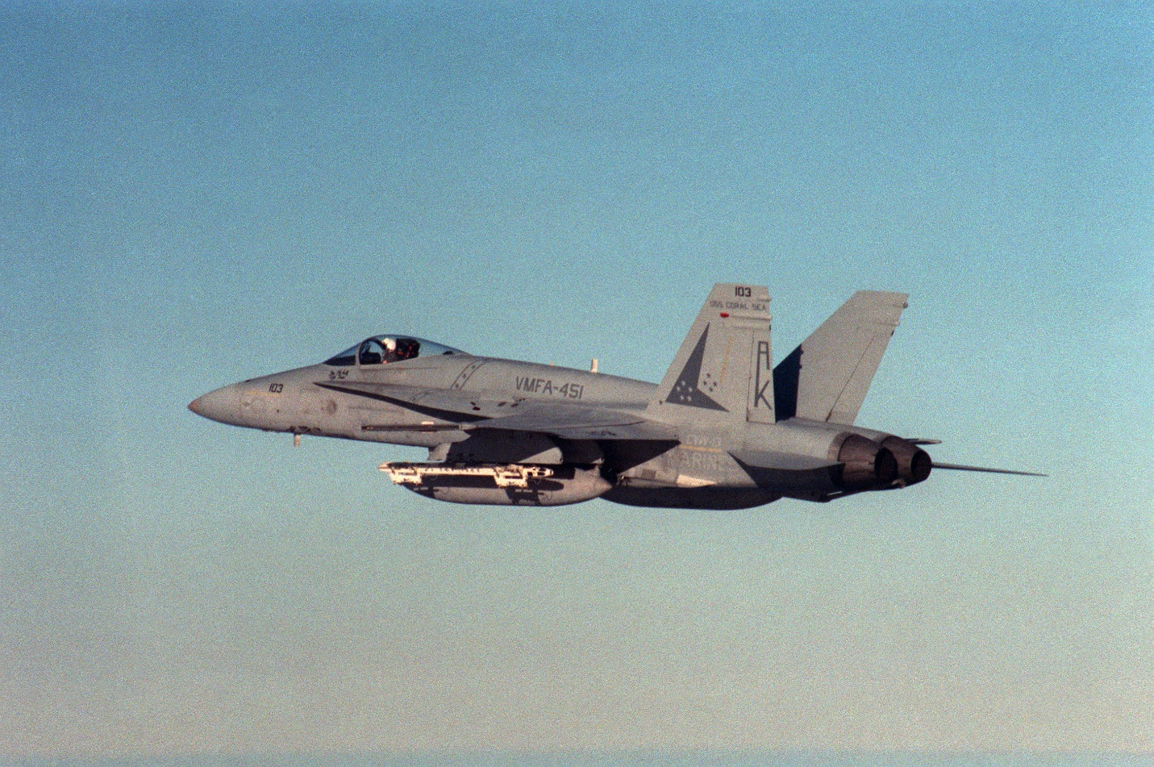

The F/A-18 was fast turning into a success story for the USN but the initial ‘A’ model came with some controversy and was a compromise of requirements.  It was not as good as the F-14 in the Air to Air role, and it did not have the bomb load or range of the A-6’s or A-7’s it was supposed to replace.  Nonetheless; it was modern, agile, quicker to repair and much cheaper to operate than the F-14, and it could drop bombs almost as good as an A-6, just not as many. To a cash strapped navy however, it was a solution to many problems, primarily because it was capable of fulfilling multiple roles. In Northern Fury this was even more important as the Navy was required to maintain more ships, and more Aircraft Carriers and therefore more Air Wings. So the retirement of the A-6 was accelerated as was the procurement of the F/A-18.

The airframe was also an international sales success with Canada, Australia, Spain and Kuwait already operating it and several others in negotiations.

The ramp up in tensions equated to an extension of F/A-18 production to equip an additional CVW and ensure there were enough capable airframes available.  In total Northern Fury has 10 additional VFA (USN Fighter Attack) squadrons and the USMC has 5 additional VMFA (USMC Fighter Attack) squadrons. Total production of F/A-18’s is up by 120 airframes over the historic figure.  Further the older ‘A’ model which was limited to using the Aim-7 Sparrow missile is being upgraded to the ‘C’ model which can use the much more capable Aim-120 AMRAAM missile. Later ‘C’ models (delivered from 1989) are equipped with improved night attack capabilities.

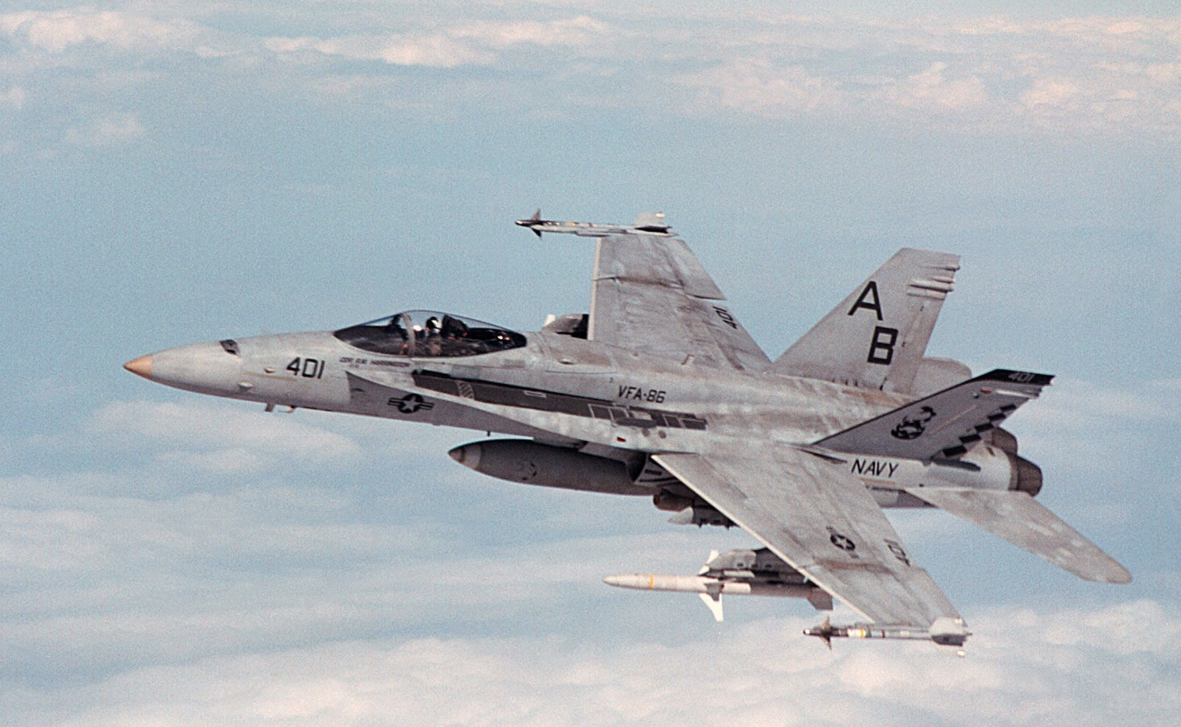

In the Northern Fury world there are some alterations to historical production detailed here:

* Procurement of F/A-18A & B (2 seat) models was extended slightly to acquire 70 additional airframes for a total of 480.
* Procurement of F/A-18C & D (2 seat) models was extended with an additional 320 ordered and 50 delivered by the start of Northern Fury for a total of 440 so far. The remainder, bringing the total to 760 will be delivered by the end of 1996.
* Procurement of USMC F/A-18D (N) – Night attack capable with the rear seat configured for a Weapon & Sensor Officer (WSO) remained steady at 96
* Therefore, instead of 896 airframes (410 ‘A’ + 390 ‘C’ + 96 ‘C(N)’), Northern Fury starts with 1,016 F/A-18s. (+70 ‘A’, +50 ‘C’ models)
* The additional production enabled the early retirement of the A-6E by the end of 1994
* Foreign production of CF-18 (Canada), AF-18 (Australia), EF-18 (Spain) and F/A-18C for Kuwait are complete.
* Foreign orders for Switzerland and South Korea are ongoing.
* Foreign order for Finland has not been entertained.
* F/A-18C & D production generally proceeded as originally planned, allowing the flow through of A models to the USMC and Reserve.
* Ongoing refit of older production ‘A’ models to ‘C’ models is ongoing at the rate of 12/month and includes life extension.
* Upgrade from later production ‘A’ model to the ‘C’ model, less life extension but enabling the use of AMRAAMs requires a software and minor hardware changes.

USN Squadrons are equipped as follows:

|  |  |  |  |  |  |
| --- | --- | --- | --- | --- | --- |
| Sqn | Name | CVW | No. | Type | Remarks |
| VFA-15 | Valions | CVW-8 | 12 | F/A-18C | USS T Roosevelt |
| VFA-22 | Fighting Redcocks | CVW-11 | 12 | F/A-18C | USS Abraham Lincoln |
| VFA-25 | Fist of the Fleet | CAW-14 | 12 | F/A-18C | USS Carl Vinson |
| VFA-27 | Royal Maces | CVW-15 | 12 | F/A-18A | USS Kitty Hawk |
| VFA-37 | Bulls | CVW-3 | 12 | F/A-18C | USS Eisenhower |
| VFA-81 | Sunliners | CVW-17 | 12 | F/A-18C | USS Saratoga |
| VFA-82 | Marauders | CVW-17 | 12 | F/A-18C | USS Saratoga |
| VFA-83 | Rampagers | CVW-7 | 12 | F/A-18C | USS JF Kennedy |
| VFA-86 | Sidewinders | CVW-1 | 12 | F/A-18C | USS America |
| VFA-87 | Golden Warriors | CVW-8 | 12 | F/A-18C | USS T Roosevelt |
| VFA-94 | Mighty Shrikes | CVW-11 | 12 | F/A-18C | USS Abraham Lincoln |
| VFA-97 | Warhawks | CVW-15 | 12 | F/A-18A | USS Kitty Hawk |
| VFA-105 | Gunslingers | CVW-3 | 12 | F/A-18C | USS Eisenhower |
| VFA-106 | Gladiators | FRS | 42 | F/A-18A/C | NAS Oceana |
| VFA-113 | Stingers | CAW-14 | 12 | F/A-18C | USS Carl Vinson |
| VFA-125 | Rough Riders | FRS | 48 | F/A-18A/C | NAS Lenmoore |
| VFA-131 | Wildcats | CVW-7 | 12 | F/A-18C | USS JF Kennedy |
| VFA-132 | Privateers | CAW-6 | 12 | F/A-18C | USS Enterprise |
| VFA-136 | Knighthawks | CVW-1 | 12 | F/A-18C | USS America |
| VFA-136 | Knight Hawks | CVW-10 | 12 | F/A-18C | USS George Washington |
| VFA-137 | Kestrels | CAW-6 | 12 | F/A-18A | USS Enterprise |
| VFA-146 | Blue Diamonds | CVW-9 | 12 | F/A-18C | USS Nimitz |
| VFA-147 | Argonauts | CVW-9 | 12 | F/A-18C | USS Nimitz |
| VFA-151 | Vigilantes | CVW-2 | 12 | F/A-18C | USS Constellation |
| VFA-151 | Chargers | CVW-17 | 12 | F/A-18C | USS Saratoga |
| VFA-161 | Chargers | CVW-10 | 12 | F/A-18C | USS George Washington |
| VFA-192 | Golden Dragons | CVW-5 | 12 | F/A-18C | USS Independence |
| VFA-195 | Dam Busters | CVW-5 | 12 | F/A-18C | USS Independence |
| VFA-201 | Hunters | CVWR-20 | 12 | F/A-18A | JRB Fort Worth |
| VFA-203 | Blue Dolphins | CVWR-20 | 12 | F/A-18A | NAS Jacksonville |
| VFA-303 | Golden Hawks | CVWR-30 | 12 | F/A-18C | NAS Alameda |
| VFA-305 | Lobos | CVWR-30 | 12 | F/A-18C | NAS Los Alamitos |

USMC Squadrons are equipped as follows:

|  |  |  |  |  |  |
| --- | --- | --- | --- | --- | --- |
| Sqn | Name | Location | No. | Type | Remarks |
| VMFA-115 | Silver Eagles | Med | 12 | F/A-18A |  |
| VMFA-122 | Werewolves | CVW 14 | 12 | F/A-18A | USS Carl Vinson |
| VMFA-251 | Thunderbolts | CVW 6 | 12 | F/A-18A | USS Enterprise |
| VMFA-312 | Checkerboards | CVW 3 | 12 | F/A-18D(N) | USS Eisenhower |
| VMFA-332 | Polka Dots | Cherry Pt | 12 | F/A-18D(N) |  |
| VMFA-451 | Warlords | Med | 12 | F/A-18A |  |
| VMFA-533 | Hawks | CVW 8 | 12 | F/A-18D(N) | USS T Roosevelt |
| VMFA-121 | Green Knights | El Toro | 12 | F/A-18C(N) |  |
| VMFA-212 | Lancers | Kaneohe | 12 | F/A-18C(N) |  |
| VMFA-224 | Bengals | Iwakuni | 12 | F/A-18D(N) |  |
| VMFA-225 | Vikings | El Toro | 12 | F/A-18D(N) |  |
| VMFA-232 | Red Devils | El Toro | 12 | F/A-18D(N) |  |
| VMFA-235 | Death Angels | Kaneohe | 12 | F/A-18A |  |
| VMFA-242 | Bats | Japan | 12 | F/A-18D(N) |  |
| VFMA-314 | Black Knights | CVW 11 | 12 | F/A-18A | USS Abe Lincoln |
| VMFA-323 | Death Rattlers | El Toro | 12 | F/A-18A |  |
| VMFA-333 | Shamrocks | Iwakuni | 12 | F/A-18A |  |
| VMFA-531 | Grey Ghosts | El Toro | 12 | F/A-18A |  |
| VMFAT-101 | Sharpshooters | El Toro | 30 | F/A-18A |  |
| VFMA-112 | Cowboys | Dallas | 12 | F/A-18A |  |
| VMFA-124 | Wistling Death | Ft Worth | 12 | F/A-18A |  |
| VMFA-131 | Dimondbacks | Willow Grv | 8 | F/A-18A |  |
| VMFA-133 | Dragons | Alameda | 12 | F/A-18A |  |
| VFMA-134 | Smoke | El Toro | 3 | F/A-18A |  |
| VMFA-142 | Flying Gators | Cecil Fd | 8 | F/A-18A |  |
| VFMA-321 | Hell's Angels | Andrews | 12 | F/A-18A |  |
| VMFA-322 | Ftg Gamecocks | Waymouth | 12 | F/A-18A |  |