**USN Support Aircraft**

The USN operates one of the largest air forces in the world, and supports another of the world’s largest air forces – the US Marine Corps. Therefore the number of aircraft needed to sustain this force is large and diverse. This section does not hope to capture every non-combat aircraft operated by the USN but simply to highlight the major types and give an idea of the scope.

**Transport**

Moving people, special cargo, important visitors and key senior officers around the world is a significant task performed by 14 ‘Fleet Logistics Support Squadrons’ (VR) flying three main types of aircraft, the venerable C-130 Hercules, the converted airliner C-9 Skytrain II and converted executive Gulfstream II and IV jets. The job of delivering the passengers and cargo to the fleet falls to 3 more tactical squadrons with the same name but designated VRC. The VRCs conduct ‘Carrier Onboard Delivery’ or COD, landing directly on the carriers, they primarily use the C-2A-R Greyhound but are supplemented by a handful of converted US-3A Vikings.

|  |  |  |  |  |  |
| --- | --- | --- | --- | --- | --- |
| Type | Name | Role | No. | Sqns | Remarks |
| C-9 | Skytrain II | Passenger/Cargo Tpt | 29 | VR-46, 52, 56, 57, 58, 59, 61 | Converted DC-9s |
| C-20D | Gulfstream III | Passenger/VIP Tpt | 2 | VR-48, 51 |  |
| C-20G | Gulfstream IV | Passenger/Cargo Tpt | 5 | VR-48, 51 |  |
| C-130T | Hercules | Cargo/Tanker | 24 | VR-53, 54, 55, 62, 64 |  |
| C-2A-R | Greyhound | Carrier Onboard Delivery | 39 | VRC-30, 40, 50 | COD |
| US-3A | Viking(COD) | Carrier Onboard Delivery | 7 | VRC-50 |  |

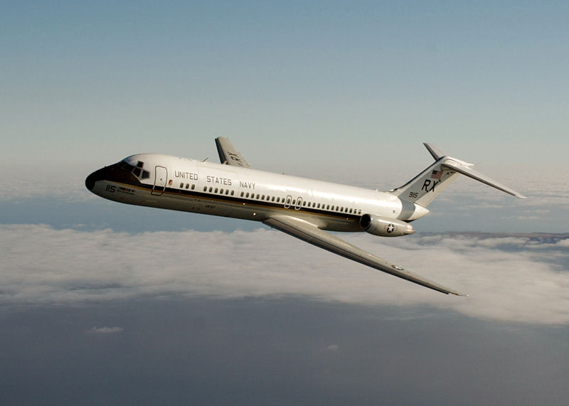

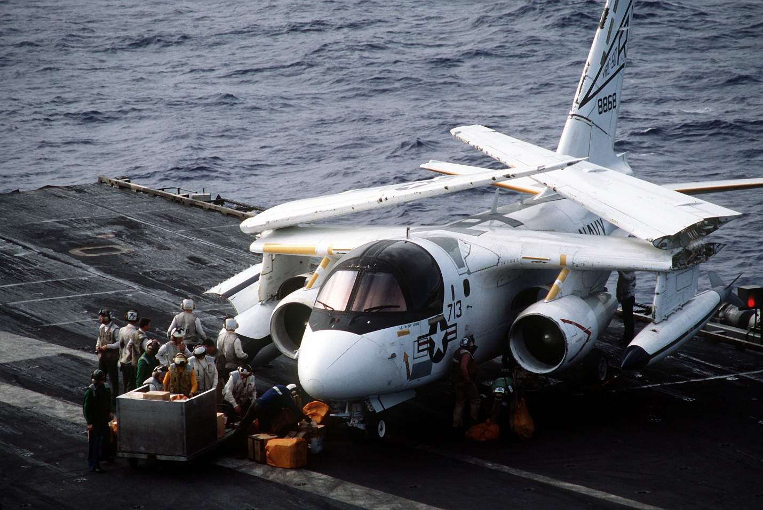

**Fleet Replacement Squadrons (FRS)**

In addition to the Fleet Replacement Squadrons mentioned specific to types of Aircraft these Three Sqns collected a wide range of aircraft and conducted adversary training for the Navy as a whole. All flew out of bases on the East Coast but deployed widely as tasks required.

|  |  |  |  |  |  |
| --- | --- | --- | --- | --- | --- |
| Sqn | Name | Location | No. | Type | Remarks |
| VF-43 | Challengers | NAS Oceana, VA | 12 | Kfir C.2 | Called F-21A, on lease |
|  |  |  | 12 | F-5F Tiger II |  |
| VA-44 | Hornets | Cecil Field, FL | 12 | A-6E |  |
|  |  |  | 12 | F-4 | F-4S & F-4N |
| VF-45 | Blackbirds | Cecil Field, FL | 12 | A-4M | Sometimes VA-45 based on role |
|  |  |  | 12 | TF-16N |  |

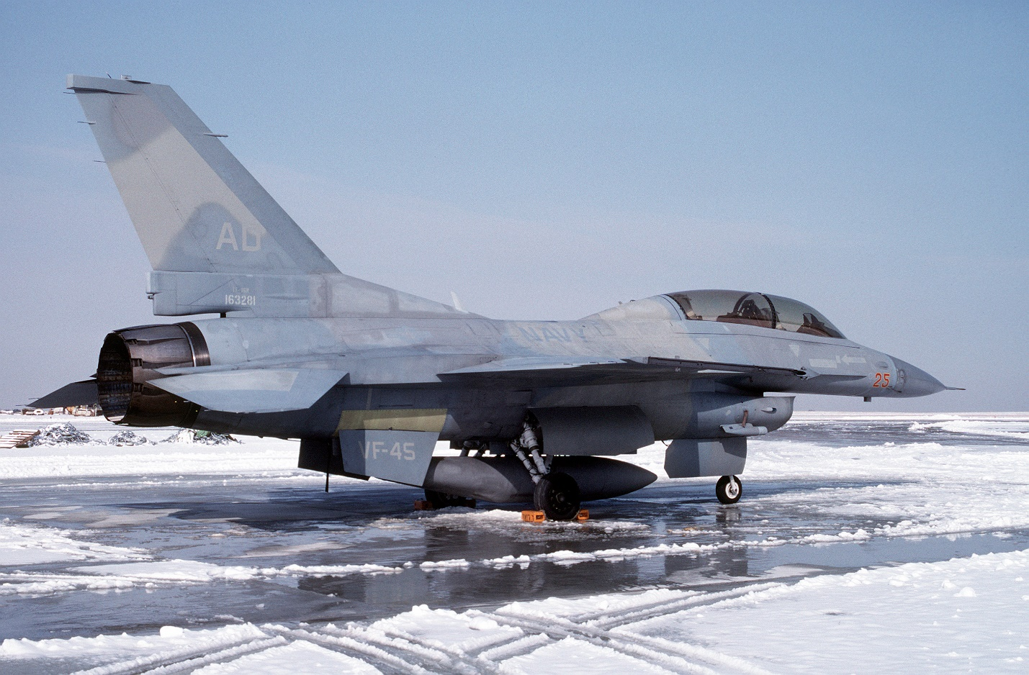

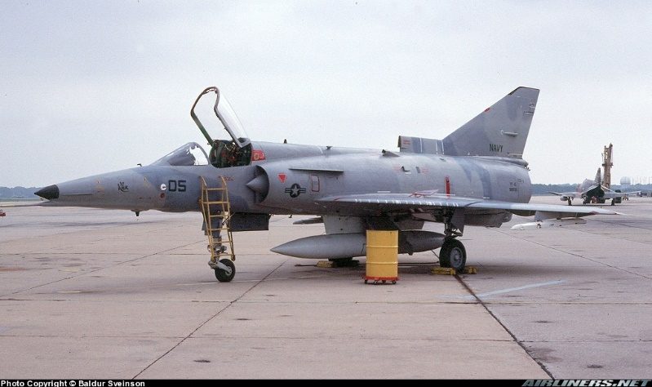

**Advanced Training**

US Naval Aviation training is some of the most advanced and progressive in the world, and requires a lot of effort to conduct. There are two main types of squadron supporting this activity, ‘Fleet Composite Squadron’ (VC) and ‘Fighter Squadron Composite’ VCR. These squadrons operate multiple types of aircraft and conduct multiple functions. The most complex function would be DACT, or Dissimilar Air Combat Training, where the VC or VCR elements try and replicate Soviet aircraft types, doctrine and tactics. Other functions performed by some of these squadrons are target towing, target drone, aerial target photography and general range services.

|  |  |  |  |  |  |
| --- | --- | --- | --- | --- | --- |
| Sqn | Name | Location | No. | Type | Remarks |
| VC-1 | Blue Alli | NAS Barbers Point | 12 | TA-4J | Various Helos & drones |
| VC-5 | Checkertails | NAS Cubi Point | 12 | TA-4J | Various Helos & drones |
| VC-6 | Firebees | NAS Norfolk | 40+ | RQ-2A | Various drones, RQ-2 to fleet |
| VC-8 | Redtails | NS Roosevelt Roads | 12 | A-4M |  |
| VC-10 | Challengers | NAS Leewad Pt | 12 | TA-4J | Guantanamo Bay |
|  |  |  | 4 | EA-4F |  |
| VFC-12 | Fighting Omars | NAS Oceana | 12 | F/A-18A/B |  |
| VFC-13 | Saints | NAS Fallon | 12 | F-5F/F-5N | Top Gun |
|  |  |  | 12 | F-16N |  |

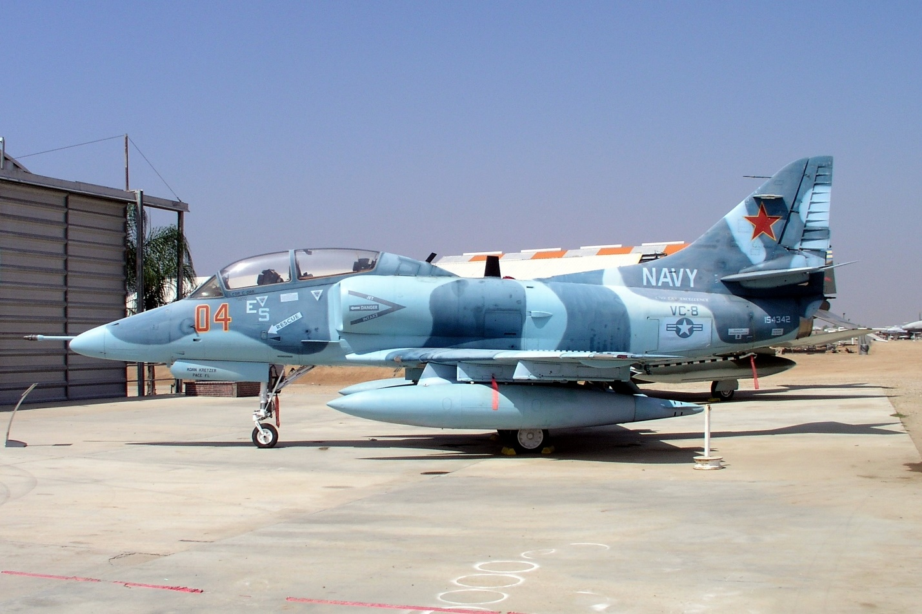

**Basic flight and carrier Training**

All naval aviators learn to fly on the T-34C ‘Mentor’ before advancing to various advanced training squadrons for either advanced jet training on the T-45C ‘Goshawk’, advanced turboprop training on the T-44A ‘Pegasus’ or advanced helicopter training on the TH-57 ‘Jet Ranger’. As a student progresses through the program s/he will be selected to proceed to specific types. Those going to VF or VFA squadrons will spend time on the TA-4J Skyhawk while those proceeding to VS or VQ squadrons will move to the T-2C Buckeye, while helicopter and turbo-prop pilots will advance to more specific training and then to the actual aircraft for operational training. All who are destined for duty on aircraft carriers will proceed through VT-86 to practice carrier operations on the USS Forrestal.

|  |  |  |  |  |  |
| --- | --- | --- | --- | --- | --- |
| Sqn | Name | Location | No. | Type | Remarks |
| VT-2 | Doerbirds | NAS Whiting Field | 48 | T-34C | Primary Training |
| VT-3 | Red Knights | NAS Whiting Field | 48 | T-34C | Primary Training |
| VT-4 | Warbucks | NAS Pensacola | 48 | T-2C | Advanced Training multi engine-Jet |
| VT-6 | Shooters | NAS Whiting Field | 48 | T-34C | Primary Training |
| VT-7 | Eagles | NAS Meridian | 48 | T-45C | Advanced Training |
| VT-9 | Tigers | NAS Meridian | 48 | T-45C | Advanced Training |
| VT-10 | Wildcats | NAS Pensacola | 48 | T-34C | Primary Training |
| VT-19 | Fighting Frogs | NAS Meridian | 48 | T-2C | Advanced Training, multi engine-Jet |
| VT-21 | Redhawks | NAS Kingsville | 48 | T-45C | Advanced Training |
| VT-22 | Golden Eagles | NAS Kingsville | 48 | T-45C | Advanced Training |
| VT-23 | Professionals | NAS Kingsville | 48 | T-2C | Advanced Training, multi engine-Jet |
| VT-24 | Bobcats | NAS Chase Field | 48 | TA-4J | Air Combat |
| VT-25 | Cougars | NAS Chase Field | 48 | TA-4J | Air Combat |
| VT-26 | Tigers | NAS Chase Field | 48 | T-2C | Advanced Training, multi engine-Jet |
| VT-27 | Boomers | NAS Corpus Christi | 48 | T-34C | Primary Training |
| VT-28 | Rangers | NAS Corpus Christi | 48 | T-34C | Primary Training |
| VT-31 | Wise Owles | NAS Corpus Christi | 24 | T-44A | Advanced Training, multi engine-Prop |
| VT-35 | Stingrays | NAS Corpus Christi | 24 | T-44A | Advanced Training, multi engine-Prop |
| VT-86 | Sabrehawks | USS Forrestal | 24 | T-45C | Advanced Training- Carrier Ops |
| HT-8 | Eightballers | NAS Whiting Field | 36 | TH-57B/C | Advanced Training-Helicopters |
| HT-18 | Vigilant Eagles | NAS Whiting Field | 36 | TH-57B/C | Advanced Training-Helicopters |
| HT-28 | Hellions | NAS Whiting Field | 36 | TH-57B/C | Advanced Training-Helicopters |

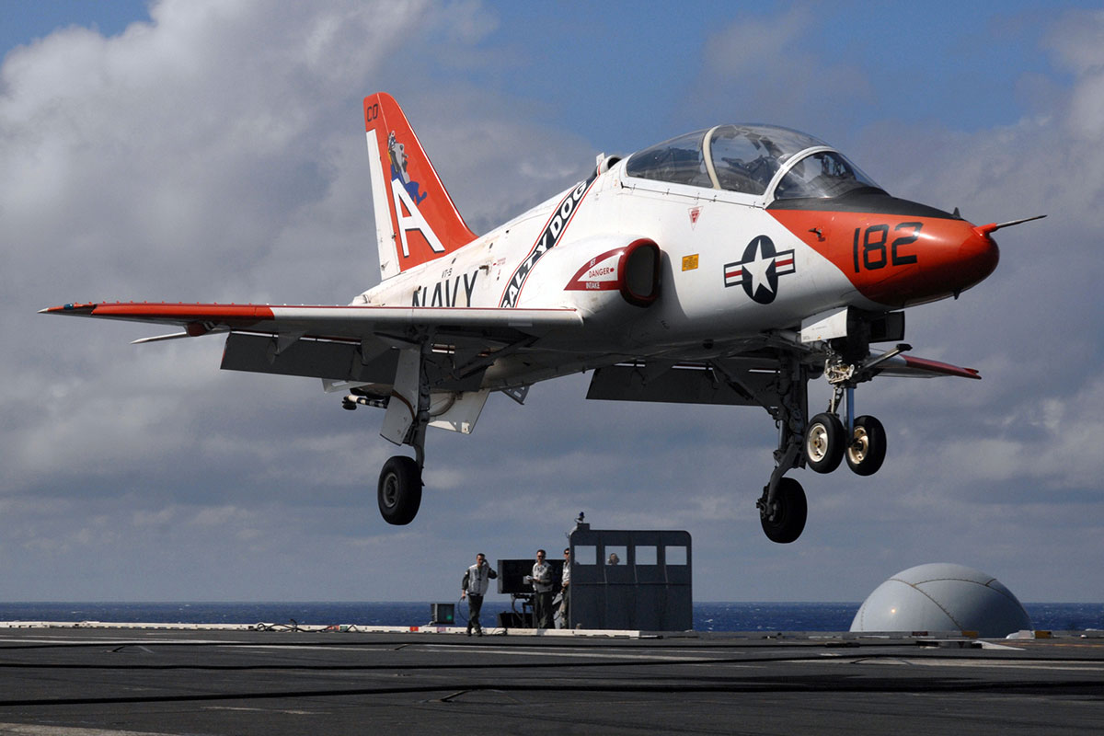

**Test & Evaluation**

The USN’s Test and Evaluation organization was undergoing change in the early 90’s in an effort to consolidate infrastructure and gain efficiency. Below represents what I believe was in place, or would have been in place in early 1994 for Northern Fury.

|  |  |  |  |  |
| --- | --- | --- | --- | --- |
| Sqn | Name | Location | Type s | Remarks |
| VX-1 | Pioneers | NAS Patuxent River | Many | ASW & AEW systems |
| VX-4 | Evaluators | NAS Point Mugu | F-14, F/A-18 | A2A tactics and weapons |
| VX-5 | Vampires | NAWS China Lake | EA-6B, F/A-18, AV-8B | Weapons delivery |
| VX-20 | Force | NAS Patuxent River | Many | ASW & AEW aircraft |
| VX-23 | Salty Dogs | NAS Patuxent River | EA-6B, F/A-18, AV-8B | Strike aircraft |

**Other**

Aircraft and squadrons that don’t fit nicely into any other category are listed here. The Polar express LC-130Rs to the Navy Demonstration team the ***Blue Angels***, as well as the specialists in Oceanographic mapping.

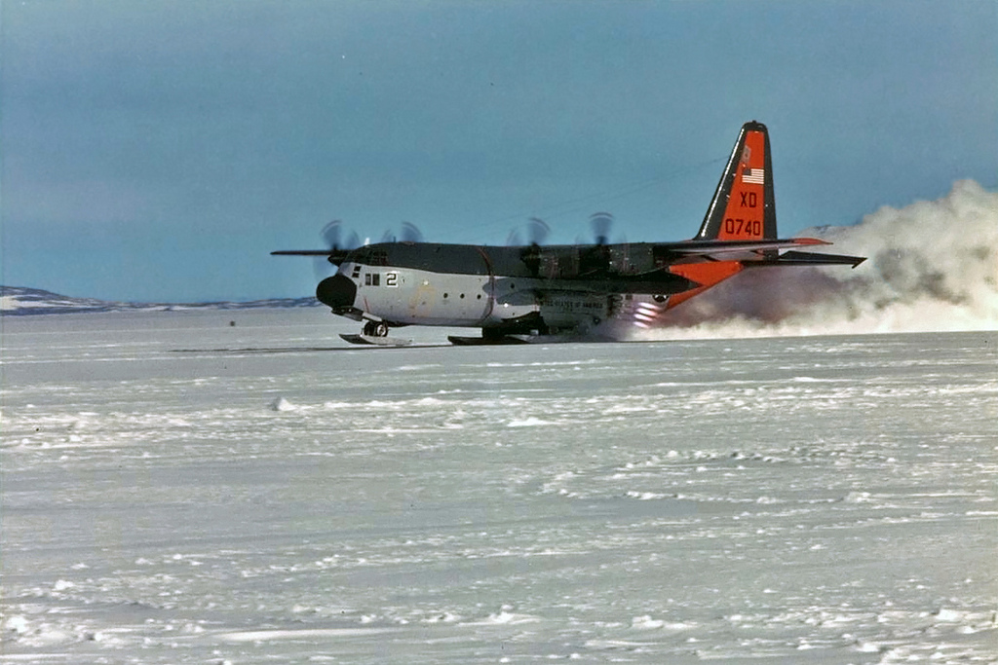

|  |  |  |  |  |  |
| --- | --- | --- | --- | --- | --- |
| Sqn | Name | Location | No. | Type | Remarks |
| VXE-6 | Puckered Penguins | NAS Point Mugu | 6 | LC-130R | Arctic/Antarctic Ski Tpt |
| VXE-8 | Blue Eagles | NAS Patuxent River | 2 | RP-3A | Oceanographic research |
|  | Blue Angels | NAS Pensacola | 12 | F/A-18A/B | Plus 1x C-130 |

