**USN Battleships**

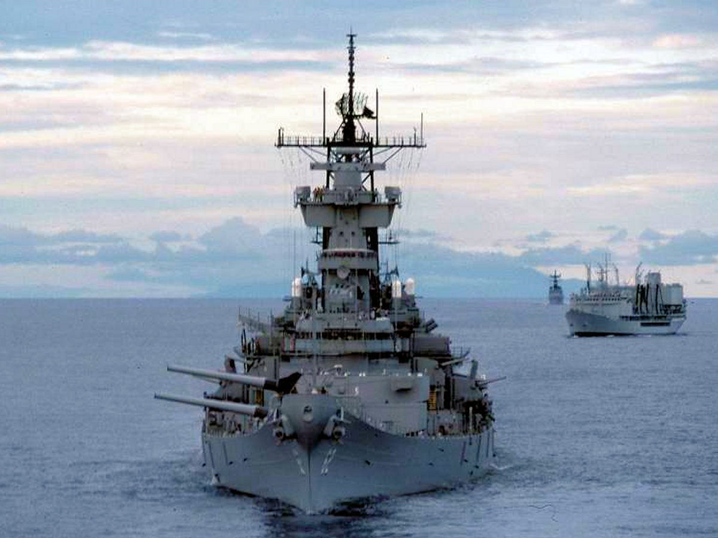

The US is the only nation in the world still holding on to World War Two era Battleships (BB) in 1994, the closest in size and scale would be the Soviet Kirov class which is much more modern and capable, but also half the displacement and one third of the crew. Although very impressive the four Iowa class BBs are hampered by their lack of a Surface to Air Missile (SAM) system, meaning that they will require an Anti-Air Warfare (AAW) as well as an Anti-Submarine Warfare (ASW) escort. Those escorts are always in high demand.

All BBs were refitted in the 1980s and carry 32 Tomahawk Land Attack Cruise Missiles (TLAM) and 16 Harpoon Anti-Ship Missiles (ASM). Defensive systems are limited to electronic countermeasures (ECM), decoys, guns and Close in Weapons System (CIWS). The one significant weapon that are unique to these ships are the 16” guns. Three of the four ships have 9 guns while the USS Iowa only had 6 because the #2 Turret was never repaired after a fire in 1989.

The USS Iowa (**BB-61**), and USS New Jersey (**BB-62**) are in the Pacific Fleet.  USS Missouri (**BB-63**), and USS Wisconsin (**BB-64**) are in the Atlantic Fleet. The Iowa is on patrol in the Mediterranean when Northern Fury starts.

