**[BBTG Missouri (BB-63)](https://en.wikipedia.org/wiki/USS_Missouri_(BB-63))**

USS Missouri or ‘**Mighty Mo**’ saw service in World War Two, Korean War, and the Gulf War. She was retired in 1955 and reactivated in 1986 after a massive upgrade and refurbishment. Historically she was decommissioned again in 1992, in the Northern Fury world, this 2nd decommissioning did not happen and she still sails as a key member of the Atlantic Fleet.

At war start she is tied up in Norfolk but is quickly put into action and participates first in the amphibious operations to retake Iceland and then Norway.

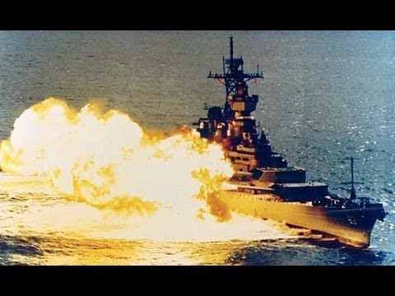

TG Missouri:

* BB-63 USS Missouri
  + Elem VC-6 ‘Firebees’ 4x RQ-2A Pioneer
  + Elem HC-2 ‘Fleet Angels’ 1x SH-3G Sea King
* CG-47 USS Ticonderoga
  + Elem HS-46 ‘Grandmasters’ 2x SH-60B Seahawks
* FFG-20 USS Antrim
  + Elem HSL-74 ‘Demon Elves’ 2x SH-2F Seasprite
* FF-1078 USS Joseph Hewes
  + Elem HSL-38 ‘Seawolves’ 1x SH-2F Seasprite