NATO/US Navy/US Navy BBTGs

BBTG New Jersey (BB-62)

USS New Jersey, earned more battle stars than any of her sister battleships, she saw service in World War Two, Korean War, Vietnam War and the Lebanese Civil War. She was retired in 1969, and reactivated in 1982 after a massive upgrade and refurbishment. Historically she was decommissioned again in 1991, in the Northern Fury world, this 2nd decommissioning did not happen and she still sails as a key member of the Pacific Fleet.

At war start she is steaming off the Philippines, returning to the West Coast via Pearl Harbor, and is quickly recalled to assist the USS Constellation CVBG.

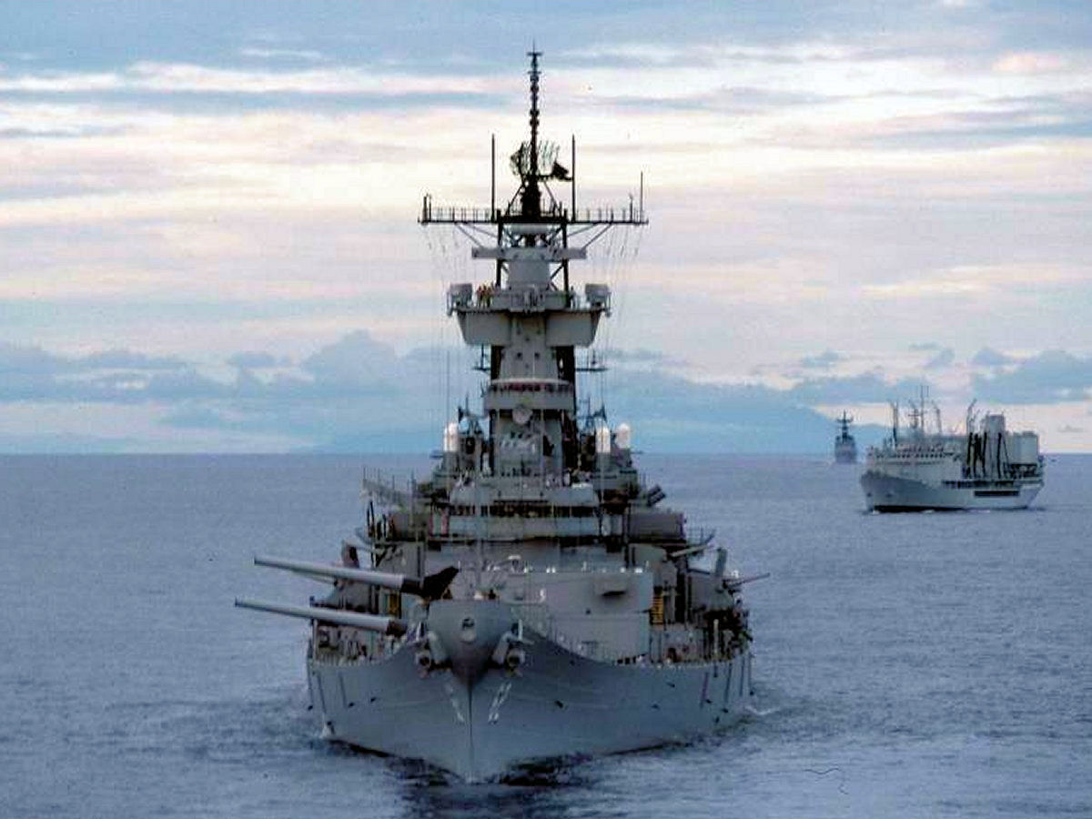

USS New Jersey

TG New Jersey:

* BB-62 USS New Jersey
* CG-27 USS Josephus Daniels
* FFG-22 USS Fahrion
* FF-1087 USS kirk