**[BBTG Wisconsin (BB-64)](https://en.wikipedia.org/wiki/USS_Wisconsin_(BB-64))**

USS Wisconsin also known as saw ‘**Wisky**’ service in World War Two, Korean War, and the Gulf War. In 1956 she was involved in a collision with the Destroyer USS Eaton, after which her bow was completely replaced with the bow from her never completed sister, USS Kentucky. She was retired in 1958, and reactivated in 1988 after a massive upgrade and refurbishment. Historically she was decommissioned again in 1992, in the Northern Fury world, this 2nd decommissioning did not happen and she still sails as a key member of the Atlantic Fleet.

At war start she is tied up in Norfolk but is quickly put into action and, along with the USS Missouri participates first in the amphibious operations to retake Iceland and then Norway.

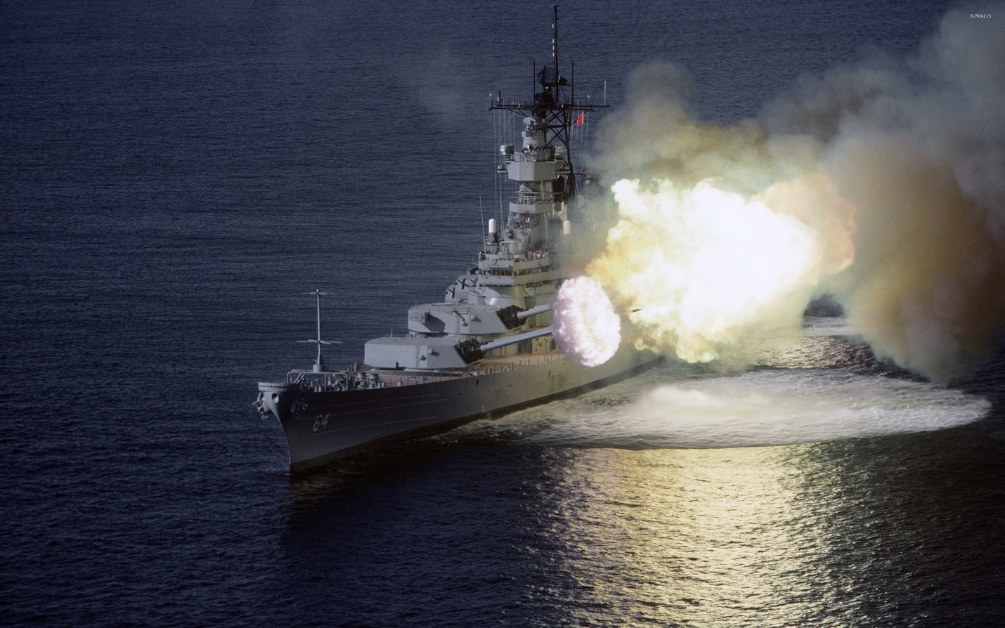

USS Wisconsin

TG Wisconsin:

* BB-64 USS Wisconsin
  + Elem VC-6 ‘Firebees’ 4x RQ-2A Pioneer
  + Elem HC-2 ‘Fleet Angels’ 1x SH-3G Sea King
* CG-26 USS Belknap
* FFG-28 USS Boone
  + Elem HS-44 ‘Swamp Foxs’ 2x SH-60B Seahawks
* FF-1085 USS Donald B. Beary
  + Elem HSL-38 ‘Seawolves’ 1x SH-2F Seasprite