NATO/US Navy/US Navy CVBGs

**USN Aircraft Carriers**

Aircraft carriers are a key lynchpin in the US global power projection policy. In peacetime they exhibit America’s military strength and interest wherever they are deployed and at war they are fundamental in carrying out theatre level plans and operations. This [blog](http://northernfury.bhgdesigns.com/blog/index.php?controller=post&action=view&id_post=8) explains in detail the situation regarding aircraft carriers at the start of Northern Fury. In the passage below the various classes of carrier are listed.

[**Midway Class**](https://en.wikipedia.org/wiki/Midway-class_aircraft_carrier): Both remaining ships of this class were built in World War Two and served a long and productive career operating throughout the Cold War, Viet Nam and many other conflicts, being modernized several times. ***Midway*** deployed to the Gulf war and ***Coral Sea*** earned the nickname ‘Ageless Warrior’. Both are retired to the inactive reserve and laid up at Bremerton Washington but could be re-commissioned with about 1 year of work. One major drawback to these carriers was that they were too small to operate the USNs primary air superiority fighter, the F-14 Tomcat, instead they would routinely deploy with three F/A-18 squadrons and two A-6E squadrons. With the A-6E retiring early in Northern Fury, they would need a full wing of F/A-18s.

|  |  |  |  |  |  |  |
| --- | --- | --- | --- | --- | --- | --- |
| Class | Ship | Pennant | Status | Location | Task | Available |
| Midway | Midway | CV-41 | Retired 1992 | West Coast | Reserve | Mar-95 |
|  | Coral Sea | CV-43 | Retired 1990 | West Coast | Reserve | May-95 |

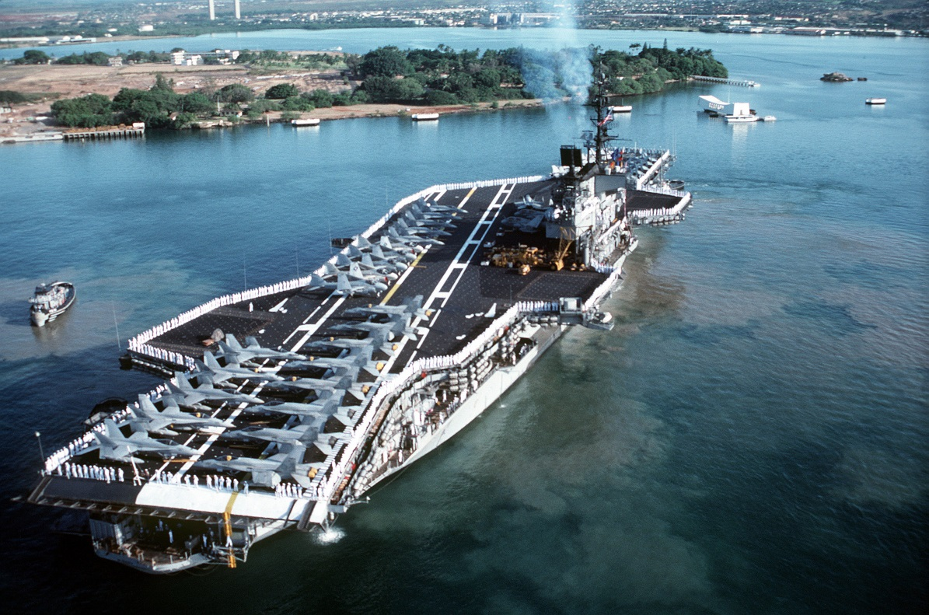

[**Forrestal Class**](https://en.wikipedia.org/wiki/Forrestal-class_aircraft_carrier): These four venerable ships have been sailing since the 50’s and have seen extensive combat experience. Built from the up as ‘Supercarriers’ they were 25% larger than the Midway class, could operate 80-100 jet aircraft and were 100 feet longer and also wider than their predecessors. They had a much deeper hull, an armored flight deck and four elevators. Although these ships were effective they were destined to retire as the Nimitz class ships come on line; until increased tensions caused a re-think on that plan. ***Saratoga*** and ***Independence*** are still operational, while ***Forrestal*** is operating as a training ship and ***Ranger*** is in active reserve with a skeleton crew, she will take 30-60 days to activate.

|  |  |  |  |  |  |  |
| --- | --- | --- | --- | --- | --- | --- |
| Class | Ship | Pennant | Status | Location | Task | Available |
| Forrestal | Forrestal | AVT-59 | Training | East Coast | Training |  |
|  | Saratoga | CV-60 | Active | Indian | Patrol |  |
|  | Ranger | CV-61 | Active Reserve | West Coast | Reserve | May-94 |
|  | Independence | CV-62 | Active | Pacific | Philippines |  |

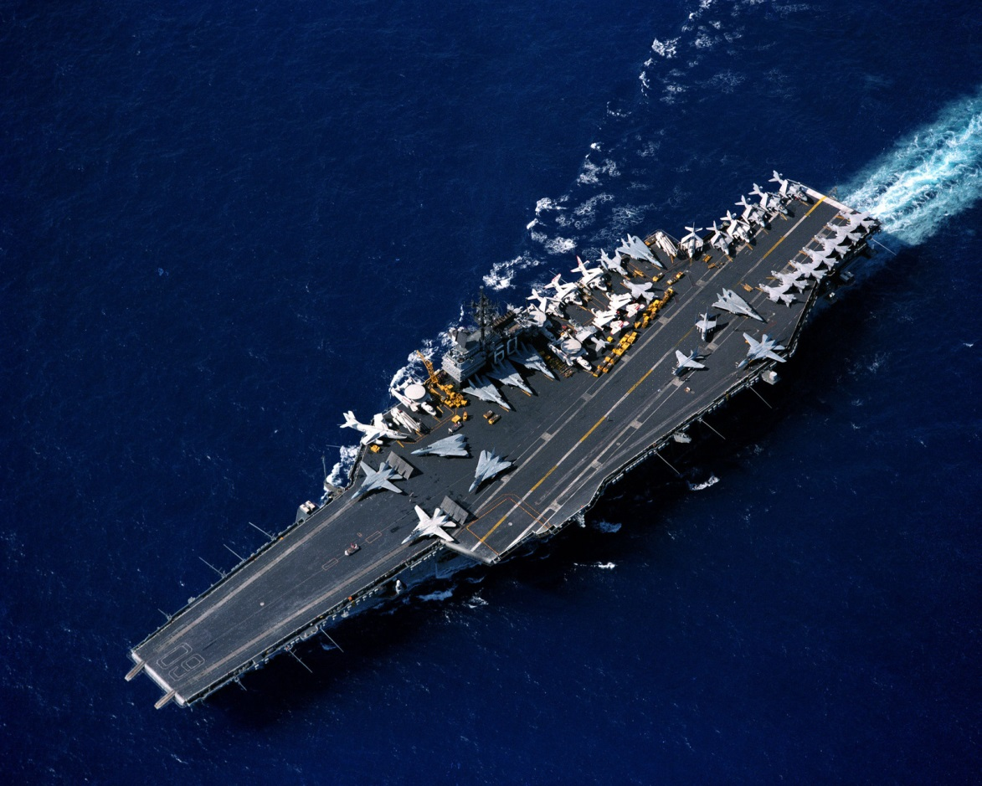

[**Kitty Hawk Class**](https://en.wikipedia.org/wiki/Kitty_Hawk-class_aircraft_carrier): Often called ‘Improved Forrestal’s’ these four ships were newer and longer, they had repositioned elevators to improve aircraft handling. Fourth in this class, the John F. Kennedy has so many variations from the original design that she is often considered a single ship class. These ships were the last conventionally powered aircraft carriers built; the USS ***Enterprise*** was built alongside the first two ships and claimed the ‘65’ pennant but more importantly paved the way for nuclear propulsion of the follow on ***Nimitz*** class.

|  |  |  |  |  |  |  |
| --- | --- | --- | --- | --- | --- | --- |
| Class | Ship | Pennant | Status | Location | Task | Available |
| Kitty Hawk | Kitty Hawk | CV-63 | Active | Pacific | Tied Up | Feb-94 |
|  | Constellation | CV-64 | Active | Pacific | Japan |  |
|  | America | CV-66 | Active | Atlantic | Refit | Jul-94 |
|  | John F Kennedy | CV-67 | Active | Caribbean | Patrol |  |

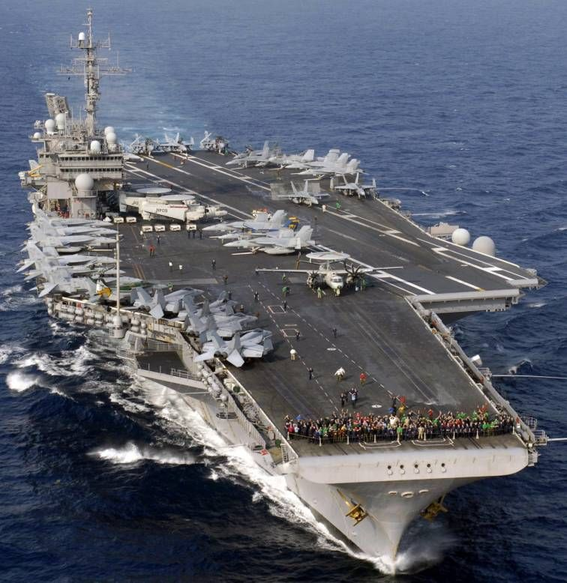

[**Enterprise**](https://en.wikipedia.org/wiki/USS_Enterprise_(CVN-65))**:** The Enterprise is the first nuclear powered aircraft carrier and a single ship out of a planned class of six. Lunched in 1961 she is just finishing her mid-life ‘Refueling and Complex Overhaul’ (RCOH) in 40 vice the actual 48 months that it took historically. She is sailing for workups in Puerto Rico on 4 Feb 94 and departing for Iceland on 11 Feb in response to heighted threat.

|  |  |  |  |  |  |  |
| --- | --- | --- | --- | --- | --- | --- |
| Class | Ship | Pennant | Status | Location | Task | Available |
| Enterprise | Enterprise | CVN-65 | Active | P Rico | Workups |  |

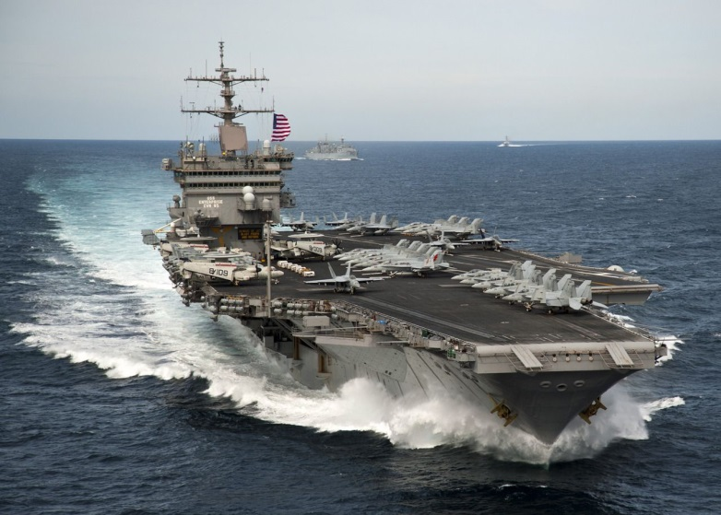

**Nimitz Class:** The epitome of modern aircraft carriers, the Nimitz represents the culmination of 50 years of evolving aircraft carrier operations. Seven of the eventual ten ships of this class are represented in Northern Fury.  The seventh, CVN-74 John C. Stennis was started in Jan 1990 in response to the increased threat from the Soviet Union, immediately space was made available behind CVN-73 George Washington. After starting work 14 months early she will be commissioned 20 months early in April of 94.

|  |  |  |  |  |  |  |
| --- | --- | --- | --- | --- | --- | --- |
| Class | Ship | Pennant | Status | Location | Task | Available |
| Nimitz | Nimitz | CVN-68 | Active | Persian Gulf | Patrol |  |
|  | Dwight D Eisenhower | CVN-69 | Active | Mediterranean | Patrol |  |
|  | Carl Vinson | CVN-70 | Active | Atlantic | Tied Up | Feb-94 |
|  | Theodore Roosevelt | CVN-71 | Active | Atlantic | Tied Up | Feb-94 |
|  | Abraham Lincoln | CVN-72 | Active | Indian | Patrol |  |
|  | George Washington | CVN-73 | Active | Pacific | Tied Up |  |
|  | John C Stennis | CVN-74 | Building | Newport |  | Jun-94 |

